prog 7313
POE PART 1



Group: Bertha Wolvaardt (st10397382) Regardt Estian Malan (st10434247) Cameron Lee Griffin (st10443441) Luan Gulamhussene da Silva (st10444978) Christopher John Leonard Janse van Rensburg (st10434337)

1. Introduction
It is imperative to conduct thorough research on best available feature of Android personal budgeting apps. Thereby the strengths and weaknesses of the most prominent apps namely, Cashew Expense Budget Tracker, You Need a Budget and The Budgeting App can be compared, so as to determine what are fairly standard features and what are desirable innovative features to reinvent and include in our app, Cash Chaos. It must also be understood what the possible pitfalls are in terms of design paradigms that fail to engage users. Ultimately, it is important to understand which features assist users in the best possible way to track and navigate their personal finances better. Our goal as researchers is to ascertain which features best assist users in both reaching savings goals and gaining insight into expense patterns in order to improve their budgeting skills, to this end an informative Infographic has been set up. This is followed by a list of features that we would like to consider including Cash Chaos.

2.1 Overview of the App: Cashew Expense Budget Tracker
Cashew allows the user to track income and expenses across multiple accounts that are displayed prominently at the top of the Home screen. Cashew understands that users want to monitor their saving and spending behavior, in order to learn what worked from past experience and better understand what happens to their money, so that they can make improvements to their spending and saving habits (Teckwise, 2025). Cashew’s design and interface is much more sleek, attractive and modern than its competitors (Teckwise, 2025).
This app guides the user into setting up different “Budgets” which help you to set spending limits and savings goals, these can be tracked as percentages or amounts and can be customized to display on the Home screen, using graphs and pie charts as well different widgets (Teckwise, 2025). Start by navigating directly to Transactions and start adding ALL your expenses.
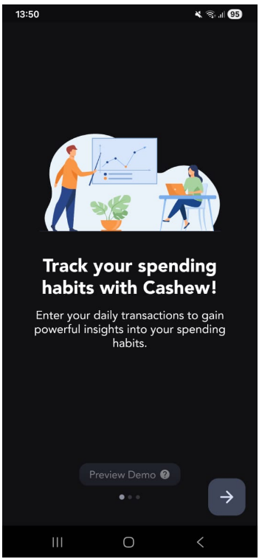
Figure 1: First Screen Upon Opening the App for the First Time (Cashew).
The app starts with an optional tutorial of the main features of the app and how to use the app. It educates the user by making use of dummy data, so that the user will see how to use it intuitively once it is set up.
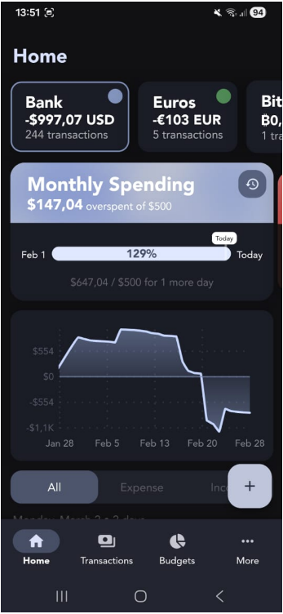
Figure 2: Navigation Bottom Bar (Cashe).
The bottom navigation bar has only four options, which is an optimal choice for two reasons. It limits the number of choices the user has, so that he/she has a smooth experience and not overwhelmed with too many choices. It also falls within thumb zones, which are on the bottom of the screen (where the user's thumbs are) making it easier to reach and allow them to navigate throughout the app effectively.

Figure 3: Home Screen (Cashew.)
The Home Screen covers various important features of the app including the different accounts at the top. Widgets for monthly spending, the user can see at a glance that he has already overspent according to the goals that he has predefined.
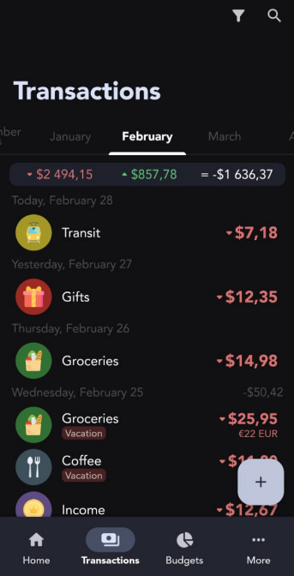
Figure 4: View All Transactions Screen (Cashew).
With this View the user can track their expenses according to the different Categories that they set up previously.
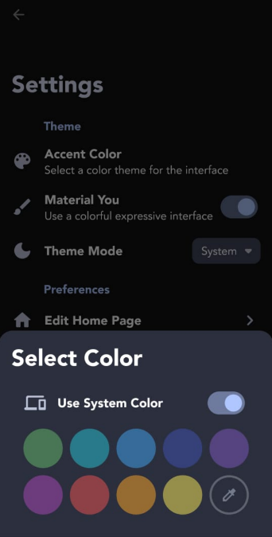
Figure 5: The Settings and Customization Options (Cashew).
It is a joy to use this app because it allows for personalization of the apps physical appearance making it more attractive to engage with for the user.
This app allows you to customize the Theme within Settings. The user can choose between System/ Light/ Dark mode and set the favourite accent colour by selecting a color theme for the interface.

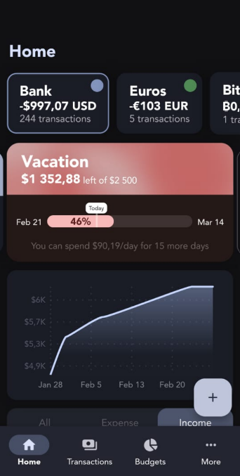
Figure 6: Income Tracker (Cashew).
Being able to toggle between Income and Expense Views that are graphically displayed in this app is one of its best features. This makes it intuitively easy for the used to get a feeling for when and how they can save the difference, in order to reach their personal finance goals.
Cashew Strengths
- Feature and customization rich (Dapper App Developer, 2024),
- Powerful visual aids and graphics (Dapper App Developer, 2024),
- The strengths of this app are that it is extremely visually pleasing and easy to navigate. (Teckwise, 2025),
- Preview Demo is helpful.

Cashew Weaknesses
- The app starts off by prompting the user to add a budget, the terminology here is unclear as “budget” could mean different things (see Cashew Budgeting App Getting Started, 2025),
- The first reaction when someone opens the app is that they need a tutorial (see Cashew Budgeting App Getting Started, 2025),
- There are different accounts that need to be setup, and you can also merge accounts (see Cashew Budgeting App Getting Started, 2025),
- One obvious drawback of this app is that it has many, many features that cause the user to feel anxious when first engaging with the app (see Cashew Budgeting App Getting Started, 2025),
- Transaction tracker (see Cashew Budgeting App Getting Started, 2025),
- Does not keep track of investing (see Cashew Budgeting App Getting Started, 2025),
- Adding subcategories is very satisfying (see Cashew Budgeting App Getting Started, 2025).

Cashew Innovative Features
- View a history of all spending periods with custom filters (Teckwise, 2025),
- Data Backup and Security features with Google Drive (Dapper App Developer, 2024),
- Emojis can be used as category icons (Dapper App Developer, 2024),
- Cashew boasts an abundance of visual aids such as pie charts and graph, this is especially helpful for people who find working with numbers challenging (Teckwise, 2025),
- Personalized expense setup called “budget” in Cashew, caters for different people with their unique spending habits (Teckwise, 2025),
- Bill Splitter (Teckwise, 2025).

2.2 Overview of You Need a Budget
All available funds get budgeted towards an expense category based (Feasible Creative,2024).
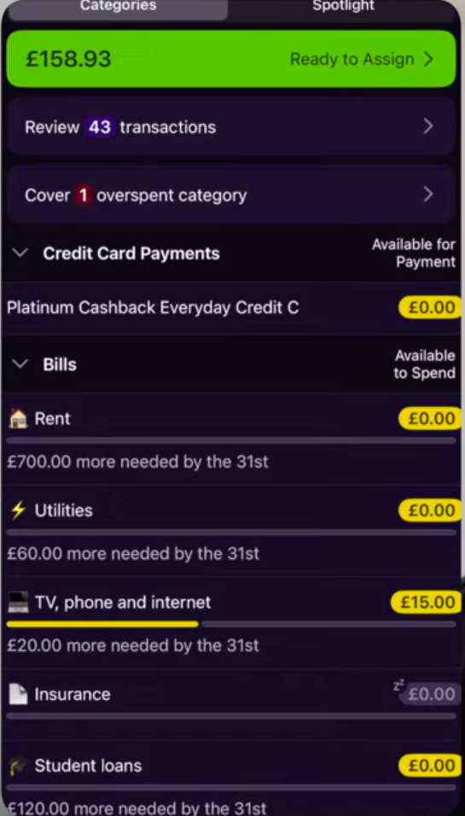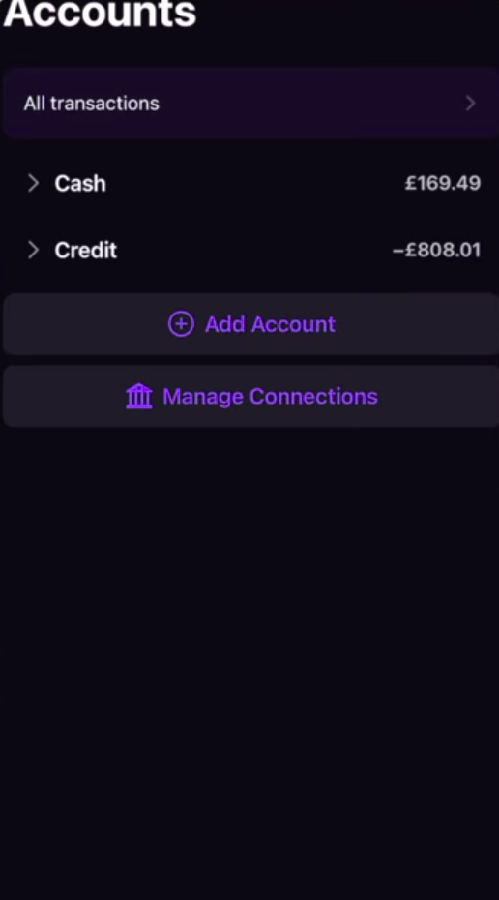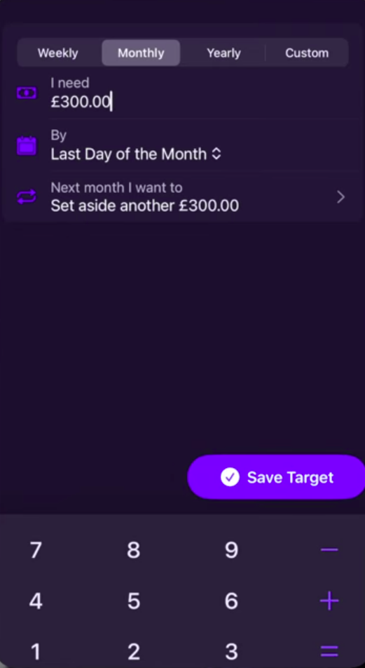
Figure 7: Expense Categories (YNAB).
Users check their plan before spending to ensure they spend within set limit.
All available funds get budgeted towards an expense category based (Feasible Creative,2024).

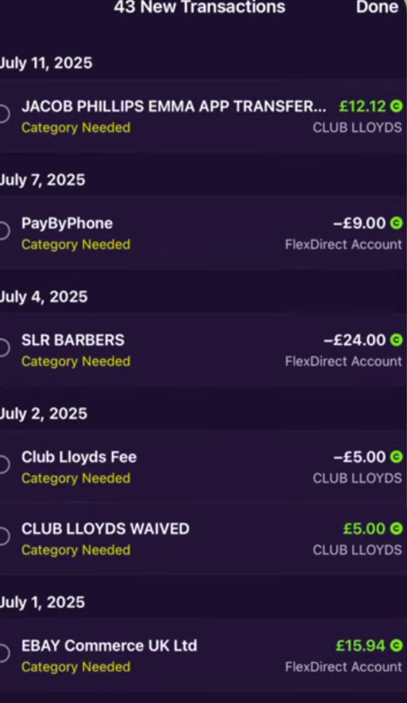
Figure 9: Accounts Screen Showing Transactions (YNAB).
Connected accounts where income and expenses come from.
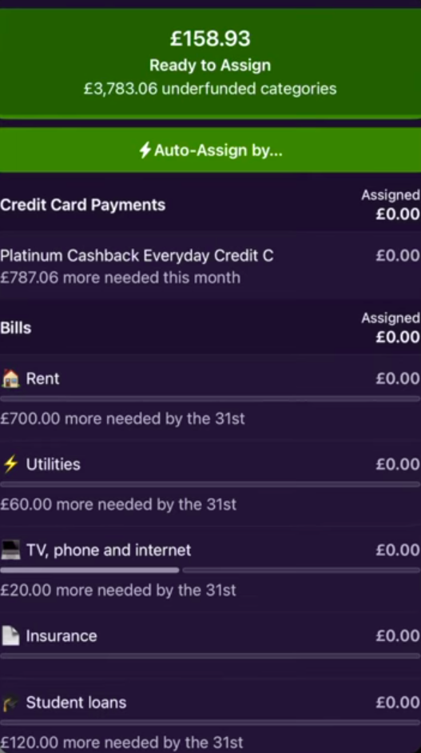
Figure 10: Setting a budget screen (YNAB).
Setting amount and frequency of budget cycle.

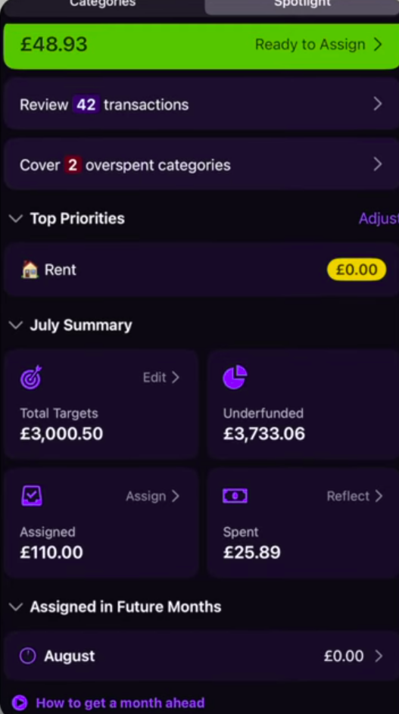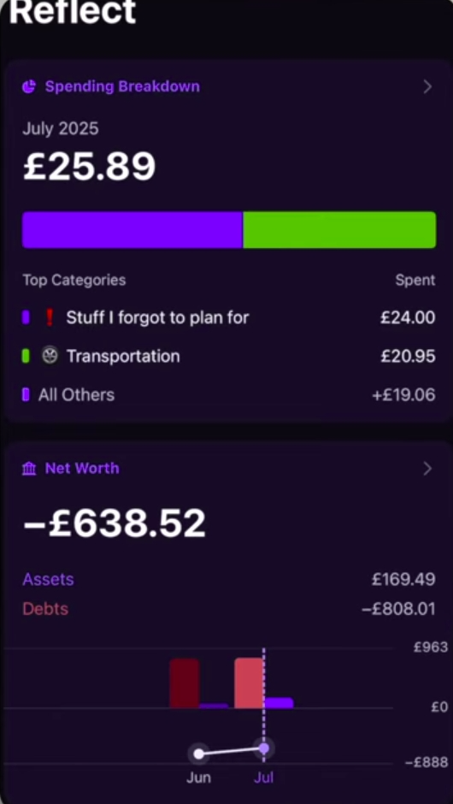
Figure 11: Spotlight screen – reports and summaries of expenses (YNAB).

Accounts Screen. Connected accounts where income and expenses come from
Main screen. At a glance user sees categories, budgets, progress and actions required.
Setting a budget screen. Setting amount and frequency of budget cycle
Review transactions screen.
Auto assign budget to expense categories
You Need a Budget: Strengths
- Multiple Device and bank sync – A single account can have multiple devices and can be connected to several bank accounts. Income and expenses are automatically uploaded to the app (Feasible Creative,2024).The user still needs to log to avoid double billings and encourages users to become aware of their finances (Feasible Creative,2024).
- Mobile and web support – users can access the platform on mobile and web browsers making uploading expenses very convenient. Reports on mobile are simple and easy to navigate (Feasible Creative,2024).
- Flexible budgeting – large expenses are broken down into monthly budgets. Money overspent in one category can be removed from a different category for breakeven. Users can budget for multiple items under the same category (Feasible Creative,2024)
- Ex. Bills category can have a budget for phone payment, rent and utilities (Feasible Creative,2024).
You Need a Budget Weaknesses
- No support of investment tracking – no real-time tracking of volatile assets such as crypto, stocks and other commodities real time. Therefore, user doesn’t get a holistic view of all the accounts.
- Learning curve - App doesn’t guide users through how to use it. By using it like a tracker it becomes hard to actually use the app (Feasible Creative,2024).
- Load speed – the app pushes all transactions to memory to perform current calculations. Over time this would cause very slow load speeds, online reviews show this.
You Need a Budget Innovative Features
- Common Goal – multiple users can add funds to a shared account (Feasible Creative,2024).
- Forsee expenses – user sets budgets for large future payments (insurance, renews, payments) automatically the app creates a budget spread across a period of time to allow user to budgeted (Feasible Creative,2024)
- Public API – large pools of user made wrappers and integrations into already apps. Allows YNAB to integrate into other tools and users can create.
- Money age – income is timestamped. The longer the app stays in the account the more “ages”. This gamification tool encourages good financial discipline by prompting users to save and not take in new expenses (Feasible Creative,2024)

2.3 Overview of The Budgeting App
The Budgeting App is a simple personal budgeting app that has been designed to minimize steps for people to track their income, expenses and transactions between accounts (Gooch, 2025). Some nice to have features are locked behind a paywall, but the core budget tracking functionality is available in the free version, though with limitations with the number of books, accounts, and savings trackers (The Budgeting App, [s.a.] b).
Books are top level containers where you can log your budgets and track your savings and debts. Your book shows you’re your actual balance across accounts including having an advanced search to find transactions.
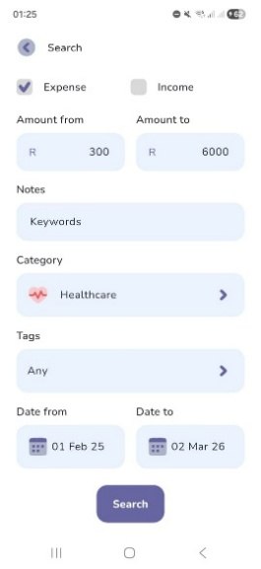
Figure 1 Books Advanced Search (The Budgeting App)
To log transactions conveniently the app focuses on capturing incomes and expenses with the amount and a category. Other optional meta data can be added such as notes, tags, reminders and transaction recurrences.
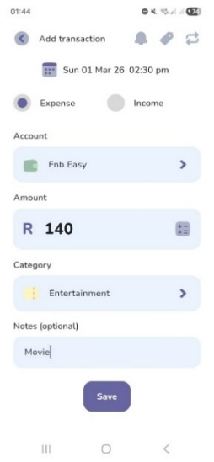
Figure 2 Log Transaction (The Budgeting App)
A focus is placed on your how often you get paid (The Budgeting App, [s.a.] a). You can view your book with the actual balances of your accounts and a grand total for your book. You can choose for your home page to show only income and expenses that have happened in the cashflow view. Or with the forecast view that also shows expected finances related to upcoming bills & incomes. If you overspend on your budget, you can carry over the expenses in your next pay cycle period (TBA_Jeremy, 2024).

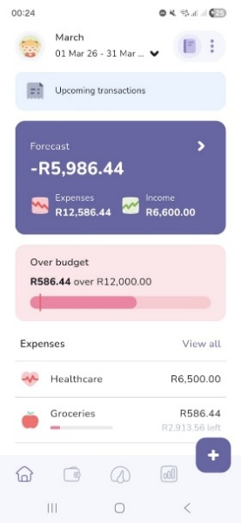
Figure 3 Budget Forecast (The Budgeting App)
The onboarding process guides the user to set a budget per category of expected expenses and set goals for reaching target incomes. Challenges continue by letting the user discover how to create trackers for saving and debt management. A user can at any time transfer some of their budget towards their trackers and allocate money towards a saving goal or a loan that they are paying off.
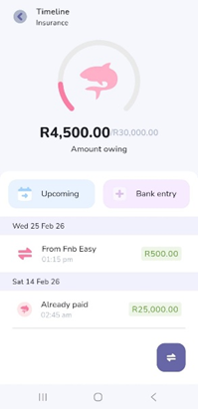
Figure 4 Loan Tracker (The Budgeting App)
Users collect achievements where the app encourages users to stay consistent with streaks, stay disciplined and consistent. Challenges are fallible meaning there are game like stakes when not completing a challenge, this father encourages users to continue to use the app and budget their finances.
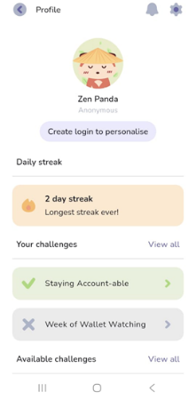
Figure 5 Profile Challenges (The Budgeting App)
The app has various free and paid analysis tools to help you analyze your money. Most of the analysis tools compare income vs expenses, predicted budget vs actual amounts, top expenses and income categories, averages per pay cycle period, days no amount was spent and various other graphs, charts, calendars and tables.
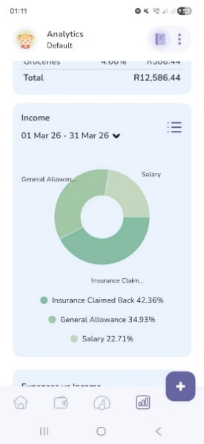
Figure 6 Income Pie Chart (The Budgeting App

The Budgeting App: Strengths
- Many users on the Play Store praise it for having a simple and Intuitive user interface (The Budgeting App, 2022).
- Supports cloud sync with access on multiple devices (Natile, 2024)
- Onboarding and clickable pop-ups helps the user discover app features
- Can customize views to show less details like income or the remaining budget
- Export data to CSV
- Many analysis

The Budgeting App: Weaknesses
- Cannot import history via a csv
- Doesn’t automatically sync transactions with your bank

The Budgeting App: Innovative Features
- Built in calculator on logging page
- Biometric App lock
- Gamification for on boarding and fallible challenges razing stakes for users to be more engaged with the app and budgeting
- Can export data to CSV
- Set reminders to review budget

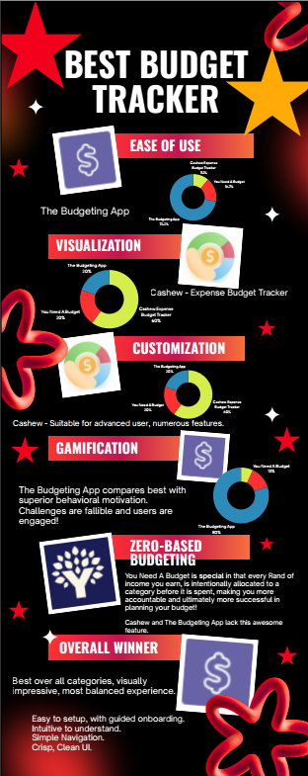
4. Best Features List to Include in Cash Chaos App
From our research on Cashew, You Need a Budget and The Budgeting App, we have identified the following desirable features to include in our own app:
- Multiple Wallet Support
For Example: FNB Cheque, Capitec Savings Account, Standard Bank (Credit Card) and Cash.
The app must be able to handle multiple accounts as well as negative account balances, overdrafts, and accounts that are in debt such as credit cards.
- Multiple Currency Support
For Example: This will allow for an account in the wallet to be expressed in foreign currency and payments or withdraws can be made using the current exchange rate and viewed under wallet/accounts.
- Bill Splitter
For Example: A restaurant bill can be easily split between any number of guests and include a tip amount.
- Forecast View
For example: Seeing the expected amounts for a date in the future, this will work by predicting expenses and incomes of upcoming subscriptions and recurring costs such as subscriptions, rent, bank fees and gym memberships.
- Duplicate Expense
For example: This helps the user to easily add an expense that is often made but is not a subscription, like a favourite R35.00 coffee at Starbucks or R 500.00 petrol purchase made. This aids the user to add an often-repeated expense quickly.
- Ability to Group Accounts
The user can make a “parent” account that can have “children” under it. For Example: Vacation can be a “parent” account while the associated costs such as food, accommodation and activities can be “child” accounts.

5. Conclusion
Personal Budgeting encompasses the concept of setting spending limits and adhering to savings goals. Our research has shown that what makes a good budgeting app a great app, is the app’s ability to aid the user with easy to understand at a glance visualization and a convenient way to keep track of ongoing daily expenses to stay on top of your financial goals. Both visualization and the ability to track metrics (expenses, account balances) over time is what sets personal budgeting apart from dated personal budgeting experience where most users used a simple spreadsheet. Working on this app is exciting because it brings value to ordinary people’s daily lives, also those people who don’t have experience in accounting or who feel that they aren’t “good with numbers”.
Our research has shown that, users prefer engaging with an app with fewer features, as this helps them to navigate easier and focus on the core functionalities of the app, namely keeping track of spending habits and monitoring saving goals therefore our design for Cash Chaos includes a top-right hand corner simple hamburger menu with options and a bottom navigation with only four options that also assists with navigation throughout the app.
Our research has shown that therefore our design includes.

6. References

1. Dapper App Developer, 2024. Track Day Challenge, Top Gear: The Stig revealed. [video online] Available at: <> [Accessed 28 February 2026]
Skyscape, 2010. Skyscape medical resources. Version 1.9.11. [App]. Available from Google Play [Accessed 22 July 2021].
Department for Environment, Food and Rural Affairs, 2007. Sustainable development: the bigger picture. [video online] Available at: [Accessed 23 June 2012].

- Cashew-Expense Budget Tracker. 2024. Dapper App Developer. Version 5.4.4. [App]. Available from Google Play [Accessed 28 February 2026].
- Cashew Budgeting App Getting Started. 2025. YouTube video, added by Rebecca Sowden. [video online] Available at: https://youtu.be/UJ4mDc_WJ24?si=-RkZgGRrgVUFdSBn [Accessed 28 February 2026].
- Feasible Creative,2024.YNAB Budget App: What I Wish I Knew Before Starting.[video online] Available at: https://www.youtube.com/watch?v=mqB_Vu2_le0 [Accessed 24 February 2026].
- Jacob Phillips,2025.YNAB Tutorial & Honest Review (2025) | Complete Setup Guide & Pro Budgeting Strategies.[video online] Available at: https://www.youtube.com/watch?v=6smi9S8Rm7s&list=TLPQMjQwMjIwMjaQEQBlrtAcdA&index=3 [Accessed 24 February 2026].
- App Review: Cashew, finally a budget app for you. 2025. YouTube video, added by Teckwise [video online] Available at: https://youtu.be/BG8Z2DTAoLg?si=yNKX5eGLhAHHka3S [Accessed 28 February 2026].
- The Budgeting App, 2022. Budgeting App - Spend Tracker. Version 5.9.8. [App] Available at: <https://play.google.com/store/apps/details?id=com.thebudgetingapp.thebudgetingapp&pcampaignid=web_share> [Accessed 1 March 2026].
- The Budgeting App, [s.a.]. The quick way to budget. [Online] Available at: <https://thebudgeting.app/> [Accessed 1 March 2026].
- The Budgeting App, [s.a.]. Plans. [Online] Available at: <https://thebudgeting.app/plans/> [Accessed 1 March 2026].
- Natile, 2024. The Budgeting App. [Online] Available at: <https://betalist.com/startups/the-budgeting-app> [Accessed 1 March 2026].
- Gooch. C, 2025. Young couple design their own budgeting app, save enough to buy a house. [Online] Available at: <https://www.thepress.co.nz/business/360564404/can-budgeting-really-be-fun-two-app-developers-think-so> [Accessed 1 March 2026].
- TBA_Jeremy, 2024. How to use the roll-over budget feature. [Reddit] 1 December. Available at: <https://www.reddit.com/r/thebudgetingapp/comments/1h4d831/how_to_use_the_rollover_budget_feature/?utm_source=share&utm_medium=web3x&utm_name=web3xcss&utm_term=1&utm_content=share_button> [Accessed 1 March 2026].

