Name: Thapelo Sefako

Student Number: ST10448181

Module: work integrated learning

Contents

Milestone1 1

Mobile application 1

Web Page 2

LOGO 2

Website 2

Mobile application 3

Wireframes 3

Website 4

Six months course 8

Mobile application 9

# Milestone1

## Mobile application

The performance of a mobile application is much easier than a web application because it has more features than a web application which it will help users to navigate through the application easy. Mobile application can function without internet connection which is good for users when they are out of data or in specific locations that does not have internet. Security measures, a mobile application can store your data which it will require the user for their biometric authentication or password. Its easy for users to access information from their smartphones in any location. Mobile applications can send users notification keeping them informed about updates, promotions, or important information.

# Web Page

Users don’t have to install any application which saves them storage and money of purchasing the application, they access it directly using browsers. Users don’t have to update web application because it does it for you with any latest version, Updates and bug fixes can be rolled out instantly on the server side. Creating a web development is much lesser than creating a mobile application. The accessibility of a web development needs you have to internet near you which is good for other users that want to use the web application because any user can log in using different devices

# LOGO

reason why I created this logo it has an emotional connection which words can’t explain. As for the eagle in the middle of the logo symbolize power and freedom, the users will understand the logo will give the users what the web and mobile application is about

# Website

**Visibility:** A website offers a place where you can be located on the internet, thus making it easier for individuals to come across your or your business.

**Credibility:** The credibility of a website that looks professional can also help establish trust with its audience.

**Accessibility:** People have access to your site at all times, which enables them to explore whatever information they require about your products, services or content.

**E-commerce:** For example, if you are selling products or services, you can create an online store through a website and provide direct facilitation of transactions.

**Content Sharing**: You will be able to give out in-depth information about your products, services, hobbies inclusive of media such as videos and pictures.

# Mobile application

**speed**: mobile apps often load faster and perform better than mobile web sites due to their capability to leverage tool-specific abilities.

**better logo Presence:** A well-designed app can fortify logo identification and make your enterprise greater memorable to customers.

**Authentication features:** utilize device-unique authentication methods like biometric reputation (fingerprint or facial popularity) for added security.

**Direct interplay**: Apps allow direct communication with users thru in-app messaging, push notifications, and customer support capabilities.

**Direct sales:** in case you offer services or products, an app can facilitate direct sales and transactions, frequently leading to better conversion quotes.

**Offline get right of entry to:** Many apps can feature offline or with restrained connectivity, allowing customers to get admission to content material or features with no need an lively internet connection.

# Wireframes

## A diagram of a diagram Description automatically generated with medium confidenceWebsite

Figure first page of the website

Figure second page of the website

Figure sewing

Figure first aid

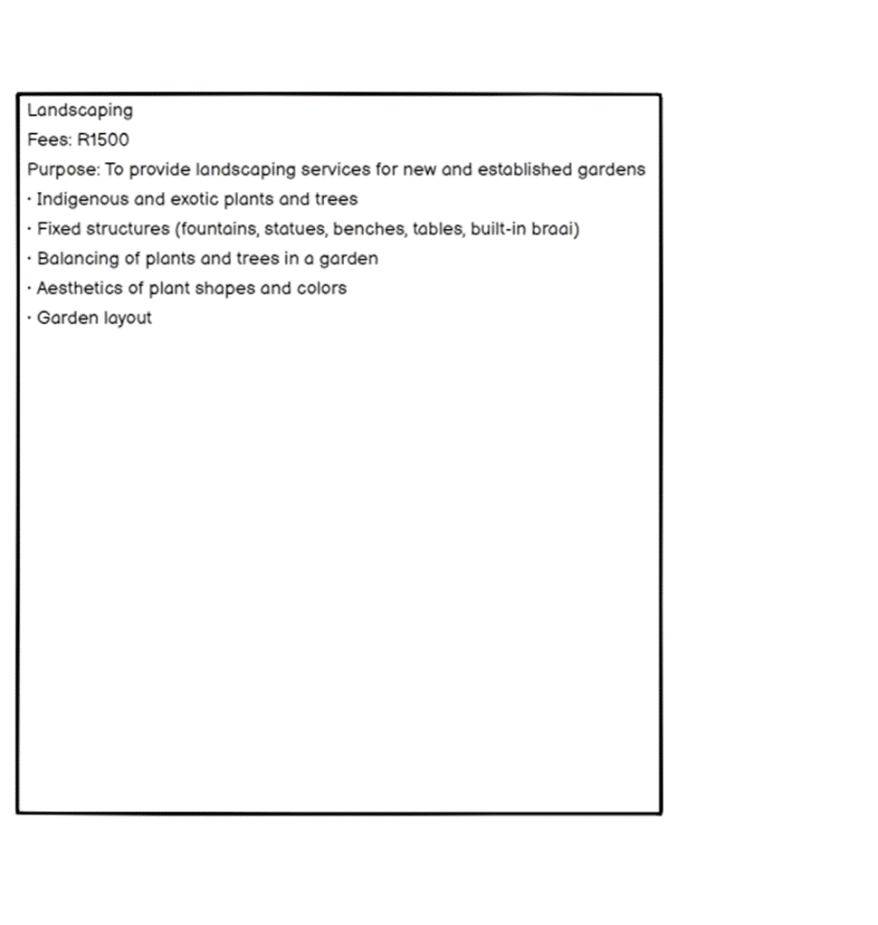

Figure landscaping

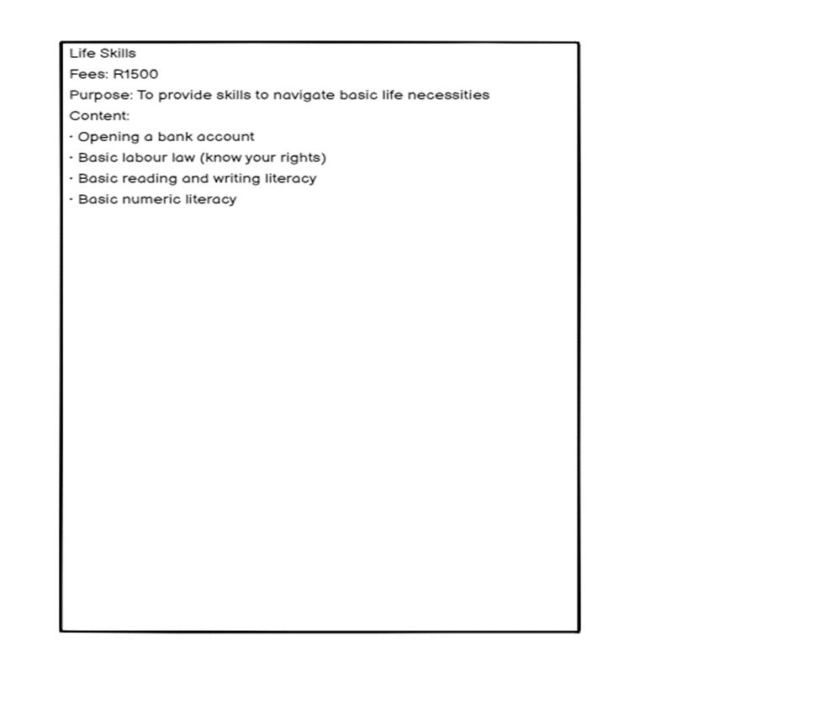

Figure life skills

## Six months course

Figure 3,4,5 and 6 are the course that the user can do if they press the link for the six months

# Mobile application

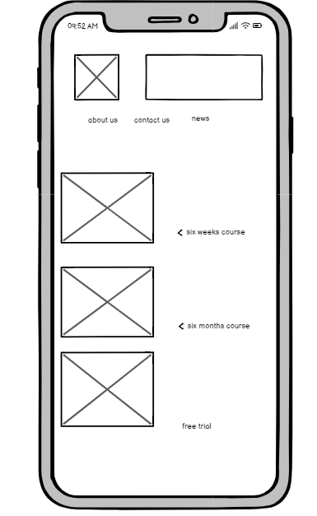

Figure first page of mobile app

This is the first page of the mobile application this is where the user can choose which course they would like to do

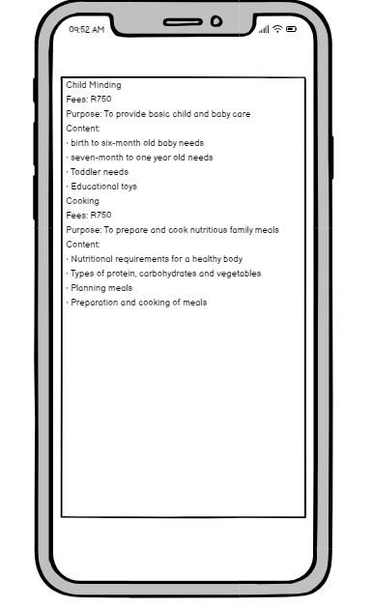

Figure six weeks courses

This is the list of the courses the user would like to do(six weeks course)

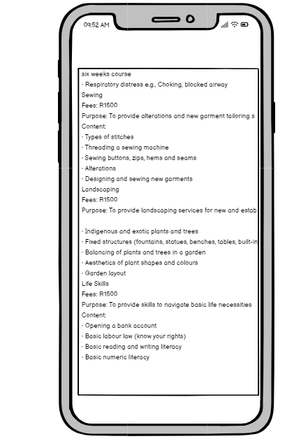

Six months courses list

Figure six months courses