1. Array: Two arrays are defined: one storing the names and information of dead celebrities ('infOfDeadPeople') I have put a max number of 10 dead celebrities in this array with either what they were famous for or their cause of death and date of death and second containing their corresponding ages ('ages'). I have put the age at which these celebrities have passed on.

2. The activity Setup: The 'MainActivity' class extends 'AppCompatActivity' and overrides the 'onCreate' method, thereby setting the contents of the view to the 'activity_main' layout. This links to the layout I have created for the program, this is where everything is displayed and what the user will see when opening the App. The layout displays the name of the app (My History App) together with an editText view where the user enters the age and a textView where the output is displayed to show information about the celebrity.

3. View Declarations: Buttons ('btnClear', 'btnGenerate'), EditText ('txtAge'), and TextView ('txtHistory') start up with 'findViewById'. These are the variables I have declared in order to code the app.

4. Generate Button Click Listener: Once the "Generate" button is clicked, the entered age is obtained from txtAge. If the entered age falls between the integers 20 and 100, it indicates whether the age is null. The age entered is then checked for in the ages array. If found, it retrieves the linked celebrity information from the infOfDeadPeople array and indicates it in txtHistory. If it is not found, a message comes up stating that no celebrity died at that age.

5. If the entered age is invalid or does not fall within the established range, an error message is presented.

6. Clear Button Click Listener: Clicking the "Clear" button clears the text in txtAge and txtHistory. This resets the program to ask for the user to re-enter the code.

Overall, the app allows users to input an age and check if a celebrity passed at that age. If so, it displays information about the died celebrity; else, it returns a message indicating that no celebrity passed at that age.

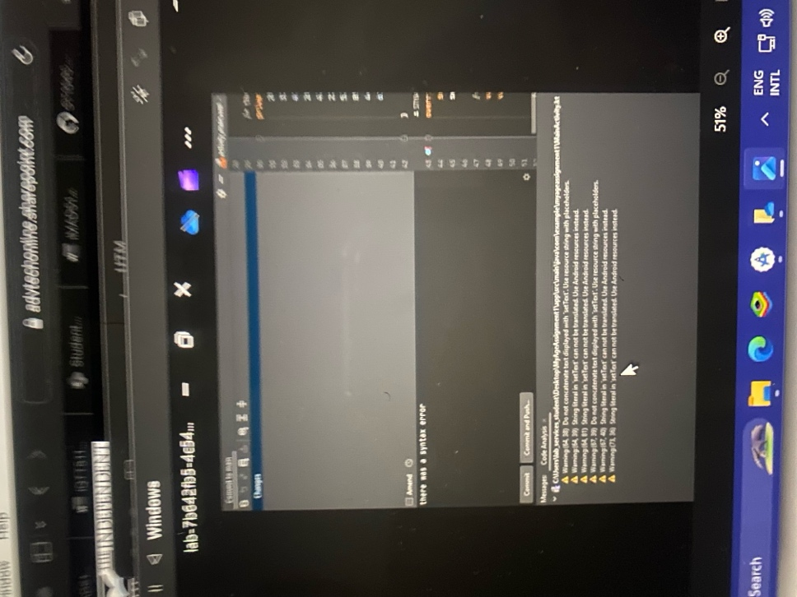

[report](https://github.com/ST10452399/ST10452399AnthonyMalunga_IMADAssignment1./assets/160646865/52fa4c13-c00f-40f0-ad44-e818f364a83f) this was the report of the program it stated that they are 18 warnings that could have caused the program to crash that are not that relevant, the report also stated that they are 24 typos. The typos are the because of the names and surnames of the celebrities. This report also should me errors that need to be fixed which will appear in the next image and explained in the next paragraph.



[invalid child element in a block sequence] (https://github.com/ST10452399/ST10452399AnthonyMalunga_IMADAssignment1./assets/160646865/482ebfc2-37bc-463f-a216-2f6ee2f04f16) The error “child element in a block sequence" usually refers to an element within a block of code or a collection, such as an array or list. This terminology is often used in YAML, a data serialization language that represents data structures like arrays and dictionaries as block sequences or block mappings. This is according to hesa.ac.uk, I had missed a comma after one of the ages in the array of ages, so i had to add that comma to get rid of the error and continue coding.

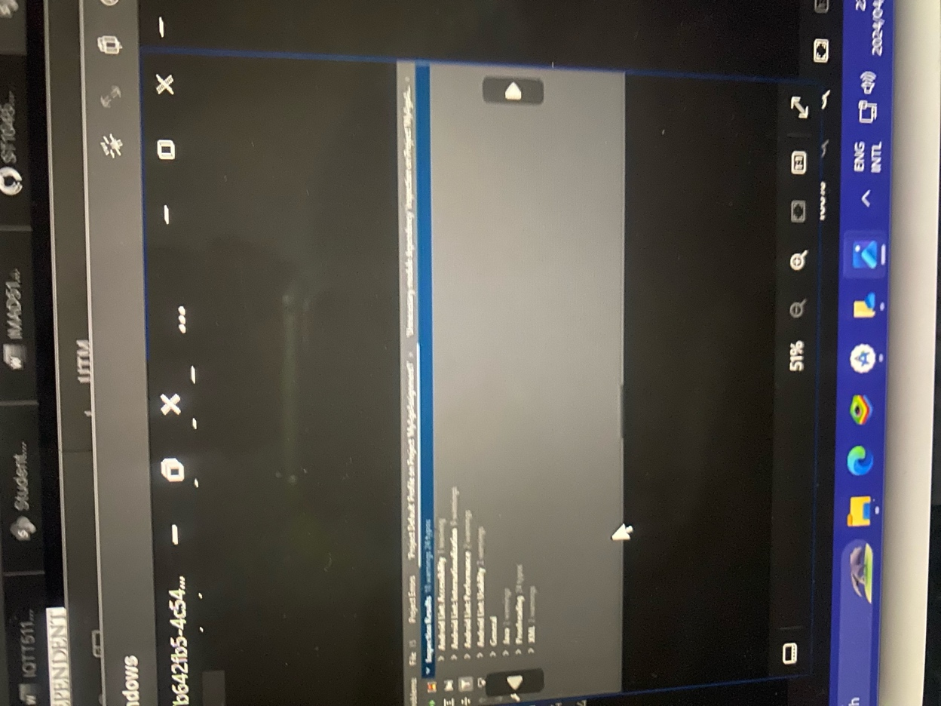

[syntax error line 40] (https://github.com/ST10452399/ST10452399AnthonyMalunga_IMADAssignment1./assets/160646865/347a465d-6fe5-431a-b8a5-95af7ca52512) the spacing was wrong i had to fix my spacing to clear the syntax error in line 40, this is something you have to look out for when coding, the spacing between a character and word is very important.