Moegammad Alexander

ST10453511

Programming 2B

PROG6212

Poe Part 2

Group1

GitHub Link:
https://github.com/ST10453511/PROG6212_PART2_ST10453511.git

YouTube Link:
https://youtu.be/gpLDhu-UuL4

Unit Tests:
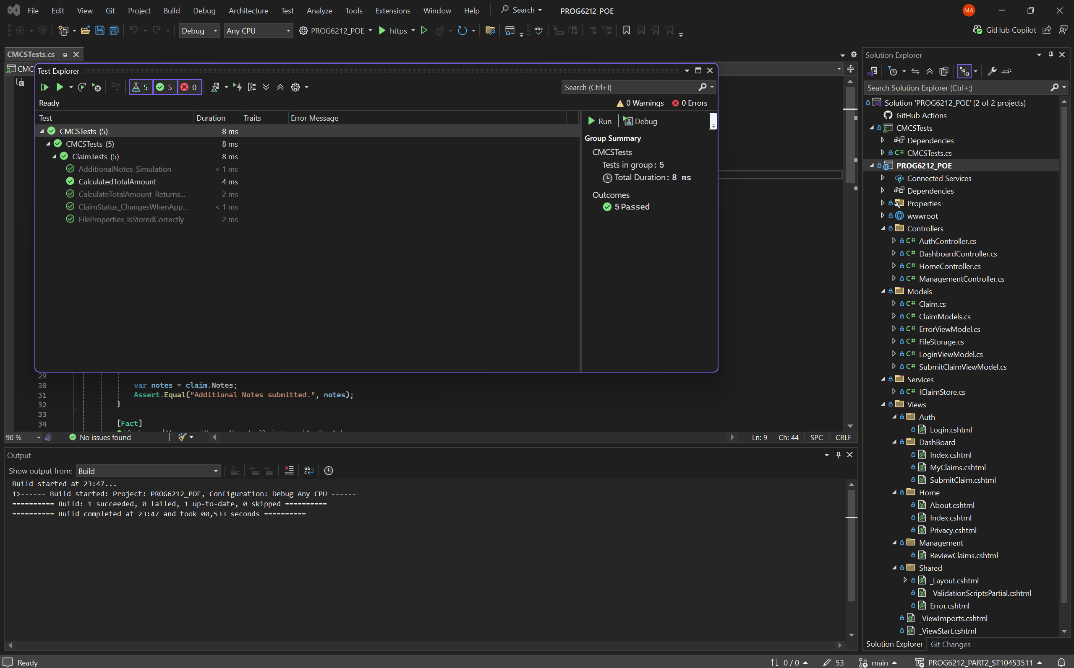

More than 10 Commits and published on GitHub:
