1. Introduction
In the modern South African economic landscape, characterized by fluctuating inflation, rising fuel costs, and the unique social phenomenon of "Black Tax," financial literacy and management have moved from luxury to necessity. The Android operating system dominates the South African mobile market, making it the primary gateway for digital financial inclusion.
Budgeting apps have evolved from simple manual ledger entries into sophisticated, AI-driven ecosystems that sync directly with National Clearing Code (NCC) participating banks. This report research three prominent Android-based solutions available in South Africa: Vault22 (formerly 22seven), FNB Smart Budgeting, and Nedbank Money App. The goal is to analyse their architecture, user experience (UX), and innovative features to inform the development of a new, competitive budgeting solution.

2. Research on Selected Apps

A. Vault22 (Formerly 22seven)

Overview
Vault22 remains the gold standard for independent budgeting in South Africa. Owned by Old Mutual, it operates as a "read-only" aggregator. On Android, the app utilizes a Material Design interface that allows users to link accounts from over 100 South African financial institutions, including banks (FNB, Capitec, Absa, etc.), investment houses, and store cards (Woolworths).
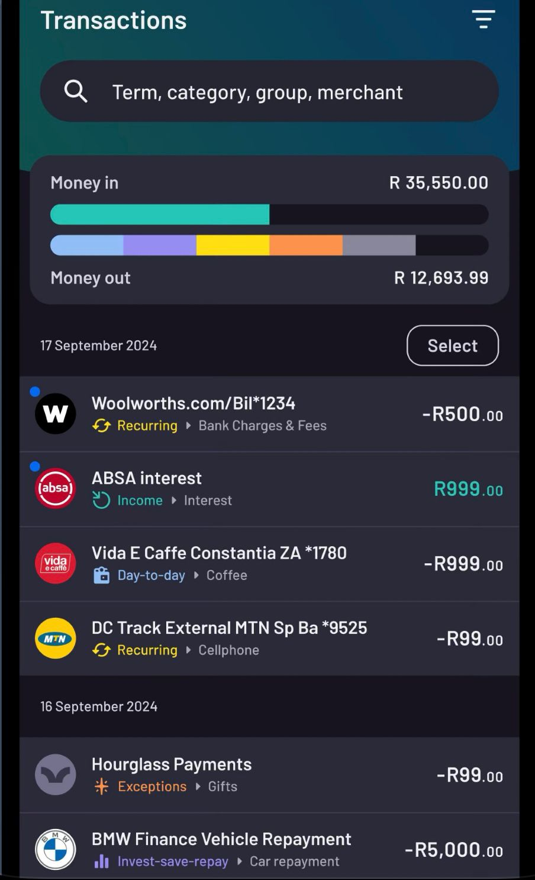
A clean, vertical list showing the "Transactions" at the top, followed by categorized cards for Bank Accounts, Credit Cards, and Investments. Each card displays the real-time balance.
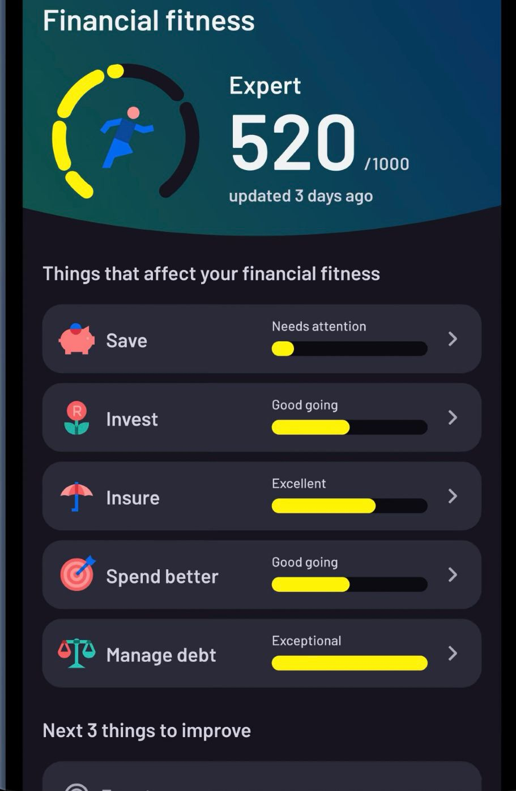
A circular "doughnut" chart representing the current months spend. With detailed bars showing your progress on your financial fitness from savings to debt management.

Strengths and Weaknesses
Strengths: Universal Syncing: Unlike bank-specific apps, it provides a holistic view of a user's entire financial life.
Automation: It automatically categorizes approximately 80% of transactions using a sophisticated merchant-mapping engine.
Cost: It is entirely free for the end-user, subsidized by its parent company.
Weaknesses:
Sync Lag: Because it relies on screen-scraping or limited APIs, there is sometimes a 24-hour delay in transaction updates.
MFA Friction: Users often must re-enter Multi-Factor Authentication (MFA) codes every time they want to refresh their data, which can be tedious on mobile.
Innovative Features
"The Nudge": An AI-driven notification system that alerts users when they are spending faster than usual in a specific category compared to the previous month.
Tax Export: A feature that allows users to export categorized business expenses directly to a CSV or PDF, simplifying the SARS tax return process.

B. FNB Smart Budgeting

Overview
FNB has long been recognized as South Africa’s leading digital bank. Their "Smart Budgeting" tool is integrated directly into the FNB Android App. It leverages the bank's internal data to provide real-time updates without the need for external syncing.
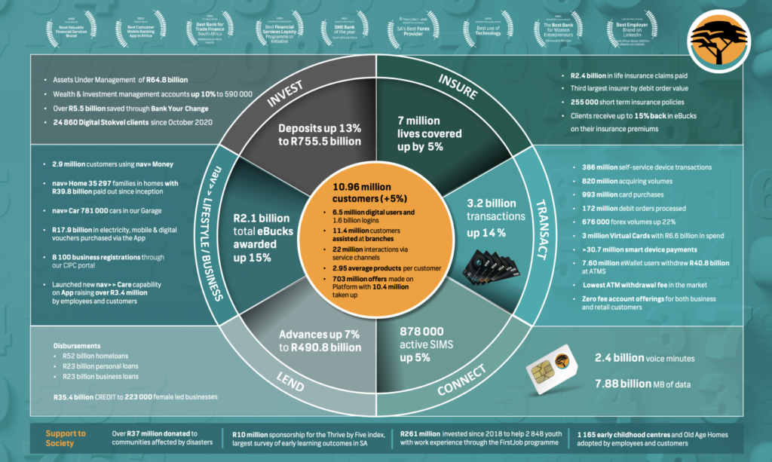
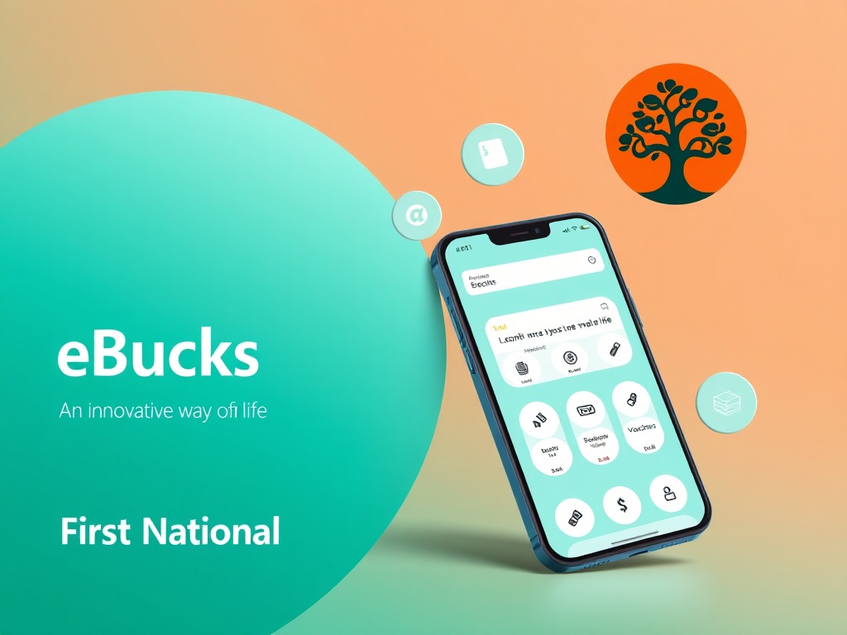

Strengths and Weaknesses
Strengths:
Real-Time Data: Since the data is internal to the bank, transactions appear the second a card is swiped.
Reward Incentives: By linking budgeting to eBucks, FNB gamifies the act of saving money.
Security: Uses the bank’s existing biometric (fingerprint/face) security, providing high trust levels.
Weaknesses:
Walled Garden: It generally only tracks FNB accounts. If a user has a credit card with Nedbank or a savings account with Capitec, those transactions are invisible to this tool.
Complexity: The FNB app is "heavy" and can be overwhelming for users with older Android devices.
Innovative Features
Predictive Alerts: The app uses historical data to predict when a user will run out of money based on their current spending velocity.
Interactive "Stop" Button: Directly from the budget screen, users can temporarily "lock" certain spend categories or cards if they see they are nearing their limit.
C. Nedbank Money App (Africa)

Overview
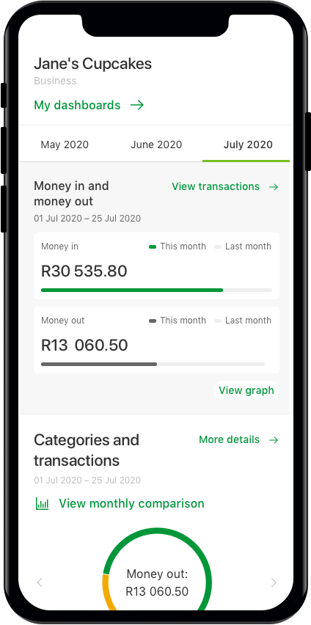
The Nedbank Money App has undergone a massive redesign to focus on "Lifestyle Banking." Its budgeting module is designed for simplicity and visual clarity, targeting users who find traditional spreadsheets intimidating.
A simple UI element showing "How much you can spend today." It divides the remaining budget by the number of days left in the month.
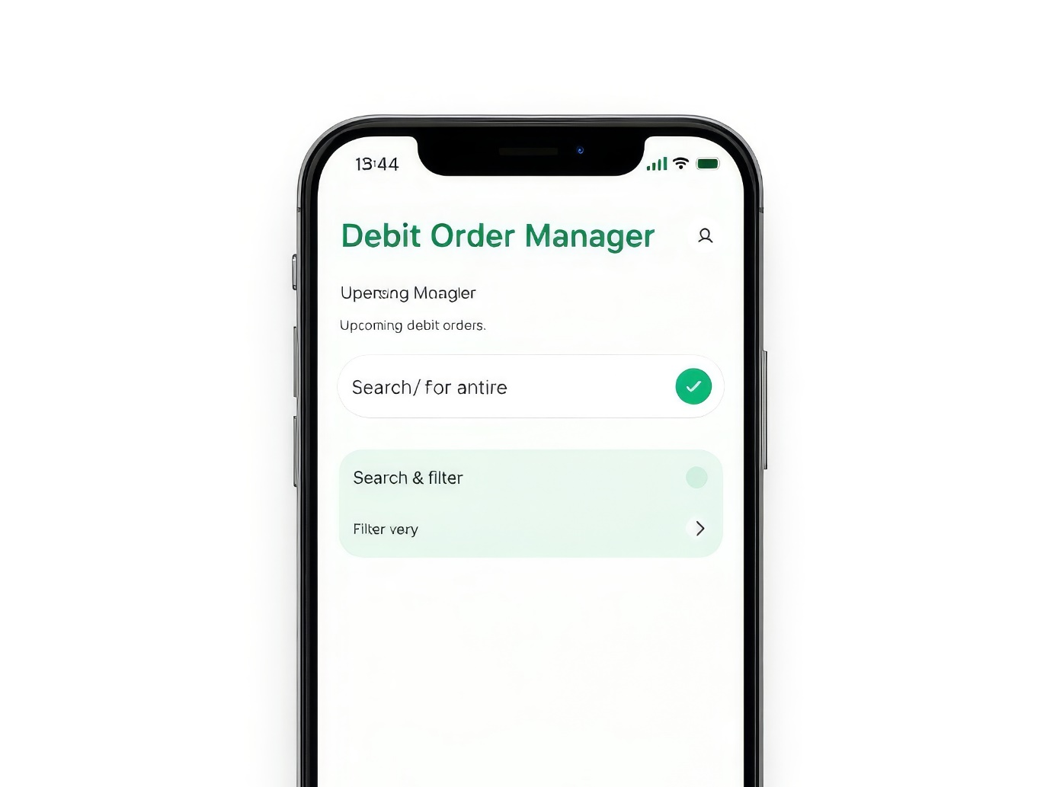

Strengths and Weaknesses
Strengths:
UX Simplicity: The interface is less cluttered than FNB’s, making it better for "casual" budgeters.
Debit Order Control: Excellent visibility into recurring payments, which is a major pain point for South Africans.
Weaknesses:
Limited Customization: Users cannot easily create highly specific sub-categories compared to Vault22.
Android Performance: Some users report higher battery drain when the app’s background "tracking" features are enabled.
Innovative Features
Credit Score Health: Integrated directly into the budget view, showing how spending habits are affecting the user's ability to get future loans.
MyPocket Integration: Allows users to instantly "sweep" leftover budget at the end of the day into a side-savings pocket that earns interest.

3. Infographic Comparison
Feature | Vault22 | FNB Smart Budget | Nedbank Money
Multi-Bank Sync | Yes (Excellent) | No (Internal) | No (Internal)
Real-time Updates | No (Delayed) | Yes (Instant) | Yes (Instant)
Price | Free | Free (For clients) | Free (for clients)
Gamification | Low | High (eBucks) | Medium
Ease of Use | 8/10 | 6/10 | 9/10
POPIA Compliant | Yes | Yes | Yes

4. Proposed "Best-in-Class" Feature Set
Based on the research, the following features are recommended for our new application to ensure market dominance:
- Hybrid Aggregation (The "Vault22" Model): The ability to link multiple bank accounts is the most requested feature. We must use a secure API (like Stitch or Revio) to allow multi-bank syncing.
- The "Daily Spend" Allowance (The "Nedbank" Model): A prominent display on the home screen telling the user exactly how much they can spend today to stay on track.
- Gamified Rewards (The "FNB" Model): Implementing a "points" system for users who stay under budget for three consecutive months.
- Debit Order Warning: An automated alert three days before a large debit order is due, comparing it against the current bank balance.
- Offline Mode: For South African users in low-connectivity areas or during "load shedding" when towers may be down, the app should allow manual entry of cash transactions that sync later.

5. Conclusion
The South African Android market for budgeting apps is split between independent aggregators and "Big Five" banking apps. While Vault22 offers the best overview of total wealth, the banking apps (FNB and Nedbank) offer superior real-time speed and security.
To succeed, a new app must bridge this gap. It needs the cross-platform visibility of Vault22 combined with the instant notification speed and reward-based incentives seen in the FNB ecosystem. Furthermore, addressing local realities like data costs (by ensuring the app is lightweight) and financial transparency will be the key differentiators.
6. References
Digital Humanity. (2025). Best 4 Budgeting Apps in South Africa [How to Choose or When to Build Your Own App Guide]. [online] Available at: https://digitalhumanity.co.za/insights/budgeting-apps-south-africa/
Google Play Store. (2023). Vault22 - Money Management App Ratings. First National Bank (FNB). (2023). Smart Budgeting Feature Documentation.
Nedbank. (2023). Money App (Africa) User Guide.

