
PROG6212_Part_1
Programming 2B

September 4, 2026
Tumelo MAtshele
ST10458344_Group2

RaceDay ERD

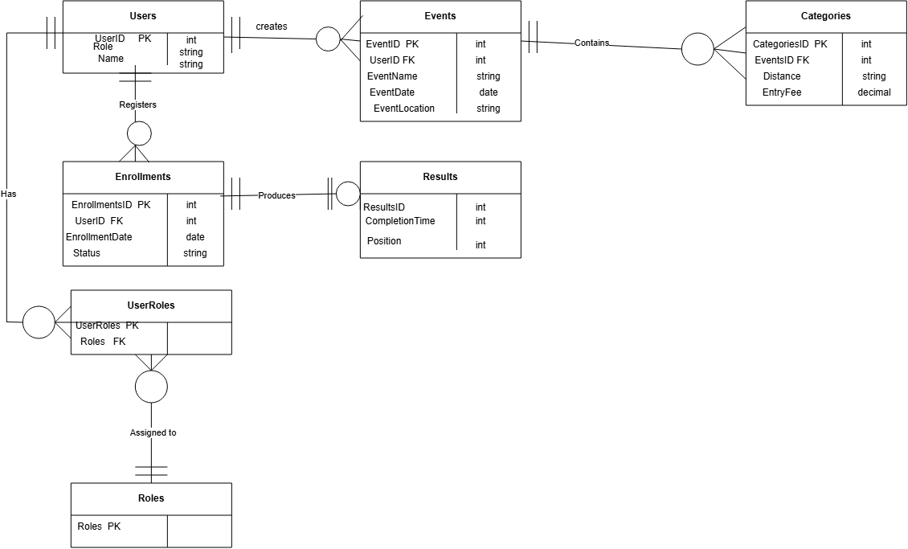

RaceDay API Endpoint Plan
This document shows the REST API endpoints that are planned for the RaceDay system. The endpoints are based on the main functions that the system needs to provide. The purpose of this plan is to show what each endpoint will be used for before the API is developed.
Base URL: /api
JWT bearer tokens will be used for authentication. The access a user has will depend on whether they are an Organiser or a Participant.

Authentication

HTTP  Method | Route | Description | Role Required | Request Body | Expected Response
POST | /api/auth/r egister | Used to create a new participant account. | Public | {“email", "password", "firstName"  ,  "lastName", "phoneNumbe r”} | 201  Created – account created successfully  . 400 Bad  Request – information is not valid. 409  Conflict – email already exists.
POST | /api/auth/l ogin | Used by a user to log into the RaceDay system. | Public | {“email", "password"  } | 200 OK –  login successful and a JWT token is returned.  401  Unauthoriz ed – login details are incorrect.

User Profile

HTTP  Method | Route | Description | Role Required | Request Body | Expected Response
GET | /api/users/ me | Gets the profile details of the user who is currently logged in. | Organiser or Participant | None | 200 OK –  user profile is returned. 401  Unauthoriz ed – user is not authenticate d.
PUT | /api/users/ me | Allows the logged-in user to update their personal information. | Organiser or Participant | {“firstNam e", "lastName", "phoneNumbe r" } | 200 OK –  profile updated successfully  . 400 Bad  Request – invalid information.
GET | /api/users/  {id} | Allows an organiser to view basic information about a specific user. | Organiser | None | 200 OK –  user information is returned. 404 Not Found – user does not exist.

Events

HTTP  Method | Route | Description | Role Required | Request Body | Expected Response
GET | /api/events | Gets a list of the upcoming events.  Participants will only see published events, while  organisers | Organiser or Participant | None | 200 OK –  list of events is returned.

HTTP  Method | Route | Description | Role Required | Request Body | Expected Response
 |  | can see all events.
GET | /api/events  /{id} | Gets the details of a specific event and its categories. | Organiser or Participant | None | 200 OK –  event details are returned. 404 Not Found – event does not exist.
POST | /api/events | Allows an organiser to create a new race event. | Organiser | { "name", "descriptio n", "eventDate"  ,  "startTime"  ,  "location", "routeDescr iption", "maxPartici pants", "isPublishe d" } | 201  Created – event created successfully  . 400 Bad  Request – invalid event information.
PUT | /api/events  /{id} | Allows an organiser to make changes to an existing event. | Organiser | Event details to be updated | 200 OK –  event updated successfully  . 404 Not  Found – event does not exist.  403  Forbidden – organiser does not have permission to update the event.
DELETE | /api/events  /{id} | Allows an organiser to delete an event. | Organiser | None | 204 No  Content – event deleted

HTTP  Method | Route | Description | Role Required | Request Body | Expected Response
successfully
. 404 Not
Found – event does not exist.
409
Conflict – event has confirmed enrolments.

Categories

HTTP  Method | Route | Description | Role Required | Request Body | Expected Response
GET | /api/events  /{eventId}/ categories | Gets all the race categories for a specific event. | Organiser or Participant | None | 200 OK –  list of categories is returned. 404 Not Found – event does not exist.
POST | /api/events  /{eventId}/ categories | Allows an organiser to add a category to an event. | Organiser | { "name", "distanceKm ",  "entryFee", "minAge",  "maxAge", "maxEntries " } | 201  Created – category created successfully  . 400 Bad  Request – invalid information. 404 Not Found – event does not exist.
PUT | /api/catego ries/{id} | Allows an organiser to change the details of a category. | Organiser | Category details to be updated | 200 OK –  category updated. 404 Not Found –  category

HTTP  Method | Route | Description | Role Required | Request Body | Expected Response
 |  |  |  |  | does not exist.
DELETE | /api/catego ries/{id} | Allows an organiser to remove a category from an event. | Organiser | None | 204 No  Content – category deleted. 404 Not Found – category does not exist. 409 Conflict – category already has enrolments.

Event Enrolments

HTTP  Method | Route | Description | Role Required | Request Body | Expected Response
POST | /api/catego ries/{categ oryId}/enro l | Allows a participant to enrol in a race category. | Participant | { "emergenc yContact" } | 201  Created – enrolment created and a bib number is provided.  404 Not Found – category does not exist. 409 Conflict – participant is already enrolled or the category is full.
GET | /api/enrolm ents/me | Shows all the enrolments belonging to  the logged- | Participant | None | 200 OK –  list of enrolments is returned.

HTTP  Method | Route | Description | Role Required | Request Body | Expected Response
 |  | in participant.
GET | /api/enrolm ents | Allows an organiser to view the enrolments in the system.  Filters can be used to find specific enrolments. | Organiser | Optional filters such as eventId, categoryId and status | 200 OK –  list of enrolments is returned.
GET | /api/enrolm ents/{id} | Gets the details of a specific enrolment. | Organiser or Participant (own enrolment) | None | 200 OK –  enrolment details are returned. 403  Forbidden – participant is trying to view another  participant’s enrolment. 404 Not Found – enrolment does not exist.
PATCH | /api/enrolm ents/{id}/s tatus | Used to change the status of an enrolment, for example cancelling an enrolment. | Organiser or Participant (own enrolment) | { "status"  } | 200 OK –  enrolment status updated. 400 Bad Request – invalid status.

Results

HTTP  Method | Route | Description | Role Required | Request Body | Expected Response
POST | /api/enrolm ents/{enrol mentId}/res ults | Allows an organiser to record the result of a participant in a race. | Organiser | { "finishTi me", "positionOv erall", "positionCa tegory", "notes" } | 201  Created – result recorded successfully  . 404 Not  Found – enrolment does not exist. 409 Conflict – result has already been recorded.
GET | /api/result s/me | Allows a participant to view their own race results. | Participant | None | 200 OK –  personal results are returned.
GET | /api/events  /{eventId}/ results | Shows the results for a specific event. | Organiser | Optional categoryId filter | 200 OK –  ranked results are returned. 404 Not Found – event does not exist.
PUT | /api/result s/{id} | Allows an organiser to update a result that has already been recorded. | Organiser | Result details to be updated | 200 OK –  result updated successfully  . 404 Not  Found – result does not exist.
DELETE | /api/result s/{id} | Allows an organiser to delete a result. | Organiser | None | 204 No  Content – result deleted  successfully

HTTP  Method | Route | Description | Role Required | Request Body | Expected Response
. 404 Not
Found – result does not exist.

Conclusion
The aforementioned endpoints cover most of the functionalities of RaceDay. The users can register and sign-in, manage their profile, create and manage events and categories, enrol in races and record results.
Each endpoint's HTTP methods, routes, user roles, request info, and expected responses are included. This present a simple blueprint of how the API will be structured, which can function as a reference when progressing onto the development of the system.

SQL Script
USE master;

IF DB_ID(N'RaceDay') IS NOT NULL
BEGIN
ALTER DATABASE RaceDay SET SINGLE_USER WITH ROLLBACK IMMEDIATE;
DROP DATABASE RaceDay;
END;

EXEC(N'CREATE DATABASE RaceDay');

USE RaceDay;

CREATE TABLE Roles (
RoleId INT NOT NULL IDENTITY(1,1),
RoleName NVARCHAR(50) NOT NULL,
CONSTRAINT PK_Roles PRIMARY KEY (RoleId),
CONSTRAINT UQ_Roles_RoleName UNIQUE (RoleName)
);

CREATE TABLE Users (
UserId INT NOT NULL IDENTITY(1,1),
Email NVARCHAR(256) NOT NULL,
PasswordHash NVARCHAR(256) NOT NULL,
FirstName NVARCHAR(100) NOT NULL,
LastName NVARCHAR(100) NOT NULL,
PhoneNumber NVARCHAR(20) NULL,
CreatedAt DATETIME2 NOT NULL DEFAULT SYSUTCDATETIME(),
IsActive BIT NOT NULL DEFAULT 1,
CONSTRAINT PK_Users PRIMARY KEY (UserId),
CONSTRAINT UQ_Users_Email UNIQUE (Email)
);

CREATE TABLE UserRoles (
UserRoleId INT NOT NULL IDENTITY(1,1),
UserId INT NOT NULL,
RoleId INT NOT NULL,
AssignedAt DATETIME2 NOT NULL DEFAULT SYSUTCDATETIME(),
CONSTRAINT PK_UserRoles PRIMARY KEY (UserRoleId),
CONSTRAINT FK_UserRoles_Users FOREIGN KEY (UserId) REFERENCES Users(UserId),
CONSTRAINT FK_UserRoles_Roles FOREIGN KEY (RoleId) REFERENCES Roles(RoleId),
CONSTRAINT UQ_UserRoles_UserId_RoleId UNIQUE (UserId, RoleId)
);

CREATE TABLE Events (
EventId INT NOT NULL IDENTITY(1,1),
Name NVARCHAR(200) NOT NULL,
Description NVARCHAR(MAX) NULL,
EventDate DATE NOT NULL,
StartTime TIME(0) NOT NULL,
Location NVARCHAR(200) NOT NULL,
RouteDescription NVARCHAR(MAX) NULL,
MaxParticipants INT NULL,
CreatedByUserId INT NOT NULL,
CreatedAt DATETIME2 NOT NULL DEFAULT SYSUTCDATETIME(),
IsPublished BIT NOT NULL DEFAULT 0,
CONSTRAINT PK_Events PRIMARY KEY (EventId),
CONSTRAINT FK_Events_Users FOREIGN KEY (CreatedByUserId) REFERENCES Users(UserId),
CONSTRAINT CK_Events_MaxParticipants CHECK (MaxParticipants IS NULL OR MaxParticipants > 0)
);

CREATE TABLE Categories (
CategoryId INT NOT NULL IDENTITY(1,1),
EventId INT NOT NULL,
Name NVARCHAR(100) NOT NULL,
DistanceKm DECIMAL(6,2) NOT NULL,
EntryFee DECIMAL(10,2) NOT NULL DEFAULT 0,
MinAge INT NULL,
MaxAge INT NULL,
MaxEntries INT NULL,
CONSTRAINT PK_Categories PRIMARY KEY (CategoryId),
CONSTRAINT FK_Categories_Events FOREIGN KEY (EventId) REFERENCES Events(EventId) ON DELETE CASCADE,
CONSTRAINT UQ_Categories_EventId_Name UNIQUE (EventId, Name),
CONSTRAINT CK_Categories_DistanceKm CHECK (DistanceKm > 0),
CONSTRAINT CK_Categories_EntryFee CHECK (EntryFee >= 0),
CONSTRAINT CK_Categories_AgeRange CHECK (
(MinAge IS NULL AND MaxAge IS NULL) OR
(MinAge IS NOT NULL AND MaxAge IS NOT NULL AND MinAge <= MaxAge)
)
);

CREATE TABLE Enrolments (
EnrolmentId INT NOT NULL IDENTITY(1,1),
UserId INT NOT NULL,
CategoryId INT NOT NULL,
EnrolmentDate DATETIME2 NOT NULL DEFAULT SYSUTCDATETIME(),
BibNumber NVARCHAR(20) NULL,
Status NVARCHAR(20) NOT NULL DEFAULT N'Confirmed',
EmergencyContact NVARCHAR(100) NULL,
CONSTRAINT PK_Enrolments PRIMARY KEY (EnrolmentId),
CONSTRAINT FK_Enrolments_Users FOREIGN KEY (UserId) REFERENCES Users(UserId),
CONSTRAINT FK_Enrolments_Categories FOREIGN KEY (CategoryId) REFERENCES Categories(CategoryId),
CONSTRAINT UQ_Enrolments_UserId_CategoryId UNIQUE (UserId, CategoryId),
CONSTRAINT UQ_Enrolments_BibNumber UNIQUE (BibNumber),
CONSTRAINT CK_Enrolments_Status CHECK (
Status IN (N'Confirmed', N'Cancelled', N'Withdrawn')
)
);

CREATE TABLE Results (
ResultId INT NOT NULL IDENTITY(1,1),
EnrolmentId INT NOT NULL,
FinishTime TIME(0) NOT NULL,
PositionOverall INT NULL,
PositionCategory INT NULL,
RecordedAt DATETIME2 NOT NULL DEFAULT SYSUTCDATETIME(),
RecordedByUserId INT NOT NULL,
Notes NVARCHAR(500) NULL,
CONSTRAINT PK_Results PRIMARY KEY (ResultId),
CONSTRAINT FK_Results_Enrolments FOREIGN KEY (EnrolmentId) REFERENCES Enrolments(EnrolmentId),
CONSTRAINT FK_Results_Users FOREIGN KEY (RecordedByUserId) REFERENCES Users(UserId),
CONSTRAINT UQ_Results_EnrolmentId UNIQUE (EnrolmentId),
CONSTRAINT CK_Results_PositionOverall CHECK (
PositionOverall IS NULL OR PositionOverall > 0
),
CONSTRAINT CK_Results_PositionCategory CHECK (
PositionCategory IS NULL OR PositionCategory > 0
)
);

SET IDENTITY_INSERT Roles ON;

INSERT INTO Roles (RoleId, RoleName) VALUES
(1, N'Organiser'),
(2, N'Participant');

SET IDENTITY_INSERT Roles OFF;

SET IDENTITY_INSERT Users ON;

INSERT INTO Users (
UserId,
Email,
PasswordHash,
FirstName,
LastName,
PhoneNumber,
CreatedAt,
IsActive
) VALUES
(1, N'organiser1@raceday.co.za', N'$2a$11$samplehashorganiser1',
N'Sipho', N'Mokoena', N'0821110001', SYSUTCDATETIME(), 1),
(2, N'organiser2@raceday.co.za', N'$2a$11$samplehashorganiser2',
N'Lerato', N'Ndlovu', N'0821110002', SYSUTCDATETIME(), 1),
(3, N'participant1@raceday.co.za', N'$2a$11$samplehashparticipant1',
N'Thabo', N'Khumalo', N'0822220001', SYSUTCDATETIME(), 1),
(4, N'participant2@raceday.co.za', N'$2a$11$samplehashparticipant2',
N'Aisha', N'Patel', N'0822220002', SYSUTCDATETIME(), 1);

SET IDENTITY_INSERT Users OFF;

INSERT INTO UserRoles (UserId, RoleId) VALUES
(1, 1),
(2, 1),
(3, 2),
(4, 2);

SET IDENTITY_INSERT Events ON;

INSERT INTO Events (
EventId,
Name,
Description,
EventDate,
StartTime,
Location,
RouteDescription,
MaxParticipants,
CreatedByUserId,
IsPublished
) VALUES
(1, N'Cape Town 10K Classic',
N'Flat coastal 10 km road race along the Atlantic seaboard.',
'2026-04-12', '07:00:00',
N'Sea Point, Cape Town',
N'Sea Point Promenade to Camps Bay and back.',
5000, 1, 1),

(2, N'Joburg City Half Marathon',
N'Urban half marathon through Johannesburg CBD and suburbs.',
'2026-05-24', '06:30:00',
N'Mary Fitzgerald Square, Johannesburg',
N'CBD loop via Maboneng and Newtown.',
8000, 1, 1),

(3, N'Durban Sunrise Cycle Challenge',
N'Morning cycling event along the Golden Mile and harbour route.',
'2026-06-14', '05:30:00',
N'North Beach, Durban',
N'North Beach to uShaka and back via the promenade.',
2000, 2, 1);

SET IDENTITY_INSERT Events OFF;

INSERT INTO Categories (
EventId,
Name,
DistanceKm,
EntryFee,
MinAge,
MaxAge,
MaxEntries
) VALUES
(1, N'Open 10K', 10.00, 250.00, 16, 99, 3000),
(1, N'Junior 5K', 5.00, 150.00, 12, 15, 500),
(1, N'Veterans 10K', 10.00, 220.00, 40, 99, 800),
(2, N'Open Half', 21.10, 350.00, 16, 99, 5000),
(2, N'Walk 10K', 10.00, 200.00, 16, 99, 1500),
(3, N'40K Sportive', 40.00, 300.00, 18, 99, 1200),
(3, N'20K Fun Ride', 20.00, 180.00, 14, 99, 600);

INSERT INTO Enrolments (
UserId,
CategoryId,
EnrolmentDate,
BibNumber,
Status,
EmergencyContact
) VALUES
(3, 1, DATEADD(DAY, -10, SYSUTCDATETIME()), N'CT10K-001',
N'Confirmed', N'0829990001'),

(3, 4, DATEADD(DAY, -5, SYSUTCDATETIME()), N'JHBHM-014',
N'Confirmed', N'0829990001'),

(4, 1, DATEADD(DAY, -8, SYSUTCDATETIME()), N'CT10K-002',
N'Confirmed', N'0829990002'),

(4, 6, DATEADD(DAY, -3, SYSUTCDATETIME()), N'DUR40-007',
N'Confirmed', N'0829990002'),

(4, 2, DATEADD(DAY, -2, SYSUTCDATETIME()), N'CT5K-003',
N'Confirmed', N'0829990002');

INSERT INTO Results (
EnrolmentId,
FinishTime,
PositionOverall,
PositionCategory,
RecordedByUserId,
Notes
) VALUES
(1, '00:52:18', 145, 120, 1, N'Strong finish on a windy day.'),
(3, '00:48:55', 78, 65, 2, N'Personal best attempt.');

PRINT 'RaceDay database created and seeded successfully.';
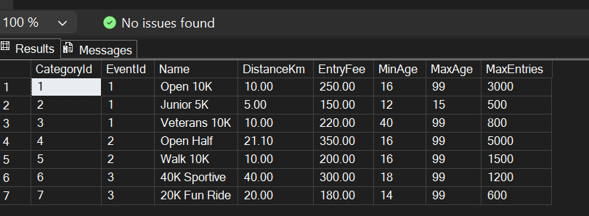
Figure 1:Category Table
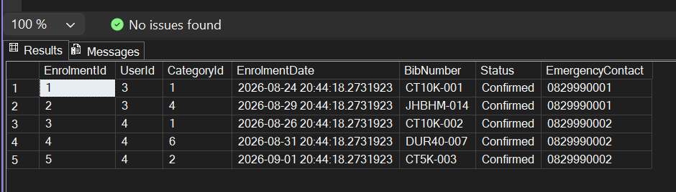
Figure 2:Enrolments Table
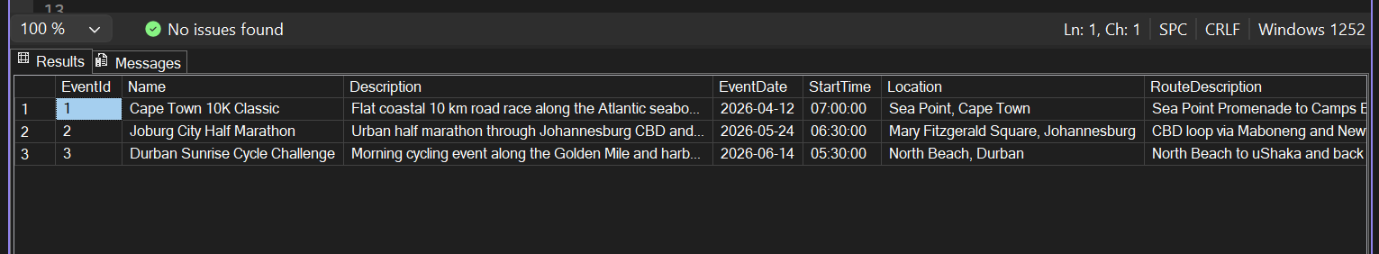
Figure 3:Events Table
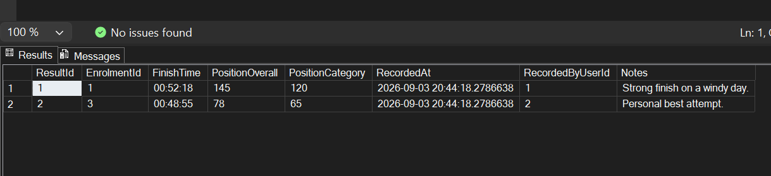
Figure 4:Results Table
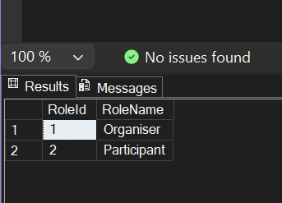
Figure 5:Roles Table
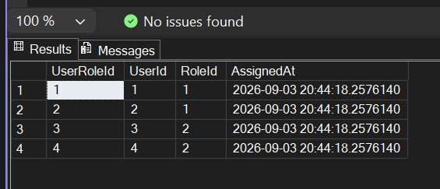
Figure 6:UserRoles Table
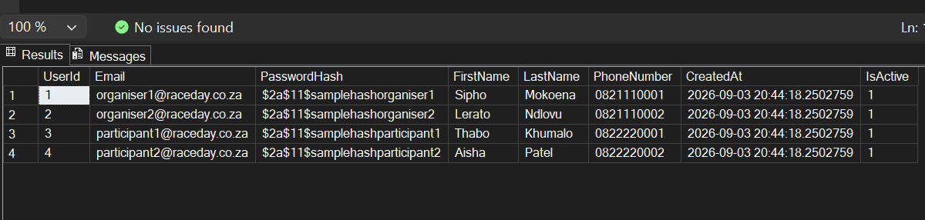
Figure 7:Users Table

