thubelunga@icloud.com

WEDE

THUBELIHLE KHOZA

ST10461605

Table of Contents

Website Concept: Top Hair Couture 2

Overview: 2

LOGO 3

ASSETS 4

ABOUT US 5

LOGO 6

REFRENCING: 9

PART 2 IMPROVEMENT 10

Here's a summary of the HTML code(HOME PAGE): 13

Here's a summary of the HTML code(ABOUT PAGE): 15

Here's a summary of the HTML code(CONTACT PAGE): 16

Here's a summary of the HTML code(NEWS PAGE): 17

Here's a summary of the HTML code(SERVICES PAGE): 18

Here are the specific changes in the home page: 20

Here are specific changes in the about page 21

Here are the specific changes in the services page 22

# Website Concept: Top Hair Couture

## Overview:

Top Hair Couture website is an e-commerce platform showcasing Top Hair Couture's extensive collection of lace wigs, allowing customers to browse, review, purchase, and track their orders online.

For my POE website project, I have chosen to create a website for Top Hair Couture, a hair business specializing in lace wigs, wig customization, and wig installation. The target audience is individuals seeking high-quality hair solutions, particularly those interested in bespoke wig designs and expert installation services. The website will showcase Top Hair Couture's services, portfolio, and expertise, providing a platform for potential clients to learn about their offerings and book appointments.

The website will feature a modern and sleek design, with a user-friendly interface and clear navigation. It will include pages for services, portfolio, about us, and contact information. The services page will detail the various wig-related services offered, including customization options and installation techniques. The portfolio page will showcase before-and-after photos of previous clients, demonstrating the quality and expertise of Top Hair Couture's work.

By creating a professional online presence, Top Hair Couture can increase visibility, attract new customers, and establish itself as a trusted and reputable hair business. The website will also provide a convenient way for clients to book appointments and contact the business, streamlining the customer service process.

Overall, my goal is to create a website that effectively showcases Top Hair Couture's services and expertise, while also providing a positive user experience for potential clients. I believe that a well-designed website is essential for any business, and I am excited to bring Top Hair Couture's online presence to life.

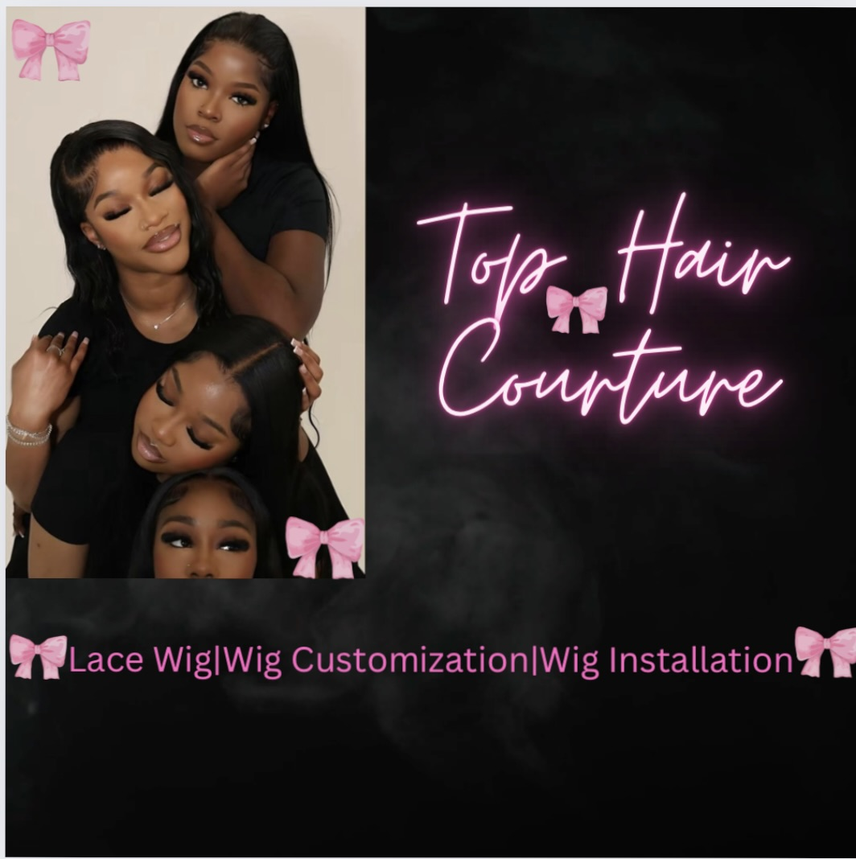

# LOGO

-I chose this logo because it helps with brand Identity, it helps establish my brand visual identity and makes your business more recognizable. A well-designed logo conveys a sense of professionalism and credibility. This logo can help build trust with potential customers and establish my brand as a reputable business. It is a crucial element in my marketing strategy and can be used to promote my brand.

# ASSETS

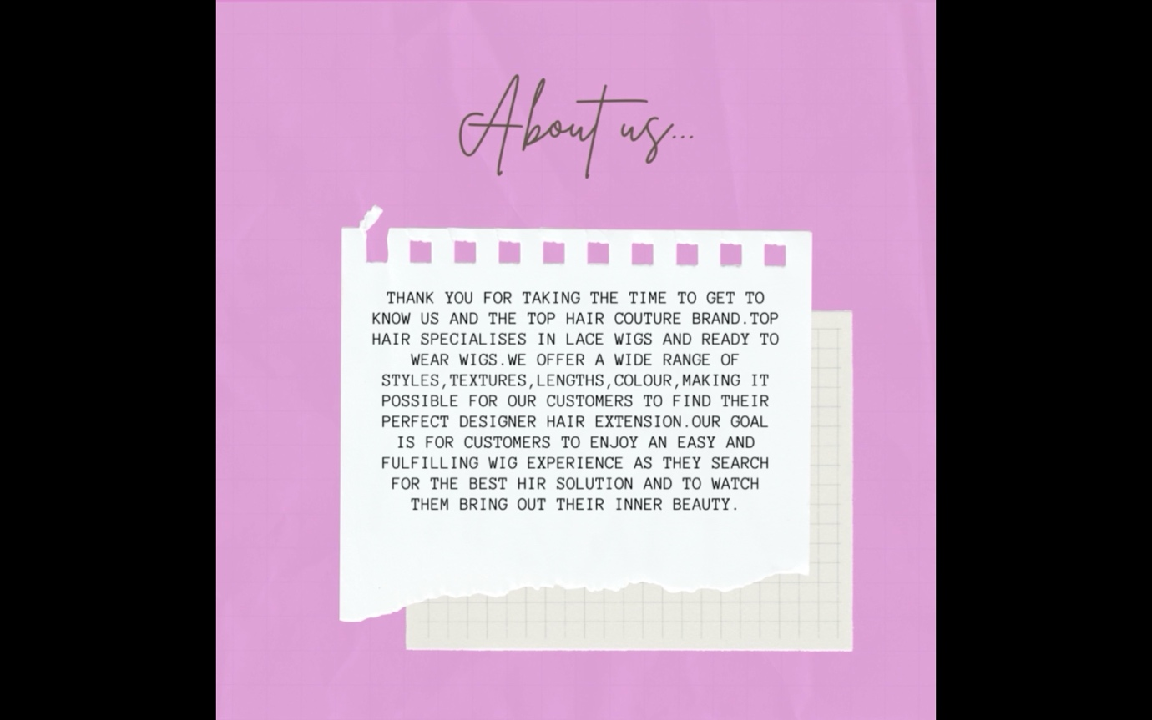

## ABOUT US

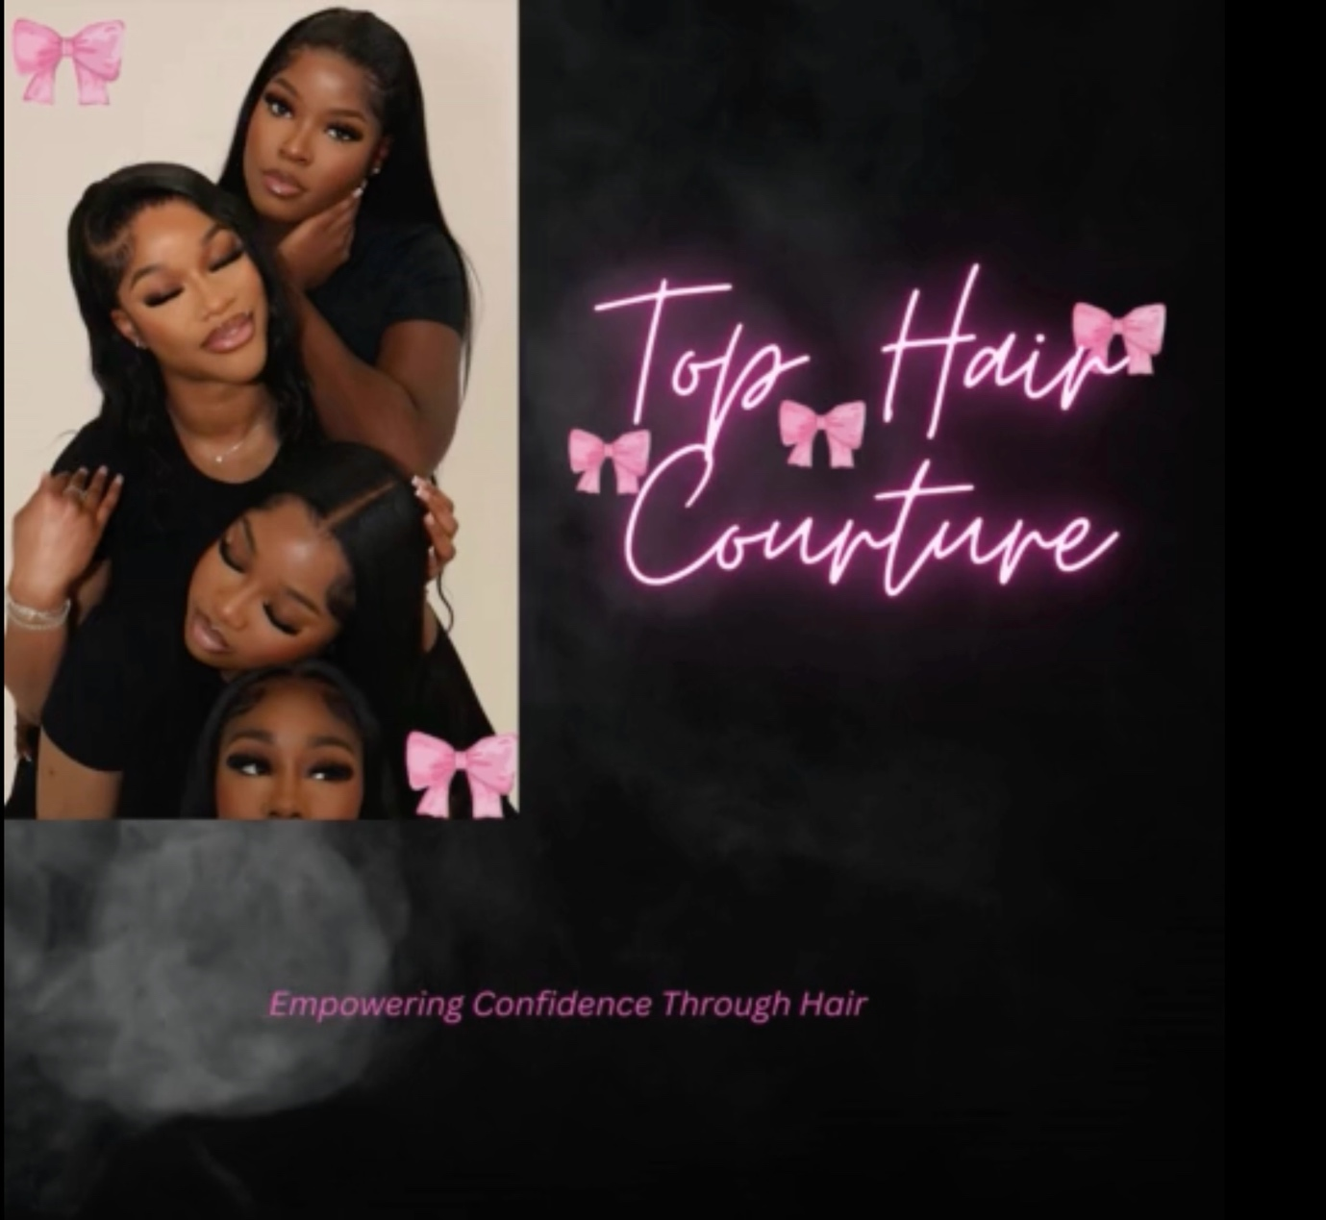

## LOGO

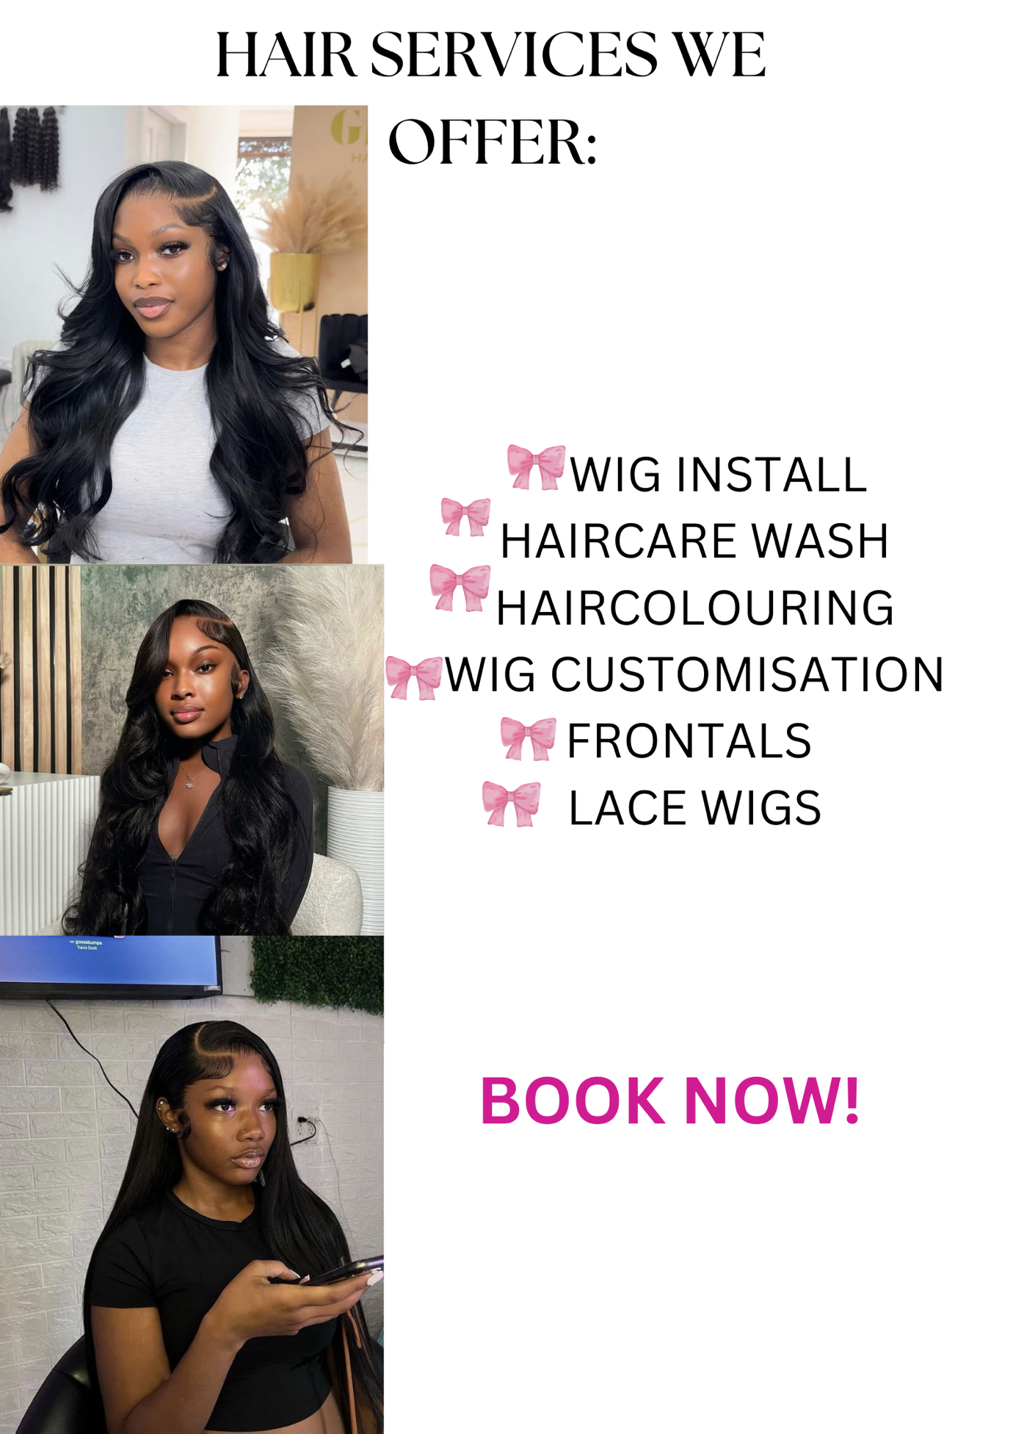SERVICES & PRODUCTS

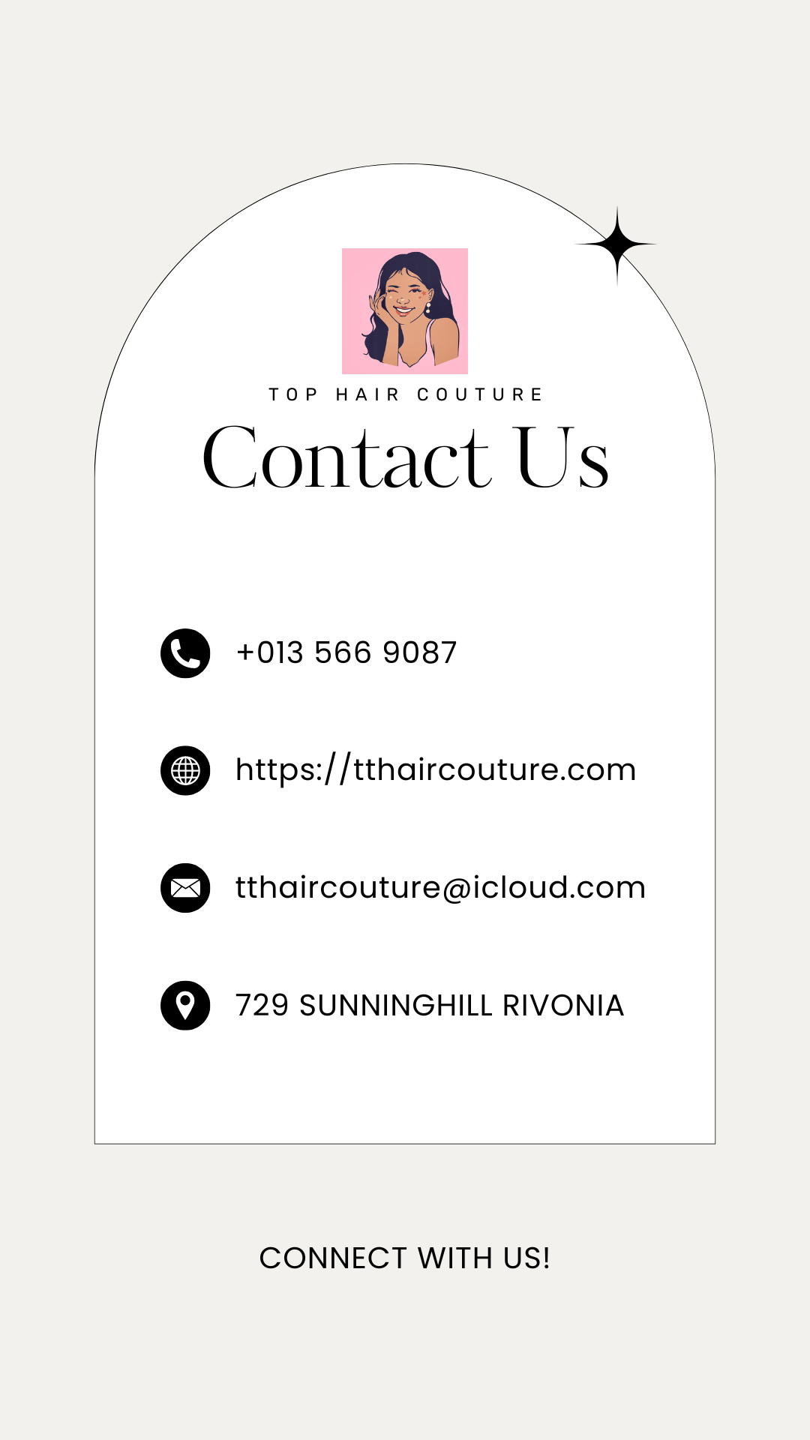 **CONTACT**

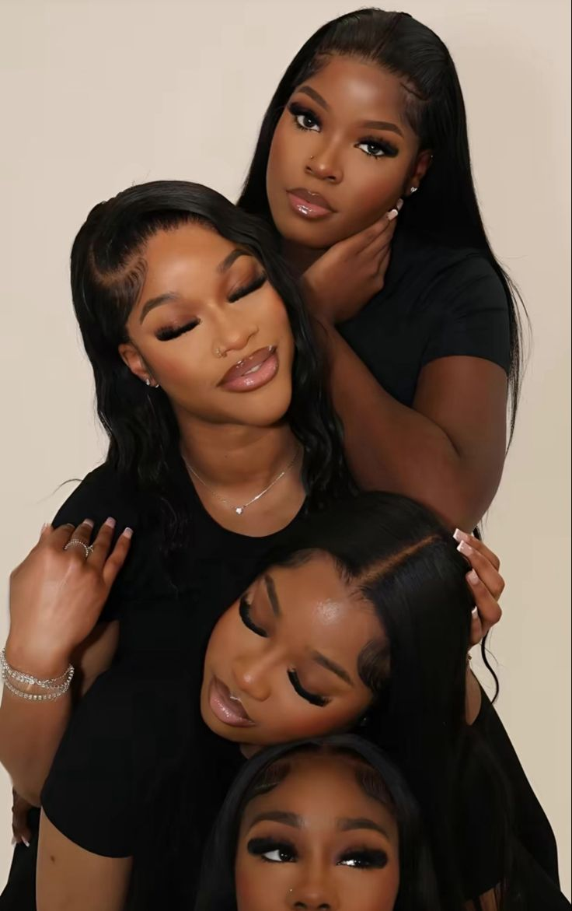BACKGROUND PICTURE

# REFRENCING:

‌https://webflow.com/blog/pages-on-a-website?utm_source=google&utm_medium=search&utm_campaign=SS-GoogleSearch-Nonbrand-DynamicSearchAds-Tier4&utm_term=dsa-1480385100845___703207072761__&gad_source=1&gbraid=0AAAAADsEFNOau4f7x_yU740jDpuhXh1Gc&gclid=CjwKCAjw_ZC2BhAQEiwAXSgClhzpy6KHn2IkXdgN73D_eDn15lKz0z5WLRdZT2g4liToBXj6SXoiKRoChTYQAvD_BwE

Pinterest. (n.d.). *Pinterest*. [online] Available at: <https://za.pinterest.com>.

‌Quora. (2019). *What inspires graphic designers to create new designs and logos?* [online] Available at: https://www.quora.com/What-inspires-graphic-designers-to-create-new-designs-and-logos#:~:text=Graphic%20designers%20find%20inspiration%20for [Accessed 20 Aug. 2024].

‌Vaiciunaite, D. (2022). *Top 10 Website KPIs to Measure Your Client’s Website Performance | Blog | Whatagraph*. [online] whatagraph.com. Available at: https://whatagraph.com/blog/articles/website-kpis.

PART 2 IMPROVEMENT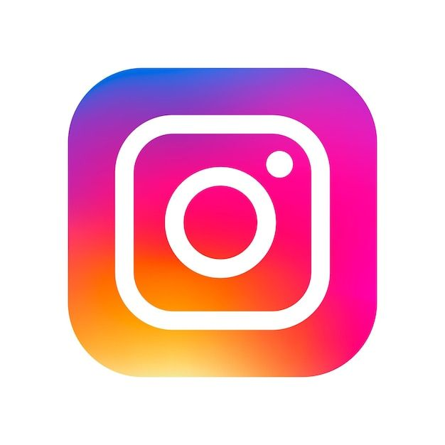INSTAGRAM,FACEBOOK AND TWITTER ICON.

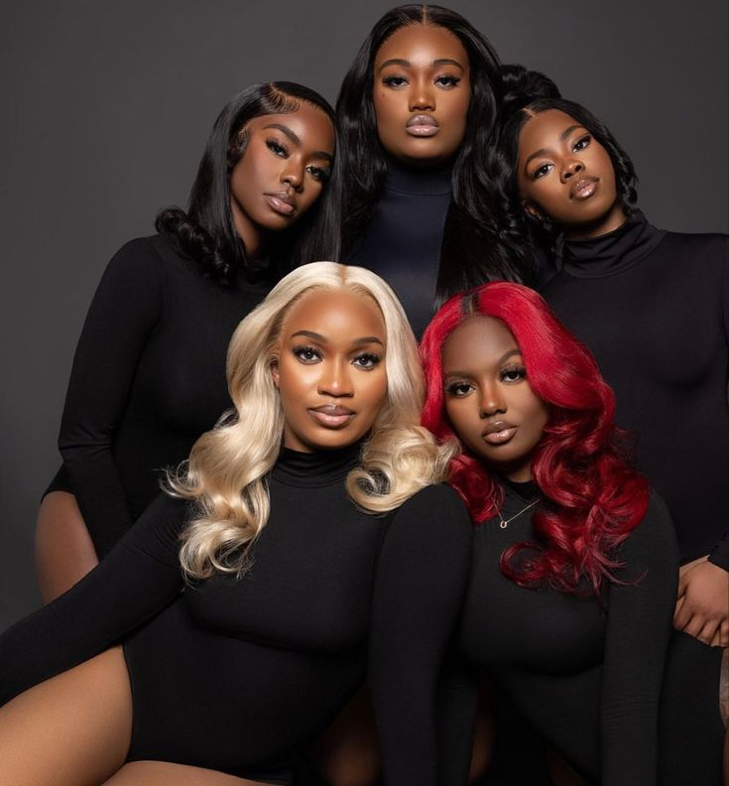 STAFF PICTURE

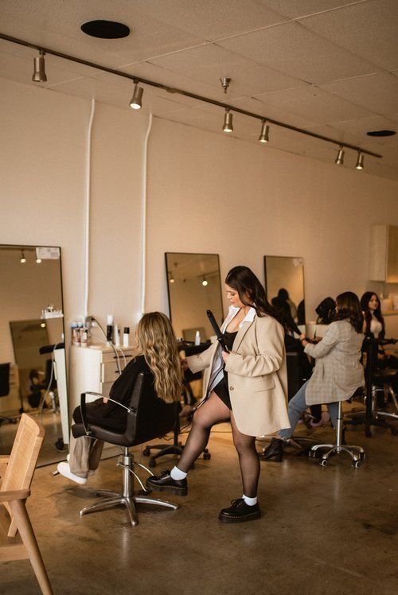 MISSION PICTURES****MISSION PICTURE

## Here's a summary of the HTML code(HOME PAGE):

Page Structure:

1. Header (Navigation Menu)

2. Main Content

- Hero Section (Video Background, Headline, Call-to-Action)

- About Section (Team Photo, Description, Testimonials)

- News Section (Latest Updates with Read More links)

- Call-to-Action Section (Schedule Visit)

3. Footer (Copyright, Social Media Links)

**Key Features:**

1. Responsive Navigation Menu

2. Full-width video background in Hero Section

3. Testimonials with quotes and citations

4. Latest News updates with Read More links

5. Call-to-Action buttons throughout the page

6. Social media links in the footer

**Pages Linked:**

1. About.html

2. Services.html

3. News.html

4. Contact.html

Styles and Scripts:

**1. External stylesheet (styles.css) linked in the head section**.

This HTML code provides a basic structure for a hair salon website, showcasing their services, team, and latest news, with a focus on attracting clients and encouraging bookings.

## Here's a summary of the HTML code(ABOUT PAGE):

**Page Structure:**

1. Navigation Menu

2. About Us Section

3. Mission Section

4. Our Story Section

5. Footer

**Key Features:**

1. Responsive Navigation Menu

2. Sectional layout for About Us, Mission, and Our Story

3. Images and text balanced throughout the page

4. Call-to-action social media links in the footer

5. Copyright notice

**Pages Linked:**

1. Home.html

2. Services.html

3. News.html

4. Contact.html

Styles and Scripts:

**1. External stylesheet (styles.css) linked in the head section.**

**Content Overview:**

This page provides information about Top Hair Couture's:

1. Founding principles and values

2. Mission to empower women through beautiful hair

3. Story, including the founder's background and vision

4. Expertise and services offered

Purpose:

The purpose of this page is to introduce visitors to Top Hair Couture's philosophy, history, and values, establishing trust and credibility with potential clients.

## Here's a summary of the HTML code(CONTACT PAGE):

**Page Structure:**

1. Navigation Menu

2. Social Media Links

3. Contact Us Section

- Contact Form

- Branch Information (Midrand and Sandton)

**Key Features:**

1. Responsive Navigation Menu

2. Social media links with icons

3. Contact form with required fields (Name, Email, Message)

4. Branch information with location, phone number, and hours of operation

Pages Linked:

1. About.html

2. Services.html

3. News.html

Styles and Scripts:

**1. External stylesheet (styles.css) linked in the head section.**

**Content Overview:**

This page provides:

1. Contact information for Top Hair Couture's branches (Midrand and Sandton)

2. A contact form for clients to send messages or inquiries

3. Social media links for clients to connect with Top Hair Couture

**Purpose:**

The purpose of this page is to facilitate communication between clients and Top Hair Couture, providing essential contact information and a convenient contact form.

## Here's a summary of the HTML code(NEWS PAGE):

Page Structure:

1. Header (Navigation Menu)

2. Main Content (Salon News)

3. Footer

**Key Features:**

1. Responsive Navigation Menu

2. News articles with headings, dates, and brief descriptions

3. Meta tags for search engine optimization (SEO)

4. Social media metadata (Open Graph protocol)

**Pages Linked:**

1. Home.html

2. About.html

3. Services.html

4. Contact.html

Styles and Scripts:

**1. External stylesheet (styles.css) linked in the head section.**

**Content Overview:**

This page provides:

1. News updates and announcements from Top Hair Couture

2. Brief summaries of each news article

3. Dates for each news article

**Purpose:**

The purpose of this page is to keep clients and visitors informed about the latest news, trends, and updates from Top Hair Couture.

- Title: Salon News

- Description: Salon News and Updates

- Keywords: salon, news, updates, beauty

- Open Graph protocol metadata for social media sharing.

## Here's a summary of the HTML code(SERVICES PAGE):

**Page Structure:**

1. Navigation Menu

2. Social Media Links

3. Hairstyle Gallery

4. Footer

**Key Features:**

1. Responsive Navigation Menu

2. Hairstyle gallery with images, descriptions, and "Book Now" buttons

3. Social media links with icons

4. Loading animation

5. Lazy loading for images

**Pages Linked:**

1. Home.html

2. About.html

3. News.html

4. Contact.html

**Styles and Scripts:**

1. External stylesheet (styles.css) linked in the head section

2. Font Awesome CSS library for icons

3. JavaScript code for loading animation

**Content Overview:**

**This page showcases various hairstyles with:**

1. High-quality images

2. Detailed descriptions

3. "Book Now" buttons for appointment scheduling

**Purpose:**

The purpose of this page is to provide a visual gallery of hairstyles offered by Top Hair Couture, allowing clients to browse and book appointments.

**Additional Features:**

1. Lazy loading for images to improve page load times

2. Loading animation to enhance user experience

3. Copyright notice in the footer.

## Here are the specific changes in the home page:

**Added:**

1. link rel="stylesheet" href="styles.css"

2. meta name="viewport" content="width=device-width, initial-scale=1.0"

3. section elements for hero, about, news, and cta

4. video element for hero background

5. source elements for video formats (mp4 and webm)

6. Font Awesome icons for social media links

7. Testimonials in the about section

8. News updates with "Read More" links

9. cta class for buttons

10. ARIA attributes for accessibility

**Removed:**

1. Logo image

2. "Our Services" section

3. "What Our Clients Say" section

4. Width attribute from images

5. "Latest News" link from footer

**Updated:**

1. Page title to "Top Hair Couture - Home"

2. Copyright notice to "2024 Top Hair Couture"

3. Navigation menu links and structure

4. Social media links to use Font Awesome icons

5. Text content to reflect Top Hair Couture's brand and services

**Renamed:**

1. index.html to home.html (implied, not shown in code)

2. Our Salon to Top Hair Couture throughout the code

**Reorganized:**

1. Header section to include navigation menu only

2. Main content section to include multiple sections (hero, about, news, cta)

3. Footer section to include copyright notice and social media links.

## Here are specific changes in the about page

**Added:**

1. Meta tags for character encoding (UTF-8) and viewport settings.

2. lang attribute in the html tag.

3. div container with class "container" wrapping the content.

4. "About Us" section with text and image.

5. "Mission" section with text and image.

6. "Our Story" section with text and image.

7. Social media links in the footer.

**Removed:**

1. Header section (replaced with navigation menu).

2. Old content (replaced with new sections).

**Updated:**

1. Navigation menu links (updated to match new page structure).

2. Footer content (updated with copyright notice and social media links).

**Changed:**

1. Structure: from a simple page with sections to a more complex layout with rows and columns.

2. Classes: added classes for styling (e.g., "about-us", "mission", "story", "section-title").

3. Image sources: updated image sources to match new content.

## Here are the specific changes in the services page

**Added:**

1. Navigation menu with links to Home, About, News, and Contact pages.

2. Social media links (Facebook, Instagram, Twitter).

3. Hairstyle gallery with four items.

4. Loading animation.

5. Font Awesome CSS library for icons.

6. External stylesheet (styles.css) link.

7. JavaScript code for loading animation.

**Removed:**

1. Inline styles (replaced with external stylesheet).

2. Simple image display (replaced with hairstyle gallery).

3. Basic service descriptions (replaced with detailed hairstyle descriptions).

**Updated:**

1. Title tag (from "Our Services" to "Hairstyles and Descriptions").

2. Meta tags (added lang attribute).

3. HTML structure (added sections, divs, and semantic elements).

**Changed:**

1. Layout (from simple to more complex).

2. Content focus (from services to hairstyles).

3. Styling (from inline to external stylesheet).

These changes transformed the page from a basic services page to a hairstyle gallery webpage with navigation, social media links, and a loading animation.

Here are the specific changes in the news page:

**Added:**

1. nav element with navigation menu links

2. Social media links (Facebook, Instagram, Twitter)

3. Hairstyle gallery section

4. Loading animation div

5. Font Awesome CSS library link

6. External stylesheet (styles.css) link

7. JavaScript code for loading animation

8. lang attribute in html tag

9. section elements for hairstyle gallery

10. div elements for hairstyle items

**Removed:**

1. Inline styles

2. Simple image display

3. Basic service descriptions

**Updated:**

1. title tag

2. Meta tags

**Changed:**

1. Layout structure

2. Content focus (services to hairstyles)

3. Styling (inline to external stylesheet)

**Moved:**

1. Image display (from simple to hairstyle gallery)

**Deleted:**

1. Basic service descriptions

**Renamed:**

1. title tag (from "Our Services" to "Hairstyles and Descriptions")

**Reorganized:**

1. HTML structure (added sections, divs, and semantic elements)