RaceDay System
Part 1: System Planning and Database

Section A - Entity Relationship Diagram (ERD)
The diagram below shows the full data model for the RaceDay system (7 entities). Primary keys, foreign keys, and cardinality are indicated for every relationship.
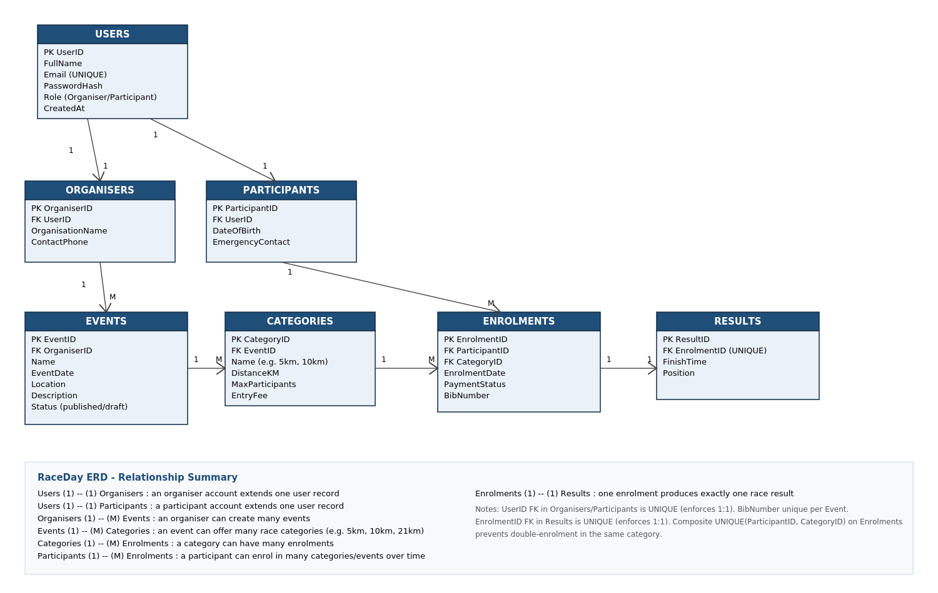
Note: this ERD image is also saved separately as erd.png in the /docs folder, as required.

Section B - API Endpoint Plan
The table below lists every planned API endpoint for the RaceDay system, covering Authentication, User Profile, Events, Categories, Event Enrolments, and Results.
HTTP  Method | Route | Description | Role Required | Request Body | Expected Response
POST | /api/auth/register | Registers a new user as either an Organiser or a Participant. | None (public) | { fullName, email, password, role } | 201 Created - user object (no password) 400 Bad Request - validation error 409 Conflict - email already registered
POST | /api/auth/login | Authenticates a user and returns an access token. | None (public) | { email, password } | 200 OK - { token, user } 401 Unauthorized - invalid credentials
GET | /api/users/me | Returns the profile of the currently logged-in user. | Any (logged in) | None | 200 OK - user profile object 401 Unauthorized - no/invalid token
PUT | /api/users/me | Updates the profile of the currently logged-in user. | Any (logged in) | { fullName, contactPhone, ... } | 200 OK - updated user object 400 Bad Request - validation error
DELETE | /api/users/me | Deactivates/deletes the currently logged-in user's account. | Any (logged in) | None | 204 No Content 401 Unauthorized
GET | /api/events | Lists all published events. Supports filtering/search. | None (public) | None | 200 OK - array of event objects
GET | /api/events/{id} | Retrieves full details for a single event, including its categories. | None (public) | None | 200 OK - event object 404 Not Found - event does not exist
POST | /api/events | Creates a new event owned by the logged-in organiser. | Organiser | { name, eventDate, location, description } | 201 Created - event object 400 Bad Request - validation error 403 Forbidden - not an organiser
PUT | /api/events/{id} | Updates an event. Only the owning organiser may edit it. | Organiser (owner) | { name, eventDate, location, description, status } | 200 OK - updated event object 403 Forbidden - not the owning organiser 404 Not Found
DELETE | /api/events/{id} | Deletes/cancels an event owned by the logged-in organiser. | Organiser (owner) | None | 204 No Content 403 Forbidden 404 Not Found
GET | /api/events/{id}/categories | Lists all race categories for a specific event. | None (public) | None | 200 OK - array of category objects 404 Not Found - event does not exist
POST | /api/events/{id}/categories | Adds a new race category to an event. | Organiser (owner) | { name, distanceKm, maxParticipants, entryFee } | 201 Created - category object 403 Forbidden - not the owning organiser 404 Not Found - event does not exist
PUT | /api/categories/{id} | Updates a race category's details. | Organiser (owner) | { name, distanceKm, maxParticipants, entryFee } | 200 OK - updated category object 403 Forbidden 404 Not Found
DELETE | /api/categories/{id} | Removes a race category from an event. | Organiser (owner) | None | 204 No Content 403 Forbidden 404 Not Found 409 Conflict - category has existing enrolments
POST | /api/categories/{id}/enrolments | Enrols the logged-in participant into a specific category. | Participant | { } | 201 Created - enrolment record with bibNumber 404 Not Found - category does not exist 409 Conflict - already enrolled / category full
GET | /api/users/me/enrolments | Lists all enrolments for the logged-in participant. | Participant | None | 200 OK - array of enrolment objects
GET | /api/categories/{id}/enrolments | Lists all participants enrolled in a category. | Organiser (owner) | None | 200 OK - array of enrolment objects 403 Forbidden - not the owning organiser
DELETE | /api/enrolments/{id} | Cancels/withdraws an enrolment. | Participant (owner) | None | 204 No Content 403 Forbidden - not the owning participant 404 Not Found
POST | /api/enrolments/{id}/results | Captures the finish time/position for a completed enrolment. | Organiser (owner) | { finishTime, position } | 201 Created - result object 403 Forbidden - not the owning organiser 404 Not Found - enrolment does not exist 409 Conflict - result already captured
GET | /api/categories/{id}/results | Lists the results/leaderboard for a category. | None (public) | None | 200 OK - array of result objects, ordered by position 404 Not Found - category does not exist
GET | /api/enrolments/{id}/results | Retrieves the result for a single enrolment. | Participant (owner) or Organiser (owner) | None | 200 OK - result object 403 Forbidden 404 Not Found - no result captured yet
Roles: "None (public)" = no authentication required. "Any (logged in)" = any authenticated user. "Organiser (owner)" / "Participant (owner)" = the authenticated user must own the related resource.

