INSY6112 Exam
STUDENT NUMBER: ST10467645

Lecturer: Prof. Lucas Khoza
Module Code: INSY6112

Contents
QUESTION 1 2
QUESTION 2 3
QUESTION 3 4
QUESTION 4 8

QUESTION 1

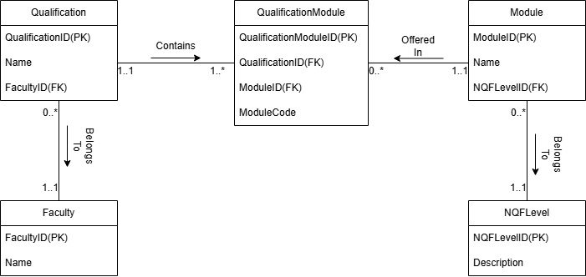

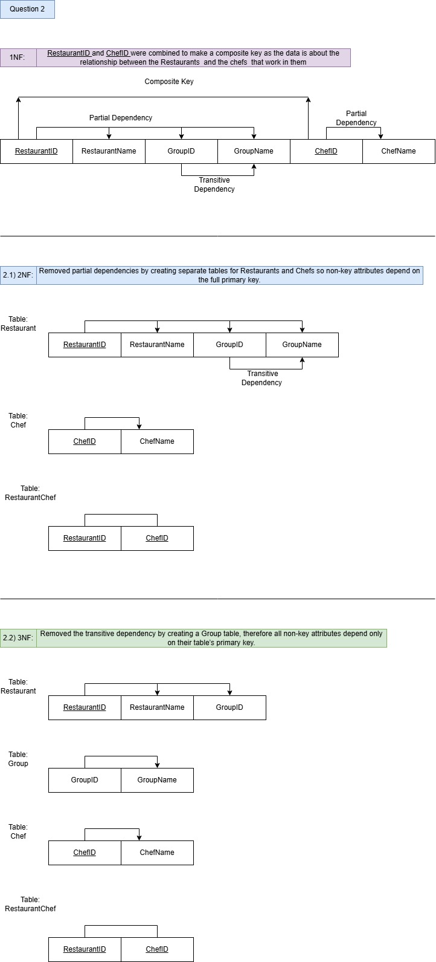
QUESTION 2

QUESTION 3

Screenshot of SQL script on workbench:

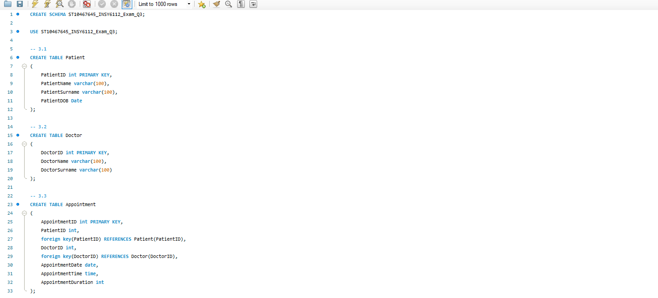
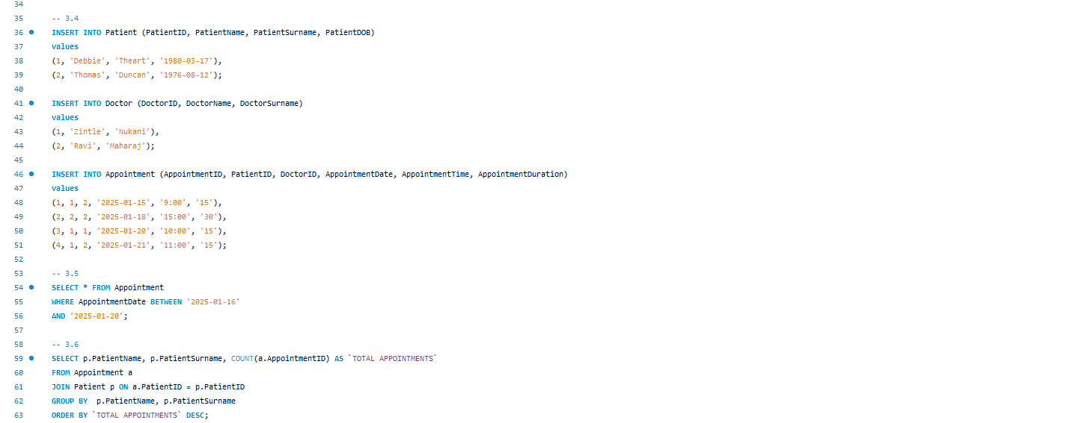
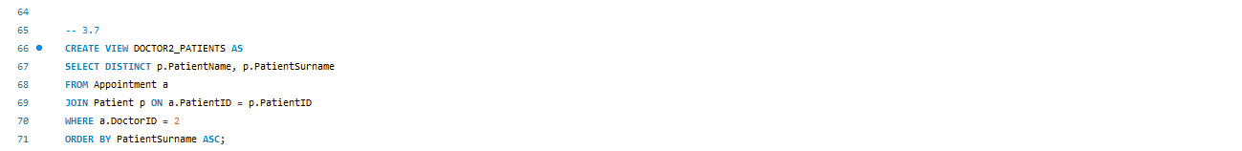

SQL Script answers:
CREATE SCHEMA ST10467645_INSY6112_Exam_Q3;

USE ST10467645_INSY6112_Exam_Q3;

-- 3.1
CREATE TABLE Patient
(
PatientID int PRIMARY KEY,
PatientName varchar(100),
PatientSurname varchar(100),
PatientDOB Date
);

-- 3.2
CREATE TABLE Doctor
(
DoctorID int PRIMARY KEY,
DoctorName varchar(100),
DoctorSurname varchar(100)
);

-- 3.3
CREATE TABLE Appointment
(
AppointmentID int PRIMARY KEY,
PatientID int,
foreign key(PatientID) REFERENCES Patient(PatientID),
DoctorID int,
foreign key(DoctorID) REFERENCES Doctor(DoctorID),
AppointmentDate date,
AppointmentTime time,
AppointmentDuration int
);

-- 3.4
INSERT INTO Patient (PatientID, PatientName, PatientSurname, PatientDOB)
values
(1, 'Debbie', 'Theart', '1980-03-17'),
(2, 'Thomas', 'Duncan', '1976-08-12');

INSERT INTO Doctor (DoctorID, DoctorName, DoctorSurname)
values
(1, 'Zintle', 'Nukani'),
(2, 'Ravi', 'Maharaj');

INSERT INTO Appointment (AppointmentID, PatientID, DoctorID, AppointmentDate, AppointmentTime, AppointmentDuration)
values
(1, 1, 2, '2025-01-15', '9:00', '15'),
(2, 2, 2, '2025-01-18', '15:00', '30'),
(3, 1, 1, '2025-01-20', '10:00', '15'),
(4, 1, 2, '2025-01-21', '11:00', '15');

-- 3.5
SELECT * FROM Appointment
WHERE AppointmentDate BETWEEN '2025-01-16'
AND '2025-01-20';

-- 3.6
SELECT p.PatientName, p.PatientSurname, COUNT(a.AppointmentID) AS `TOTAL APPOINTMENTS`
FROM Appointment a
JOIN Patient p ON a.PatientID = p.PatientID
GROUP BY p.PatientName, p.PatientSurname
ORDER BY `TOTAL APPOINTMENTS` DESC;

-- 3.7
CREATE VIEW DOCTOR2_PATIENTS AS
SELECT DISTINCT p.PatientName, p.PatientSurname
FROM Appointment a
JOIN Patient p ON a.PatientID = p.PatientID
WHERE a.DoctorID = 2
ORDER BY PatientSurname ASC;

QUESTION 4

Screenshot of MongoDB interactive Shell Commands:

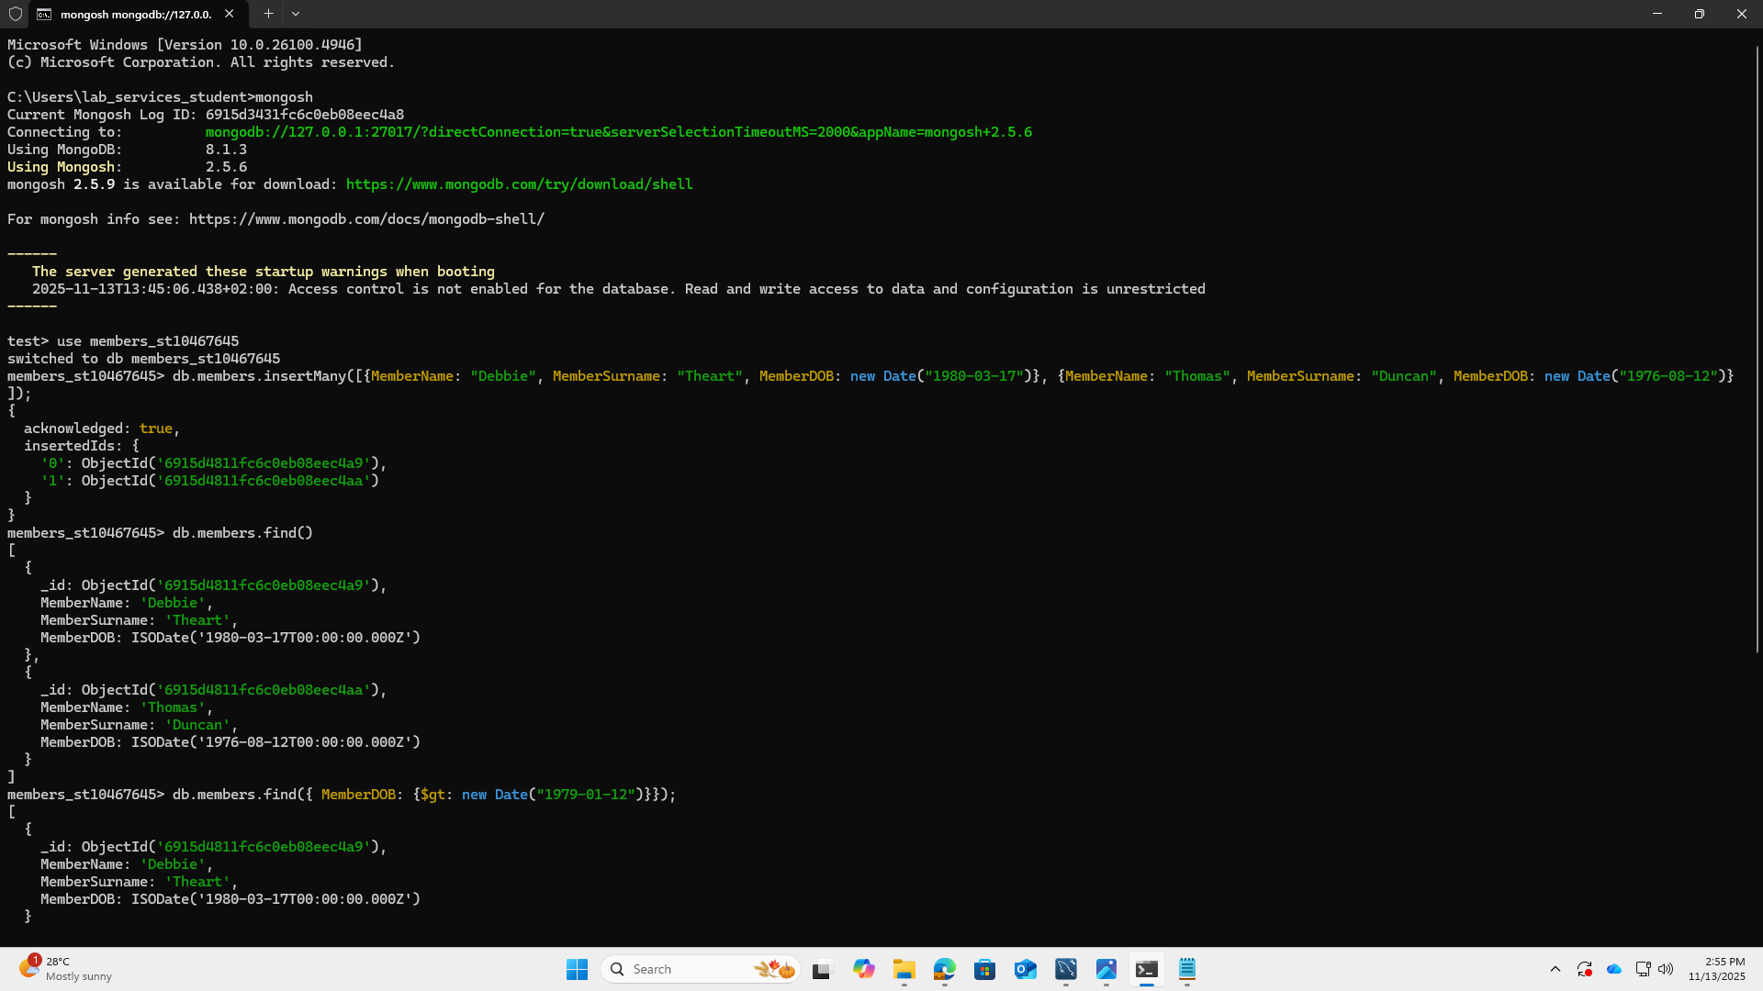

Copied and pasted commands from the shell:

Microsoft Windows [Version 10.0.26100.4946]
(c) Microsoft Corporation. All rights reserved.

C:\Users\lab_services_student>mongosh
Current Mongosh Log ID: 6915d3431fc6c0eb08eec4a8
Connecting to: mongodb://127.0.0.1:27017/?directConnection=true&serverSelectionTimeoutMS=2000&appName=mongosh+2.5.6
Using MongoDB: 8.1.3
Using Mongosh: 2.5.6
mongosh 2.5.9 is available for download: https://www.mongodb.com/try/download/shell

For mongosh info see: https://www.mongodb.com/docs/mongodb-shell/

------
The server generated these startup warnings when booting
2025-11-13T13:45:06.438+02:00: Access control is not enabled for the database. Read and write access to data and configuration is unrestricted
------

test> use members_st10467645
switched to db members_st10467645
members_st10467645> db.members.insertMany([{MemberName: "Debbie", MemberSurname: "Theart", MemberDOB: new Date("1980-03-17")}, {MemberName: "Thomas", MemberSurname: "Duncan", MemberDOB: new Date("1976-08-12")}]);
{
acknowledged: true,
insertedIds: {
'0': ObjectId('6915d4811fc6c0eb08eec4a9'),
'1': ObjectId('6915d4811fc6c0eb08eec4aa')
}
}
members_st10467645> db.members.find()
[
{
_id: ObjectId('6915d4811fc6c0eb08eec4a9'),
MemberName: 'Debbie',
MemberSurname: 'Theart',
MemberDOB: ISODate('1980-03-17T00:00:00.000Z')
},
{
_id: ObjectId('6915d4811fc6c0eb08eec4aa'),
MemberName: 'Thomas',
MemberSurname: 'Duncan',
MemberDOB: ISODate('1976-08-12T00:00:00.000Z')
}
]
members_st10467645> db.members.find({ MemberDOB: {$gt: new Date("1979-01-12")}});
[
{
_id: ObjectId('6915d4811fc6c0eb08eec4a9'),
MemberName: 'Debbie',
MemberSurname: 'Theart',
MemberDOB: ISODate('1980-03-17T00:00:00.000Z')
}
]
members_st10467645>

TEXT FILE
- A text file with the MongoDB shell commands is attached to the submission.

