INSY6112 Test
Student Number: ST10467645

Lecturer: Prof. Lucas Khoza
Module Code: INSY6112

Contents
Question 1 2
Question 2 3
Question 3 4

Question 1

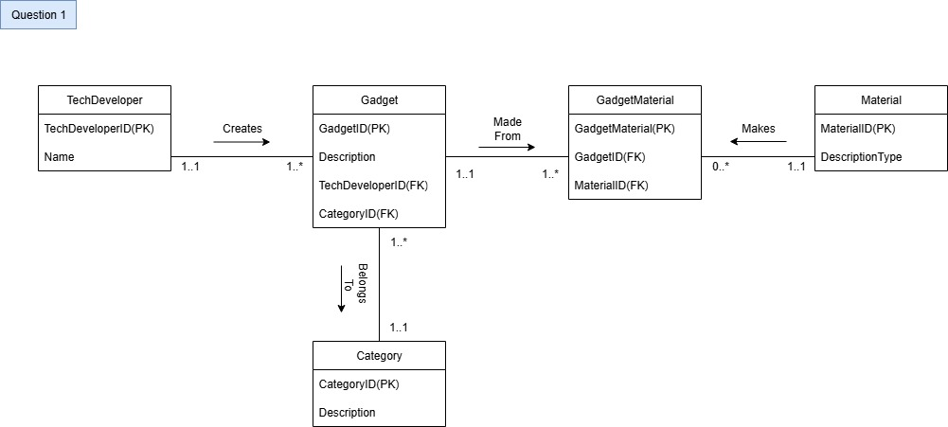

Question 2

2.1)

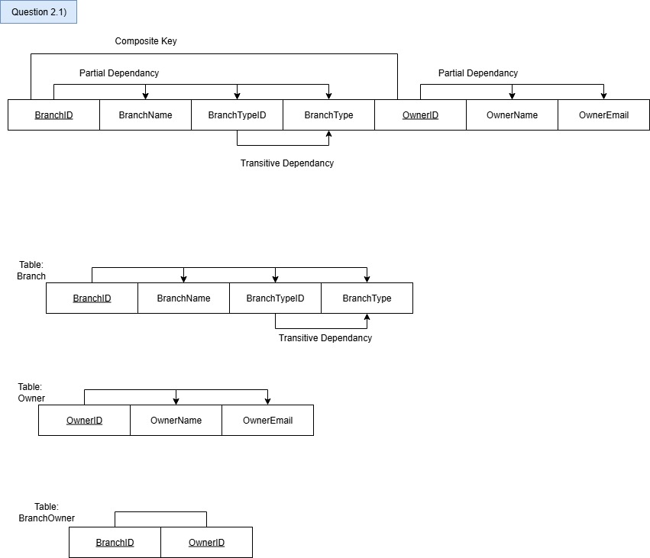

Question 3

Screenshot of SQL script on workbench:

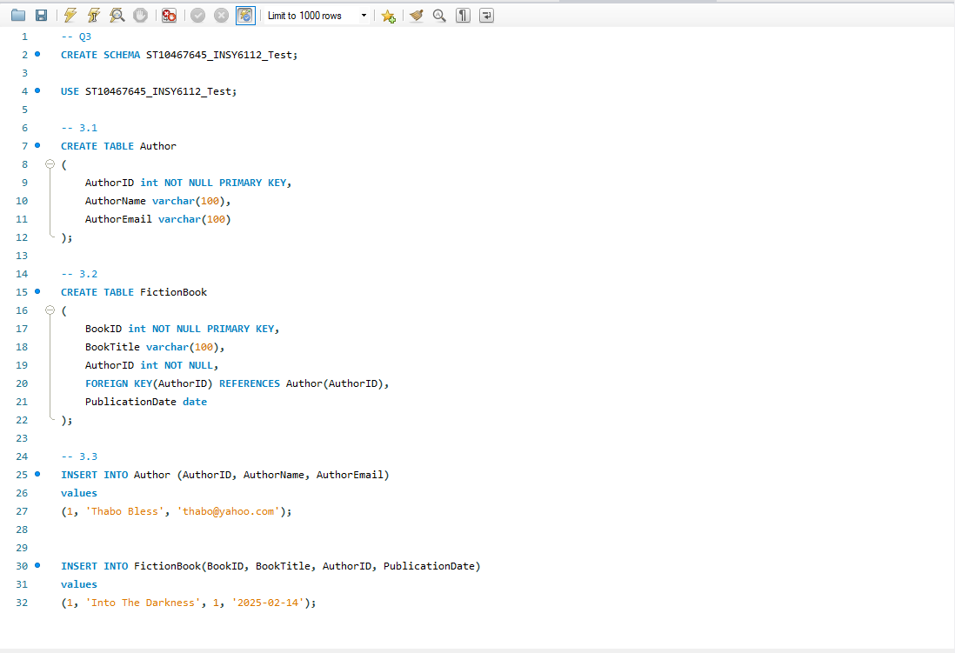

Actual SQL script typed:
-- Q3
CREATE SCHEMA ST10467645_INSY6112_Test;

USE ST10467645_INSY6112_Test;

-- 3.1
CREATE TABLE Author
(
AuthorID int NOT NULL PRIMARY KEY,
AuthorName varchar(100),
AuthorEmail varchar(100)
);

-- 3.2
CREATE TABLE FictionBook
(
BookID int NOT NULL PRIMARY KEY,
BookTitle varchar(100),
AuthorID int NOT NULL,
FOREIGN KEY(AuthorID) REFERENCES Author(AuthorID),
PublicationDate date
);

-- 3.3
INSERT INTO Author (AuthorID, AuthorName, AuthorEmail)
values
(1, 'Thabo Bless', 'thabo@yahoo.com');

INSERT INTO FictionBook(BookID, BookTitle, AuthorID, PublicationDate)
values
(1, 'Into The Darkness', 1, '2025-02-14');

