Tyric Singh
ST10479817@imconnect.edu.za
Proposal 1 Housing Repairs
The chosen proposal is about Housing Repairs
WEDE5020

Student ID: ST10479817
Module: WEDE5020
Assessment Type: POE Part 1, Part 2 & Part 3
Group: 2
Table of Contents
Task A Choose a Target Organization 3
Proposal 1: Plumbing and House Maintenance 3
Task B. Research and Planning – Website Project Proposal Content 4
Organisation Overview 4
A brief history of the organisation 4
Mission Statement 4
Vision Statement 4
Target Audience 4
Website Goals and Objectives 5
Website Goals 5
Website Objectives 5
Key Performance Indicators (KPIs) 5
Proposed Website Features and Functionality 6
The Essential Features & Functionality 6
Design and User Experience 7
Overall Design 7
Colour Scheme 7
Typography 7
Layout and Design 7
User Experience 7
Wireframes 8
Technical Requirements 9
Timeline and Milestones 10
Part 1 Gantt Chart 10
Part 2 Gantt Chart 11
Part 3 Gantt Chart 11
Budget 12
Content Research and Sourcing 13
Sitemap 14
GitHub Repository 15
Proposal 2 16
Part 2 21
2. CSS Styling for Desktop Solution 21
2.1 Creating an Stylesheet 21
2.2 Establishing a Base Style 21
2.3 Applying Typograpy Styles 21
2.4 Creating a Layout Structure 21
2.5 Applying all Visual Styles 21
3. Resonsive Design 22
3.1 Breakpoints 22
3.2 Relative Units 22
3.3 Responsive Images 23
3.4 Test and Iterate 23
References 26
References for Proposal 2 27

Task A Choose a Target Organization

Proposal 1: Plumbing and House Maintenance
Name: Housing Repairs
Type of Business: Small Business
Focus of the Business: Service information, quote requests, service booking, galleries and want to split Plumbing and House Maintenance
Content to be on website: Many types of services, safety certifications

Task B. Research and Planning – Website Project Proposal Content

Organisation Overview
Name: Housing Repairs

A brief history of the organisation
Housing repairs is a hypothetical small business, that started in 2021 to provide reliable, professional plumbing and house maintenance services to the residents and apartments in Johannesburg area. The company is growing stronger everyday allowing themselves to have a very good reputation.

Mission Statement
To insure to deliver high-quality and dependable home maintenance and plumbing services that improve and help fix our clients’ homes.

Vision Statement
We want to be the most trusted and accessible home services provider in South Africa though our exceptional service delivery and creating a strong community relationship with each client we help.

Target Audience
• Homeowners
• Landlords and Property Manages
• Small Business owners
• Real Estate Agents

Website Goals and Objectives

Website Goals
- Presenting a professional online presence for Housing Repairs
- Allow users to easily navigate the website to book services or request quotes.
- Present all services clearly to educate customers.
- Build trust and credibility with customers.
- Increase online visibility and search presence.

Website Objectives
- We need to generate 20 or more services inquiries per month through online forms.
- To improve Customer engagement by offering 24/7 service booking.
- Providing detailed service pages to reduce the number of customers support queriers.
- Insure to we have consent traffic.
- Creating an enquiry from (using Google Forms) that lets users book services or request a free quote.

Key Performance Indicators (KPIs)
Objectives | Key Performance Indicators
Drive online orders | The number of contacts from submissions per month has increased.
Build customer loyalty | The amount of happy customer reviews grow over time.
Improve customer engagement | Average session duration.
Building Trust with Customers | Number of Customers that choose to come back will increase.
Improved Search Presence | Traffic from Google(SEO performance) will increase.

Proposed Website Features and Functionality

The Essential Features & Functionality
- Homepage
Purpose of page: Introduce the business, highlight key services and channels to contact.
Key elements: Images, testimonials, information and easy to read layout.
Implementation notes: Text about how the services work and testimonials.
- About Us
Purpose of page: Build trust with company history, mission, vision, certifications and Brands we work with.
Key elements: Information, images, logos and using sections.
- Services
Purpose: Describe services in detail so users can self-assess and request the correct service.
Main page: short intro links to three service pages: ”Plumbing, Electrical and Maintenance”.
Service subpages: Plumbing, Electrical and Maintenance pages are full of information and images.
Implementation notes: Structured content to make it more appealing.
- Gallery
Purpose: show before/ after and completed works to demonstrate competence, but mainly is full of images.
Key elements: Grid gallery with lightbox, categories in plumbing, electrical and maintenance.
Implementation notes: Using alt text and using responsive images.
- Contact Page
Purpose: Capture enquiries and allow for the ability for users to contact the business and Locations.
The Google Form: Full name, Email, phone number, location, services and description.
implementation notes: Embed Google form and embed Google Maps.

Header utilities: Logo and navigation links. There is also a phone number and WhatsApp link.
Footer utilities: Logo and some information about the business. There is also logos of social media that are links.

Design and User Experience

Overall Design
The design will be more professional and be easy to use. The visual approach will be modern and will easy on the eyes. Below is a detailed plan on how the website will be planned out.

Colour Scheme
• Primary colour: Dark Blue
• Secondary Colour: Orange
• Neutral Colour: Light Grey

Typography
• Headings: Montserrat Bold this will make the tiltes be clear and stand out.
• Body Text: Arial or Open Sans this will allow for the text to be easy to read.
• A Hierarchy of Font sizes:
o H1: For Page titles
o H2: For Section titles
o Body: 14 – 16px, for paragraphs for readability.

Layout and Design
• A spilt-feature design on the Service page. Putting Plumbing on the left and Maintenance on the right.
• Grid-based structure for galleries to display the before and after images.
• A navigation bar on the top for quick access to key sections.
• Google form for booking and getting a quote. This will be their own section
• Will be a about us page with all information.
• A contact us page with the FAQs too.

User Experience
A Clear navigation bar with easy and quick access to what the client may want. Fast loading times with quick image optimization. The client with quick navigation on subpages for easy backtracking and simple design that looks neat.

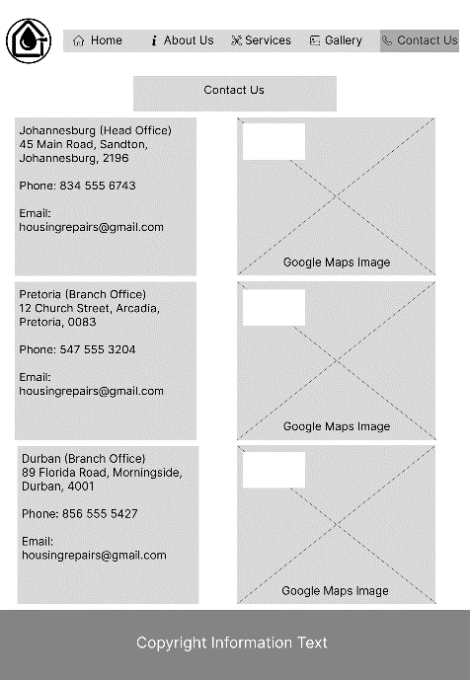
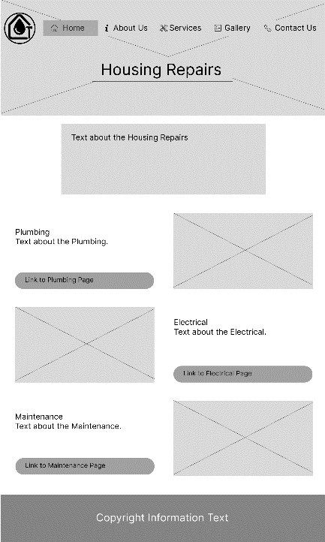
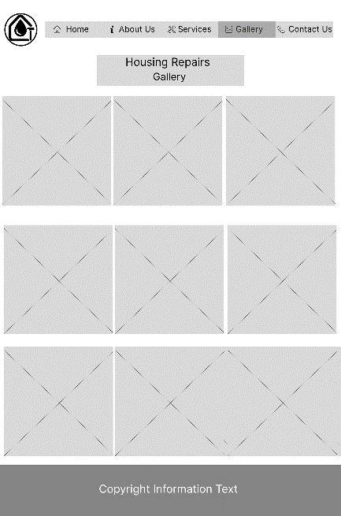
Wireframes
Contact Us Page
Gallery Page
Home Page

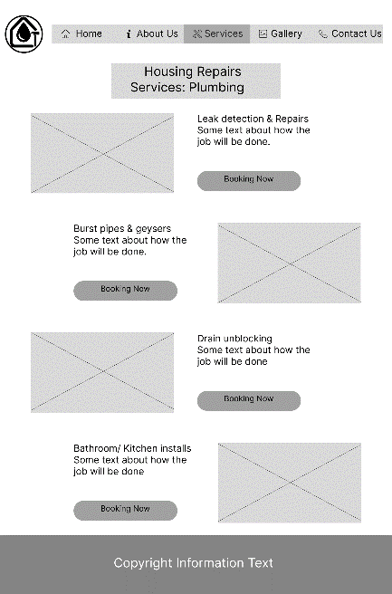
Services Electrical Page
Services Plumbing Page
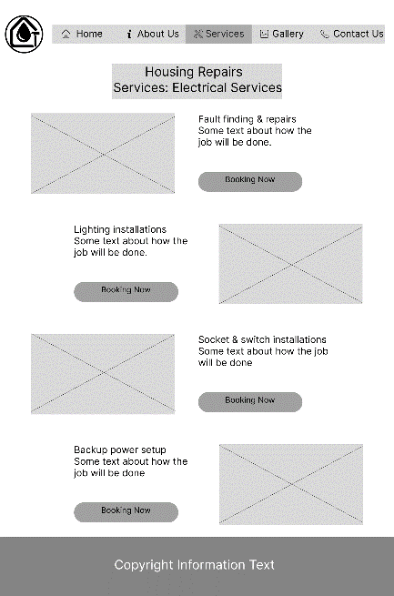
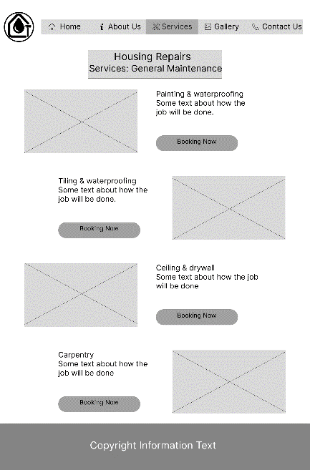

Services General Maintenance Page
About Us Page
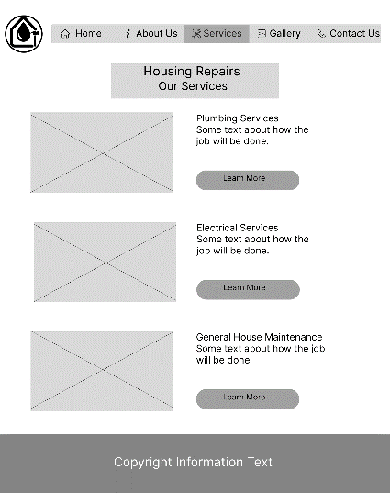
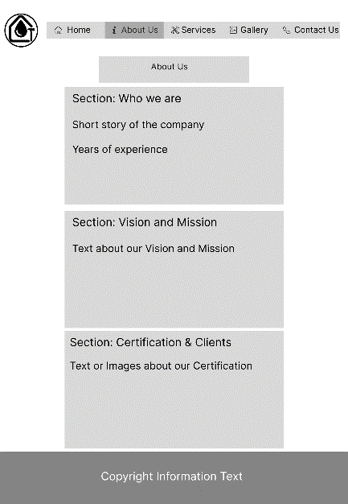
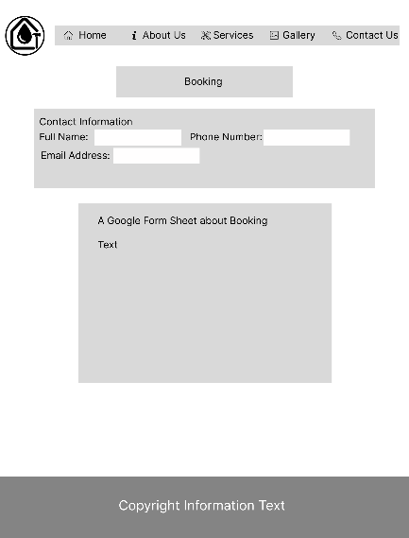
Services Page

Technical Requirements
Domain Name: www.HousingRepairs.co.za
Programming Languages: HTML, CSS and JavaScript.(May add more depending how advance the website becomes).

Timeline and Milestones

Part 1 Gantt Chart
August | 6 | 7 | 8 | 9 | 10 | 11 | 12 | 13 | 14 | 15 | 16 | 17 | 18 | 19 | 20 | 21 | 22 | 23 | 24 | 25 | 26 | 27
Task/Activities | W | T | F | S | S | M | T | W | T | F | S | S | M | T | W | T | F | S | S | M | T | W
Choosing a Target Organisation
Research and Planning
Organisation Overview
Website Goals and Objectives
Website Features and Functionality
Design and User Experience
Technical Requirements
Budget
Research and Sourcing
Website Structure and Planning
Sitemap
File and Folder Structure
HTML Structure
Content Integration
Navigation
Testing and debugging
Comments
GitHub Repository
Website Project Proposal
Content Research and Sourcing
HTML Files
GitHub Repository Link

Part 2 Gantt Chart
September | 9 | 10 | 11 | 12 | 13 | 14 | 15 | 16 | 17 | 18 | 19 | 20 | 21 | 22 | 23 | 24 | 25 | 26 | 27 | 28 | 29 | 30
Task/Activities | W | T | F | S | S | M | T | W | T | F | S | S | M | T | W | T | F | S | S | M | T | W
Create an External Stylesheet
Establish a Base Style
Apply Typography Styles
Create a Layout Structure
Apply Visual Style
Breakpoints
Relative Units
Responsive Images
Test and iterate
GitHub Repository

Part 3 Gantt Chart
October | 1 | 2 | 3 | 4 | 5 | 6 | 7 | 8 | 9 | 10 | 11 | 12 | 13 | 14 | 15 | 16 | 17 | 18 | 19 | 20 | 21 | 22
Task/Activities | W | T | F | S | S | M | T | W | T | F | S | S | M | T | W | T | F | S | S | M | T | W
Interactive Elements
Dynamic Content
On-Page SEO
Off-Page SEO
HTML Form
GitHub Repository

Budget
Housing Repairs is based on realistic cost for a small business found in South Africa. It will cover elements needed in the website development; this will include maintenance for a year.
Items | Price (ZAR)
Domain Registration | R85
Web Hosting | R500
Web Design & Development | R5000
Booking Form(Google Form) | R350
SEO Setup | R300
Gallery Images Taken | R450
Maintenance of Website | R1500

Content Research and Sourcing
Content Research
Home Page
Information text about each service, images making the page more appealing to the user. Testimonials about what their experiences.
About Us
Mission, Vision, Certifications and company history text. Logo brands images
Services
Plumbing, Electrical and Maintenance information and links to other 3 web site.
Gallery
Plumbing, Electrical and Maintenance images about work in progress or finished jobs.
Contact Us
Contact information about each office.3 Embedded Google locations and a google form for contact for a quote.

Content Sourcing
All Text: written in mind about how each component works in the company. Research has been done to find all details, to make the website as qualified and professional as possible.
Images: All images were taken from free licensing websites.
Google Maps and Forms: Google embed tags will be used to show the user and allow them to interact with.
Icons: I will be using default logos from the social media, brands and companies. I will be displaying the business logo with colour and right sizing.

Sitemap
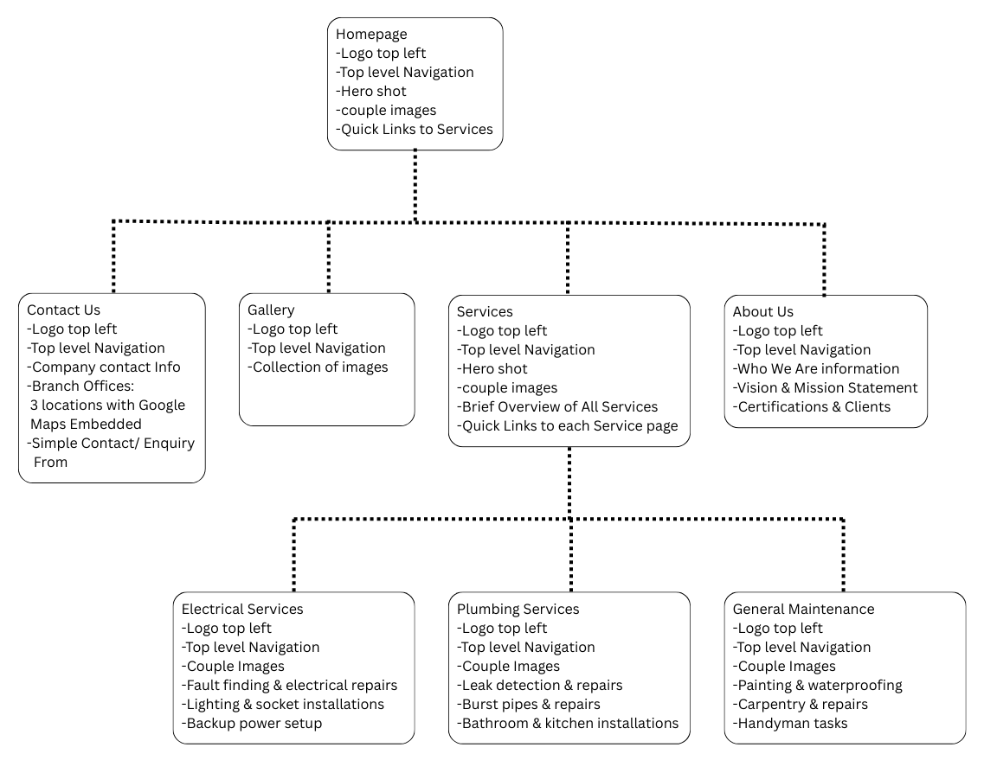

GitHub Repository
https://github.com/ST10479817/ST10479817-WEDE5020-POE.git

Proposal 2
Task A. Choose a Target Organization
Proposal 2: Cupcake Shop
Name: Too Sweet
Type of Business: Retail Store
Focus of the Business: Showing products, online orders available, gallery and customer review option.
Content to be on website: all information needs to provide to a customer and many types of products.
Task B. Research and Planning – Website Project Proposal Content
Organisation Overview
Name: Too Sweet
A brief history of the organisation
Too Sweet is a hypothetical company founded in 2022 to bring handcrafted cupcakes and many other types of dessert to South Africa. The brand is described to be joyful, colourful and welcoming. Their aim is to operate online and have a bigger target audience like for birthdays, corporate events, weddings and to achieve same-day local deliveries.
Mission Statement
To create moments of happiness and to spread quality delicious cakes made by people that love baking.
Vision Statement
We To be South Africa’s leading online cake and sweet boutique, known for creativity and customer-first digital experience.
Target Audience
• Parents planning events for their children
• People that are having Birthdays.
• Event Planners
• Social media people(Instagram)
• Maybe local cafes of small retailers interested in reselling baked goods

Website Goals and Objectives
Website Goals
• To enable online orders and combine it with making custom cupcakes request
• Showcase all products in high quality to appeal to social media
• Educate customers on what the business is provide to stop confusion
• Offer a user-friendly experience to show the quality of the product.
Website Objectives
• We want to get at least 25 orders every month
• Gain a lot of attention for the business.
• Providing detailed service pages to reduce the number of customers support queriers.
• Insure to we have consent traffic.
Key Performance Indicators (KPIs)
Objectives | Key Performance Indicators
Drive online orders | The number of contacts from submissions per month has increased.
Build customer loyalty | The amount of happy customer reviews grow over time.
Improve customer engagement | Average session duration.
Building Trust with Customers | Number of Customers that choose to come back will increase.
Improved Search Presence | Traffic from Google(SEO performance) will increase.

Proposed Website Features and Functionality
The Essential Features
• Homepage
• About Us
• Shop
• Custom Ordering Page
• Blog
• Gallery
• Customer Reviews
• Contact Page
• FAQ
• Booking a service Page
Functionality
• Google Form for Booking a Service
• Contact information Available
• Social Media Interaction
• Images of previous orders on display

Design and User Experience
Overall Design
The design will be more fun and colourful to seem warmth and delight. The site will encourage browsing and convert visitors into customers.
Colour Scheme
• Primary colour: Blush Pink
• Secondary Colour: Cream and Off-White
• Neutral Colour: Mint Green
Typography
• Headings: Playfair Display makes the theme of elegant.
• Body Text: Arial or Poppins this will allow for the text to be easy to read.
• A Hierarchy of Font sizes:
o H1: For Page titles
o H2: For Section titles
o Body: 14–16px, for paragraphs for readability.
Layout and Design
• A lot of creative designs in pink to yellow.
• Grid-based structure for galleries to display images of previous work.
• A navigation bar on the top for quick access to key sections.
• Google form for booking and getting a quote. This will be their own section
• Will be a about us page with all information.
• A contact us page with the FAQs too.
User Experience
A Clear navigation bar with easy and quick access to what the client may want. Fast loading times with quick image optimization. The client with quick navigation on subpages for easy backtracking and simple design that looks neat. Adding a theme of creativity and passion for every part of the website.

Wireframe
Homepage
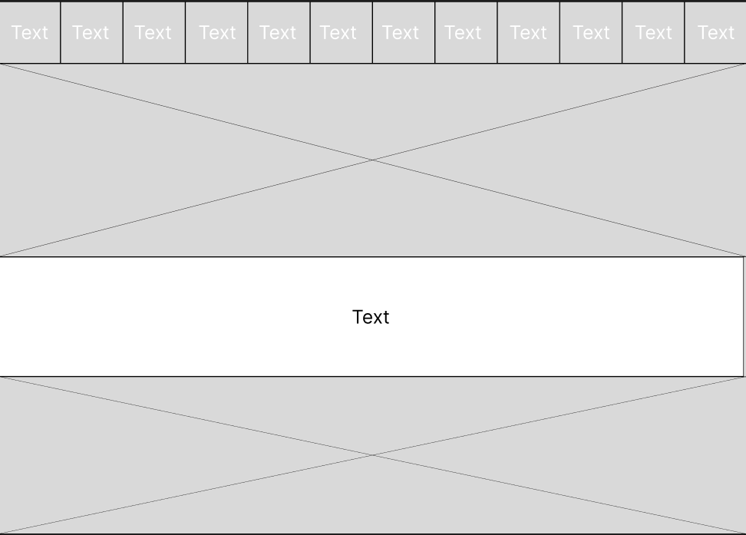
Technical Requirements
Domain Name: www.SweetTreats.co.za
Programming Languages: HTML, CSS and JavaScript.(May add more depending how advance the website becomes).
Hosting Provider: Xneelo

Part 2

2. CSS Styling for Desktop Solution

2.1 Creating a Stylesheet
I have created a CSS file "style.css" that is linked to each page. By using consistent naming convention in the stylesheet makes all pages look consistent and joined with the same theme.

2.2 Establishing a Base Style
I have set default styles for the website for each page to use and look similar. I have also used a CSS reset to ensure consistent styling across the pages. "* { margin: 0; padding: 0; box-sizing: border-box; }"

2.3 Applying Typograph Styles
I have added classes and id's to each page to help with controlling the CSS properties. I used all types of CSS properties to make my website look as perfect and readable as possible.

2.4 Creating a Layout Structure
I have added divs to section my content and make the layout easy to create the structure. Organized content into semantic sections (header, mainContent and footer).

2.5 Applying all Visual Styles
I have applied all different types of styles to help create my website to look as applying as possible. Styled navigation with hover effects, shadows and rounded corners. Added an orange border line below the header and above the footer for a polished look. Created visually distinct service boxes with aligned images and text.

3. Responsive Design

3.1 Breakpoints
I have added the appropriate "@media" tags to work with tablets and mobile screens.

3.2 Relative Units
I have added the correct units to work perfectly with each screen.

3.3 Responsive Images
I have the correct tags to my images and it will react to every screen. It will get smaller depending on the size of the screen.

3.4 Test and Iterate
Screenshots of the Homepage in Desktop size
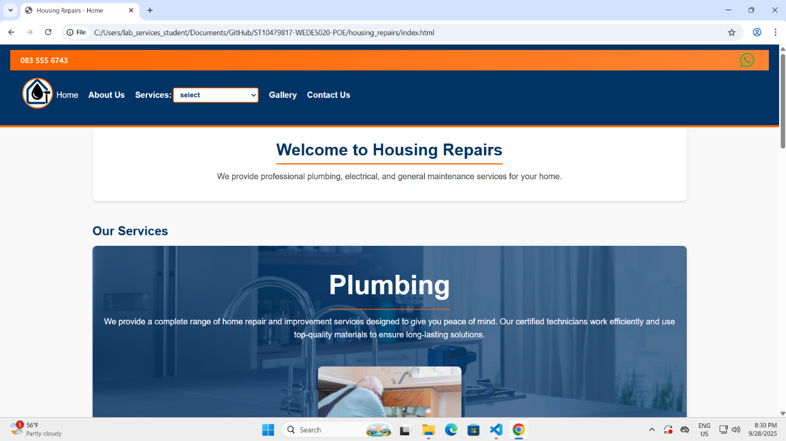
Screenshots of the Gallery in Desktop size
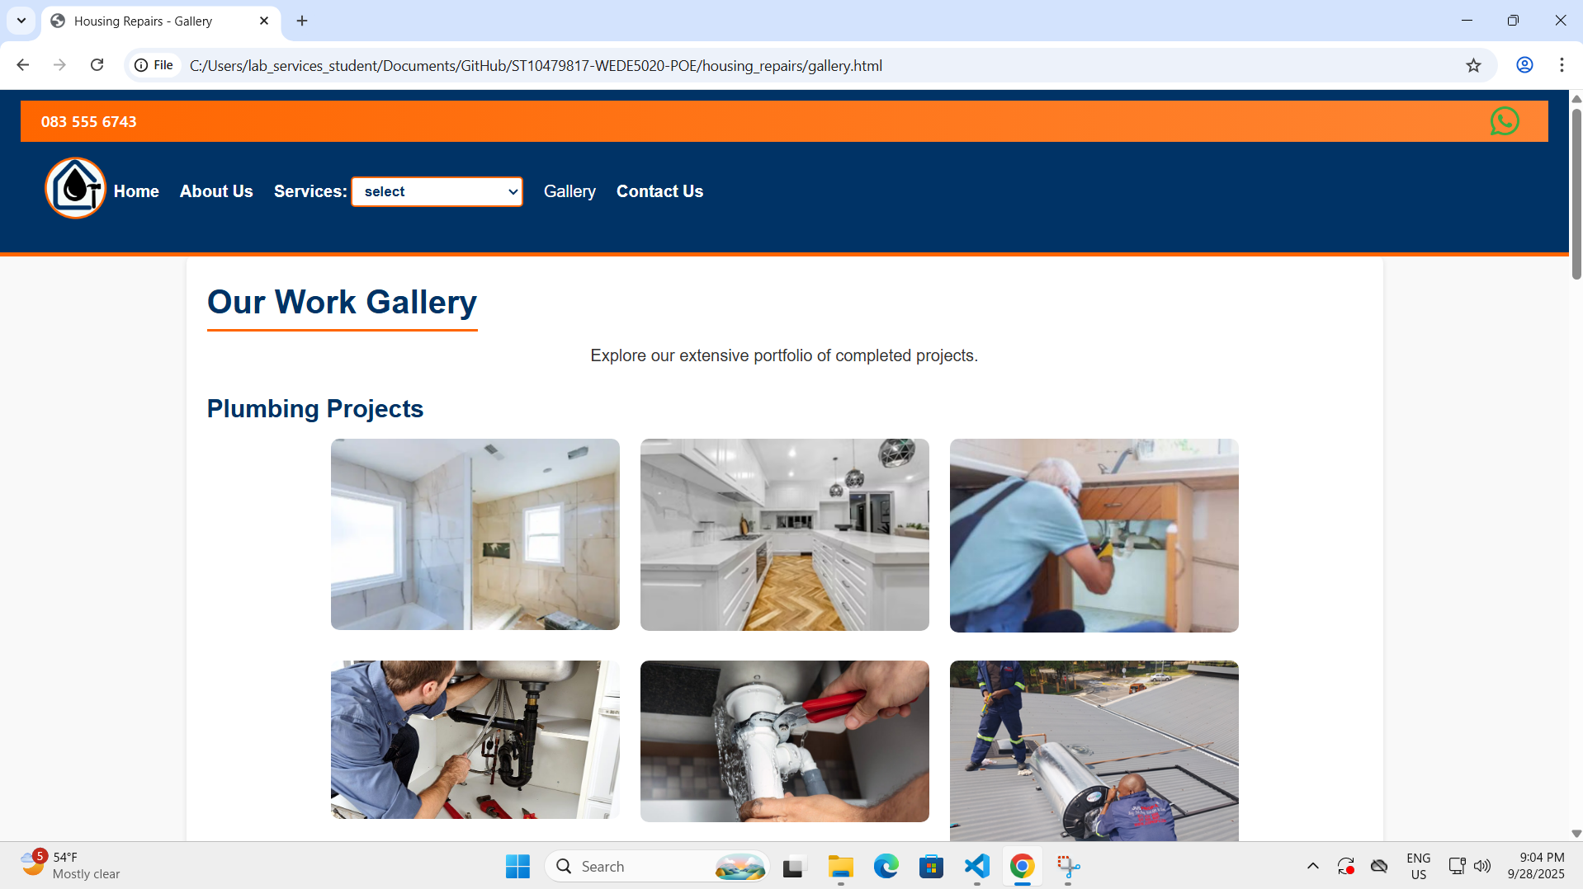

Screenshots of the Homepage in Tablet size
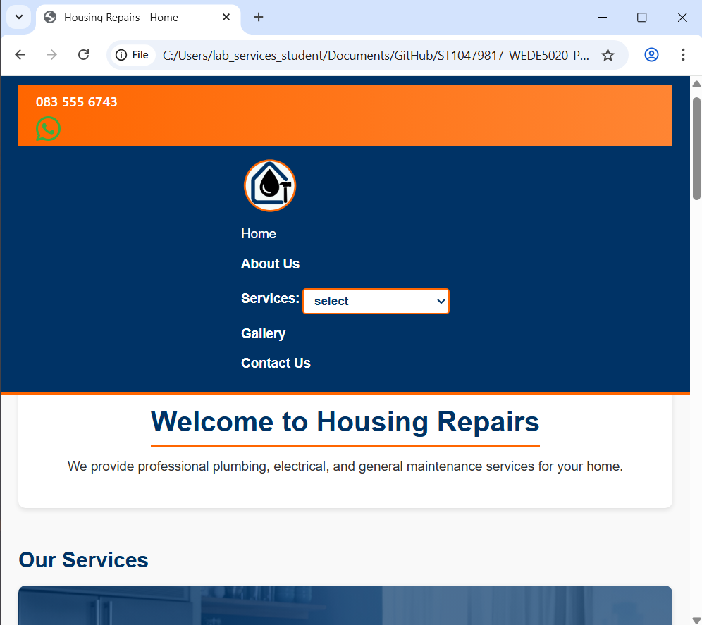
Screenshots of the Gallery in Tablet size
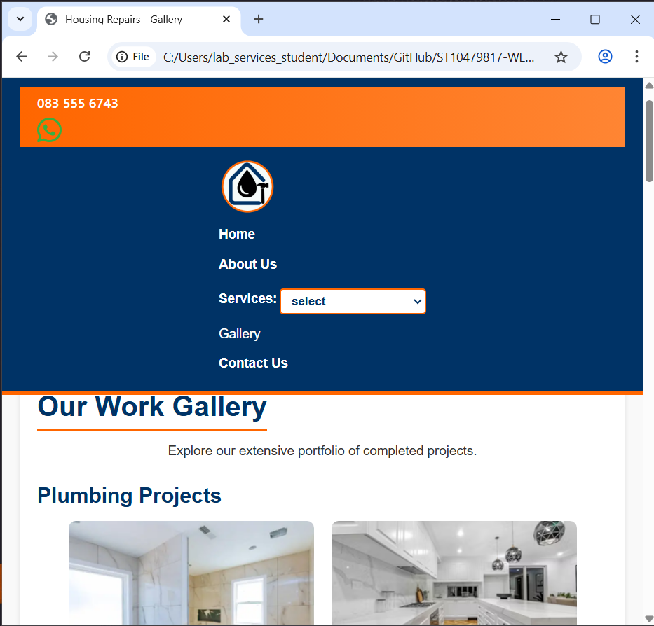

Screenshots of the Homepage in Phone size
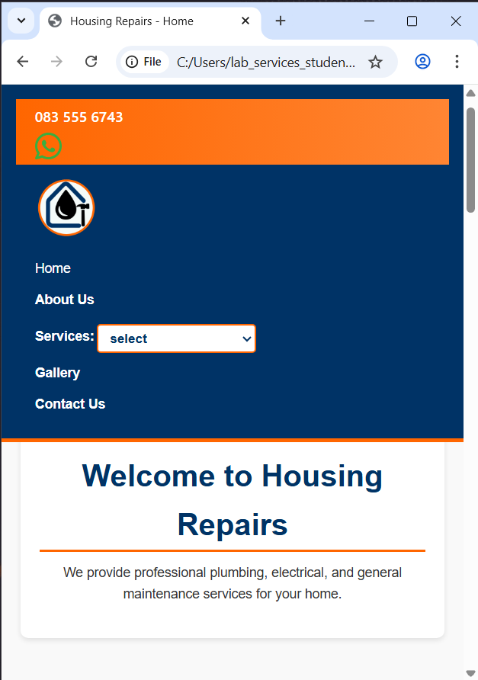
Screenshots of the Gallery in Phone size
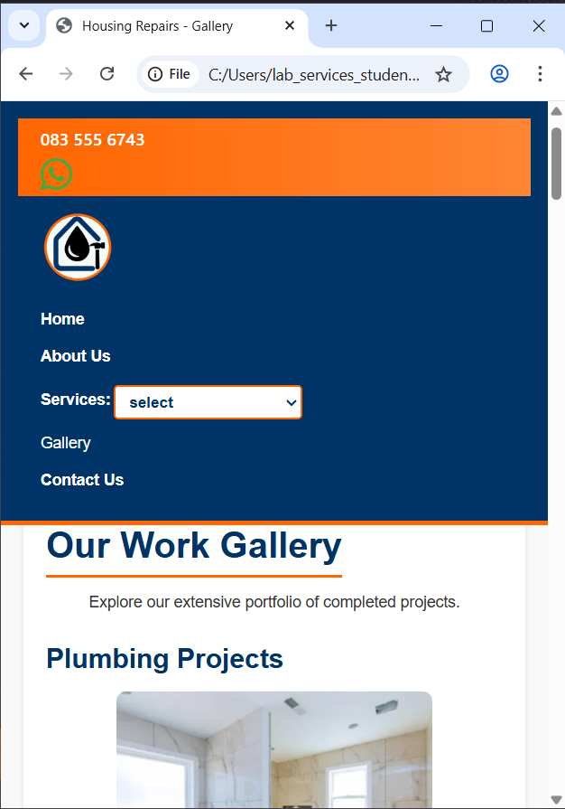

References
GoDaddy, no date. GoDaddy Philippines. [Online]
Available at: https://www.godaddy.com/en-ph
[Accessed 6 August 2025].
Google Analytics, no date. Analytics Provision. [Online]
Available at: https://analytics.google.com/analytics/web/provision/#/provision
[Accessed 6 August 2025].
Google Fonts, no date. Google Fonts. [Online]
Available at: https://fonts.google.com/
[Accessed 6 August 2025].
Leaflet, 2010. Leaflet An open-source JavaScript library for interactive maps. [Online]
Available at: https://leafletjs.com/
[Accessed 1 November 2025].
Unsplash, 2025. Unsplash Photos. [Online]
Available at: https://unsplash.com/
[Accessed 24 August 2025].
W3C, no date. Web Content Accessibility Guidelines. [Online]
Available at: https://www.w3.org/WAI/standards-guidelines/wcag/
[Accessed 6 August 2025].
WordPress.org, no date. WordPress Showcaase. [Online]
Available at: https://wordpress.org/showcase/
[Accessed 6 August 2025].
Xneelo, no date. Xneelo — South Africa. [Online]
Available at: https://xneelo.co.za/
[Accessed 6 August 2025].

References for Proposal 2
GoDaddy, no date. GoDaddy Philippines. [Online]
Available at: https://www.godaddy.com/en-ph
[Accessed 6 August 2025].
Google Analytics, no date. Analytics Provision. [Online]
Available at: https://analytics.google.com/analytics/web/provision/#/provision
[Accessed 6 August 2025].
Google Fonts, no date. Google Fonts. [Online]
Available at: https://fonts.google.com/
[Accessed 6 August 2025].
Leaflet, 2010. Leaflet An open-source JavaScript library for interactive maps. [Online]
Available at: https://leafletjs.com/
[Accessed 1 November 2025].
Unsplash, 2025. Unsplash Photos. [Online]
Available at: https://unsplash.com/
[Accessed 24 August 2025].
W3C, no date. Web Content Accessibility Guidelines. [Online]
Available at: https://www.w3.org/WAI/standards-guidelines/wcag/
[Accessed 6 August 2025].
WordPress.org, no date. WordPress Showcaase. [Online]
Available at: https://wordpress.org/showcase/
[Accessed 6 August 2025].
Xneelo, no date. Xneelo — South Africa. [Online]
Available at: https://xneelo.co.za/
[Accessed 6 August 2025].

