Tyric Singh

ST10479817@imconnect.edu.za

Proposal 1 Housing Repairs

The chosen proposal is about Housing Repairs

WEDE5020

Student ID: ST10479817

Module: WEDE5020

Assessment Type: POE Part 1

Group: 2

Table of Contents

Task A Choose a Target Organization 2

Proposal 1: Plumbing and House Maintenance 2

Task B. Research and Planning – Website Project Proposal Content 3

Organisation Overview 3

A brief history of the organisation 3

Mission Statement 3

Vision Statement 3

Target Audience 3

Website Goals and Objectives 4

Website Goals 4

Website Objectives 4

Key Performance Indicators (KPIs) 4

Proposed Website Features and Functionality 5

The Essential Features & Functionality 5

Design and User Experience 6

Overall Design 6

Colour Scheme 6

Typography 6

Layout and Design 6

User Experience 6

Wireframes 7

Technical Requirements 8

Timeline and Milestones 9

Part 1 Gantt Chart 9

Part 2 Gantt Chart 10

Part 3 Gantt Chart 10

Budget 11

Content Research and Sourcing 12

Sitemap 13

GitHub Repository 14

Proposal 2 15

References 20

References for Proposal 2 21

# Task A Choose a Target Organization

## Proposal 1: Plumbing and House Maintenance

Name: Housing Repairs

Type of Business: Small Business

Focus of the Business: Service information, quote requests, service booking, galleries and want to split Plumbing and House Maintenance

Content to be on website: Many types of services, safety certifications

# Task B. Research and Planning – Website Project Proposal Content

## Organisation Overview

Name: Housing Repairs

### A brief history of the organisation

Housing repairs is a hypothetical small business, that started in 2021 to provide reliable, professional plumbing and house maintenance services to the residents and apartments in Johannesburg area. The company is growing stronger everyday allowing themselves to have a very good reputation.

### Mission Statement

To insure to deliver high-quality and dependable home maintenance and plumbing services that improve and help fix our clients’ homes.

### Vision Statement

We want to be the most trusted and accessible home services provider in South Africa though our exceptional service delivery and creating a strong community relationship with each client we help.

### Target Audience

• Homeowners

• Landlords and Property Manages

• Small Business owners

• Real Estate Agents

## Website Goals and Objectives

### Website Goals

* Presenting a professional online presence for Housing Repairs
* Allow users to easily navigate the website to book services or request quotes.
* Present all services clearly to educate customers.
* Build trust and credibility with customers.
* Increase online visibility and search presence.

### Website Objectives

* We need to generate 20 or more services inquiries per month through online forms.
* To improve Customer engagement by offering 24/7 service booking.
* Providing detailed service pages to reduce the number of customers support queriers.
* Insure to we have consent traffic.
* Creating an enquiry from (using Google Forms) that lets users book services or request a free quote.

### Key Performance Indicators (KPIs)

|  |  |
| --- | --- |
| Objectives | Key Performance Indicators |
| Drive online orders | The number of contacts from submissions per month has increased. |
| Build customer loyalty | The amount of happy customer reviews grow over time. |
| Improve customer engagement | Average session duration. |
| Building Trust with Customers | Number of Customers that choose to come back will increase. |
| Improved Search Presence | Traffic from Google(SEO performance) will increase. |

## Proposed Website Features and Functionality

### The Essential Features & Functionality

1. Homepage

* Top-level navigation bar
* Images

1. About Us

* Company history and mission
* Certifications

1. Services

* Links to 3 websites
* Information about all services
* Images

1. Gallery

* All types of images about the business previous work

1. Contact Page

* Top-level navigation bar
* Embedded Google Map

## Design and User Experience

### Overall Design

The design will be more professional and be easy to use. The visual approach will be modern and will easy on the eyes. Below is a detailed plan on how the website will be planned out.

### Colour Scheme

• Primary colour: Dark Blue

• Secondary Colour: Orange

• Neutral Colour: Light Grey

### Typography

• Headings: Montserrat Bold this will make the tiltes be clear and stand out.

• Body Text: Arial or Open Sans this will allow for the text to be easy to read.

• A Hierarchy of Font sizes:

o H1: For Page titles

o H2: For Section titles

o Body: 14 – 16px, for paragraphs for readability.

### Layout and Design

• A spilt-feature design on the Service page. Putting Plumbing on the left and Maintenance on the right.

• Grid-based structure for galleries to display the before and after images.

• A navigation bar on the top for quick access to key sections.

• Google form for booking and getting a quote. This will be their own section

• Will be a about us page with all information.

• A contact us page with the FAQs too.

### User Experience

A Clear navigation bar with easy and quick access to what the client may want. Fast loading times with quick image optimization. The client with quick navigation on subpages for easy backtracking and simple design that looks neat.

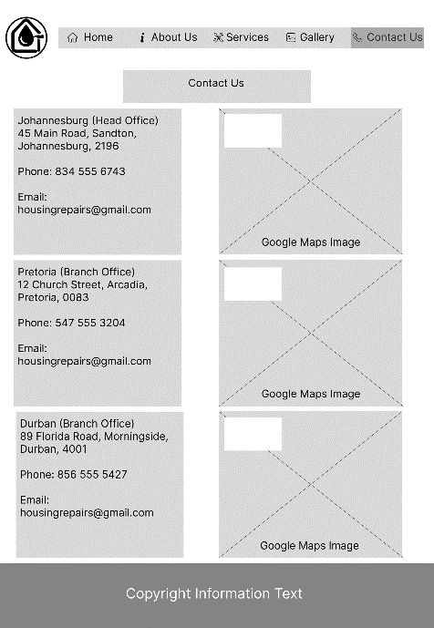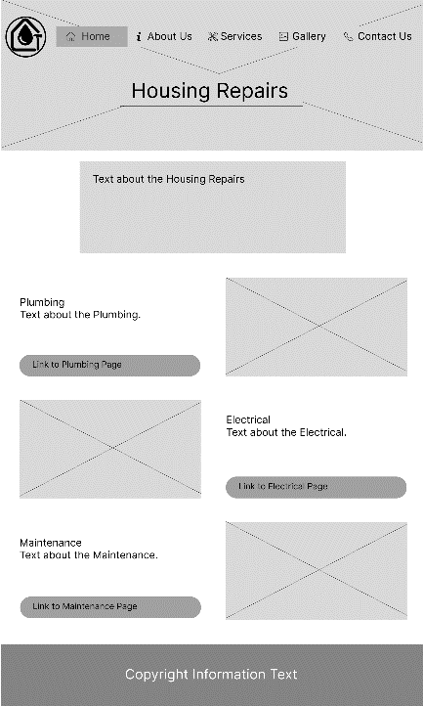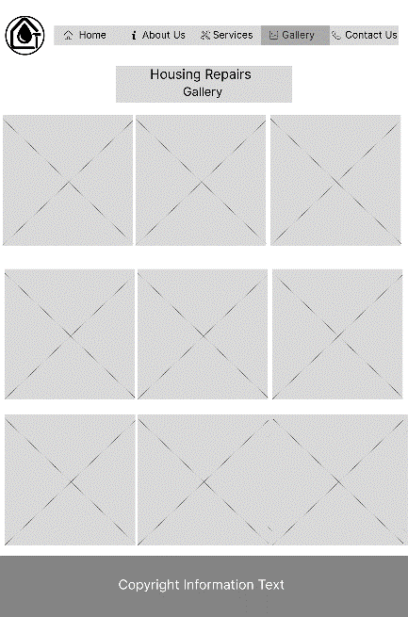Wireframes

Contact Us Page

Gallery Page

Home Page

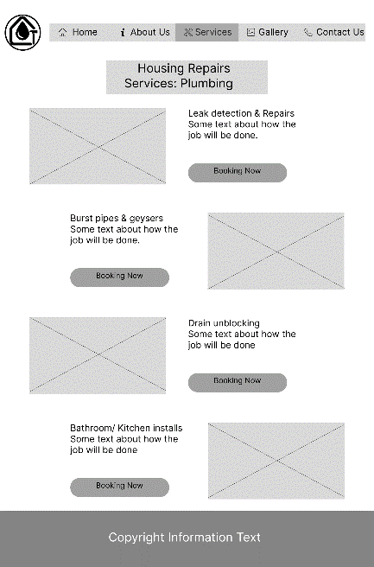

Services Electrical Page

Services Plumbing Page

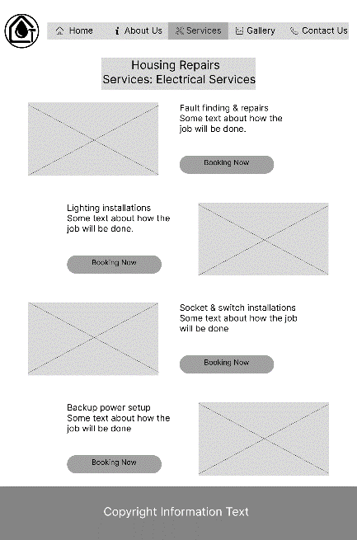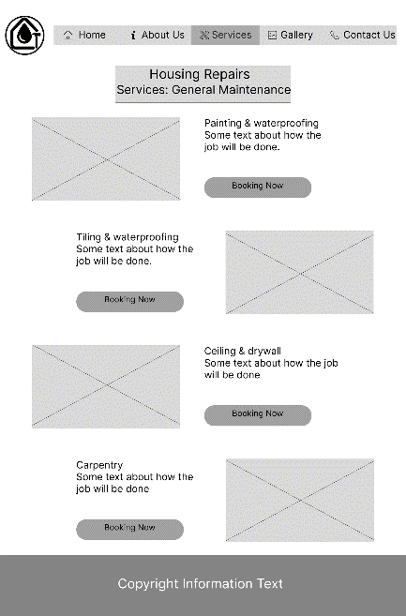

Services General Maintenance Page

About Us Page

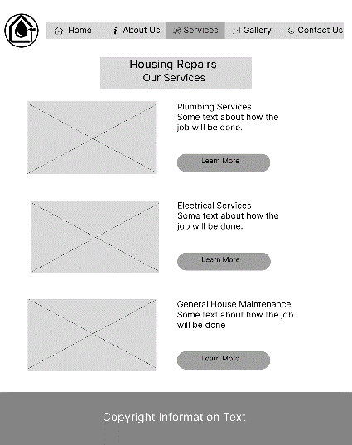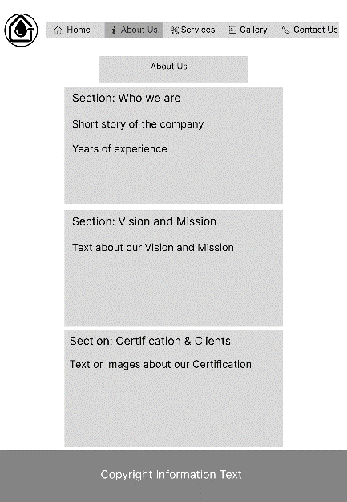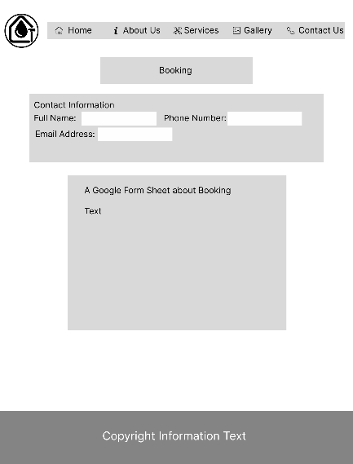

Services Page

## Technical Requirements

Domain Name: www.HousingRepairs.co.za

Programming Languages: HTML, CSS and JavaScript.(May add more depending how advance the website becomes).

## Timeline and Milestones

### Part 1 Gantt Chart

|  |  |  |  |  |  |  |  |  |  |  |  |  |  |  |  |  |  |  |  |  |  |  |
| --- | --- | --- | --- | --- | --- | --- | --- | --- | --- | --- | --- | --- | --- | --- | --- | --- | --- | --- | --- | --- | --- | --- |
| August | 6 | 7 | 8 | 9 | 10 | 11 | 12 | 13 | 14 | 15 | 16 | 17 | 18 | 19 | 20 | 21 | 22 | 23 | 24 | 25 | 26 | 27 |
| Task/Activities | W | T | F | S | S | M | T | W | T | F | S | S | M | T | W | T | F | S | S | M | T | W |
| Choosing a Target Organisation |  |  |  |  |  |  |  |  |  |  |  |  |  |  |  |  |  |  |  |  |  |  |
| Research and Planning |  |  |  |  |  |  |  |  |  |  |  |  |  |  |  |  |  |  |  |  |  |  |
| Organisation Overview |  |  |  |  |  |  |  |  |  |  |  |  |  |  |  |  |  |  |  |  |  |  |
| Website Goals and Objectives |  |  |  |  |  |  |  |  |  |  |  |  |  |  |  |  |  |  |  |  |  |  |
| Website Features and Functionality |  |  |  |  |  |  |  |  |  |  |  |  |  |  |  |  |  |  |  |  |  |  |
| Design and User Experience |  |  |  |  |  |  |  |  |  |  |  |  |  |  |  |  |  |  |  |  |  |  |
| Technical Requirements |  |  |  |  |  |  |  |  |  |  |  |  |  |  |  |  |  |  |  |  |  |  |
| Budget |  |  |  |  |  |  |  |  |  |  |  |  |  |  |  |  |  |  |  |  |  |  |
| Research and Sourcing |  |  |  |  |  |  |  |  |  |  |  |  |  |  |  |  |  |  |  |  |  |  |
| Website Structure and Planning |  |  |  |  |  |  |  |  |  |  |  |  |  |  |  |  |  |  |  |  |  |  |
| Sitemap |  |  |  |  |  |  |  |  |  |  |  |  |  |  |  |  |  |  |  |  |  |  |
| File and Folder Structure |  |  |  |  |  |  |  |  |  |  |  |  |  |  |  |  |  |  |  |  |  |  |
| HTML Structure |  |  |  |  |  |  |  |  |  |  |  |  |  |  |  |  |  |  |  |  |  |  |
| Content Integration |  |  |  |  |  |  |  |  |  |  |  |  |  |  |  |  |  |  |  |  |  |  |
| Navigation |  |  |  |  |  |  |  |  |  |  |  |  |  |  |  |  |  |  |  |  |  |  |
| Testing and debugging |  |  |  |  |  |  |  |  |  |  |  |  |  |  |  |  |  |  |  |  |  |  |
| Comments |  |  |  |  |  |  |  |  |  |  |  |  |  |  |  |  |  |  |  |  |  |  |
| GitHub Repository |  |  |  |  |  |  |  |  |  |  |  |  |  |  |  |  |  |  |  |  |  |  |
| Website Project Proposal |  |  |  |  |  |  |  |  |  |  |  |  |  |  |  |  |  |  |  |  |  |  |
| Content Research and Sourcing |  |  |  |  |  |  |  |  |  |  |  |  |  |  |  |  |  |  |  |  |  |  |
| HTML Files |  |  |  |  |  |  |  |  |  |  |  |  |  |  |  |  |  |  |  |  |  |  |
| GitHub Repository Link |  |  |  |  |  |  |  |  |  |  |  |  |  |  |  |  |  |  |  |  |  |  |

### Part 2 Gantt Chart

|  |  |  |  |  |  |  |  |  |  |  |  |  |  |  |  |  |  |  |  |  |  |  |
| --- | --- | --- | --- | --- | --- | --- | --- | --- | --- | --- | --- | --- | --- | --- | --- | --- | --- | --- | --- | --- | --- | --- |
| September | 9 | 10 | 11 | 12 | 13 | 14 | 15 | 16 | 17 | 18 | 19 | 20 | 21 | 22 | 23 | 24 | 25 | 26 | 27 | 28 | 29 | 30 |
| Task/Activities | W | T | F | S | S | M | T | W | T | F | S | S | M | T | W | T | F | S | S | M | T | W |
| Create an External Stylesheet |  |  |  |  |  |  |  |  |  |  |  |  |  |  |  |  |  |  |  |  |  |  |
| Establish a Base Style |  |  |  |  |  |  |  |  |  |  |  |  |  |  |  |  |  |  |  |  |  |  |
| Apply Typography Styles |  |  |  |  |  |  |  |  |  |  |  |  |  |  |  |  |  |  |  |  |  |  |
| Create a Layout Structure |  |  |  |  |  |  |  |  |  |  |  |  |  |  |  |  |  |  |  |  |  |  |
| Apply Visual Style |  |  |  |  |  |  |  |  |  |  |  |  |  |  |  |  |  |  |  |  |  |  |
| Breakpoints |  |  |  |  |  |  |  |  |  |  |  |  |  |  |  |  |  |  |  |  |  |  |
| Relative Units |  |  |  |  |  |  |  |  |  |  |  |  |  |  |  |  |  |  |  |  |  |  |
| Responsive Images |  |  |  |  |  |  |  |  |  |  |  |  |  |  |  |  |  |  |  |  |  |  |
| Test and iterate |  |  |  |  |  |  |  |  |  |  |  |  |  |  |  |  |  |  |  |  |  |  |
| GitHub Repository |  |  |  |  |  |  |  |  |  |  |  |  |  |  |  |  |  |  |  |  |  |  |

### Part 3 Gantt Chart

|  |  |  |  |  |  |  |  |  |  |  |  |  |  |  |  |  |  |  |  |  |  |  |
| --- | --- | --- | --- | --- | --- | --- | --- | --- | --- | --- | --- | --- | --- | --- | --- | --- | --- | --- | --- | --- | --- | --- |
| October | 1 | 2 | 3 | 4 | 5 | 6 | 7 | 8 | 9 | 10 | 11 | 12 | 13 | 14 | 15 | 16 | 17 | 18 | 19 | 20 | 21 | 22 |
| Task/Activities | W | T | F | S | S | M | T | W | T | F | S | S | M | T | W | T | F | S | S | M | T | W |
| Interactive Elements |  |  |  |  |  |  |  |  |  |  |  |  |  |  |  |  |  |  |  |  |  |  |
| Dynamic Content |  |  |  |  |  |  |  |  |  |  |  |  |  |  |  |  |  |  |  |  |  |  |
| On-Page SEO |  |  |  |  |  |  |  |  |  |  |  |  |  |  |  |  |  |  |  |  |  |  |
| Off-Page SEO |  |  |  |  |  |  |  |  |  |  |  |  |  |  |  |  |  |  |  |  |  |  |
| HTML Form |  |  |  |  |  |  |  |  |  |  |  |  |  |  |  |  |  |  |  |  |  |  |
| GitHub Repository |  |  |  |  |  |  |  |  |  |  |  |  |  |  |  |  |  |  |  |  |  |  |

## Budget

Housing Repairs is based on realistic cost for a small business found in South Africa. It will cover elements needed in the website development; this will include maintenance for a year.

|  |  |
| --- | --- |
| Items | Price (ZAR) |
| Domain Registration | R85 |
| Web Hosting | R500 |
| Web Design & Development | R5000 |
| Booking Form(Google Form) | R350 |
| SEO Setup | R300 |
| Gallery Images Taken | R450 |
| Maintenance of Website | R1500 |

## Content Research and Sourcing

Home Page

Hero shot and text: Housing Repairs – Plumbing, Electrical & Home Maintenance Services.

Services:

Plumbing: Leaks, burst pipes, drain unblocking.

Electrical: Lighting, sockets, backup power.

Maintenance: Painting, carpentry, tiling.

Images: 3 images that show the company at work.

About Us

Mission, Vision and Certifications

Services

Links to other 3 web site.

Plumbing, Electrical and Maintenance.

Gallery

3 Plumbing images

3 Electrical images

3 Maintenance images

Contact Us

Contact information about each office.

3 Embedded Google locations.

## Sitemap

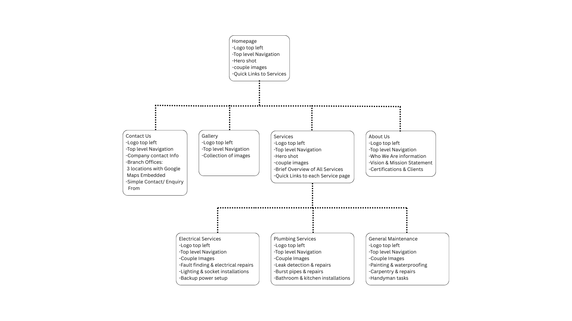

## GitHub Repository

# Proposal 2

Task A. Choose a Target Organization

Proposal 2: Cupcake Shop

Name: Too Sweet

Type of Business: Retail Store

Focus of the Business: Showing products, online orders available, gallery and customer review option.

Content to be on website: all information needs to provide to a customer and many types of products.

Task B. Research and Planning – Website Project Proposal Content

Organisation Overview

Name: Too Sweet

A brief history of the organisation

Too Sweet is a hypothetical company founded in 2022 to bring handcrafted cupcakes and many other types of dessert to South Africa. The brand is described to be joyful, colourful and welcoming. Their aim is to operate online and have a bigger target audience like for birthdays, corporate events, weddings and to achieve same-day local deliveries.

Mission Statement

To create moments of happiness and to spread quality delicious cakes made by people that love baking.

Vision Statement

We To be South Africa’s leading online cake and sweet boutique, known for creativity and customer-first digital experience.

Target Audience

• Parents planning events for their children

• People that are having Birthdays.

• Event Planners

• Social media people(Instagram)

• Maybe local cafes of small retailers interested in reselling baked goods

Website Goals and Objectives

Website Goals

• To enable online orders and combine it with making custom cupcakes request

• Showcase all products in high quality to appeal to social media

• Educate customers on what the business is provide to stop confusion

• Offer a user-friendly experience to show the quality of the product.

Website Objectives

• We want to get at least 25 orders every month

• Gain a lot of attention for the business.

• Providing detailed service pages to reduce the number of customers support queriers.

• Insure to we have consent traffic.

Key Performance Indicators (KPIs)

|  |  |
| --- | --- |
| Objectives | Key Performance Indicators |
| Drive online orders | The number of contacts from submissions per month has increased. |
| Build customer loyalty | The amount of happy customer reviews grow over time. |
| Improve customer engagement | Average session duration. |
| Building Trust with Customers | Number of Customers that choose to come back will increase. |
| Improved Search Presence | Traffic from Google(SEO performance) will increase. |

Proposed Website Features and Functionality

The Essential Features

• Homepage

• About Us

• Shop

• Custom Ordering Page

• Blog

• Gallery

• Customer Reviews

• Contact Page

• FAQ

• Booking a service Page

Functionality

• Google Form for Booking a Service

• Contact information Available

• Social Media Interaction

• Images of previous orders on display

Design and User Experience

Overall Design

The design will be more fun and colourful to seem warmth and delight. The site will encourage browsing and convert visitors into customers.

Colour Scheme

• Primary colour: Blush Pink

• Secondary Colour: Cream and Off-White

• Neutral Colour: Mint Green

Typography

• Headings: Playfair Display makes the theme of elegant.

• Body Text: Arial or Poppins this will allow for the text to be easy to read.

• A Hierarchy of Font sizes:

o H1: For Page titles

o H2: For Section titles

o Body: 14–16px, for paragraphs for readability.

Layout and Design

• A lot of creative designs in pink to yellow.

• Grid-based structure for galleries to display images of previous work.

• A navigation bar on the top for quick access to key sections.

• Google form for booking and getting a quote. This will be their own section

• Will be a about us page with all information.

• A contact us page with the FAQs too.

User Experience

A Clear navigation bar with easy and quick access to what the client may want. Fast loading times with quick image optimization. The client with quick navigation on subpages for easy backtracking and simple design that looks neat. Adding a theme of creativity and passion for every part of the website.

Wireframe

Homepage

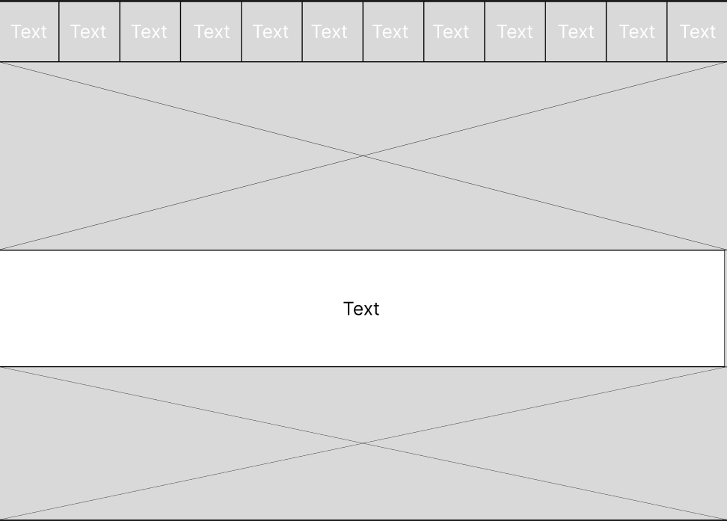

Technical Requirements

Domain Name: www.SweetTreats.co.za

Programming Languages: HTML, CSS and JavaScript.(May add more depending how advance the website becomes).

Hosting Provider: Xneelo

# References

GoDaddy, no date. *GoDaddy Philippines.* [Online]   
Available at: https://www.godaddy.com/en-ph  
[Accessed 6 August 2025].

Google Analytics, no date. *Analytics Provision.* [Online]   
Available at: https://analytics.google.com/analytics/web/provision/#/provision  
[Accessed 6 August 2025].

Unsplash, 2025. *Unsplash Photos.* [Online]   
Available at: https://unsplash.com/  
[Accessed 24 August 2025].

W3C, no date. *Web Content Accessibility Guidelines.* [Online]   
Available at: https://www.w3.org/WAI/standards-guidelines/wcag/  
[Accessed 6 August 2025].

WordPress.org, no date. *WordPress Showcaase.* [Online]   
Available at: https://wordpress.org/showcase/  
[Accessed 6 August 2025].

Xneelo, no date. *Xneelo — South Africa.* [Online]   
Available at: https://xneelo.co.za/  
[Accessed 6 August 2025].

# References for Proposal 2

GoDaddy, no date. *GoDaddy Philippines.* [Online]   
Available at: https://www.godaddy.com/en-ph  
[Accessed 6 August 2025].

Google Analytics, no date. *Analytics Provision.* [Online]   
Available at: https://analytics.google.com/analytics/web/provision/#/provision  
[Accessed 6 August 2025].

Google Fonts, no date. *Google Fonts.* [Online]   
Available at: https://fonts.google.com/  
[Accessed 6 August 2025].

W3C, no date. *Web Content Accessibility Guidelines.* [Online]   
Available at: https://www.w3.org/WAI/standards-guidelines/wcag/  
[Accessed 6 August 2025].

WordPress.org, no date. *WordPress Showcaase.* [Online]   
Available at: https://wordpress.org/showcase/  
[Accessed 6 August 2025].

Xneelo, no date. *Xneelo — South Africa.* [Online]   
Available at: https://xneelo.co.za/  
[Accessed 6 August 2025].