WEBSITE PROJECT PROPOSAL
Braamfontein Bake House
Subject: Web Development (WEDE5020)
Full Name: Roby
Student Number: ST10480499
Group: N/A
Academic Year: 2026

Table of Contents

1. Organisation Overview

1.1 Name
Braamfontein Bake House

1.2 Brief History
Braamfontein Bake House started in 2021 as a small home-based baking operation run by a single baker supplying cakes and pastries to friends and colleagues around Braamfontein, Johannesburg. Due to growing demand from students and professionals in the area, the business has since opened a small retail counter and now supplies a limited range of local coffee shops.

1.3 Mission and Vision Statements
- Mission: To bake and deliver fresh, handcrafted cakes, pastries, and bread for the Braamfontein community using quality, locally sourced ingredients.
- Vision: To become Braamfontein's favourite neighbourhood bakery, known for custom celebration cakes and a warm, welcoming online and in-store experience.

1.4 Target Audience
Students, young professionals, and residents in and around Braamfontein and the Johannesburg CBD who want fresh baked goods, as well as customers planning birthdays or events who need custom cakes.

2. Website Goals and Objectives

2.1 Specific Goals
- Showcase the daily and weekly product menu online.
- Allow customers to submit custom cake order requests through the website.
- Increase foot traffic to the physical shop by displaying location and opening hours prominently.
- Build an email/newsletter list for promotions and new product announcements.

2.2 Key Performance Indicators (KPIs)
Goal | Key Performance Indicator (KPI)
Increase online orders/enquiries | 20+ custom order enquiries per month via the contact form
Grow newsletter subscribers | 50+ sign-ups within the first 2 months
Drive foot traffic | Increase in-store customers referencing the website by 15%
Improve engagement | Average time on the menu page above 45 seconds

3. Current Website Analysis
Braamfontein Bake House currently relies solely on an Instagram page to display products, with no dedicated website, meaning potential customers searching on Google cannot easily find the business or its menu.

3.1 Strengths and Weaknesses
- Strength: Strong visual product photography already exists on Instagram.
- Strength: Loyal, growing local customer base near a busy student area.
- Weakness: No searchable website, so the business does not appear in Google search results.
- Weakness: No structured way to handle custom cake order requests other than direct messages.

3.2 Areas for Improvement
- Build a website with a clear, categorised menu so customers can browse products easily.
- Add a custom order form specifically for celebration cakes with date and flavour fields.
- Display the shop's address, map, and opening hours clearly on every page.

4. Proposed Website Features and Functionality
- Homepage with a warm hero image, featured products, and a call-to-action to view the menu.
- Menu/Products page organised by category (cakes, pastries, bread, drinks).
- Custom Orders page with a request form for celebration cakes.
- About/Gallery page sharing the bakery's story and photos of the shop and products.
- Contact page with address, embedded map, opening hours, and social media links.
- Consistent navigation bar and footer linking all pages of the site.

5. Design and User Experience

5.1 Colour Scheme
A warm palette of cream (#FFF8F0), blush pink (#F4C7C3), and chocolate brown (#4B2E2B) to evoke a cosy, handmade bakery feel, with a soft gold accent (#D4A24C) for highlights.

5.2 Typography
A friendly script or serif display font (Playfair Display) for headings to suggest craftsmanship, paired with a clean sans-serif (Lato) for body text to keep menus and descriptions easy to read.

5.3 Layout and Design Approach
A warm, image-led layout with a full-width hero image, a grid-based menu section for easy scanning, and a simplified footer, mobile-first so customers can browse the menu easily from their phones.

5.4 User Experience Considerations
- Large product images with clear pricing to reduce uncertainty before ordering.
- A simple, short custom order form to avoid discouraging enquiries.
- Clearly visible opening hours and location on every page for walk-in customers.

5.5 Low-Fidelity Wireframe
Figure 1 below shows the low-fidelity wireframe layout used to plan the information hierarchy of the homepage before development begins.
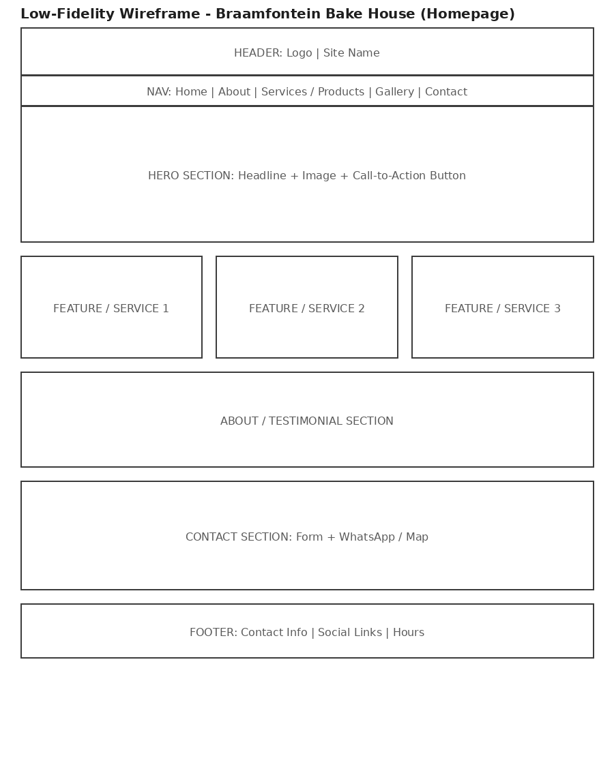
Figure 1: Homepage wireframe - Braamfontein Bake House

6. Technical Requirements

6.1 Hosting and Domain
The site will use a domain such as www.braamfonteinbakehouse.co.za, registered through a local registrar, and will be hosted for free during development using GitHub Pages.

6.2 Programming Languages and Frameworks
- HTML5 - semantic page structure (Part 1)
- CSS3 - styling, responsive layout with Flexbox/Grid (Part 2)
- JavaScript (vanilla) - interactivity, form validation, embedded services (Part 3)

7. Timeline and Milestones
Goal | Key Performance Indicator (KPI)
Part 1 - Planning & HTML structure | Due 14 August 2026
Part 2 - CSS styling & responsive design | To be confirmed per module timetable
Part 3 - JavaScript functionality & SEO | To be confirmed per module timetable

8. Budget
Goal | Key Performance Indicator (KPI)
Domain registration (.co.za) | R150 - R200 per year
Hosting (GitHub Pages) | R0 (free tier)
Product photography | R0 (existing Instagram photos to be reused with permission)
Development time (student project) | No direct cost - academic assignment
Estimated total (Year 1) | Approximately R150 - R200

9. References
Unsplash (2026) Free stock photos. Available at: https://unsplash.com (Accessed: 9 August 2026).
Google Fonts (2026) Playfair Display & Lato. Available at: https://fonts.google.com (Accessed: 9 August 2026).
Mozilla Developer Network (2026) CSS: Cascading Style Sheets. Available at: https://developer.mozilla.org/en-US/docs/Web/CSS (Accessed: 9 August 2026).

