WEBSITE PROJECT PROPOSAL
Sparks & Bolt Electrical Services
Subject: Web Development (WEDE5020)
Full Name: Roby
Student Number: ST10480499
Group: 15
Academic Year: 2026

Table of Contents
Table of Contents 1
1. Organisation Overview 1
1.1 Name 1
1.2 Brief History 1
1.3 Mission and Vision Statements 1
1.4 Target Audience 1
2. Website Goals and Objectives 1
2.1 Specific Goals 1
2.2 Key Performance Indicators (KPIs) 1
3. Current Website Analysis 1
3.1 Strengths and Weaknesses 1
3.2 Areas for Improvement 1
4. Proposed Website Features and Functionality 1
5. Design and User Experience 1
5.1 Colour Scheme 1
5.2 Typography 1
5.3 Layout and Design Approach 1
5.4 User Experience Considerations 1
5.5 Low-Fidelity Wireframe 1
6. Technical Requirements 1
6.1 Hosting and Domain 1
6.2 Programming Languages and Frameworks 1
7. Timeline and Milestones 1
8. Budget 1
9. References 1

1. Organisation Overview

1.1 Name
Sparks & Bolt Electrical Services

1.2 Brief History
We're a small family-run electrical outfit based in Joburg. Started back in 2015 when our founder, a qualified electrician, decided to go solo—he was doing mostly residential work around the CBD and Braamfontein to begin with. Since then we've taken on a few commercial clients, but honestly, we've never lost that down-to-earth, get-our-hands-dirty way of working. We've never had a website, not once. All our work has come from people talking, plus a bit of help from our local Facebook page, and that's how we've built a proper loyal bunch of customers over the years.

1.3 Mission and Vision Statements
Our mission is straightforward: do safe, solid work at a reasonable price, whether it's installing something new, fixing a problem, or doing a compliance check. Vision-wise, we'd love to be the sparkies everyone in Joburg thinks of first—the ones who pitch up on time, take safety seriously, and don't slip in extra charges you weren't expecting.

1.4 Target Audience
We deal mostly with homeowners, landlords, property managers, and small business owners around Johannesburg, usually aged between 25 and 55. These are the people who suddenly need a new circuit, a plug that's stopped working, or a COC because they're selling their place. They tend to either Google for help or ask a friend for a name, especially if it's an emergency and they need someone quickly.

2. Website Goals and Objectives

2.1 Specific Goals
With our new site, we've got four things we really want to nail. First off, we need to come across as professional and trustworthy so new clients actually pick up the phone. Next, we want a dead-simple quote request form and a WhatsApp button—because nobody likes jumping through hoops just to ask for a price. We also plan to put up photos of jobs we've done and let our past customers speak for us with genuine reviews. And lastly, we'll list everything we offer, from emergency callouts to COC certificates, so people know exactly what we can help with, no guesswork.

2.2 Key Performance Indicators (KPIs)
Goal | Key Performance Indicator (KPI)
Increase website traffic | 300+ unique visitors per month within 3 months of launch
Generate leads | 15+ quote requests submitted through the contact form per month
Build trust | 5+ visible customer testimonials displayed on the site
Improve response time perception | Average bounce rate below 50% and average session over 1 minute

3. Current Website Analysis
Sparks & Bolt does not currently have a website. The business maintains a Facebook page, but it is updated infrequently and does not appear prominently in local search results for electrical services.
3.1 Strengths and Weaknesses
A clear strength is the established base of loyal customers, built over years of referral-based work. The business also enjoys a solid reputation for reliability within the local community. On the other hand, the lack of a searchable online presence makes it difficult for potential new customers to discover the business. Additionally, there is no formal system for customers to request a quote other than making a phone call.
3.2 Areas for Improvement
The priority is to create a dedicated, mobile-friendly website that ranks well in local search results. An online quote request form and a WhatsApp click-to-chat link should be added to enable fast communication. It would also be beneficial to display a gallery of completed projects and customer testimonials to build trust with prospective clients.
4. Proposed Website Features and Functionality
The proposed website will include a homepage featuring a hero banner, a concise overview of key services, and a prominent call-to-action button. An About Us page will cover the company’s history, qualifications, and approach to safety compliance. A Services page will list electrical installations, repairs, COC certification, and emergency callouts. A Gallery page will showcase photos of completed work, and a Contact page will offer a quote request form, a WhatsApp link, an embedded Google Map, and business hours. A consistent navigation bar and footer will appear across all pages to maintain a cohesive user experience.
5. Design and User Experience
5.1 Colour Scheme
Navy blue (#1F3864) will serve as the primary colour to convey trust and professionalism, with amber/yellow (#F2A900) used as an accent to suggest energy and electricity. The background will remain white or light grey to ensure readability.
5.2 Typography
Headings will use Montserrat, a bold modern sans-serif, for visual impact, while body text will be set in Open Sans, a highly legible sans-serif suitable for all age groups, including older homeowners.
5.3 Layout and Design Approach
The layout will follow a clean, mobile-first, single-column structure, with a fixed top navigation bar, a full-width hero section, three columns for service highlights, and a simplified footer. This approach ensures easy scanning on both mobile and desktop devices.
5.4 User Experience Considerations
Buttons will be large enough for easy tapping on mobile devices. A clear visual hierarchy will place the most critical information—services and contact details—near the top to minimise scrolling. High colour contrast between text and background will support readability and accessibility for all users.
5.5 Low-Fidelity Wireframe
Figure 1 below presents the low-fidelity wireframe that was developed to plan the information hierarchy of the homepage prior to the development phase.
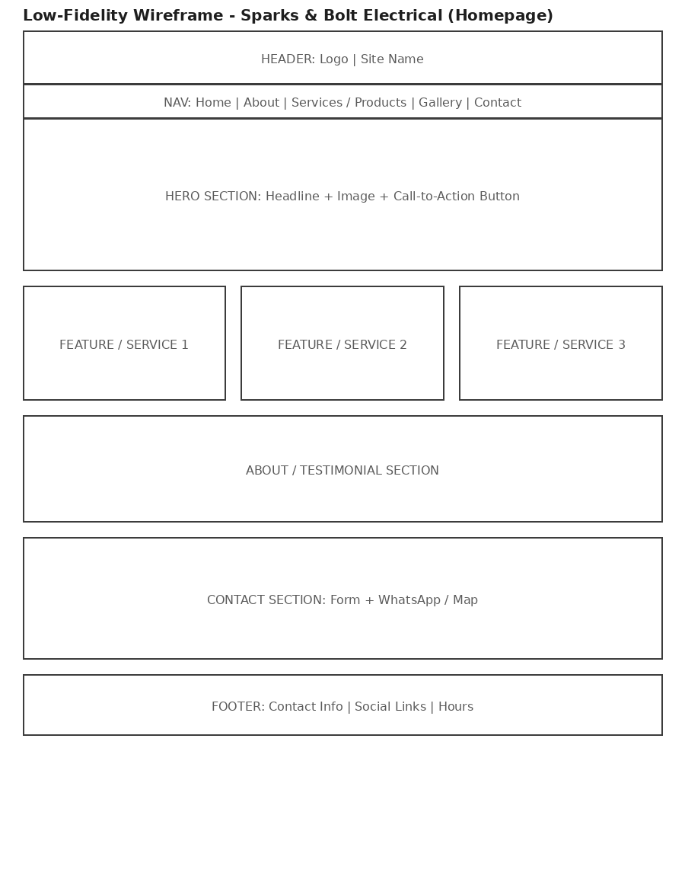
Figure 1: Homepage wireframe - Sparks & Bolt Electrical Services

6. Technical Requirements

6.1 Hosting and Domain
The business will register a South African-relevant domain – www.sparksandbolt.co.za – through a local registrar. During development, the site will be hosted on GitHub Pages at no cost, giving us a practical environment to test and refine everything before launch. Once we're satisfied and ready to go live, we'll move to an affordable local hosting provider that's better equipped for regular daily operation.

6.2 Programming Languages and Frameworks
Standard web technologies will be used throughout the building. HTML5 will deliver the semantic structure for each page, providing a clean foundation. CSS3 will manage styling and responsive layout, with Flexbox and Grid ensuring the site adapts properly across all devices. For interactive features, form validation, and embedded services, we'll use vanilla JavaScript – keeping the code lightweight and avoiding any unnecessary external libraries.

7. Timeline and Milestones
We'll roll the project out in phases over several weeks. Week one is dedicated to building the basic structure – the HTML framework and core content pages. Week two moves into styling and responsive design, ensuring the site works well on phones and desktops alike. Week three introduces JavaScript functionality, including the quote form and any interactive components. The final week is set aside for testing, final adjustments, and preparation for launch, with a few extra days built in to handle anything unexpected that comes up.

Goal | Key Performance Indicator (KPI)
Part 1 - Planning & HTML structure | Due 14 August 2026
Part 2 - CSS styling & responsive design | To be confirmed per module timetable
Part 3 - JavaScript functionality & SEO | To be confirmed per module timetable

8. Budget
Goal | Key Performance Indicator (KPI)
Domain registration (.co.za) | R150 - R200 per year
Hosting (GitHub Pages) | R0 (free tier, sufficient for a small business site)
Stock images (Unsplash/Pexels) | R0 (free, properly licensed)
Development time (student project) | No direct cost - academic assignment
Estimated total (Year 1) | Approximately R150 - R200

9. References
Unsplash (2026) Free stock photos. Available at: https://unsplash.com (Accessed: 9 August 2026).
Pexels (2026) Free stock photos & videos. Available at: https://www.pexels.com (Accessed: 9 August 2026).
Department of Employment and Labour (2026) Electrical Installation Regulations and Certificate of Compliance requirements. Available at: https://www.labour.gov.za (Accessed: 9 August 2026).
Mozilla Developer Network (2026) HTML: HyperText Markup Language. Available at: https://developer.mozilla.org/en-US/docs/Web/HTML (Accessed: 9 August 2026).

