WEBSITE PROJECT PROPOSAL
Braamfontein Bake House
Subject: Web Development (WEDE5020)
Full Name: Roby
Student Number: ST10480499
Group: 15
Academic Year: 2026

Table of Contents
Table of Contents 1
1. Organisation Overview 1
1.1 Name 1
1.2 Brief History 1
1.3 Mission and Vision Statements 1
1.4 Target Audience 1
2. Website Goals and Objectives 1
2.1 Specific Goals 1
2.2 Key Performance Indicators (KPIs) 1
3. Current Website Analysis 1
3.1 Strengths and Weaknesses 1
3.2 Areas for Improvement 1
4. Proposed Website Features and Functionality 1
5. Design and User Experience 1
5.1 Colour Scheme 1
5.2 Typography 1
5.3 Layout and Design Approach 1
5.4 User Experience Considerations 1
5.5 Low-Fidelity Wireframe 1
6. Technical Requirements 1
6.1 Hosting and Domain 1
6.2 Programming Languages and Frameworks 1
7. Timeline and Milestones 1
8. Budget 1
9. References 1

1. Organisation Overview

1.1 Name
Braamfontein Bake House

1.2 Brief History
Braamfontein Bake House began in 2021 as a single-person home-baking operation, providing cakes and pastries to friends and colleagues around Braamfontein. As word spread and demand grew—particularly from students and professionals in the area—we opened a small retail counter and now also supply a limited selection of local coffee shops.

1.3 Mission and Vision Statements
Our purpose is to bake and deliver fresh, handmade cakes, pastries, and bread for the Braamfontein community, using quality locally sourced ingredients. We intend to become the neighborhood’s favorite bakery, known for custom celebration cakes and a warm experience whether you're ordering online or stepping into the shop.

1.4 Target Audience
We work with students, young professionals, and residents in and around Braamfontein and the Johannesburg CBD who are after fresh baked goods. We also take orders from customers planning birthdays or events who require a custom cake tailored to their preferences.

2. Website Goals and Objectives

2.1 Specific Goals
The website has four core objectives. First, we want to feature our daily and weekly product menu so customers can see what's on offer. Second, we need an easy-to-use online form for custom cake order submissions. Third, we aim to drive foot traffic to the shop by displaying our location and opening hours clearly. Fourth, we plan to grow an email list for sharing promotions and announcing new products.

2.2 Key Performance Indicators (KPIs)
Goal | Key Performance Indicator (KPI)
Increase online orders/enquiries | 20+ custom order enquiries per month via the contact form
Grow newsletter subscribers | 50+ sign-ups within the first 2 months
Drive foot traffic | Increase in-store customers referencing the website by 15%
Improve engagement | Average time on the menu page above 45 seconds

3. Current Website Analysis
Braamfontein Bake House operates without a website, relying purely on Instagram to display its products. This means that customers using Google to find the business are unable to locate it easily or view the menu in an organised, browsable format.
3.1 Strengths and Weaknesses
The business has strong product photography on Instagram and a loyal, expanding local customer base near a busy student area. Those are definite advantages. However, the absence of a searchable website means the business does not appear in Google search results. There is also no structured way to handle custom cake orders – everything comes through direct messages, which can become unmanageable.
3.2 Areas for Improvement
A website needs to be built with a clear, categorised menu that allows customers to browse without difficulty. A custom order form for celebration cakes, including fields for date and flavour preferences, should also be added. The shop's address, map, and opening hours must be displayed clearly on every page rather than tucked away.
4. Proposed Website Features and Functionality
The site will include a homepage with a warm hero image, featured products, and a call-to-action encouraging visitors to view the menu. A Menu/Products page will organise offerings by category – cakes, pastries, bread, and drinks. A Custom Orders page will feature a request form for celebration cakes. An About/Gallery page will share the bakery's story and include photos of the shop and products. A Contact page will display the address, embedded map, opening hours, and social media links. Consistent navigation and a footer will appear on every page.
5. Design and User Experience
5.1 Colour Scheme
A warm palette of cream (#FFF8F0), blush pink (#F4C7C3), and chocolate brown (#4B2E2B) will create a cosy, handmade bakery atmosphere, with a soft gold accent (#D4A24C) used for highlights.
5.2 Typography
Headings will be set in Playfair Display, a script-inspired serif that suggests craftsmanship, while body text will use Lato, a clean sans-serif that keeps menus and descriptions easy to read.
5.3 Layout and Design Approach
An image-led layout with a full-width hero image, a grid-based menu section for easy scanning, and a simplified footer will be used. The design will be mobile-first, enabling customers to browse the menu comfortably on their phones.
5.4 User Experience Considerations
Large product images with clear pricing will reduce uncertainty before ordering. A short, simple custom order form will prevent discouraging potential customers from enquiring. Opening hours and location will be clearly visible on every page to accommodate walk-in customers.
5.5 Low-Fidelity Wireframe
Figure 1 below shows the low-fidelity wireframe layout used to plan the information hierarchy of the homepage prior to development.

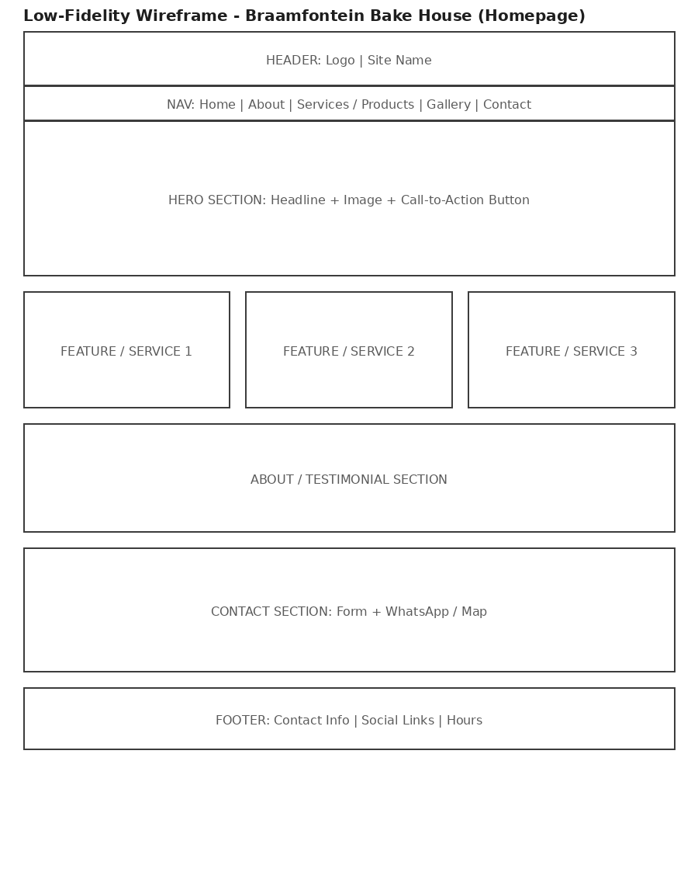
Figure 1: Homepage wireframe - Braamfontein Bake House

6. Technical Requirements

6.1 Hosting and Domain
The site will use a domain such as www.braamfonteinbakehouse.co.za, registered through a local registrar, and will be hosted for free during development using GitHub Pages.

6.2 Programming Languages and Frameworks
- HTML5 - semantic page structure (Part 1)
- CSS3 - styling, responsive layout with Flexbox/Grid (Part 2)
- JavaScript (vanilla) - interactivity, form validation, embedded services (Part 3)

7. Timeline and Milestones
Goal | Key Performance Indicator (KPI)
Part 1 - Planning & HTML structure | Due 14 August 2026
Part 2 - CSS styling & responsive design | To be confirmed per module timetable
Part 3 - JavaScript functionality & SEO | To be confirmed per module timetable

8. Budget
Goal | Key Performance Indicator (KPI)
Domain registration (.co.za) | R150 - R200 per year
Hosting (GitHub Pages) | R0 (free tier)
Product photography | R0 (existing Instagram photos to be reused with permission)
Development time (student project) | No direct cost - academic assignment
Estimated total (Year 1) | Approximately R150 - R200

9. References
Unsplash (2026) Free stock photos. Available at: https://unsplash.com (Accessed: 9 August 2026).
Google Fonts (2026) Playfair Display & Lato. Available at: https://fonts.google.com (Accessed: 9 August 2026).
Mozilla Developer Network (2026) CSS: Cascading Style Sheets. Available at: https://developer.mozilla.org/en-US/docs/Web/CSS (Accessed: 9 August 2026).

