WEBSITE PROJECT PROPOSAL
Sparks & Bolt Electrical Services
Subject: Web Development (WEDE5020)
Full Name: Roby
Student Number: ST10480499
Group: N/A
Academic Year: 2026

Table of Contents

1. Organisation Overview

1.1 Name
Sparks & Bolt Electrical Services

1.2 Brief History
Sparks & Bolt Electrical Services is a small, family-run electrical contracting business based in Johannesburg, South Africa. Founded in 2015 by a qualified electrician, the business began by servicing residential clients in the Johannesburg CBD and Braamfontein area before expanding to include small commercial clients. The business has built its reputation entirely through word-of-mouth referrals and a local Facebook page, and has never had a dedicated website.

1.3 Mission and Vision Statements
- Mission: To provide safe, reliable, and affordable electrical installation, repair, and compliance services to homes and small businesses across Johannesburg.
- Vision: To become the most trusted electrical service provider in the greater Johannesburg area, known for punctuality, safety compliance, and honest pricing.

1.4 Target Audience
Homeowners, landlords, property managers, and small business owners in Johannesburg who need electrical installations, repairs, or Certificates of Compliance (COC), typically aged 25-55, who search online or ask for referrals when they have an urgent or planned electrical need.

2. Website Goals and Objectives

2.1 Specific Goals
- Establish a professional online presence to build trust with new customers.
- Generate qualified leads through an online quote request form and click-to-WhatsApp button.
- Showcase completed projects and customer testimonials to demonstrate quality of work.
- Provide clear information on services offered, including emergency callouts and COC certification.

2.2 Key Performance Indicators (KPIs)
Goal | Key Performance Indicator (KPI)
Increase website traffic | 300+ unique visitors per month within 3 months of launch
Generate leads | 15+ quote requests submitted through the contact form per month
Build trust | 5+ visible customer testimonials displayed on the site
Improve response time perception | Average bounce rate below 50% and average session over 1 minute

3. Current Website Analysis
Sparks & Bolt currently has no website. Their only online presence is a Facebook business page that is updated infrequently and does not rank well in local search results.

3.1 Strengths and Weaknesses
- Strength: Existing loyal customer base from years of referral-based work.
- Strength: Strong reputation for reliability within the local community.
- Weakness: No searchable online presence, making it hard for new customers to find the business.
- Weakness: No formal way for customers to request a quote outside of phone calls.

3.2 Areas for Improvement
- Create a dedicated, mobile-friendly website that appears in local search results.
- Add an online quote request form and a WhatsApp click-to-chat link for fast communication.
- Display a gallery of completed jobs and customer testimonials to build trust.

4. Proposed Website Features and Functionality
- Homepage with hero banner, key services overview, and call-to-action button.
- About Us page detailing company history, qualifications, and safety compliance.
- Services page listing electrical installations, repairs, COC certificates, and emergency callouts.
- Gallery page showcasing photos of completed projects.
- Contact page with a quote request form, WhatsApp link, embedded Google Map, and business hours.
- Consistent navigation bar and footer across all pages linking every section of the site.

5. Design and User Experience

5.1 Colour Scheme
Navy blue (#1F3864) as the primary colour to convey trust and professionalism, paired with an amber/yellow accent (#F2A900) to represent electricity and energy, on a white/light-grey background for readability.

5.2 Typography
Headings in a bold, modern sans-serif (Montserrat) for impact, with body text in a highly readable sans-serif (Open Sans) to ensure clarity for all age groups, including older homeowners.

5.3 Layout and Design Approach
A clean, single-column, mobile-first layout with a fixed top navigation bar, a full-width hero section, three-column service highlights, and a simplified footer, ensuring the site is easy to scan on both mobile and desktop devices.

5.4 User Experience Considerations
- Large, easily tappable buttons for mobile users calling or messaging on the go.
- Clear visual hierarchy so the most important information (services and contact details) is visible without scrolling extensively.
- High colour contrast between text and background to support readability and accessibility.

5.5 Low-Fidelity Wireframe
Figure 1 below shows the low-fidelity wireframe layout used to plan the information hierarchy of the homepage before development begins.
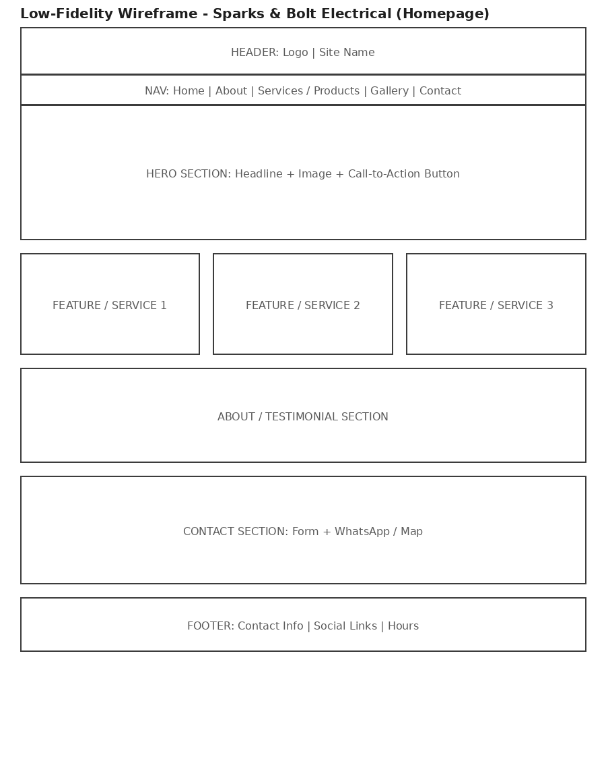
Figure 1: Homepage wireframe - Sparks & Bolt Electrical Services

6. Technical Requirements

6.1 Hosting and Domain
The site will use a South African-relevant domain such as www.sparksandbolt.co.za, registered through a local registrar. It will be hosted for free during development using GitHub Pages, with the option to migrate to affordable local hosting for production use.

6.2 Programming Languages and Frameworks
- HTML5 - semantic page structure (Part 1)
- CSS3 - styling, responsive layout with Flexbox/Grid (Part 2)
- JavaScript (vanilla) - interactivity, form validation, embedded services (Part 3)

7. Timeline and Milestones
Goal | Key Performance Indicator (KPI)
Part 1 - Planning & HTML structure | Due 14 August 2026
Part 2 - CSS styling & responsive design | To be confirmed per module timetable
Part 3 - JavaScript functionality & SEO | To be confirmed per module timetable

8. Budget
Goal | Key Performance Indicator (KPI)
Domain registration (.co.za) | R150 - R200 per year
Hosting (GitHub Pages) | R0 (free tier, sufficient for a small business site)
Stock images (Unsplash/Pexels) | R0 (free, properly licensed)
Development time (student project) | No direct cost - academic assignment
Estimated total (Year 1) | Approximately R150 - R200

9. References
Unsplash (2026) Free stock photos. Available at: https://unsplash.com (Accessed: 9 August 2026).
Pexels (2026) Free stock photos & videos. Available at: https://www.pexels.com (Accessed: 9 August 2026).
Department of Employment and Labour (2026) Electrical Installation Regulations and Certificate of Compliance requirements. Available at: https://www.labour.gov.za (Accessed: 9 August 2026).
Mozilla Developer Network (2026) HTML: HyperText Markup Language. Available at: https://developer.mozilla.org/en-US/docs/Web/HTML (Accessed: 9 August 2026).

