**Student Full Name:**  Tumelo Masinga

**Student ID:** ST10483018

**Module Code:** WEDE5020

**Assessment Type:** POE Part 1

**Group:** 2

Table of Contents

Target Organization 1 3

Organization Overview: 4

History 4

Mission 4

Vision 4

Target Audience: 4

Website goals and objectives 4

Current website analysis 5

Proposed website features and functionality 5

Design and user experience 6

Low Fidelity Wireframes: 6

Technical requirements 7

Timeline and milestones 7

Budget 7

Target Organization 2 8

Organization Overview: 9

History 9

Mission 9

Vision 9

Target Audience: 9

Website goals and objectives 9

Proposed website features and functionality 10

Design and user experience 10

Low Fidelity Wireframes: 11

Technical requirements 11

Timeline and milestones 12

Budget 12

Bibliography 13

# Target Organization 1

**Enrichium**

## Organization Overview:

Name: Enrichium

### History

Enrichium is a dynamic South African company specializing in remodeling and renovation. Founded in 2015, the organization has grown to provide a turnkey operation for the altered or new residential build to clients across South Africa. (Enrichium, n.d.)

### Mission

"To empower businesses through innovative digital solutions that drive growth and efficiency." (Enrichium, n.d.)

### Vision

"To be a leading digital transformation partner in Africa, enabling sustainable success for our clients." (Enrichium, n.d.)

### Target Audience:

* Small to medium enterprises (SMEs)
* Corporate clients in manufacturing
* Individual Residential home’s

## Website goals and objectives

* **Goal 1: Increase Brand Awareness and Website Traffic**
  + **Objective 1:** Implement a blog and publish at least two high-quality articles per month, optimized with relevant keywords to improve organic search rankings.
  + **Objective 2:** Make sure every page of the website is on-page SEO optimized, which includes using clear headings, creating descriptive meta titles and descriptions, and giving images alt-text.
  + **Objective 3:** Actively promote website content and services across social media platforms (e.g., Facebook, LinkedIn, Instagram) by posting at least three times a week to drive referral traffic.
* **Goal 2: Generate and Qualify High-Quality Leads**
  + **Objective 1:** Put a prominent button that reads "Contact Us" or "Request a Quote" on each of the website's important pages.
  + **Objective 2:** Create a useful downloadable resource that people may obtain by entering their email address, such a whitepaper or an industry checklist, to expand your contact list.

Key Performance Indicators (KPIs)

* Traffic & Awareness:
  + Total Website Visitors: The quantity of distinct visitors to your website.
  + Growth in Organic Traffic: The proportion of more visitors that come from search engines like Google.
* Lead Generation:
  + **Number of Form Submissions:** The total number of completed inquiry, quote, or contact forms.
  + **Cost Per Lead:** The typical price of obtaining a new lead, particularly when paid promotion is being used.
* Engagement:
  + **Average Session Duration:** The average amount of time a user spends on your site.
  + **Returning Visitors:** The percentage of visitors who return to your site after their first visit.

## Current website analysis

|  |  |  |
| --- | --- | --- |
| **Aspect** | **Strengths** | **Weaknesses** |
| **Design** | Clean, professional layout | Outdated colour scheme |
| **Navigation** | Easy-to-use menu | Delayed load times on mobile |
| **Content** | Informative service descriptions | Lack of blog/SEO optimization |

**Areas for Improvement:**

* Mobile responsiveness optimization.
* Integration of a blog for SEO.
* Modern UI/UX redesign.

## Proposed website features and functionality

**Essential Pages:**

* Home.html
* About.html
* Services.html
* Blog.html
* Contact.html

**Desired Functionality:**

* Live chat support
* Newsletter subscription
* Mobile-responsive design

## Design and user experience

**Font size:**

* Headings: 88.4px
* Body: 20.2px

**Color scheme:** Primary: Grey, Black, White.

**Typography:**

* Headings **–** TT Commons Pro(Regular)
* Body Text **-** Open Sans (Regular).

**Hierarchy:** project names in TT Commons Pro (Regular), description Open Sans (Regular), Quotes in italic lora.

**Layout and Design**: Minimalist and professional.

**User experience considerations:**

* Intuitive navigation
* Fast load times
* Clear call-to-action buttons

### Low Fidelity Wireframes:

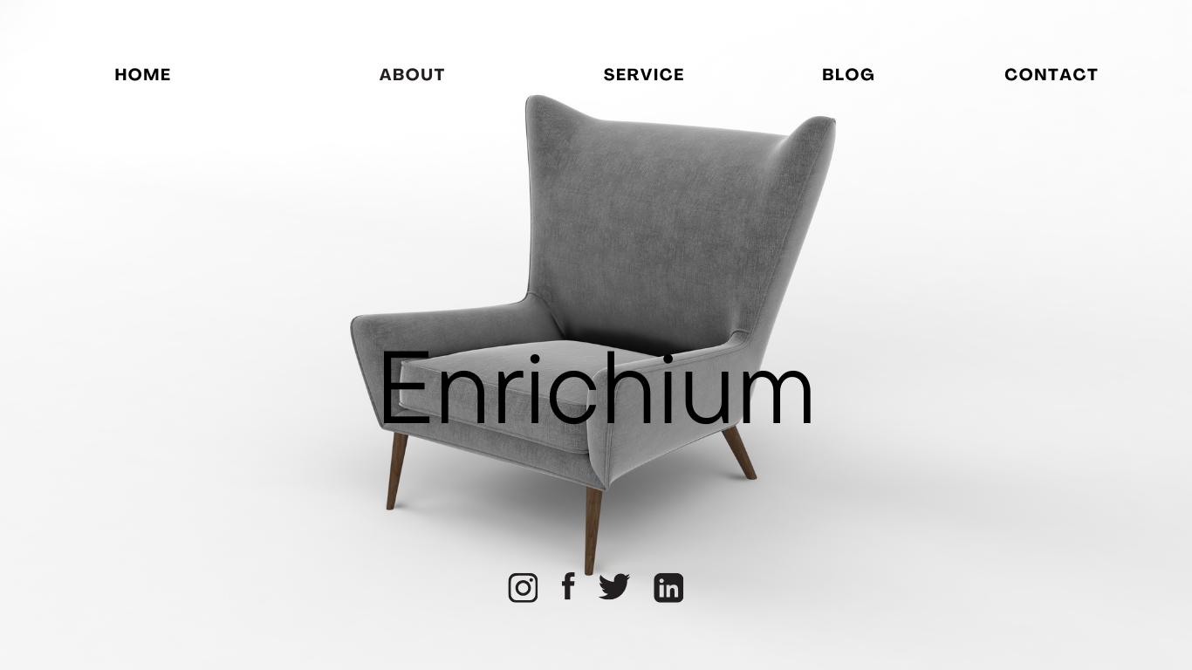

(canva, 2025)

## Technical requirements

Doman name: enrichium.co.za

Hosting: Afrihost

Programming language: CSS, HTML, JavaScript

## Timeline and milestones

|  |  |  |  |
| --- | --- | --- | --- |
| Task | Start Date | End Date | Duration (Days) |
| Week 1: Planning & Research | Aug 7 | Aug 11 | 5 |
| 1. Examine Social Account | Aug 7 | Aug 7 | 1 |
| 2. Establish Objectives | Aug 8 | Aug 8 | 1 |
| 3. Complete Branding & Style Guide | Aug 9 | Aug 9 | 1 |
| 4. Draft Low-Fidelity Wireframes | Aug 10 | Aug 11 | 2 |
| Milestone 1 | Aug 11 | Aug 11 | 0 |
| Week 2: Design & Content | Aug 12 | Aug 18 | 7 |
| 5. Design Website Grid Layout | Aug 12 | Aug 13 | 2 |
| 6. Create Story Highlight Covers | Aug 14 | Aug 14 | 1 |
| 7. Source & Create Graphics | Aug 15 | Aug 17 | 3 |
| Milestone 2 | Aug 18 | Aug 18 | 0 |
| Week 3: Testing & Launch | Aug 19 | Aug 25 | 7 |
| 8. Test Designs & Gather Feedback | Aug 19 | Aug 19 | 1 |
| 9. Make Revisions | Aug 20 | Aug 21 | 2 |
| 10. Final QA | Aug 22 | Aug 23 | 2 |
| 11. Schedule Content & Launch | Aug 24 | Aug 25 | 2 |
| Final Submission Prep | Aug 25 | Aug 26 | 2 |

## Budget

* Website Visual Design: R5,000
* Content Creation and Sourcing: R1500
* Image Sourcing: R500
* Ongoing & Operational Costs (Recurring): R99 per month (Afrihost, n.d.)
* Hosting on a Web Server: R99 per month (Afrihost, n.d.)
* Website Maintenance: R4500

# Target Organization 2

Linthinkdesign

## Organization Overview:

Name: Linthinkdesign (linthinkdesign, n.d.)

### History

The company is one the renovate and interior designs houses and outside of the house it is run by an individual that is looking at improving the space of the clients inside and outside. They have been active since 2020 and its run buy Lindelani Tsanwani who is educated in Interior Design but with the knowledge of Safety Management and Human Resource Development. (Mukandila, 2024)

### Mission

To reimagine a space and turn it into something new more appeasing to people. The owner was looking at different business ventures that can be great for him and by him getting retrenched it pushed him into the field. (lin_thinkdesign, n.d.)

### Vision

Create a turnkey space that can better uplift the environment of the client and be enjoy being more creative in new spaces.

### Target Audience:

New or old homeowners and restaurants.

## Website goals and objectives

* **Goal 1: Increase Brand Awareness and Website Traffic**
  + **Objective 1:** Implement a blog and publish at least two high-quality articles per month, optimized with relevant keywords to improve organic search rankings.
  + **Objective 2:** Make sure every page of the website is on-page SEO optimized, which includes using clear headings, creating descriptive meta titles and descriptions, and giving images alt-text.
  + **Objective 3:** Actively promote website content and services across social media platforms (e.g., Facebook, LinkedIn, Instagram) by posting at least three times a week to drive referral traffic.
* **Goal 2: Generate and Qualify High-Quality Leads**
  + **Objective 1:** Put a prominent button that reads "Contact Us" or "Request a Quote" on each of the website's important pages.
  + **Objective 2:** Create a useful downloadable resource that people may obtain by entering their email address, such a whitepaper or an industry checklist, to expand your contact list.

Key Performance Indicators (KPIs)

* Traffic & Awareness:
  + Total Website Visitors: The quantity of distinct visitors to your website.
  + Growth in Organic Traffic: The proportion of more visitors that come from search engines like Google.
* Lead Generation:
  + **Number of Form Submissions:** The total number of completed inquiry, quote, or contact forms.
  + **Cost Per Lead:** The typical price of obtaining a new lead, particularly when paid promotion is being used.
* Engagement:
  + **Average Session Duration:** The average amount of time a user spends on your site.
  + **Returning Visitors:** The percentage of visitors who return to your site after their first visit.

## Proposed website features and functionality

Home.html

About.html

Service.html

Quote.html

Gallery.html

Contact.html

Embed the social pages for the company in gallery

Google Map Embedded in contact page

Google form for inquiring for a quote or showing interest for potential redesign embedded in contact us page and on the service page.

## Design and user experience

Font type:

* headers: font size: 53.9px
* body: font size: 20.2px

Color scheme: Light grayish orange and black

Typography:

* headings – comic sans MS, Regular,
* body- Agrandir, Regular

**Hierarchy:** project names in comic sans MS, description Agrandir, Quotes in italic lora.

**Layout and Design:**

* Grid Consistency: Make sure to balance text and graphics by using a three- column grid for postings.
* White Space: To improve readability, put more padding around captions.
* Highlights of the Story: Personalized icons for simple navigation (such as sketch, portfolio, and process).

**User experience considerations:**

* Navigation: linktree in Home page for contact
* Live videos showing what before and after.

### Low Fidelity Wireframes:

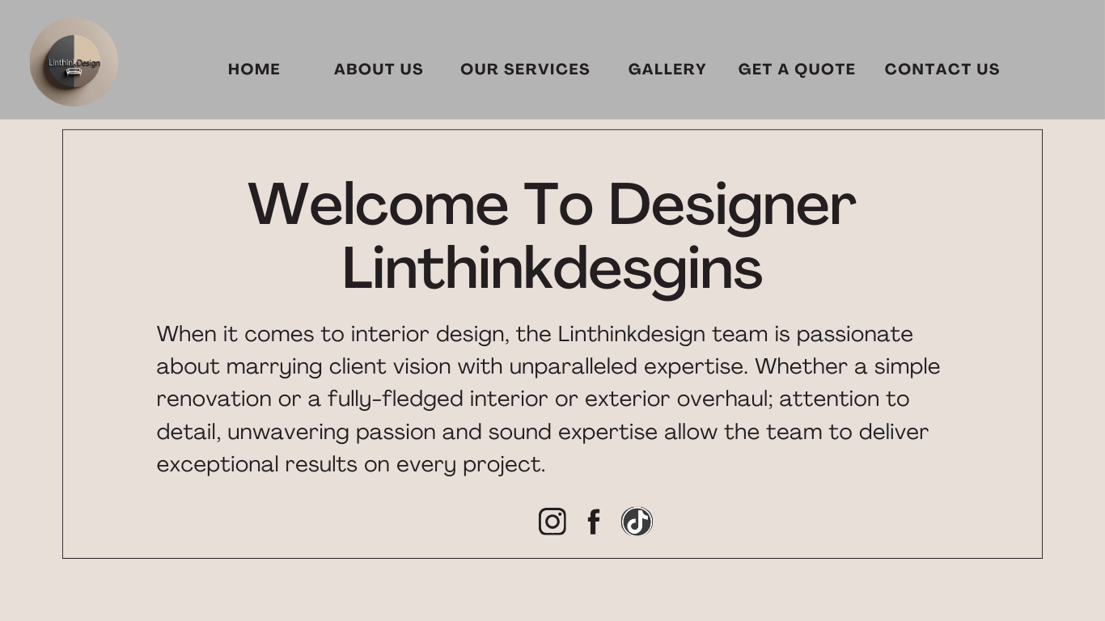

(canva, 2025)

## Technical requirements

Doman name: Linthinkdesgin.co.za

Hosting: Afrihost

Programming language: CSS, HTML, JavaScript

## Timeline and milestones

|  |  |  |  |
| --- | --- | --- | --- |
| Task | Start Date | End Date | Duration (Days) |
| Part 1: Planning & Research | Aug 7 | Aug 11 | 5 |
| Examine Social Account | Aug 7 | Aug 7 | 1 |
| Establish Objectives | Aug 8 | Aug 8 | 1 |
| Complete Branding & Style Guide | Aug 9 | Aug 9 | 1 |
| Draft Low-Fidelity Wireframes | Aug 10 | Aug 11 | 2 |
| Milestone 1 | Aug 11 | Aug 11 | 0 |
| Week 2: Design & Content | Aug 12 | Aug 18 | 7 |
| Design Website Grid Layout | Aug 12 | Aug 13 | 2 |
| Create Story Highlight Covers | Aug 14 | Aug 14 | 1 |
| Source & Create Graphics | Aug 15 | Aug 17 | 3 |
| Milestone 2 | Aug 18 | Aug 18 | 0 |
| Week 3: Testing & Launch | Aug 19 | Aug 25 | 7 |
| Final making of the files and content | Aug 20 | Aug 21 | 2 |
| Make Revisions | Aug 22 | Aug 23 | 2 |
| Schedule Content & Launch | Aug 24 | Aug 25 | 2 |
| Part one Submission | Aug 25 | Aug 26 | 2 |
| Part Two submission | Aug 28 | Sep 29 | 32 |

## Budget

* Website Visual Design: R5,000
* Content Creation and Sourcing: R1500
* Image Sourcing: R500
* Ongoing & Operational Costs (Recurring): R99 per month (Afrihost, n.d.)
* Hosting on a Web Server: R99 per month (Afrihost, n.d.)
* Website Maintenance: R4500

# Bibliography

Afrihost, n.d. *Shared Hosting.* [Online]   
Available at: https://www.afrihost.com/shared-hosting  
[Accessed 18 August 2025].

Enrichium, n.d. *Enrichium.* [Online]   
Available at: https://enrichium.co.za  
[Accessed 07 August 2025].

Mukandila, J., 2024. *Man Transforms Entertainment Area into Jaw-Dropping Master Bedroom in a Video, SA Wowed Read.* [Online]   
Available at: https://briefly.co.za/people/185986-man-transforms-entertainment-area-jaw-dropping-master-bedroom-a-video-sa-wowed/  
[Accessed 06 August 2025].

canva, 2025. *Canva.* [Online]   
Available at: https://www.canva.com  
[Accessed 18 August 2025].

linthinkdesign, n.d. *TikTok profile.* [Online]   
Available at: https://www.tiktok.com/@linthinkdesign  
[Accessed 23 August 2025].

lin_thinkdesign, n.d. *Instagram profile.* [Online]   
Available at: https://www.instagram.com/lin_thinkdesign/  
[Accessed 23 August 2025].