  WEDEPOE  Final Draft | Temogo Esitang  ST10485364

Contents
Website Proposal 2
NextGen Electricity 2
Mission 2
Vision 2
Target Audience 2
The specific goals for this website are: 2
Proposed Website Features and Functionality 3
5. Design and User Experience 3
7. Timeline and Milestones 4
8. Budget 4
Wireframes 5
References 10
Professionalism 10
Business Clients 10
Types of Electrical Companies (Residential, Commercial, Industrial) 10
Mission Statements 10
Vision Statements 10
Goals and Objectives 11

Website Proposal

NextGen Electricity
Established in 2000, the company has built a strong reputation for their professionalism and response time. The company consists of a team of qualified and licensed electricians who bring experience to electrical repairs, maintenance, and emergency services.

NextGen Electronics is a locally owned company dedicated to providing safe, reliable and high-quality electrical solutions to their clients The company consists of a team of qualified and licensed electricians who bring experience to electrical repairs, maintenance and emergency services. We offer a wide range of services including residential, commercial, and industrial electrical work. Whether you need a simple repair or a complex installation, NextGen Electronics has the expertise to get the job done right.

Mission
The company's mission is to deliver reliable and high-quality solutions and services which will exceed the clients' expectations while upholding the highest standards of professionalism and customer service. We are committed to safety, integrity, and continuous improvement in all aspects of our business.

Vision
The company’s vision is to be the most trusted electrical service provider in the region, which can be recognised for innovation and unwavering commitment to safety and customer satisfaction. We aim to expand our services and reach more clients while maintaining our core values and dedication to excellence.

Target Audience
Homeowners - those that need repairs, installations or even upgrades.
Small and medium businesses - which require electrical Maintenance or even new installations.
Property managers - are looking for reliable services for their multiple units.
Construction companies - wanting experienced electrical subcontractors.
Emergency services clients - that need fast response for their electrical issues.

The specific goals for this website are:
1. Establish Trust and Credibility
- Showcase licensing, certifications, insurance, and years in business (est. 2000) prominently on the homepage.
- Display customer testimonials, reviews, and case studies/photos of completed projects.
- Highlight response-time guarantees and professionalism as key differentiators.
2. Clearly Communicate Services Offered
- Create dedicated service pages for residential, commercial, industrial, and emergency electrical work so each audience segment finds relevant information quickly.
3. Improve Local Search Visibility
- Improve for local SEO ("electrician near me," city/region-specific keywords) to be found by clients in the service area.
4. Build a Professional Brand Image
- Consistent visual identity (logo, colours, imagery of licensed electricians at work) that reflects reliability and professionalism.
- Clear "About Us" page detailing history (est. 2000), mission, vision, and team credentials.
5. Enable Easy Contact and Scheduling
- Multiple contact options: phone, contact form, and (if feasible) online booking/scheduling tool.

Proposed Website Features and Functionality
- Homepage: Store name, image, and opening hours
- About Us: Short history and mission
- Products Page: List of main service categories with prices
- Contact Page: Address, phone number, WhatsApp, and Google Maps location
- Basic functionality: Mobile friendly, simple navigation

5. Design and User Experience
- Colour Scheme: Blue and white - simple and clean
- Typography: Arial font, headings bigger than body text
- Layout: Simple layout with the menu displayed horizontally and products in the middle
- UX: Easy navigation, clear buttons, works on phone
- Wireframe: [Basic boxes: Header, Menu, Product images, Footer]

6. Technical Requirements
- Hosting: Basic shared hosting
- Languages: HTML, CSS, JavaScript

7. Timeline and Milestones
- Week 1-2: Research and planning
- Week 3-4: Design and wireframes
- Week 5-6: Build website
- Week 7: Test and launch

8. Budget
- Development: R2,000
- Hosting + Domain for 1 year: R1,200
- Maintenance: R500 per year
- Total Estimated: R3,700

Wireframes
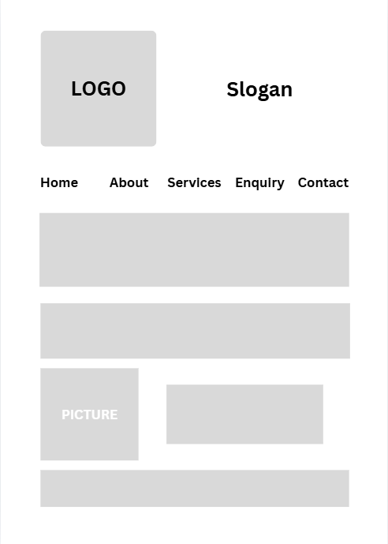
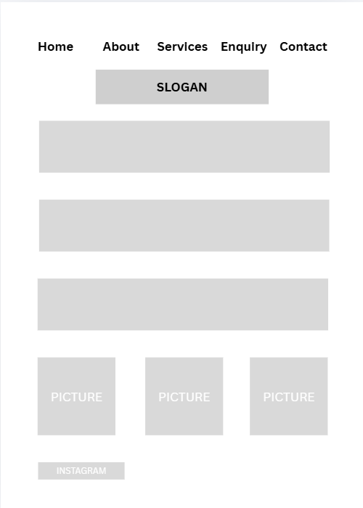
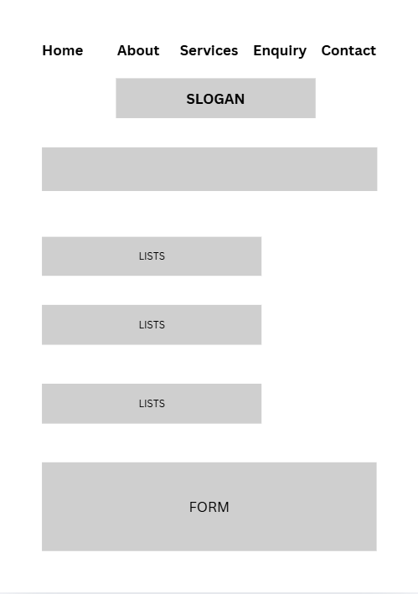


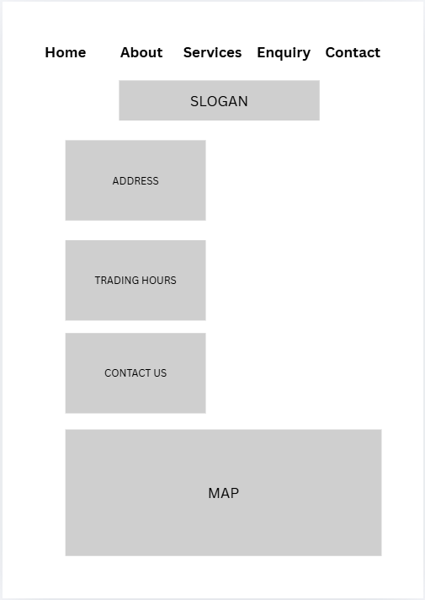

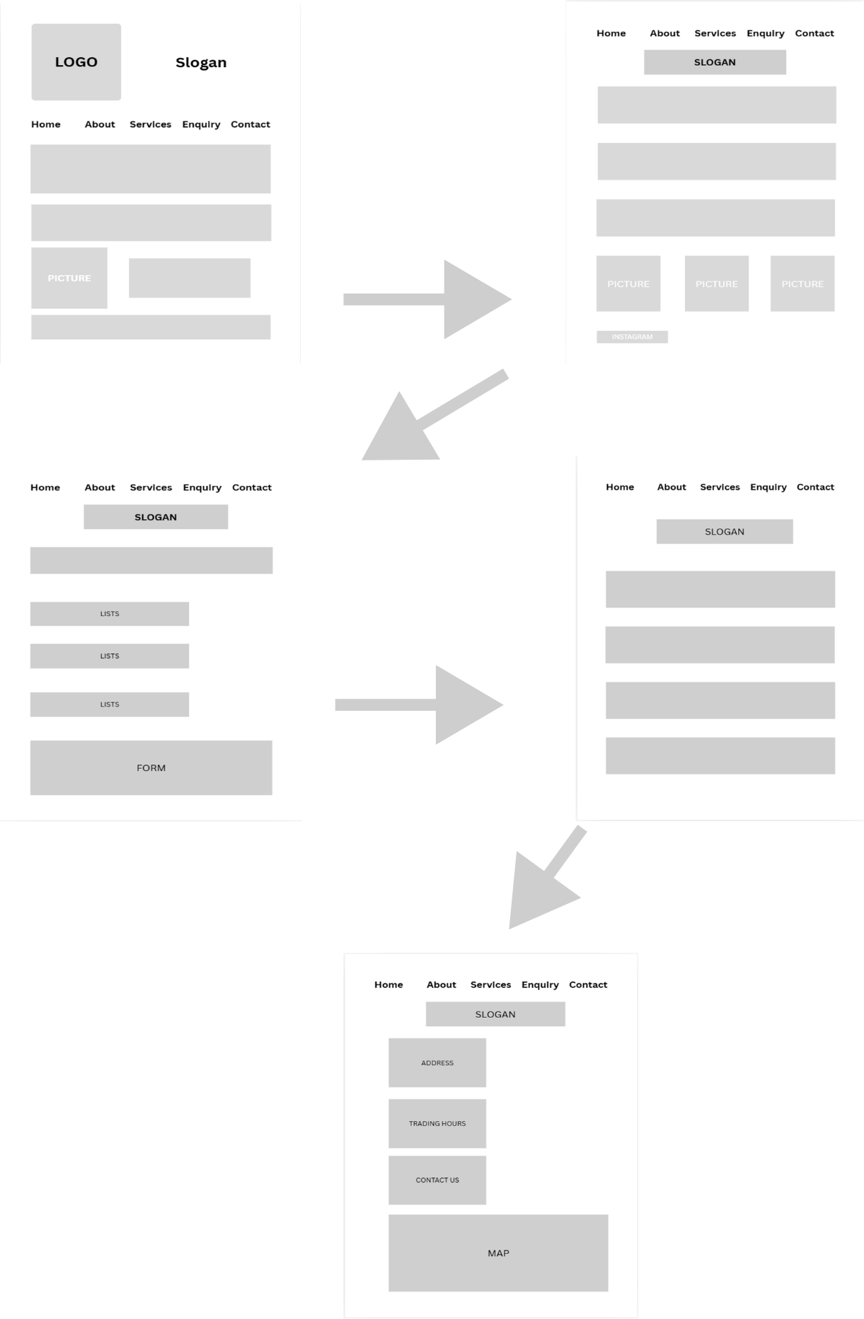
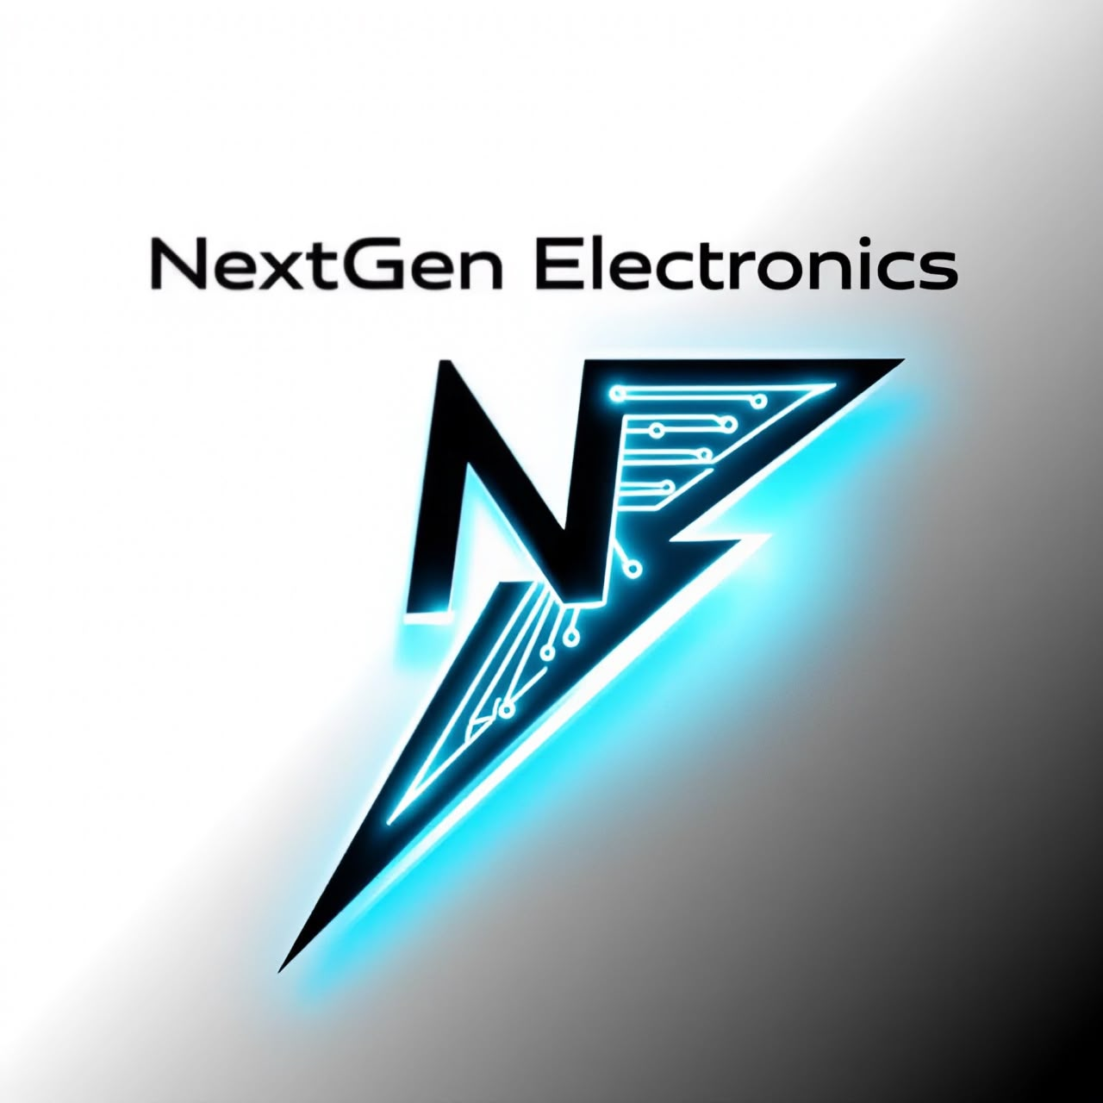I created this logo using AI

References

Professionalism
Nerdbot (2024) The Importance of Licensed Electricians: Ensuring Safety and Quality Electrical Work. Available at: The Importance of Licensed Electricians: Ensuring Safety and Quality Electrical Work (Accessed: 14 August 2026).
RSB Electrical Inc. (n.d.) The Role and Importance of a Licensed Electrician. Available at: https://www.rsbelectricalinc.com/blog/the-role-and-importance-of-a-licensed-electrician (Accessed: 14 August 2026).

Business Clients
Jolt Electric (2026) Commercial Electrical Maintenance: Your 2026 Guide. Available at: https://www.joltelectric.biz/post/commercial-electrical-maintenance (Accessed: 14 August 2026).

Types of Electrical Companies (Residential, Commercial, Industrial)
Palmer Electric Company (2021) The Difference Between Commercial, Industrial & Residential Electricians. Available at: https://www.palmer-electric.com/electrician-orlando-florida/the-difference-between-commercial-industrial-residential-electricians/ (Accessed: 14 August 2026).

Mission Statements
Status.net (2024) 10+ Mission Statement Examples for Energy & Chemicals. Available at: https://status.net/articles/vision-mission-statements-examples-energy-chemicals/ (Accessed: 14 August 2026).
Terminal-Andrae Inc. (n.d.) Milwaukee Electrical Contractors Mission Statement. Available at: https://www.terminalandrae.com/WiElectricalContractor/MissionVision (Accessed: 14 August 2026).

Vision Statements
Lucidity (2025) 125+ Example Company Vision Statements to Blow Your Mind. Available at: https://getlucidity.com/strategy-resources/125-example-company-vision-statements/ (Accessed: 14 August 2026).

Goals and Objectives
Franking (2023) What are the objectives of an electrical company? Available at: https://franking.home.blog/2023/10/24/what-are-the-objectives-of-an-electrical-company/ (Accessed: 14 August 2026).
Shockproof Business (2025) Essential Components of an Electrical Business Plan: A Guide for Aspiring Entrepreneurs. Available at: https://www.shockproofbusiness.com/articles/essential-components-electrical-business-plan-guide/ (Accessed: 14 August 2026).

