

**Oatile Morudu**

**ST10488465**

**WEDE5020**

**Part 1 proposal 2**

**Table of content**

Table of Contents

Organization Overview 3

Website goals and objectives 4

KPI’s 4

Features and functionality 4

Design and user experience 5

Technical requirements 7

Timeline 7

Budget 8

References 8

# Proposal Content 2

**Name:** Nations2Nations

There is not much history to this organization but this organization takes inspiration from my previous retail store that I made a few years ago called Nations which provided a wide variety of products. Products such as clothing, technology, etc.

**Mission and vision statement**

**Mission**

* To provide high-quality fashion, beauty, and tech products to customers worldwide.
* Encouraging self-expression, creativity, and self-assurance with each purchase.

**Statement**

* To become the world’s leading global retail platform
* Where technology, beauty, and style from every country come together to serve every nation

**Target Audience**

I have two types of target audiences

**Primary Target Audience**

#### **1. Millennials and Gen Z (Ages 18–35)**

* **Why:** They are trend-driven, tech-savvy, appearance conscious, and most frequent online shoppers
* **What they want:** Affordable, fashionable apparel; hair care products for a range of textures; and personal technology
* **Where they are:** Tiktok, Instagram, Youtube and online shopping store

**Secondary Target Audience**

**2. Value-Conscious Online Shoppers (Ages 25–45)**

* **Why:** They purchase online in search of discounts, ease, and distinctive goods, particularly if you have reasonably priced goods and packaged goods
* **What they want:** Reliable delivery, high-quality goods, and attentive customer support. Not necessarily trendsetters, but devoted customers.
* **Where they are:** Search engines, review sites, comparison platforms

## Website goals and objectives

I have four main goals that I would like to achieve with my retail store website.

Goal1: To boost brand awareness and social media following.  
Objective 1: Include sharing tools and social media links on the website. Publish interesting information on a regular basis (blog entries, promotions, etc.) to increase traffic to social media sites.  
  
Goal 2: To create at least R10 000 in income during the first 6 months.  
Objective 2: Provide e-commerce features that enable users to peruse, add items to their carts, and safely make purchases online, backed by competitive pricing and unambiguous product descriptions.  
  
Goal 3: Within the first three months, 500 orders must be placed.  
Objective 3: Use discounts, promotions, and an easy checkout procedure to entice customers to buy, all the while keeping track of orders with a dependable backend system.

Goal 4: To enhance customer service by responding to all inquiries from clients within the day.

## Key performance indicators(KPI’s)

|  |  |  |
| --- | --- | --- |
| **Area** | **KPI** | **Target** |
| 1. Customer service | Repeat purchase rate | 15-20% |
| 1. Marketing | Instagram and Tiktok followers | 10 000+ in a year |
| 1. Sales | Conversion rate | 1-2% |
| 1. Website | Bounce rate | <50% |
| 1. Operations | Order fullfilment time | 7-10 days |

## Website features and functionalities

There are multiple feature and functionality ideas for my website, Nations2Nations.

**Products**

* Categories: Clothing, hair, and technology.
* Prices, description, images, and sizes.

**Checkout and shopping cart**

* Each product has an Add to Cart button.
* View the cart page to see the final cost.
* Secure checkout with payment options and shipping details.
* Guest Checkout: No account creation is required to make a purchase.

**Payment integration**

* Allow EFT, credit/debit cards, and mobile wallets(Paypal, e.t.c)
* If in South Africa, display the currency in Rands(ZAR)
* Send emails confirming the order

**Account for users**

* Make an account/ Login/ Logout
* Track orders, see order history, and save favourites(wishlist)

**Shipping and delivery**

* Display the estimate delivery times
* Options for shipping: Regular or Express
* Accept tracking numbers and SMS or email status updates

**Mobile response**

* Quick loading, simple navigation with touch support

**Contact and support**

* A contact us page with phone number, form or whatsapp link

**Ratings and reviews**

* Allow customers to give reviews and rate the goods
* On product pages, display the average star ratings

**Promotions**

* Banner advertisements promoting sales or new goods

**Security Features**

* Use **SSL encryption (https://)** for secure browsing
* Protect customer info and payment details

## Design and User Experience

I have a few ideas regarding my design and user experience. I am going to discuss the colour scheme, typography, user experience considerations, and layout and design.

**Colour scheme**

* I am going to use mainly white and blue for the background

**Typography**

* For the logo/headlines I am going to use Sans-serif Fonts because it is modern and clean
* For the main body text or description I am going to use Roboto to make it look more digital

**Layout and design**

* Simple, present day, and minimalistic
* Uses white and blue to convey clarity and trust
* A welcoming atmosphere with rounded components
* A worldwide theme with delicate patterns or icons
* Search bar, Account, Cart icons and logo
* Category-based navigation menu

**User experience consideration**

* Have a clear menu structure
* A single click “add to cart”
* Persistent shopping cart(incase users leave the site and want to come back)
* Have clear product filters
* Have fast loading times ( Optimizes fonts, images and scripts)
* Have safe and secure payment options
* Show estimated delivery times by location

## Wireframes

## Technical requirements

* Domain: https//: Nations2Nations . com
* Fast performance
* SSL and email included

**Programming languages and frameworks**

* HTML, CSS, and JavaScript
* For database i will use MySQL
* For Payments i will use PayPal, Credit/Debit cards

## Timeline

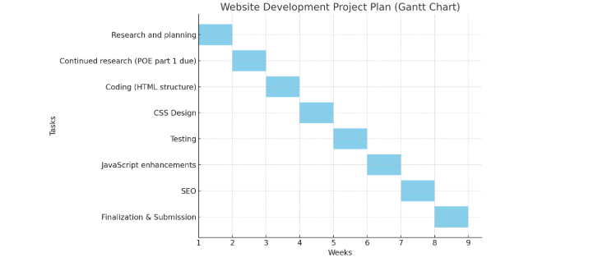

|  |  |  |
| --- | --- | --- |
| **Week** | **Description** | **Task** |
| Week 1 | Research and planning | Finish off the proposal and do continuous research |
| Week 2 | Continued research (POE part 1 due) | Regards the website structure and planning (including HTML structure) |
| Week 3 | Coding | Coding HTML website without making it look nice |
| Week 4 | CSS Design | Making the website look more aesthetically pleasing (using CSS) |
| Week 5 | Testing | I will test the website and see if it actually works |
| Week 6 | JavaScript | Enhancing the JavaScript to allow the navigation to be better |
| Week 7 | SEO | I will Search Engine Optimizing my website so it is easily accessible |
| Week 8 |  |  |

## Budget

|  |  |
| --- | --- |
| **Item** | **Budget** |
| * Domain | R300-R500/year |
| * Host | R1000-R2000 |
| * SSL Certificate | R500 |
| * Payment gateway | R500 |
| * Marketing | R1000-R5000 |

## Sitemap

# Organization Overview

**Name:** CustomPrints

**History:** Printing things on products and objects has been around for many years and it all started in China around the 1900.

**Mission statement**

* To give people and businesses more power by making high quality, personalized printed products that spark creativity, boost brands, and brings ideas to life, one print at a time.

**Vision**

* To be one of the biggest leaders in personalized product printing, known for being innovative, excellent, and making custom design available to everyone.

**Target market**

* Small businesses and startups need branded goods and promotional products like pens, mugs, and t- shirts.
* Normal customers and gift givers are able to customize presents for holidays, anniversaries, and birthdays. They could be very sentimental and unforgettable presents.

# Website goals and objectives

* Objective 1:to give thorough details regarding the selection of goods that CustomPrints sells.
* Goal 1: Create and implement content rich "About Us" and "Products" websites that include comprehensive descriptions of each product category, including costs, ingredients (if any), and usage guidelines.
* Objective 2:to raise brand awareness online and boost consumer interaction.
* Goal 2: Incorporate blog elements, social media links, and client endorsements into the website to promote engagement and increase traffic from many channels.
* Objective 3:to facilitate online order placement for clients.
* Goal 3: To expedite the purchasing process, provide an intuitive e-commerce section with a shopping cart, secure checkout system, and several payment choices.

## KPI’s

* Website traffic
* Run monthly promotions and influencer campaigns to market the store.
* Gain a very strong following on Instagram and Tiktok following. Around 10 000 followers in the first year
* I would like the website to generate at least R20 000 - R50 000 in revenue within the first year.
* Achieve 1500 sales within 6 months after the launch of the store.

# Features and functionality

**1. Home Page**

* Logo, slogan, and top navigation
* Hero banner/slider
* Featured products/services
* Call-to-action buttons
* Testimonials and footer with contact/social links

**2. Products/Services Page**

* Product showcase with filters and search
* Product details with images and pricing
* Add to cart + related products

**3. Customization Page**

* Real-time design tool (upload logos, add text, choose fonts/colors, live preview)
* Save design (for accounts)
* Add customized items to cart

**4. Contact Us Page**

* Contact info (address, phone, email)
* Google Map integration
* Contact form (Google Form or custom)
* Social media links and optional live chat

**5. About Us Page**

* Company mission, vision, and history
* Team introduction
* Achievements/certifications

**Shared Across All Pages**

* Responsive design (mobile-friendly)
* Secure login/account system
* Shopping cart & secure payment gateways
* SEO optimization
* Social media integration

# Design and user experience

**Colour scheme:** I am going to use red and white.

**Typography:** I am going to use open-sans and sans-serif to give the website a more aesthetic look.

**Layout and design**

* Simple, present day, and minimalistic
* Uses white and red to convey clarity and trust
* A welcoming atmosphere with rounded components
* A worldwide theme with delicate patterns or icons
* Search bar, Account, Cart icons and logo

**User experience consideration**

* Have a clear menu structure
* A single click “add to cart”
* Persistent shopping cart(incase users leave the site and want to come back)
* Have clear product filters
* Have fast loading times ( Optimizes fonts, images and scripts)
* Have safe and secure payment options
* Show estimated delivery times by location

# Wireframes

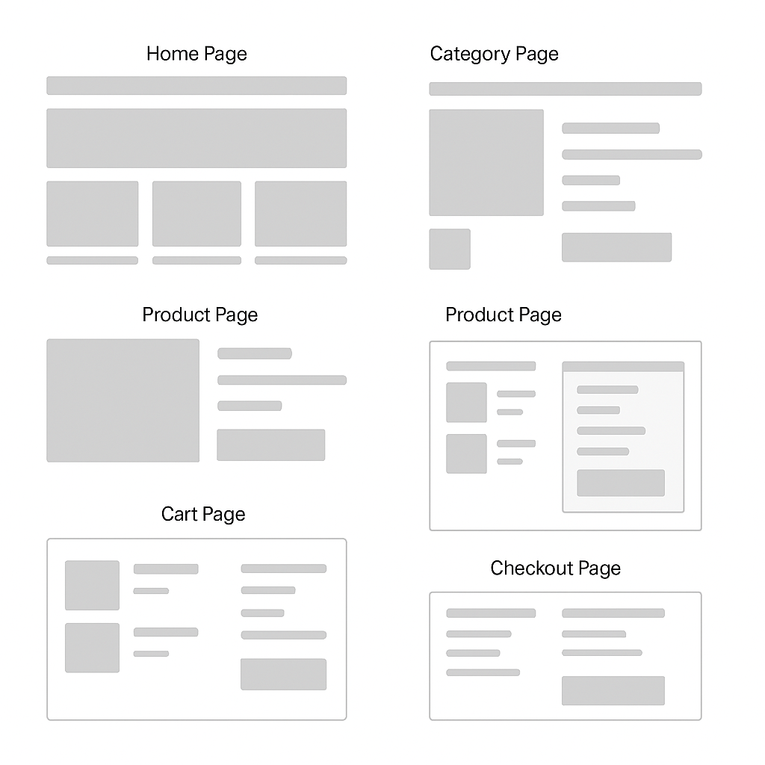

# Technical requirements

* Domain: https//: Nations2Nations . com
* Fast performance
* SSL and email included

**Programming languages and frameworks**

* HTML, CSS, and JavaScript
* For database i will use MySQL
* For Payments i will use PayPal, Credit/Debit cards

# Timeline



# Budget

|  |  |
| --- | --- |
| **Item** | **Budget** |
| * Domain | R300-R500/year |
| * Host | R1000-R2000 |
| * SSL Certificate | R500 |
| * Payment gateway | R500 |
| * Marketing | R1000-R5000 |

## References

* blog.converted.in. (2022). *8 Ways To Determine Ecommerce Target Audience For Your Store*. [online] Available at: https://blog.converted.in/en-us/blog/8-ways-to-determine-ecommerce-target-audience-for-your-store.
* ‌AgencyAnalytics. (n.d.). *12 Ecommerce Goals That Drive Client Success*. [online] Available at: https://agencyanalytics.com/blog/ecommerce-goals.
* ‌Softermii. (n.d.). *Most Popular Programming Languages and Frameworks for 2023*. [online] Available at: <https://www.softermii.com/blog/top-programming-languages-and-frameworks-for-software-development>.OpenAI (2025). *ChatGPT*. [online] ChatGPT. Available at: https://chatgpt.com/.
* ‌ Figma. (2025). *Figma*. [online] Available at: https://www.figma.com/design/T9eMsJRJmlqregvdz1nd8P/WEDE5020?node-id=0-1&p=f&t=JgmMDYAmFxq3es3b-0 [Accessed 27 Aug. 2025].