Ngqabutho Antony Mafu
ST10492085

PROG ASSIGNMENT 1
PROG6212

Section A

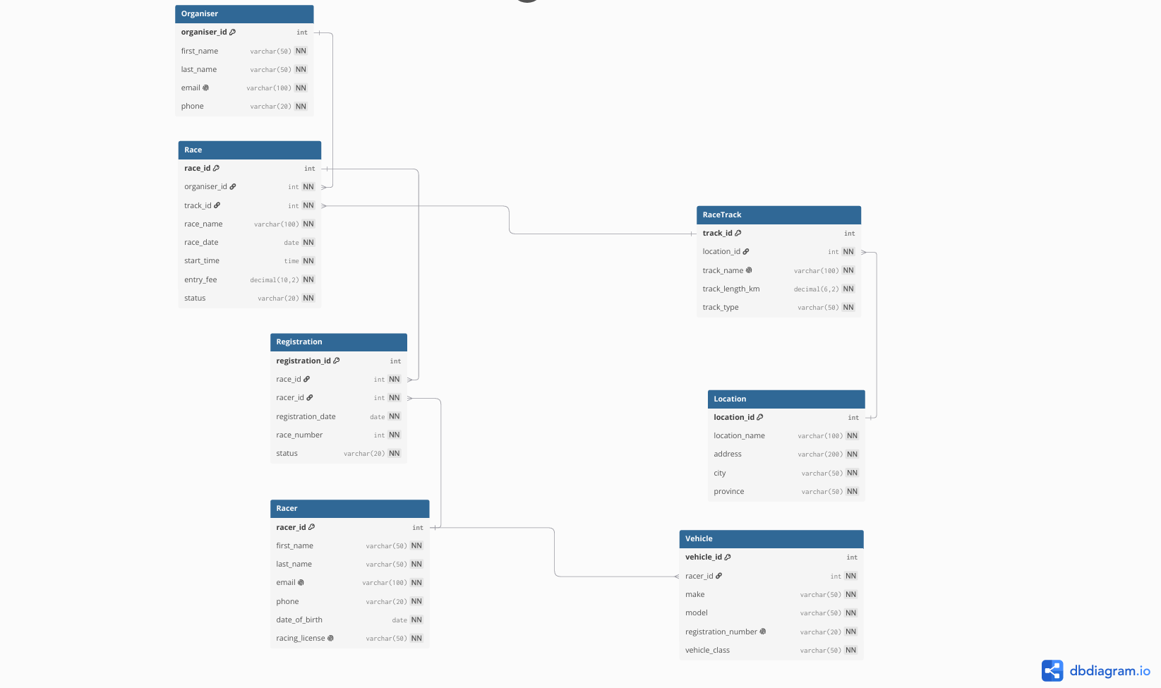

Section B
HTTP method | Route | Description | Role required | Request body Expected response
POST | /api/auth/register | Registers a new RaceDay user account (Participant or Organizer). | Public | `{ "firstName": "string", "lastName": "string", "email": "string", "password": "string", "phone": "string", "role": "Participant | Organizer" }`
POST | /api/auth/login | Authenticates user and returns JWT token for API access. | Public | { "email": "string", "password": "string" } | 200 OK – token + user info; 401 Unauthorized – invalid credentials
GET | /api/users/me | Returns logged-in user profile summary. | Logged-in user | None | 200 OK – current user profile; 401 Unauthorized
PUT | /api/users/me | Updates logged-in user details. | Logged-in user | { "firstName": "string", "lastName": "string", "phone": "string" } | 200 OK – updated profile; 400 Bad Request; 401 Unauthorized
POST | /api/participants/profile | Creates participant profile for logged-in participant. | Participant | { "dateOfBirth": "yyyy-mm-dd", "gender": "string", "emergencyContactName": "string", "emergencyContactPhone": "string", "clubName": "string" } | 201 Created; 400 Bad Request; 409 Conflict – profile exists
GET | /api/participants/profile | Gets participant profile details. | Participant | None | 200 OK; 404 Not Found; 401 Unauthorized
PUT | /api/participants/profile | Updates participant profile details. | Participant | { "dateOfBirth": "yyyy-mm-dd", "gender": "string", "emergencyContactName": "string", "emergencyContactPhone": "string", "clubName": "string" } | 200 OK; 400 Bad Request; 404 Not Found
POST | /api/organizers/profile | Creates organizer profile for logged-in organizer. | Organizer | { "organizationName": "string", "organizationType": "string", "bio": "string" } | 201 Created; 400 Bad Request; 409 Conflict
GET | /api/organizers/profile | Gets organizer profile details. | Organizer | None | 200 OK; 404 Not Found; 401 Unauthorized
PUT | /api/organizers/profile | Updates organizer profile details. | Organizer | { "organizationName": "string", "organizationType": "string", "bio": "string" } | 200 OK; 400 Bad Request; 404 Not Found
POST | /api/events | Creates a new event record. | Organizer | `{ "eventName": "string", "description": "string", "eventDate": "yyyy-mm-dd", "startTime": "HH:mm:ss", "city": "string", "province": "string", "routeInfo": "string", "registrationOpenDate": "yyyy-mm-dd", "registrationCloseDate": "yyyy-mm-dd", "status": "Draft | Open
GET | /api/events | Returns list of available events (filterable). | Public | None | 200 OK – list of events
GET | /api/events/{eventId} | Returns one event by id. | Public | None | 200 OK; 404 Not Found
PUT | /api/events/{eventId} | Updates event owned by organizer. | Organizer (Owner) | `{ "eventName": "string", "description": "string", "eventDate": "yyyy-mm-dd", "startTime": "HH:mm:ss", "city": "string", "province": "string", "routeInfo": "string", "registrationOpenDate": "yyyy-mm-dd", "registrationCloseDate": "yyyy-mm-dd", "status": "Draft | Open
DELETE | /api/events/{eventId} | Deletes an event owned by organizer. | Organizer (Owner) | None | 204 No Content; 403 Forbidden; 404 Not Found
POST | /api/events/{eventId}/categories | Adds category to selected event. | Organizer (Owner) | { "categoryName": "string", "distanceKm": 0.0, "entryFee": 0.0, "maxParticipants": 0, "minAge": 0, "startBatchTime": "HH:mm:ss" } | 201 Created; 400 Bad Request; 403 Forbidden; 404 Not Found
GET | /api/events/{eventId}/categories | Returns all categories for selected event. | Public | None | 200 OK; 404 Not Found
GET | /api/categories/{categoryId} | Returns one category by id. | Public | None | 200 OK; 404 Not Found
PUT | /api/categories/{categoryId} | Updates category details. | Organizer (Owner) | { "categoryName": "string", "distanceKm": 0.0, "entryFee": 0.0, "maxParticipants": 0, "minAge": 0, "startBatchTime": "HH:mm:ss" } | 200 OK; 400 Bad Request; 403 Forbidden; 404 Not Found
DELETE | /api/categories/{categoryId} | Deletes category from event. | Organizer (Owner) | None | 204 No Content; 403 Forbidden; 404 Not Found
POST | /api/categories/{categoryId}/enrollments | Enrolls participant into selected category. | Participant | `{ "paymentStatus": "Pending | Paid
GET | /api/enrollments/me | Returns logged-in participant enrollments. | Participant | None | 200 OK
GET | /api/enrollments/{enrollmentId} | Returns one enrollment record. | Participant / Organizer (Owner) | None | 200 OK; 403 Forbidden; 404 Not Found
DELETE | /api/enrollments/{enrollmentId} | Cancels enrollment if rules allow. | Participant / Organizer (Owner) | None | 204 No Content; 403 Forbidden; 404 Not Found; 409 Conflict
POST | /api/enrollments/{enrollmentId}/result | Creates race result for one enrollment. | Organizer (Owner) / Admin | `{ "finishTimeSeconds": 0, "positionOverall": 0, "positionCategory": 0, "completionStatus": "Finished | DNF
PUT | /api/enrollments/{enrollmentId}/result | Updates race result for one enrollment. | Organizer (Owner) / Admin | `{ "finishTimeSeconds": 0, "positionOverall": 0, "positionCategory": 0, "completionStatus": "Finished | DNF
GET | /api/enrollments/{enrollmentId}/result | Gets result linked to enrollment. | Participant / Organizer (Owner) | None | 200 OK; 403 Forbidden; 404 Not Found
GET | /api/events/{eventId}/results | Returns event leaderboard/results list. | Public | None | 200 OK; 404 Not Found
section C

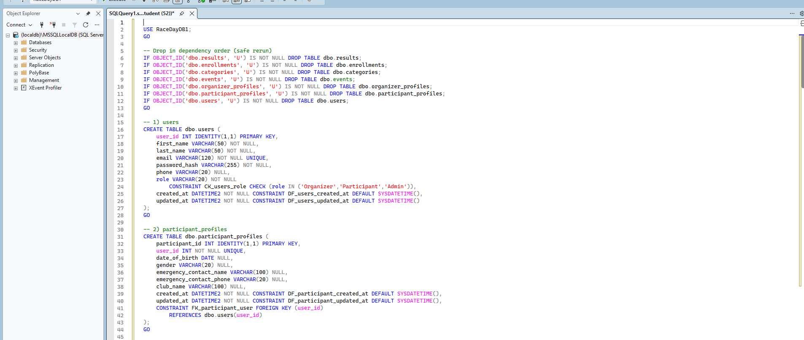
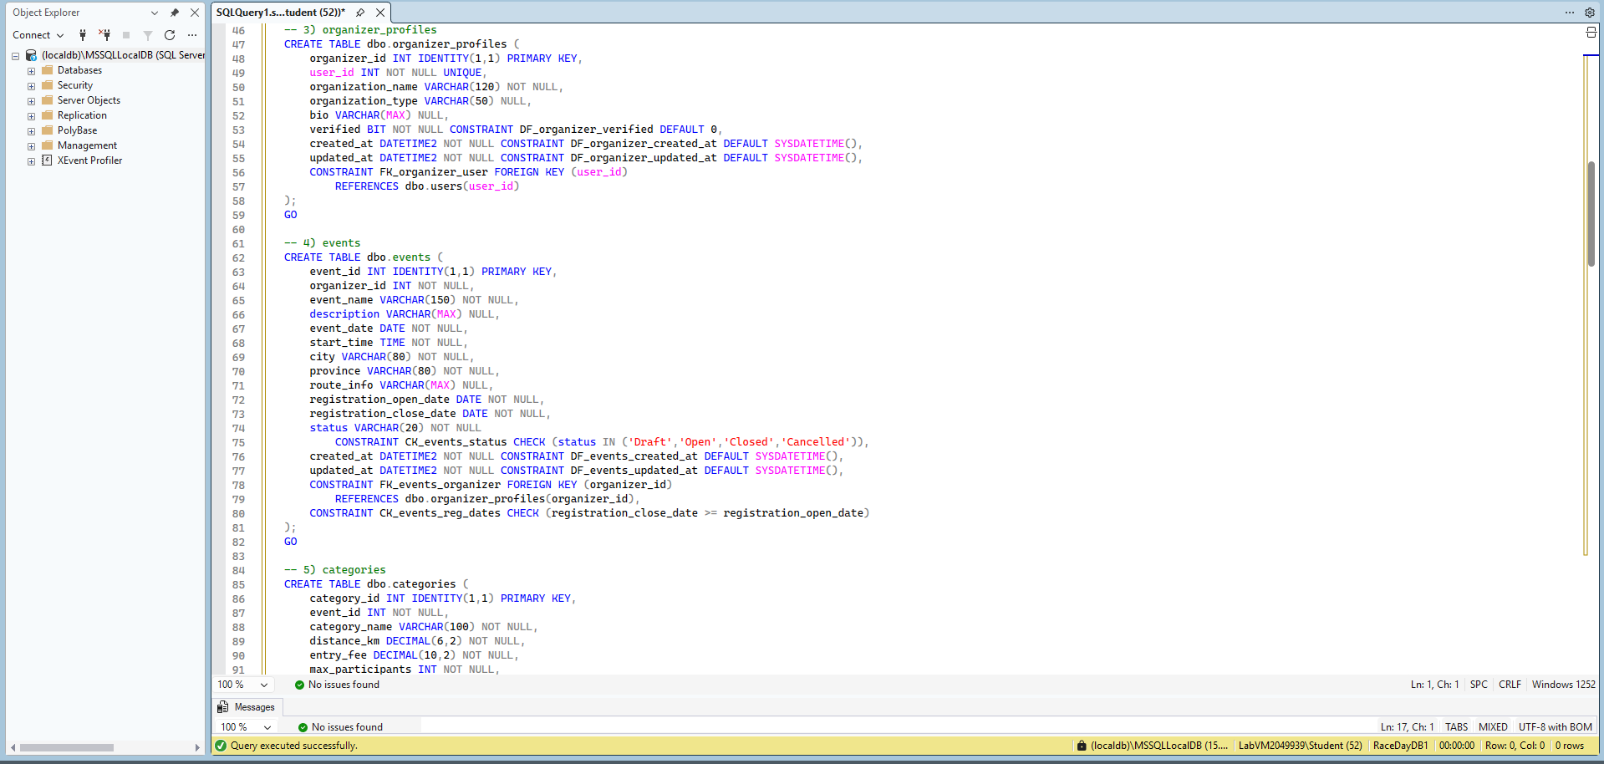
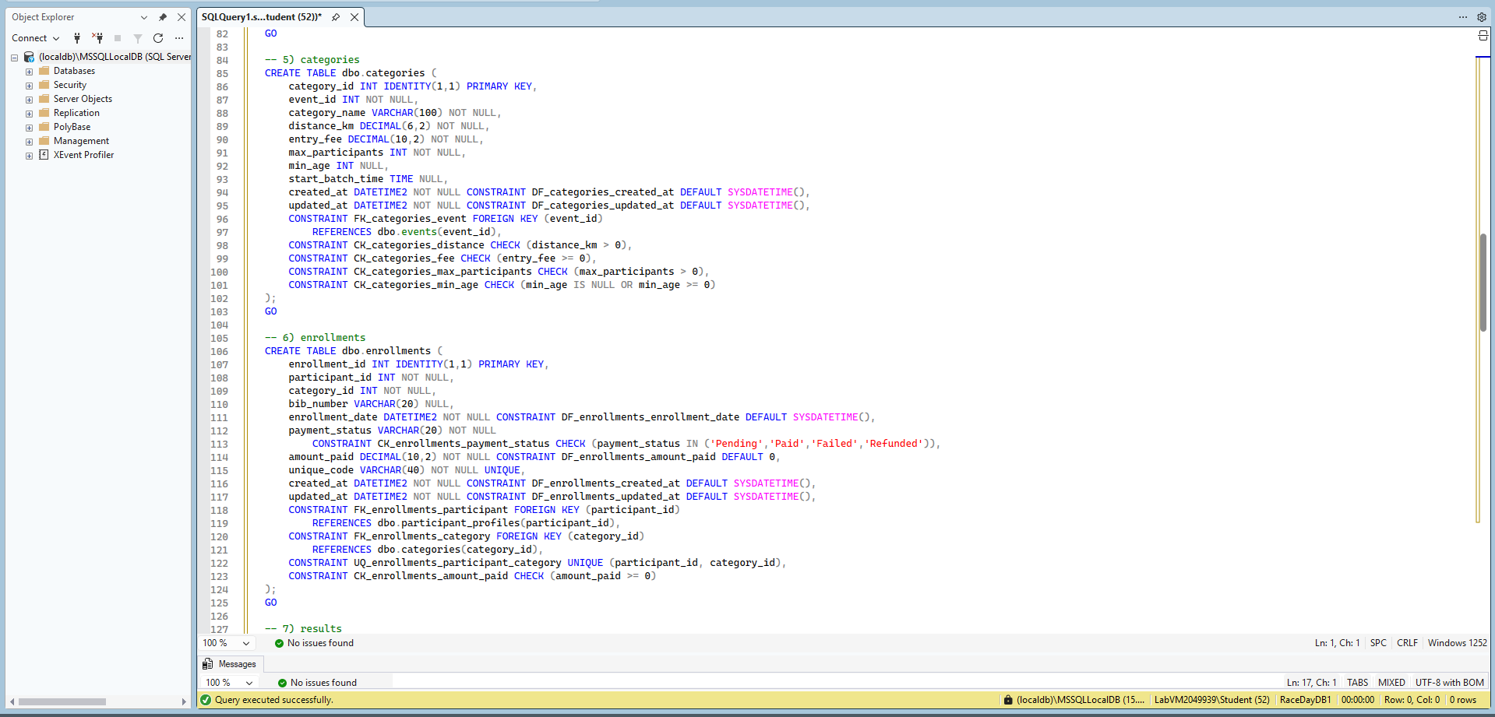
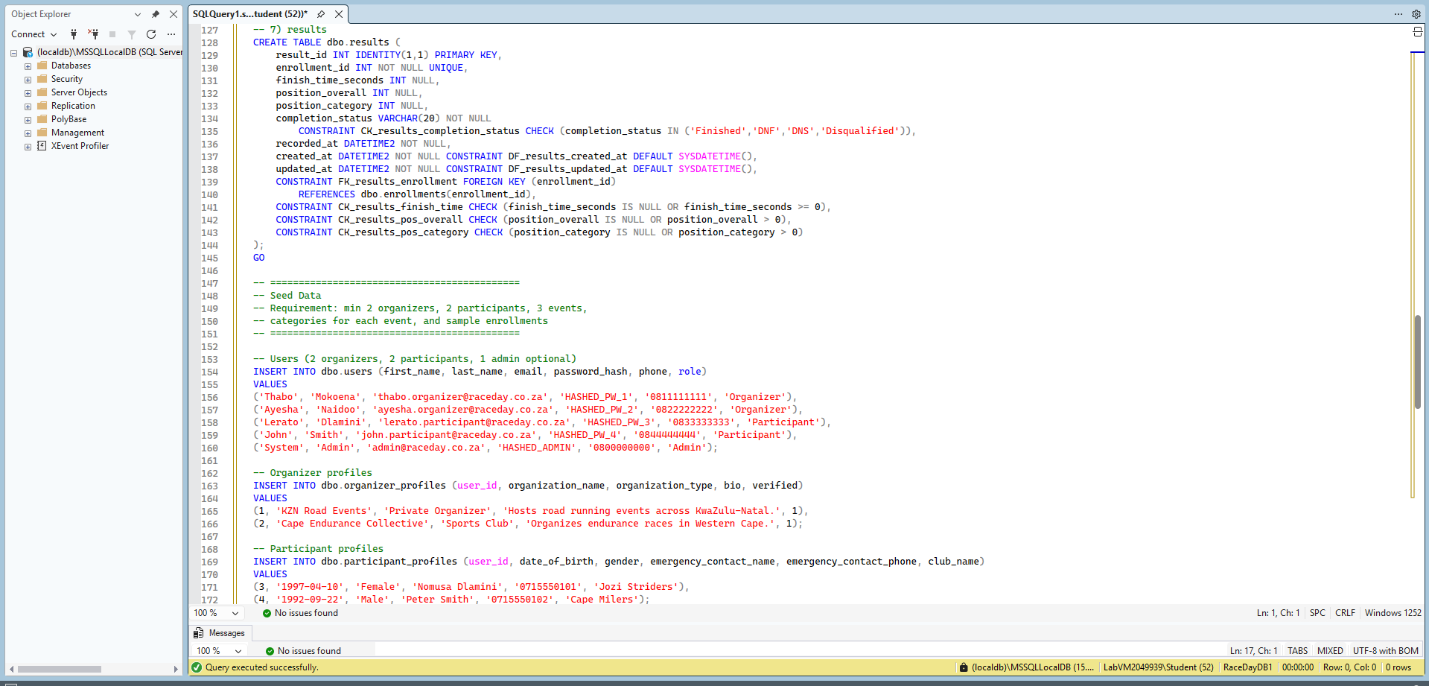
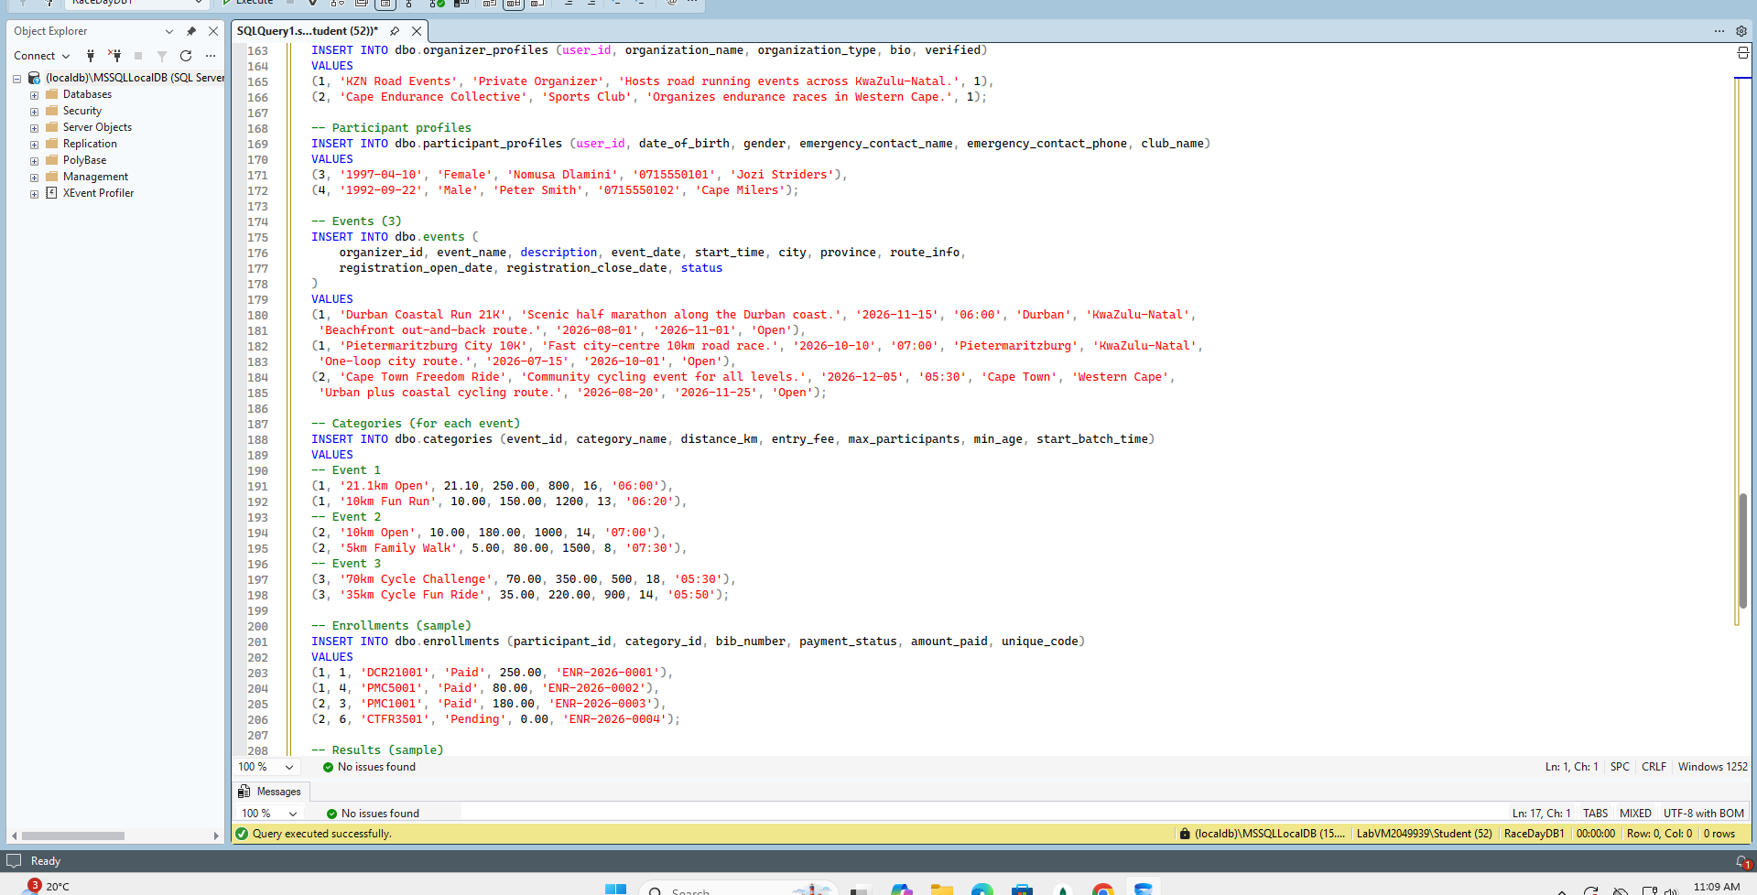
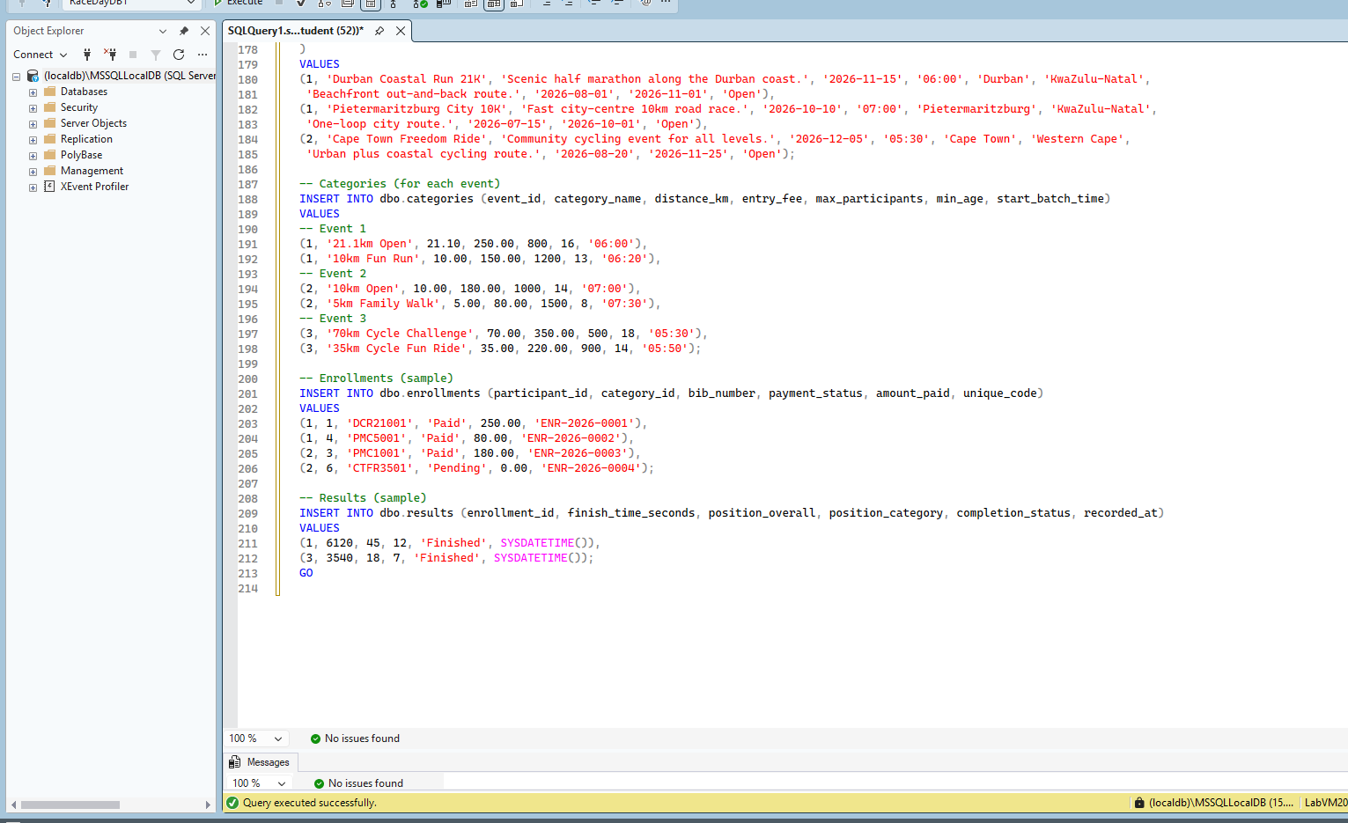
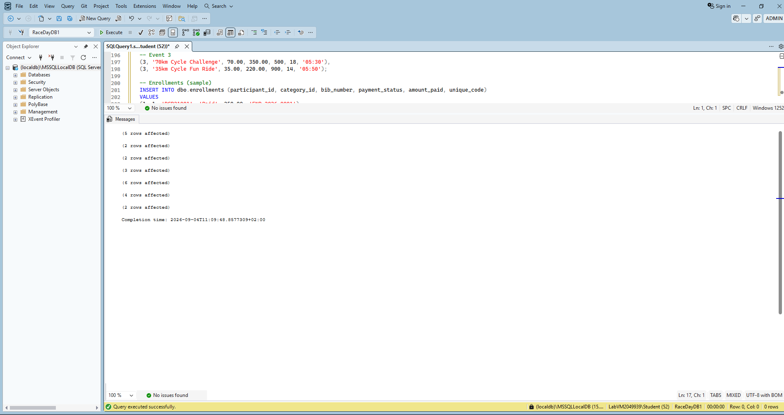

Reference
- The Independent Institute of Education (IIE). 2026. Portfolio of Evidence (PoE): RaceDay Project Brief. Unpublished class handout.

LINKS
https://github.com/ST10492085/prog_assignment1_sept.git

