Table of Contents
1. Introduction 2
2. Entity Relationship Diagram (ERD) 2
2.1 Entities 2
2.2 Relationships 2
3. API Endpoint Plan 3
4. SQL Database Script 6
4.1 Tables 6
4.2 Seed Data and Testing 6
5. GitHub and CI/CD 6
6. Demonstration Video 7

RaceDay Part 1

1. Introduction
The RaceDay platform is designed to modernise the management of sporting events such as running, walking, and cycling. It replaces outdated paper based systems with a digital solution that supports two distinct user roles: Organiser and Participant.
- Organiser: creates, edits, and deletes events; manages categories; views enrolments; records and updates results.
- Participant: registers an account; browses events and categories; enrols in events; views personal results and profile information.
This first part of the Portfolio of Evidence focuses on system planning. It includes the Entity Relationship Diagram (ERD), the API Endpoint Plan, the SQL database script, and evidence of GitHub version control and CI/CD validation.

2. Entity Relationship Diagram (ERD)
The ERD defines the logical structure of the RaceDay database. It contains six core entities: Users, Events, Categories, EventCategories, Enrolments, Results.

2.1 Entities
- Users: stores organiser and participant accounts, roles, and profile information.
- Events: details of sporting events, linked to the organiser who created them.
- Categories: participation categories, including optional age or distance restrictions.
- EventCategories: junction table resolving the many-to-many relationship between Events and Categories.
- Enrolments: participant registrations for events and selected categories.
- Results: finish times and positions associated with completed enrolments.

2.2 Relationships
- One organiser can create many events (Users 1:N Events).
- One participant can have many enrolments (Users 1:N Enrolments).
- Each event can have many enrolments (Events 1:N Enrolments).
- Each category can be linked to many enrolments (Categories 1:N Enrolments).
- Events and categories are linked through EventCategories (Events N:N Categories).
- Each enrolment may have zero or one result (Enrolments 1:0..1 Results).

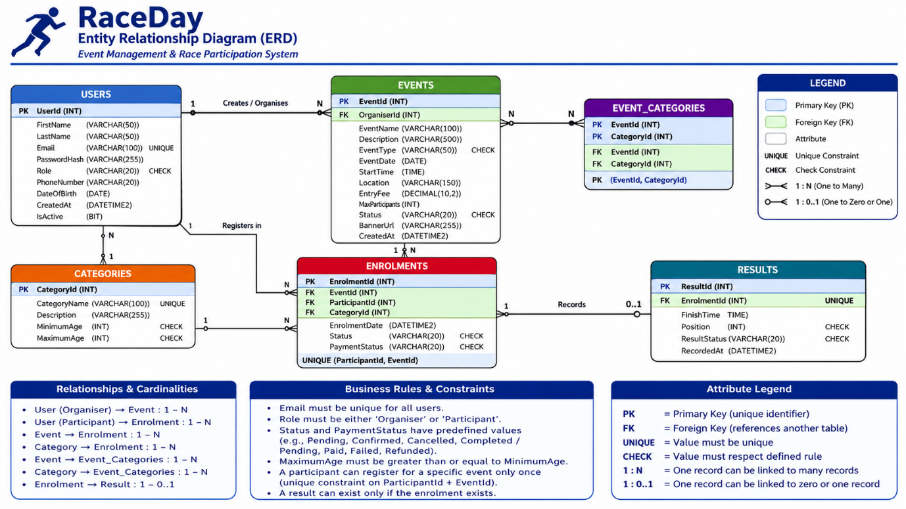
Figure 1: RaceDay Entity Relationship Diagram

3. API Endpoint Plan
The RaceDay API is planned as a RESTful service. The endpoint plan specifies HTTP method, route, description, role required, request body, and expected response/error codes.
It contains 28 endpoints covering authentication, profiles, events, categories, event-category relationships, enrolments, and results.
Example Endpoints
- POST /api/auth/register → Register a new user (201 Created; 400 Bad Request; 409 Conflict).
- POST /api/auth/login → Authenticate a user (200 OK; 401 Unauthorized).
- GET /api/events → List available events (200 OK).
- POST /api/events → Create an event (201 Created; 400 Bad Request; 401 Unauthorized; 403 Forbidden).
- POST /api/enrolments → Create enrolment (201 Created; 400 Bad Request; 401 Unauthorized; 404 Not Found; 409 Conflict).
- POST /api/results → Record a result (201 Created; 400 Bad Request; 401 Unauthorized; 403 Forbidden; 404 Not Found; 409 Conflict).
HTTP Method | Route | Description | Role | Request Body | Response / Error Codes
POST | /api/auth/register | Register a new user | Public | FirstName, LastName, Email, Password, Role | 201; 400; 409
POST | /api/auth/login | Authenticate a user | Public | Email, Password | 200; 401
POST | /api/auth/logout | End authenticated session | Authenticated | None | 200; 401
GET | /api/users/me | Get current profile | Authenticated | None | 200; 401
PUT | /api/users/me | Update current profile | Authenticated | Profile fields | 200; 400; 401
GET | /api/events | List available events | Public | Optional filters | 200
GET | /api/events/{id} | Get one event | Public | None | 200; 404
POST | /api/events | Create an event | Organiser | Event details | 201; 400; 401; 403
PUT | /api/events/{id} | Update an event | Organiser | Event details | 200; 400; 401; 403; 404
DELETE | /api/events/{id} | Delete an event | Organiser | None | 204; 401; 403; 404
GET | /api/categories | List categories | Public | None | 200
GET | /api/categories/{id} | Get one category | Public | None | 200; 404
POST | /api/categories | Create category | Organiser | Category details | 201; 400; 401; 403
PUT | /api/categories/{id} | Update category | Organiser | Category details | 200; 400; 401; 403; 404
DELETE | /api/categories/{id} | Delete category | Organiser | None | 204; 401; 403; 404
GET | /api/events/{eventId}/categories | List event categories | Public | None | 200; 404
POST | /api/events/{eventId}/categories/{categoryId} | Assign category to event | Organiser | None | 201; 400; 401; 403; 404; 409
DELETE | /api/events/{eventId}/categories/{categoryId} | Remove category from event | Organiser | None | 204; 401; 403; 404
POST | /api/enrolments | Create enrolment | Participant | EventId, CategoryId | 201; 400; 401; 404; 409
GET | /api/enrolments/my | List my enrolments | Participant | None | 200; 401
GET | /api/enrolments/{id} | Get an enrolment | Authenticated | None | 200; 401; 403; 404
DELETE | /api/enrolments/{id} | Cancel an enrolment | Participant | None | 204; 401; 403; 404
GET | /api/events/{eventId}/enrolments | View event enrolments | Organiser | None | 200; 401; 403; 404
POST | /api/results | Record a result | Organiser | EnrolmentId, FinishTime, Position, ResultStatus | 201; 400; 401; 403; 404; 409
GET | /api/results/{id} | View a result | Authenticated | None | 200; 401; 404
PUT | /api/results/{id} | Update a result | Organiser | FinishTime, Position, ResultStatus | 200; 400; 401; 403; 404
GET | /api/results/my | View my results | Participant | None | 200; 401
GET | /api/events/{eventId}/results | View event results | Public / Organiser | None | 200; 404

4. SQL Database Script
The SQL script (RaceDayDB.sql) implements the ERD by creating the six tables, applying constraints, and inserting seed data.

4.1 Tables
- Users
- Events
- Categories
- EventCategories
- Enrolments
- Results

4.2 Seed Data and Testing
The script includes:
- Two organisers
- Two participants
- Three events with categories
- Sample enrolments and results
Verification queries are included at the end of the script to confirm correct relationships and data integrity. Screenshots of successful execution in SQL Server Management Studio (SSMS) should be retained as evidence.

5. GitHub and CI/CD
The repository contains all Part 1 artefacts, a README, and a GitHub Actions workflow (.github/workflows/part1-validation.yml).
- Commits: At least 20 meaningful commits following the commit plan.
- Workflow: Validates repository structure and artefacts.
- Evidence: Screenshots of a successful green build and commit history must be included.

6. Demonstration Video
A YouTube demonstration (unlisted):
- Explain the RaceDay design.
- Show the ERD and endpoint plan.
- Demonstrate the SQL script running successfully in SSMS.
- Highlight the GitHub repository and CI/CD validation.
- API-Plan/RaceDay_API_Endpoint_Plan.md text version.
- Database/RaceDayDB.sql database, constraints, seed data, verification queries.
- README.md system description, roles, setup, evidence notes.

