Please follow these instructions to download R and R Studio onto your computer.

- Click on this link: https://archive.linux.duke.edu/cran/

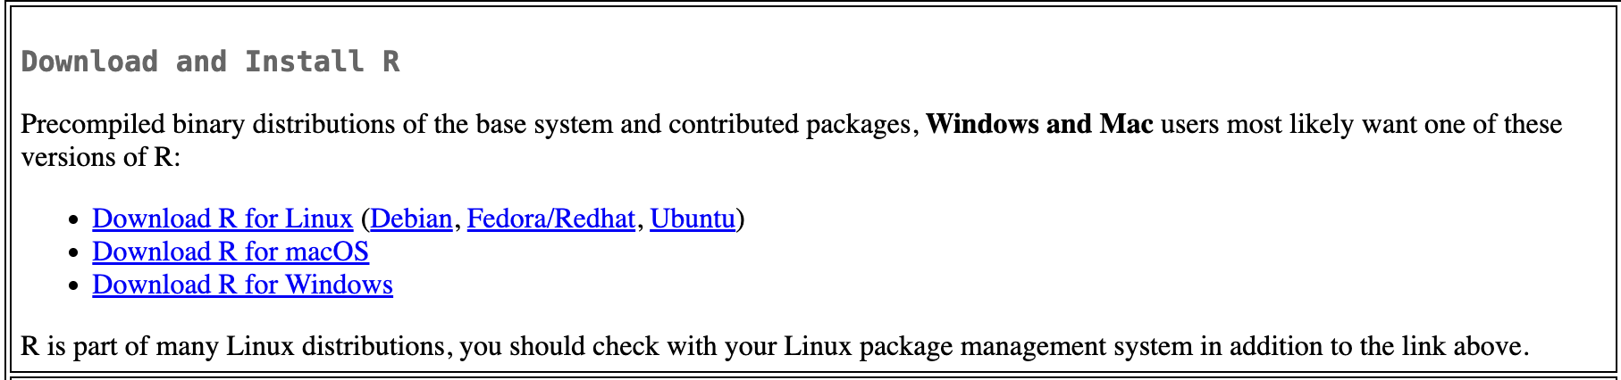
- The top of this page should now have a section that looks similar to this. Click on the download button that best matches the type of computer that you have. For example, if you have a MacBook, click “Download R for macOS”. If you have a Windows computer, click “Download R for Windows”.

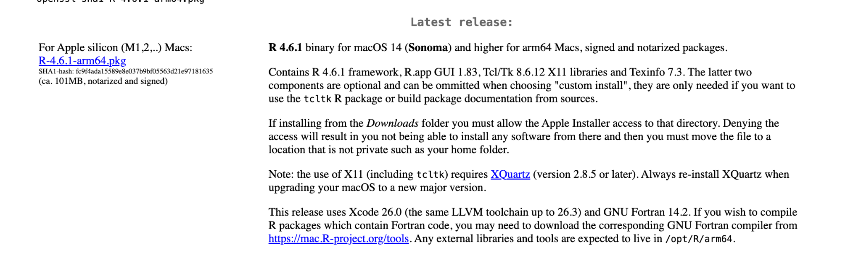
- Now, we need to download a version of R. For Mac users, we will use “Version R - 4.6.1”, which is the newest version. Click download on that version. For Windows users, click the button that says: “install R for the first time” to download the current version of R.
Mac Users:

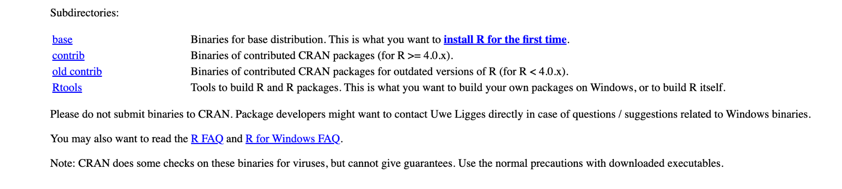
Windows Users:

- Once this downloads onto your computer, open the .pkg file with your package manager and install R on your computer (defaults should generally be fine).

- Once you install R and see this on your desktop, we also need to download R Studio. Click on this link: https://posit.co/download/rstudio-desktop/#download. Make sure to navigate to Direct Downloads (Open Source) and NOT Direct Downloads (Commercial).

- Scroll down until you see the links shown for “ R Studio IDLE” in the picture below. Again, make sure you are downloading the correct version of R Studio depending on if you have Windows or a Mac just like we did above. For Mac Users, you will need to know your current MacOS version so you can download the correct version of R Studio. If you want to verify, you can go to Settings, click General, and click Software Update to see what your current update is.
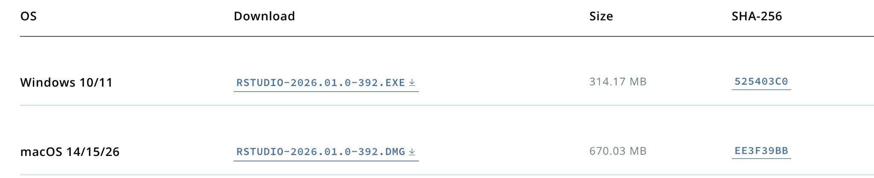

- Once this downloads, there is a .exe file for Windows based computers and a .dmg file for mac based computers. Use these to install and open RStudio.

Once you go through all 7 of these steps, you are good to go! You should now be able to open RStudio and have access to a great coding environment that we'll use throughout this course! We will discuss more about R Studio and do an introduction to this coding environment during Week 2.

