

IBSU LUNCH ORDERING SYSTEM
IT0206 — Advanced Computer Programming
Assessment 2c
Team members: [Replace placeholders before submission]
10 September 2026

Project Proposal

IBSU Lunch Ordering System
Course: IT0206 — Advanced Computer Programming 2
Assessment: Team Project — Designing, Building, and Delivering a Professional Python Application
Team members: [Member 1— ID], [Member 2— ID], [Member 3 — ID]
Project domain: Restaurant Ordering System / Campus Lunch Ordering

1. Problem Statement
Campus cafeteria ordering can become inefficient when menu information, stock availability and order tracking are handled manually. Students need a simple way to view available food and place orders, while cafeteria administrators need reliable tools for menu management, stock control, order status tracking and reporting.

2. Proposed Solution
The IBSU Lunch Ordering System is a menu-driven Python console application that provides authenticated, role-based access for students and administrators. Students can browse the menu, place orders, view order history and cancel eligible orders. Administrators can manage categories and menu items, monitor orders, update order status, import menu data, export records and generate reports and charts.

3. Aim
To design, build, test and deliver a professional Python application that digitises the campus lunch-ordering workflow while demonstrating object-oriented programming, MVC architecture, relational database programming, file handling, exception handling, testing and professional software engineering practices.

4. Objectives
- Implement secure username/password authentication using hashed credentials.
- Provide at least two roles with differentiated permissions: Student and Administrator.
- Implement a navigable console interface with input validation and graceful error handling.
- Provide CRUD operations for core domain entities including categories, menu items and orders.
- Implement transactional order placement and stock restoration for eligible cancellations/deletions.
- Provide search/filter functions and management reports using pandas and matplotlib.
- Support CSV, JSON and plain-text file handling.
- Implement application-wide logging and custom exceptions.
- Develop automated pytest tests and document functional and UAT testing.
- Deliver professional documentation, a reproducible SQL script, GitHub repository and recorded/live demonstration.

5. Scope
In scope: authentication, student ordering, order cancellation, menu/category CRUD, order management, stock management, reporting, CSV/JSON import/export, SQLite persistence, logging, automated testing and documentation.
Out of scope: online payment processing, real-time delivery tracking, production cloud deployment, mobile application and integration with an institutional student information system.

6. Feasibility
- **Technical:** Python 3.11+, SQLite, pytest, pandas, matplotlib, requests and tabulate are sufficient for the required features.
- **Operational:** The console workflow is simple enough for students and cafeteria administrators to use after a short orientation.
- **Economic:** The selected technologies are free/open-source and SQLite requires no database server.
- **Schedule:** The solution aligns with the seven-week SDLC structure in the assessment brief.

7. Stakeholders and Roles

8. Team Roles
Replace placeholders with the registered team details before submission.

Software Requirements Specification (SRS)

IBSU Lunch Ordering System

1. System Purpose
The system provides a persistent, role-based lunch-ordering workflow for a campus cafeteria. It is implemented as a menu-driven Python console application using SQLite.

2. User Roles
Student
- Authenticate with username/password.
- Browse menu and view stock.
- Place an order containing one or more items.
- View own orders.
- Cancel an order while it is Pending or Confirmed.
- View own profile.
Administrator
- Authenticate with username/password.
- Create/update/delete/search menu items.
- Create/update/delete/view categories.
- View all orders and update order status.
- Delete an order for administrative correction.
- Generate reports and charts.
- Import menu data from CSV/JSON.
- Export order data to CSV/JSON/text.
- Manage users.

3. Functional Requirements

4. Non-Functional Requirements
- **Usability:** menus use numbered options and clear prompts.
- **Reliability:** database transactions prevent partial multi-step orders.
- **Maintainability:** responsibilities are separated into models, repositories, services, controllers and views.
- **Security:** passwords are hashed; SQL uses parameterised queries; roles restrict access to functions.
- **Portability:** the application uses Python and SQLite without a database server.
- **Performance:** the target dataset is small enough for SQLite and console reporting.
- **Auditability:** application events are written using Python's logging module.

5. Use Cases
UC-01 Login: user enters credentials → system validates hash → role-specific session opens.
UC-02 Place Order: student browses menu → selects item/quantity → system validates stock → transaction creates order and line items → stock decreases.
UC-03 Cancel Order: student selects own order → system checks ownership/status → transaction changes status to Cancelled and restores stock.
UC-04 Manage Menu: administrator selects menu management → creates/reads/updates/deletes/searches food items.
UC-05 Manage Order: administrator views order → updates status or deletes order for administrative correction.
UC-06 Generate Report: administrator selects report → service queries repository → pandas builds DataFrame → console/chart/export output is produced.

6. Data Requirements
The application stores users, categories, food items, orders, order items and order statuses in SQLite. Foreign keys enforce relationships.

7. Traceability

Database Design

IBSU Lunch Ordering System

1. Database Technology
SQLite is used as the relational database. The application creates the database automatically, while `database/schema.sql` provides a reproducible standalone schema and seed-data script.

2. Tables

3. Relationships
- One user can have many orders.
- One order can have many order items.
- One food item can appear in many order items.
- One category can contain many food items.
- One order status can apply to many orders.

4. Normalisation
The schema separates independent entities and uses foreign keys rather than repeating category, user or status data in order/menu records. `order_items.item_name`, `unit_price` and `subtotal` are intentionally stored as order-time snapshots so historical order information remains stable if a menu item is later renamed or repriced.

5. Integrity Constraints
- `username` is unique.
- User role is restricted to `student` or `admin`.
- Food price and stock cannot be negative.
- Order-item quantity must be greater than zero.
- Foreign keys are enabled.
- Status names are unique.

6. CRUD and Transactions
Repositories perform parameterised `INSERT`, `SELECT`, `UPDATE` and `DELETE` operations. Order creation and cancellation/deletion use explicit transactions so related changes are committed together or rolled back on failure.

7. Reproduction
From the project root:
sqlite3 database/ibsu_lunch.db < database/schema.sql
If the SQLite CLI is unavailable, the same script can be executed with Python's built-in `sqlite3` module.

8. Diagram
See `docs/diagrams/erd.png` for the implemented ER diagram.

IBSU Lunch Ordering System — User Manual

1. Getting Started

Requirements
- Python 3.11 or later
- pip
- Windows, macOS or Linux terminal

Installation
From the project root:
python -m venv .venv
Windows:
.venv\Scripts\activate
macOS/Linux:
source .venv/bin/activate
Install dependencies:
python -m pip install -r requirements.txt
Start the application:
python -m src.main
Run automated tests:
python -m pytest -q
Run core-logic coverage:
python -m pytest -q --cov=src.models --cov=src.repositories --cov=src.services --cov=src.utils --cov=src.exceptions --cov-report=term-missing

2. Main Menu
- Login
- Register (New Student)
- Register (New Administrator)
- Exit
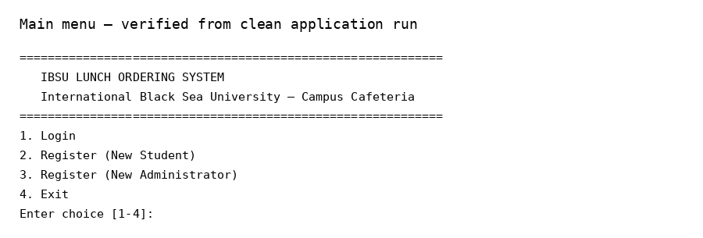

3. Demo Accounts
- Administrator: `admin` / `admin123`
- Student: `student` / `student123`
These credentials are for assessment demonstration only.

4. Student Workflow
After student login:
- Browse Menu
- Place an Order
- View My Orders
- Cancel an Order
- View My Profile
- Logout
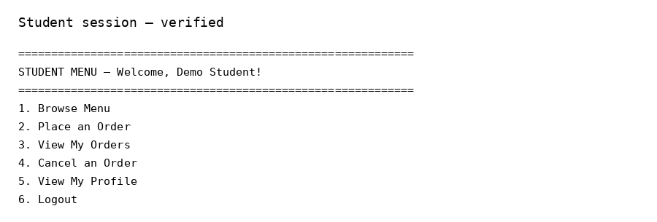

Browse Menu
Displays food items grouped by category with ID, description, price and current stock.

Place an Order
- Choose **2. Place an Order**.
- Enter a food-item ID.
- Enter quantity.
- Enter `done` when finished.
- Confirm with `y`.
- The system creates the order transactionally and decreases stock.
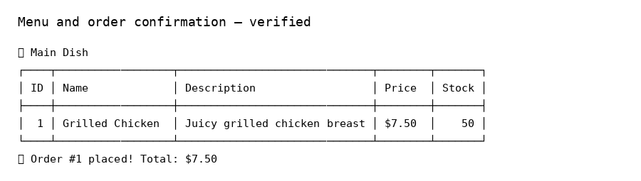

View My Orders
Displays the student's order history with date, total and status.

Cancel an Order
- Choose **4. Cancel an Order**.
- Enter the order ID.
- Only Pending and Confirmed orders can be cancelled.
- Eligible cancellation restores reserved stock.

View My Profile
Displays the logged-in student's username, name and contact information.

5. Administrator Workflow
After administrator login:
- Manage Menu Items
- Manage Categories
- View All Orders
- Update Order Status
- View Reports
- Import Menu from File
- Export Data
- Manage Users
- Delete Order
- Logout
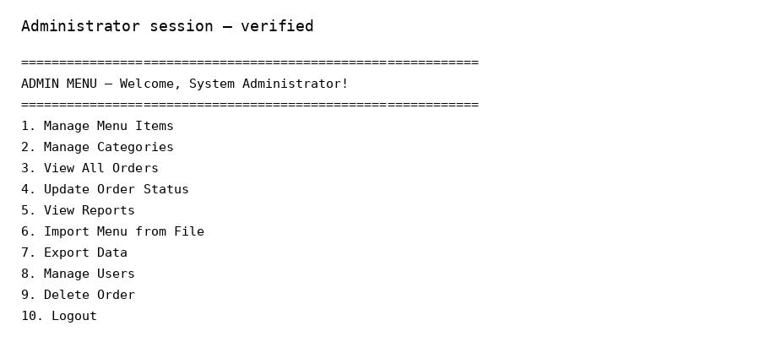

Manage Menu Items
The submenu supports add, update, delete, view and search operations.

Manage Categories
Supports add, update, delete and view operations.

View/Update Orders
Administrators can view all orders and change status through the defined status list:
Pending → Confirmed → Preparing → Ready → Completed, with Cancelled as the cancellation state.

Delete Order
Administrative deletion is provided for CRUD completeness. Pending/Confirmed orders restore reserved stock before deletion; later-stage orders do not restore stock.

Reports
The report menu provides daily sales, popular items, category revenue, charts and full report export.
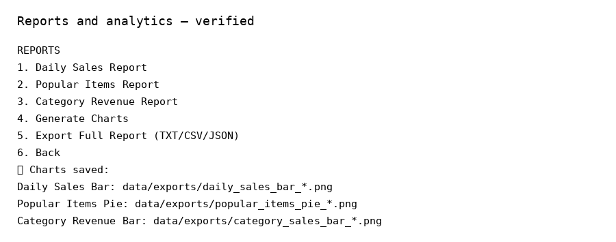

Import Menu
Use the sample files in `data/imports/`:
- `sample_menu.csv`
- `sample_menu.json`

Export Data
Exports order records to CSV, JSON or plain text in `data/exports/`.

6. Error Handling
Common messages include invalid credentials, duplicate username, insufficient stock, missing order/food/category and invalid input. The application logs errors and continues where recovery is possible.

7. Data Locations
- Database: `database/ibsu_lunch.db`
- SQL script: `database/schema.sql`
- Imports: `data/imports/`
- Exports: `data/exports/`
- Logs: `logs/app_YYYYMMDD.log`

8. Troubleshooting
- If dependencies are missing, activate `.venv` and rerun `python -m pip install -r requirements.txt`.
- If the database needs a clean rebuild, stop the application and remove `database/ibsu_lunch.db`, then restart.
- If the quote service is unavailable, the application displays a fallback quote; the main system remains usable.
- If a menu item cannot be deleted because of database relationships, review dependent order records before changing the data.

Technical Documentation

IBSU Lunch Ordering System

1. Architecture
The application uses a layered Model–View–Controller design.
View → Controller → Service/Model → Repository → SQLite
↑ ↓ ↓ ↓
└────── results/output ────────────────┘
- **Model:** domain objects such as `User`, `Student`, `Administrator`, `FoodItem`, `Order`, `OrderItem`, `Category` and `OrderStatus`.
- **View:** console menus, prompts and formatted output. Views do not access the database.
- **Controller:** validates/orchestrates requests and selects role-specific workflows.
- **Service:** authentication, file operations and reporting.
- **Repository:** object-oriented data-access layer wrapping parameterised SQLite queries.
- **Utilities:** validation and logging.
See `docs/diagrams/mvc.png` for the architecture diagram.

2. Object-Oriented Programming Evidence
See `docs/diagrams/classes.png` for a simplified class diagram.

3. Database Access
Repositories use parameterised SQL with `?` placeholders. No user input is concatenated into SQL statements. The order repository performs multi-step transactions for order creation, cancellation and administrative deletion.

4. Error Handling
Custom exceptions inherit from `IBSUAppError`, including credential, validation, stock, order, category, database, file and report errors. Controllers convert these exceptions into user-facing messages while logging unexpected failures.

5. File Handling
`FileService` demonstrates:
- CSV reading/writing using `csv.DictReader` and `csv.DictWriter`.
- JSON reading/writing using `json.load` and `json.dump`.
- Plain-text report writing using `with open(...)` for safe resource management.

6. Libraries
The implementation uses Python's `datetime`, `os` and `logging` plus external libraries including `requests`, `pandas`, `matplotlib`, `tabulate`, `pytest` and `pytest-cov`.

7. External HTTP Interaction
`ReportService.fetch_daily_quote()` uses `requests` to retrieve a daily quote. Network failures are handled gracefully with a local fallback message, so the core application remains usable offline.

8. Reporting and Analytics
`ReportService` converts repository results into pandas DataFrames and generates matplotlib charts for daily sales, popular items and category revenue. Full reports can be exported to text, CSV and JSON.

9. Logging
`setup_logger()` configures a named application logger with file and console handlers. The log file is stored in `logs/` and records application events, warnings and errors.

10. Security and Privacy
Passwords are stored as SHA-256 hashes for this academic implementation. A production deployment should use a password-specific password hashing algorithm such as Argon2 or bcrypt with unique salts. User data is limited to account identity/contact information required by the application. Demo credentials are for assessment use only.

11. Documentation and Code Quality
Public classes and public methods include PEP 257-style docstrings. Modules are grouped by responsibility and the final repository includes setup instructions, user guidance, diagrams, testing evidence and the reproducible SQL script.

12. AI, Copyright and Academic Integrity Disclosure
Generative AI assistance was used during final project review for code inspection, debugging suggestions, documentation drafting, assessment-rubric mapping and presentation preparation. The team remains responsible for understanding, verifying, testing and presenting the submitted code. Any third-party libraries, assets or external datasets must be acknowledged in the final submission. This disclosure is included to comply with the assessment's requirement for transparent AI use.

13. Known Limitations
- SHA-256 is retained for academic compatibility; Argon2/bcrypt is recommended for production.
- The quote API depends on Internet availability but has a fallback.
- The console interface is intentionally menu-driven for the assessment; a GUI/web layer is a future extension.
- The supplied ZIP did not contain a prior Git repository, so original Week 5 history and genuine historical pull requests cannot be reconstructed without fabricating evidence. The final repository should therefore be pushed to the team's real GitHub repository if historical work exists there.

Test Report

IBSU Lunch Ordering System
Test date: 10 September 2026
Environment: Python 3.13.5 runtime used for final verification; project targets Python 3.11+

1. Test Strategy
Testing combines:
- Automated pytest tests for models, repositories, services, validators and SQL schema reproduction.
- Negative-path tests for invalid credentials, duplicate accounts, invalid input, missing records, insufficient stock and invalid states.
- Manual black-box functional testing of the console application.
- User Acceptance Testing (UAT) sign-off to be completed by a human team member/stakeholder before submission.

2. Automated Results
160 passed
0 failed
Core-logic/data-access coverage command result:
Core source coverage: 81%
The overall source coverage is lower because interactive controllers, views and the entry point are primarily validated through manual end-to-end testing rather than unit tests.
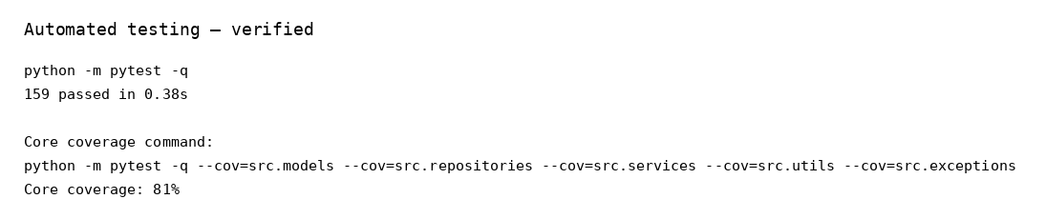

3. Functional Test Cases

4. Negative/Edge Cases
- Invalid menu selection.
- Non-numeric quantity.
- Zero/negative quantity.
- Negative price.
- Invalid username/password format.
- Duplicate username/category.
- Missing food/order/category record.
- Insufficient stock.
- Cancelling an already cancelled order.
- Cancelling a completed order.
- Invalid JSON/missing files.

5. Defect Log and Fixes

6. UAT Sign-Off Record
UAT must be completed by an actual user/team member and signed before submission. Do not fabricate this signature.
Tester name: ____________________________________
Role: ___________________________________________
Date: ___________________________________________
Version/commit: __________________________________
I confirm that I used the application according to the User Manual and that the major workflows met the agreed acceptance criteria.
Accepted: Yes / No
Signature: _______________________________________

7. Evidence Files
See `docs/screenshots/` for application/test screenshots and `docs/diagrams/` for architecture/database/class diagrams.

