`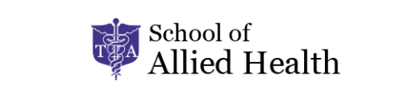

CNA
Student Handbook

Effective Date: January 2025
This handbook is designed to provide an overview of the services, programs, policies, and resources at the School of Allied Health in conjunction with the Technical Institute of America (TIA). It does not include all institute policies and procedures and is not meant to be exhaustive. Students are responsible for understanding and complying will all policies and procedures. Complete information on policies and procedures is provided online, available at www.tiamedical.com. All information contained in this student handbook is current as of January 2025.
Please be aware that the School of Allied Health in conjunction with the Technical Institute of America reserves the right to change the policies contained within the student handbook from time to time. School of Allied Health will make reasonable attempts to notify students promptly of any policy changes through website or email posting, or other methods deemed appropriate by the School of Allied Health administration.

Contents
General Information 4
Welcome to School of Allied Health 4
Nondiscrimination and Equal Opportunity 4
Emergency Procedures 4
Student Services & Support 5
Student Services Information 5
Directory of Student Services and Support 5
Achieving Success in Your Course 6
Enrollment and Registration 6
Payment Plan Schedule of Payments 6
Attendance Policy 6
Refund Policy 7
Classroom Dress Code Policy 7
Student Assessment Policy 8
Reciprocity 8
Behavior Policy…………………………………………………………………………………………………………………………………………….10-11
How to File a Complaint……………………………………………………………………………………………………………………………….12-13
Additional Program Information 13
Student Externship 13-14
Makeup Externship 15
Policy on Access to Student Records…………………………………………………………………………………………………………….15
Policy on Student/Faculty Access to Records………………………………………………………………………………………………..15
Copyright and Software License Infringement Policy……………………………………………………………………………………16
Applying for State Certification Exam 17-23

General Information

Welcome to TIA School of Allied Health
Welcome! Thank you for choosing TIA School of Allied Health for your training needs. We have created this Student Handbook to:
- Provide you with an introduction to our facility.
- Support you as you get started in your program and help address questions.
- Provide you pertinent information about your course structure.
- Inform you of policies and how they impact you.
It’s imperative you take the time to review this handbook to become informed of the things that will be expected of you as you progress in your course. TIA School of Allied Health makes every attempt to remain flexible; however, rules and penalties will not be waived or exceptions granted just because a student is unaware of specific policies or procedures. In addition to this handbook, School of Allied Health also provides up-
to-date information about our facility and programs on our website, www.tiamedical.com.
As a School of Allied Health student, you will have access to experienced and accomplished faculty members, rich course content, and expansive resources. Our programs provide the ability to work hands-on with full access to our in-facility lab which gives you the edge to completing your program successfully.

Nondiscrimination and Equal Opportunity
School of Allied Health is fully committed to complying with all federal, state and local civil rights anti-discrimination and equal opportunity laws, rules and regulations. School of Allied Health does not engage in harassment or discrimination against any person because of race, color, religion, national origin, ancestry, age, gender, gender identity, sexual orientation, disability, citizenship status, marital status, military status or any characteristic protected by law, in admission and access to, treatment and employment in its programs and activities. School of Allied Health will make reasonable accommodations in compliance with the Americans with Disabilities Act, a student’s immutable characteristic(s) substantially impairs the student’s ability to perform the requirements of an academic program or related program activities.

Emergency Procedures
In the case of national and local emergencies that affect the delivery of education to the student body, the facilities faculty will use email and telephone to alert students and other staff to alternate dates to make up the course work in class.

Emergency Preparedness Plan
Purpose and Scope
The purpose of this Emergency Preparedness Plan is to ensure the safety and well-being of students, faculty, and staff in the event of an emergency. This plan outlines the procedures for responding to various emergencies, including medical incidents, natural disasters, fire, security threats, and other critical situations.
This plan applies to all TIA School of Allied Health locations and is designed to comply with local, state, and federal safety regulations.
The Emergency Response Policy ensures that the staff is responsible for implementing and managing emergency procedures. This includes:
Director (Emergency Response Leader) – Oversees emergency response efforts and communication. Ensures adherence to emergency protocols and regulatory requirements.
Administrative Staff & Faculty Representatives – Assist with student safety and emergency drills.
Emergency Communication Plan
Effective communication is critical in an emergency. TIA School of Allied Health utilizes multiple notification methods to ensure timely alerts.
Emergency Notification System (ENS): Alerts sent via email and cellular devices to students, faculty, and staff.
Emergency Procedures
Medical Emergency
Call 911 immediately and notify the Director or nearest faculty/staff member.
Provide first aid if trained and only if it is safe to do so.
Direct emergency responders to the affected individual’s location.
Complete an Incident Report after the emergency has been resolved.
Fire Emergency
Activate the nearest fire alarm and call 911.
Evacuate the building following posted evacuation routes.
Faculty should guide students to designated assembly areas.
Do not use elevators. Assist individuals with mobility impairments.
Wait for further instructions from emergency personnel before re-entering the building.
Severe Weather / Natural Disaster
Tornado/Hurricane: Move to interior rooms away from windows and doors.
Earthquake: Take cover under desks or sturdy furniture. Stay indoors until shaking stops.
Flooding: Move to higher ground and avoid flooded areas.
The school will follow local emergency management alerts and advise closures if necessary.
D. Security Threat (Intruder/Active Shooter)
Follow the Run, Hide, Fight protocol:
Run – Evacuate if it is safe.
Hide – Lock or barricade doors, turn off lights, and remain silent.
Fight – As a last resort, attempt to incapacitate the intruder.
Call 911 and provide detailed information.
Await law enforcement instructions before exiting a secure area.
Power Outage
Report outages to the Director immediately.
If necessary, classes may be temporarily suspended or moved to a safe area with backup lighting.
Maintain communication through mobile alerts and school staff.
Hazardous Materials Spill
Evacuate the affected area immediately.
Call 911 and notify the Director & Safety.
Do not attempt to clean up the spill unless trained to do so.
Follow emergency response guidance from fire or hazmat teams.
Evacuation Plan
Assembly points are designated outside the building where roll calls will be conducted.
Faculty and staff will assist students and visitors in evacuating safely.
Emergency Drills & Training
Fire drills will be conducted at least twice per year.
Faculty and staff will receive annual emergency response training.
Emergency procedures will be reviewed annually and updated as needed.
Plan Review and Updates
This Emergency Preparedness Plan is reviewed annually by the director and staff and updated based on new regulations, incident reports, and best practices.

Student Services & Support

Student Services Information
We are glad you are a student at TIA School of Allied Health. During your time here, we vow to provide you with support in your educational goals. A list of services and contacts is provided below to help direct your questions. In addition, your training coordinator serves as a point contact for any/all inquiries.
Student services are available to you from the time you enroll to post State Board examination. Please contact your training coordinator for any/all inquiries regarding student services at selenaa@tia.edu or nycreceptionist@tia.edu
Hours of Operation:
Open Facility: Monday – Sunday 8:30am – 5pm
Head Administrator: Monday – Friday 9am to 5pm

Directory of Student Services and Support
Department/Service | Functions
Head Administrator:  Selena Augustus  [selenaa@tia.edu] | Program coordinator can assist you with scheduling your exam (after your externship is completed), and making payments. Can assist via email with any concerns/questions/complaints you may have about the course.
Assistant Administrator:  Jessenia Lopez [nycreceptionist@tia.edu] | Can assist you with class requirements such as submitting your diploma, make up hours, and making payments.  For externship concerns, including medical paperwork review and scheduling your externship (after the final class day), reach out to John Cruz at johnc@tia.edu
CNA/Nurse Aide Instructors | Your CNA/Nurse Aide instructor will be able to assist you with questions you may have about the field and passing your State Board exam. Will also go over the state exam application and money order with you.
Prometric  1 (800) 805-9128  [nycnasupport@prometric.com] | Prometric is the company that processes State Board exam applications as well as proctors exams. They can assist you with anything regarding your State Board exam application after it has been mailed out as well as State Board exam results.

Achieving Success in Your Course

Enrollment and Registration
It is required; a student must have a high school diploma or GED to register for the CNA program. A high diploma or GED must be submitted by the end of the first week of your class schedule.
After the completion of the course registration, students must meet ALL obligations to pay tuition fees by the payment deadline in order to maintain their access to the course. Students who have enroll in our payment plan option, a $300.00 payment is asked during the time of registration, an additional $340 on the first day and the remaining tuition balance must be paid by the 5th week of classes. Below you will find our payment plan. Students who do not meet the tuition obligation deadline will not be allowed to continue their course until balance is paid. This will result in missing course hours. Please refer to Attendance Policy section.

Payment Plan Schedule of Payments
- First day of the class you MUST pay $340 to start the class.
- Second week of class you MUST pay $339.80 to continue in the class.
- Third week of class you MUST pay $339.80 to continue in the class.
- Fourth week of class you MUST pay $339.80 to continue in the class.
- Fifth week of class you MUST pay $339.80 to be able to attend the externship and CNA state exam.

Attendance Policy
Students MUST attend the first day of class. Failure to do so will result in being dropped from the course. Maximum learning outcomes are achieved through course attendance and interaction. All students are responsible for regular attendance during their course schedule. This is designed to measure the student’s active engagement in the class. It counts toward your overall average in class. This includes class discussions, group activities and overall participation in the learning process. Regular attendance is important for a student’s success. ALL missed course hours MUST be made up in order to graduate. Any student missing more than 16 hours will automatically be withdrawn from the course with a partial refund, based on enrollment agreement. Tardiness, absences, and early dismissal will contribute to hours not attended. Lateness is rounded up to the nearest hour, so even 1 minute of lateness will count as a full hour of missed class which will need to be made up. DON’T BE LATE!
To makeup course hours, students must attend makeup during any course aside from the class you are registered for. Student will have up to one (1) month to complete their make-up hours. Student must keep track their own makeup hours by using the make-up form, which the instructor can provide.
All make-up hours must be documented and signed by the course instructor in order to receive credit for made up hours. Please ask your instructor to provide a make-up hours form. All students must have 100% attendance.

Refund Policy
To request a refund, use the following link and complete the form. https://tiamedical.com/refund

A student who cancels within 7 days of signing the enrollment agreement but before instruction begins receives all monies returned with the exception of the non-refundable registration fee. Thereafter, a student will be liable for the non-refundable registration fee plus the cost of any textbooks or supplies accepted plus tuition liability as of the student's last date of physical attendance.

Tuition liability is divided by the number of quarters in the program. Total tuition liability is limited to the quarter during which the student withdrew or was terminated and any previous quarter completed.

If Termination Occurs | Subsequent Quarters | School Can Keep
Prior to or during the first week |  | 0%
During the second week | During the first week | 25%
During the third week | During the second week | 50%
During the fourth week | During the third week | 75%
After the fourth week | After the third week | 100%

Classroom Dress Code Policy
Student must arrive daily with clean and ironed TIA uniform. Any color closed toe shoes are required. NOT acceptable: sandals, flip-flops, hats, bonnets, head wraps (unless for religious reasons), durags, excessive lashes, or jewelry (unless wedding band or religious). Artificial nails and/or colorful nail polish are also not acceptable during class. Natural, trimmed nails are required for CNA students.
*Long hair must be tied up in skills lab*

Student Assessment Policy
Students must complete all course exams. Failure to do so may be subject to review of your performance by the instructor and academic advisor. Academic deception is grounds for immediate discharge from the program. Your assessments are the overall score of your exams only. These include Exams 1, 2, 3, 4, a midterm, and a final exam. These exams are mandatory evaluations designed to measure the student’s understanding and knowledge. In order to pass this course, a student must achieve a 70% overall grade, or higher. There are no retakes on exams. If a student misses an exam day, they must have proof of excuse of absence or they will receive an automatic 0%. If a student does not meet the minimum requirement of a 70%, they will need to repeat the entire course and will be required to pay the current tuition rate at the time of re-enrollment.
Competency
In this program, you are required to learn hands on skills training. Competency is a major factor in successful completion of this course. This will determine whether a student qualifies to graduate or not. These necessary skills are a requirement before you can enter the workforce.
Grading Rubic
ATTENDANCE: 10%
EXAM 1: 10%
EXAM 2: 10%
MIDTERM:20%
EXAM 4: 20%
FINAL EXAM 30%

Reciprocity
To transfer a student’s CNA/Nurse Aide certification to another state, the student must contact that State’s Department of Health or the department that is responsible for CNA/Nurse Aide certification. If a student is considering relocating to another state, please contact Prometric at 1-800-805-9128 at the start of your course to put a plan in place.

Behavior Policy
Students are expected to conduct themselves in a professional and responsible manner. This means the demonstration of mutual respect and civility towards all other students, staff, and other authorized representatives. Students must take responsibility for their behavior and as such, if a student is unable to conduct themselves in a professional manner and chooses to take part in the inappropriate behaviors below, that student will face potential removal from the program.
Inappropriate behaviors include but are not limited to:
- Harsh words and/or actions; threats made verbally and/or written will be considered harassment, or in some cases criminal behavior.
- Harassment-sexual, racial, ethnic, or otherwise-that has the intentional or unintentional effect of creating a hostile or offensive educational work environment of any student, faculty or staff member.
- Any disruptive behavior in the classroom, labs, or any part of the school including the use of profanity, interrupting other students or teachers during designated learning, or
unnecessary/excessive cellphone usage.
- Refusing to obey ANY reasonable directive given by staff members, being combative when given instructions.
- The use of drugs or alcohol is not permitted under any circumstances. This includes coming to class under the influence of any drugs or alcohol. Vaping or smoking cigarettes is not allowed on the school floor or inside the building.
- Cheating- any use or attempts to use unauthorized materials, information, copying another student’s work, or study aids in academic exercise, INCLUDING EXAMS.
- Falsification of ANY information, citation or legal document.
- Exhibiting threatening behavior, either verbal or physical to any fellow students or staff members.
- Cleanliness- all students are required to clean up after themselves including the bathrooms, labs, and classrooms. Be mindful of the handling of fragile school supplies or materials. If any are damaged or destroyed, please notify a staff member so that it can be cleaned, fixed, or replaced.
- Violation of the academic integrity policy, other facility regulations and polices, or any other violations of federal, state, or local laws or regulations that impact the facility’s educational environment.
- Any actions not specifically mentioned which can be reasonably expected to result in the degradation of educational environment for other students.

Failure to comply with the school’s behavior policy may result in the student being removed from the class/program and/or from the facility entirely after 3 strikes:
- Verbal warning
- Written warning with student signature
- Removed from course with refund depending on EA

How can a complaint be filed by a student or employee?
Student Code of Conduct Violation Policy
TIA School of Allied Health is committed to maintaining a safe, respectful, and fair educational environment. The institution has established a Code of Conduct Violation Report process to provide students with a clear pathway for raising concerns or complaints and receiving a timely, impartial response.
Policy Summary:
- Step 1 – Informal Resolution:
Students are encouraged to first address their concern directly with the instructor or staff member involved. If the issue cannot be resolved informally, the student may proceed to the formal resolution process.
- Step 2 – Written Complaint to Director of Operations:
Students must submit a written grievance using the Code of Conduct Violation Report, detailing the issue, individuals involved, and desired outcome. The Director will investigate and provide a written response within 3–5 business days.
- Step 3 – Final Review:
If the student is dissatisfied with the Director’s response, they may request a final review by upper management or ownership. A final written decision will be issued within 10 business days, and no further internal appeal is available.
- External Escalation:
If the matter remains unresolved internally, students may escalate their complaint to the New York State Education Department or the Accrediting Council for Continuing Education and Training (ACCET). Contact details are available in the student handbook and catalog.
This policy is provided to all students through the student handbook and reviewed during orientation to ensure transparency, accessibility, and understanding.

TIA School of Allied health takes complaints of sexual and other unlawful discrimination, including sexual harassment, sexual assault and sexual violence very seriously. The School encourages students, employees and third parties who have experienced or know of an incident of sexual or other unlawful discrimination, including sexual harassment, sexual assault and sexual violence to speak with the School Director about what happened so that the School can respond appropriately. If any employee of this School experiences, observes or learns of an incident of unlawful discrimination, the employee must immediately report the incident to the School Director. There is no time limit for reporting discrimination. However, allegations should be reported as promptly as possible as a delay in making the report may make it more difficult for the School to investigate allegations. The School strongly encourages all individuals to seek assistance from a medical provider and or local law enforcement immediately after an incident of sexual violence.

Student Complaint Contact Information
Students who have concerns or grievances that are not resolved through TIA School of Allied Health’s internal complaint process may contact the following external agencies:
Accrediting Council for Continuing Education & Training (ACCET)
Accrediting Commission
www.accet.org
Email: complaints@accet.org
Address: 1722 N Street NW, Washington, DC 20036
Phone: (202) 955-1113
New York State Education Department (BPSS)
Bureau of Proprietary School Supervision
Email: bpss@nysed.gov
Phone: (518) 474-3969
Address: 89 Washington Avenue, EBA Room 560, Albany, NY 12234

Additional Program Information
If a student finishes class 95 Hours only and they have to take externship, they have a year to take it from the end Date from the 95 hours class. No Exceptions. If student Finish class 95 Hours only and they have to make up hours, they have a month to make up the time from the end date of the course (unless they have proof of reason for why they can’t take within month, examples include: doctors note, death in family, personal injury/surgery, and/or pre plan trip before the start date of the class) . No exceptions

Student Externship
At the end of the training course students with a balance of $0.00 and have submitted all required documentation are eligible to schedule their internship. Students will be automatically scheduled for the soonest available externship closest to them. Externships are scheduled on a first come first serve basis, based on whoever submitted their physical first. Physical forms must include ALL required documents, or they will not be accepted. Only eight (8) to ten (10) students are scheduled at a time.
After scheduling a student’s externship, a second confirmation email with further details will be sent to the student’s email address two (2) days prior to the first day of the schedule externship.
Externships are scheduled Monday-Thursday, Saturdays or Saturday-Sunday from 7am – 2:30pm, 7am – 3pm or 7:30am - 3:30pm. Students MUST attend all 30 hours.
Saturdays Only and Monday - Thursday externships are held at:
Oceanview Nursing Home (7am – 2:30pm)
315 Beach 9th St, Far Rockaway, NY 11691
OR
Rebekah Rehab Extended Care Center (7am – 3pm)
1070 Havenmeyer Ave, Bronx, NY 10462

Saturday & Sunday Weekend externships are held at:
Isabella Center for Rehabilitation and Nursing Care (7:30am – 3:30pm)
515 Audubon Ave, New York, NY 10040
Students must arrive in a clean and ironed TIA uniform with solid white shoes (ABSOLUTELY NO color or NO open toe shoes) Ready and prepared to begin promptly at the listed start time for your externship. Students are not allowed to show up with any of the following:
- Any shoe that is not COMPLETELY white (white shoe, white shoe laces, etc)
- No open toe shoes such as sandals or flip-flops
- No sneakers
- No loose or messy hair
- No jewelry (meaning no facial jewelry or wrist or around neck)
- No ACRYLIC nails (gel or wrap) No color nail polish Natural nails only.
- No headwear unless it is for religious purposes and hair must be pulled away from face.
- All tattoos must be covered.
- No eating in the lobby of the nursing home.
- No flags, symbols, pins, badges, or patterns. Must strictly wear uniform: the only exceptions are religious attire (e.g. hijab)
- No hats, bonnets, head wraps (unless for religious reasons), or durags
- No excessive lashes or jewelry (unless wedding band or religious).
Everything that is expected for the externship is expected in class as well, except in regards to the footwear rules. However: the no open toe shoes rule still applies.
Failure to comply with any of the above information will results in dismissal of the externship for that day, and in some cases, dismissal from the CNA program.

Makeup Externship
Missed, late, or dismissed externship students MUST reschedule for a future date.

Policy on Student Access to Records:
TIA School of Allied Health guarantees students the right to access their educational records in compliance with the Family Educational Rights and Privacy Act (FERPA). The institution will not release personally identifiable information about an individual student without the student’s written consent, except as permitted by law. Students have the right to request and review their academic, financial, and enrollment records. Requests must be submitted in writing to administrative staff emails, which will provide access within 2-3 business days. Students may request copies of their transcripts, attendance records, and financial statements as needed. Access is granted only to the student unless written consent is provided for third-party release.

Policy on Faculty Access to Records:
Faculty may access relevant student records, such as grades and attendance, through the Student Information System (SIS) to support academic monitoring and student success. Faculty do not have access to financial or disciplinary records. Requests for additional records must be approved by the Director.

Communication of Policies:
Student Handbook & Catalog: Policies on record access and privacy are outlined in the Student Handbook and Course Catalog, which are distributed during orientation and available online.
Faculty Handbook: Faculty access policies are documented in the Faculty Handbook, provided during onboarding and available on the institution’s internal portal.
Training & Advising: Staff and faculty receive training on FERPA compliance and student records management to ensure proper handling and confidentiality.
These policies ensure that students and faculty can securely access records while maintaining compliance with regulatory and institutional guidelines.

Copyright and Software License Infringement Policy
TIA School of Allied Health is committed to upholding all applicable copyright laws and software licensing agreements. In accordance with federal and state regulations, as well as institutional values of academic integrity and ethical conduct, all students, faculty, and staff are expected to respect and adhere to copyright protections and licensing terms for all forms of intellectual property.
Prohibited Conduct
The following actions are strictly prohibited and may result in disciplinary action, including but not limited to suspension, expulsion, or legal consequences:
- Unauthorized reproduction, distribution, or display of copyrighted materials, including textbooks, articles, videos, images, and online content.
- Installation, use, or sharing of software without a valid license or in violation of the licensing agreement.
- Downloading or sharing copyrighted media (such as music, films, or software) through peer-to-peer networks or unauthorized websites.
- Circumventing digital rights management (DRM) protections or using unauthorized methods to access protected content.
Responsibility and Compliance
All members of the TIA community are responsible for ensuring that their use of digital and printed materials complies with copyright laws and software licenses. Faculty and staff are also responsible for guiding students in the appropriate use of academic and technological resources.
Institutional Measures
TIA School of Allied Health provides access to legally licensed software and educational materials through approved channels. The institution regularly monitors systems and networks to identify and address potential infringements, and provides educational resources to promote awareness and compliance.
Reporting Violations
Suspected violations of this policy should be reported to the appropriate administrative office. TIA School of Allied Health will investigate all reported incidents promptly and take appropriate action in accordance with institutional procedures.
Conclusion
TIA School of Allied Health takes copyright and software license compliance seriously and encourages all members of its community to act responsibly and ethically in their academic and professional activities.

Applying for State Certification Exam
The end of a student’s course will mark the last day of their externship. The course is only fully complete after a student has attended their externship. Once externship is completed, students can apply to take the State Certification Exam.
State Exams are proctored by Prometric a state testing agency. The exam is made up of two (2) parts which consist of written and clinical skills. Exams are administered on Thursdays from 10am-6pm or Fridays from 10am-4pm at the school. Students must show up half an hour early at 9:30am. Exam dates are subject to change. Exam applications must be completed by printing it out from the Student Portal on https://tiamedicalcourses.com, or by visiting the below link to print and fill out the forms under “Candidate Resources”, followed by “Paper Application”. You must submit the application and money order to your instructor, so that they can go over it with you in class.
https://www.prometric.com/nurseaide/ny
For instructions on how to complete the application on your own, please refer to “How to Complete Your Prometric Application“, on pages 14-19 of this Student Handbook. Then, submit the application to your instructor.
All Prometric applications and exam fees must be mailed by the school in order to complete the application process. Please visit http://cna.tiamedical.com/ to view available exam dates.
If not done in class, a physical copy of the student’s exam application and money order in the amount of $115.00 must be presented to TIA between Monday-Friday, 9am - 5pm. All money orders are made payable to “NY Commissioner of Health, NYNA”. Exams are scheduled on a first come first serve basis. Deadlines for application and money order submissions are 11 business days before the exam date. Only six (8) students are scheduled at a time but a minimum of four (4) are required.
If student cancels or reschedules once they confirm their testing date, the student must pay the rescheduling fee which is $115. Student must in bring in a new money order as well as new application.
TIA does not have control of Prometric. we try our best to assist our students within reason however understand that Prometric has full reign over the following
- Cancelations of students’ exams.
- Rescheduling,
- New Dates
- new money order.
- grades, pass or fail
- Access to Prometric records.
- Etc.

TIA School of Allied Health is only responsible for mailing applications and money orders to Prometric in order to process. Once Prometric has received a student’s application and money order, the process can take up to three (3) weeks. Applications are not sent to Prometric until TIA receives four (4) candidate’s applications but no more than eight (8).
As the student, you are responsible for making sure all the information filled out on the application is accurate. If the student’s application is fill out will inaccurate information, the application may not be processed. If the student’s application is not turned in by the deadline, the application will not be processed in time.
If a student’s application has been mailed with exam fees, all issues thereafter are the responsibility of Prometric. All complaints, concerns, and inquires must be addressed with Prometric by calling 1-800-805-9128.

School of Allied Health is not responsible for the following:
- Applications and money orders that have been lost after mailing
- Applications not processed on time

Other Important Information Regarding the State Certification Exam:
Students are expected to arrive no later than 9:30am with two (2) forms of identification on exam day. One (1) identification must include a picture and a signature. Example of proper id are: passports, EBT cards, state driver’s license or identification cards. Failure to arrive without the proper ID, will result in forfeit exam fees and will be obligated to pay again. Students are also expected to stay the entire exam day from 9:30am-4:00pm.
Students are allowed two (2) years from the last day of internship to complete the exam. If a student does not complete the exam within two years, the student will have to complete the training course, internship and schedule the exam again. Students will be subject to pay tuition fees again.
There is a $100 fee to reschedule the exam once applications have been mailed out. All rescheduled exam requests must be submitted to TIA five (5) business days prior to the schedule exam. Any students who miss the exam or arrive late will forfeit all exam fees and will be obligated to pay exam fees again.
Students are allowed to retake their exam by submitting a new application and money order. The following money order amounts are for retaking the exam only:
$115.00-first exam
$57.00- written exam
$68.00- clinical skill exam
$125.00- both exams (written and clinical skills)

According to New York State Regulations, any student who fails the certification exam after the third attempt must complete their CNA training course at another school.

How to Complete Your Prometric Application

*You can only apply after your externship and class requirements are complete*
- You must first purchase a $115 money order. This can be purchased at a bank, convenience store, or post office.

- You must then visit the following link on Prometric’s website. Go to the link below and click on “Candidate Resources”.

https://www.prometric.com/nurseaide/ny

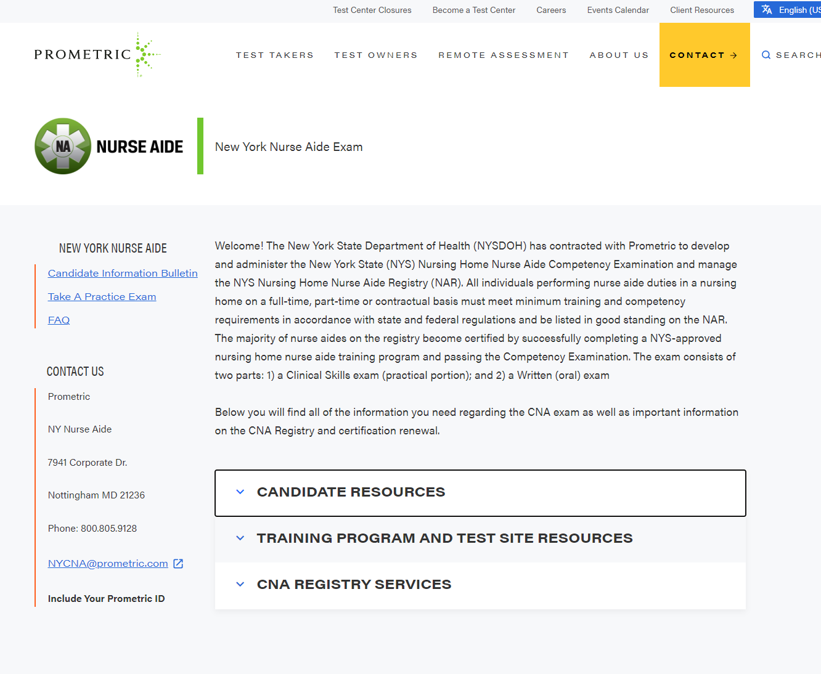
- Click “Paper Application” under “Applications & Other Forms and print it out. 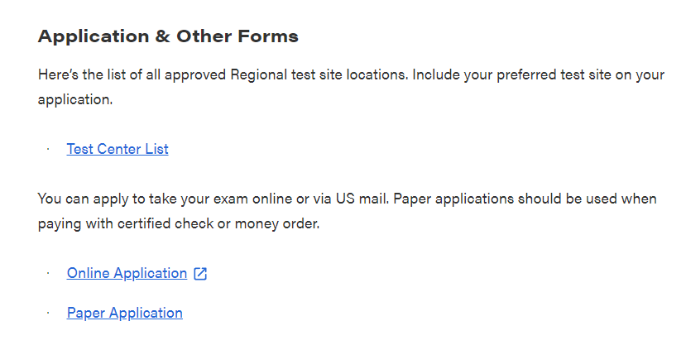
- Please complete every section and page of the application, except for page 3. Page 3 will be completed by the CNA Coordinator at the front desk upon submitting your application and money order.

- Make sure to check off “Not Employed” under Current Nursing Home Employment Status (page 2)
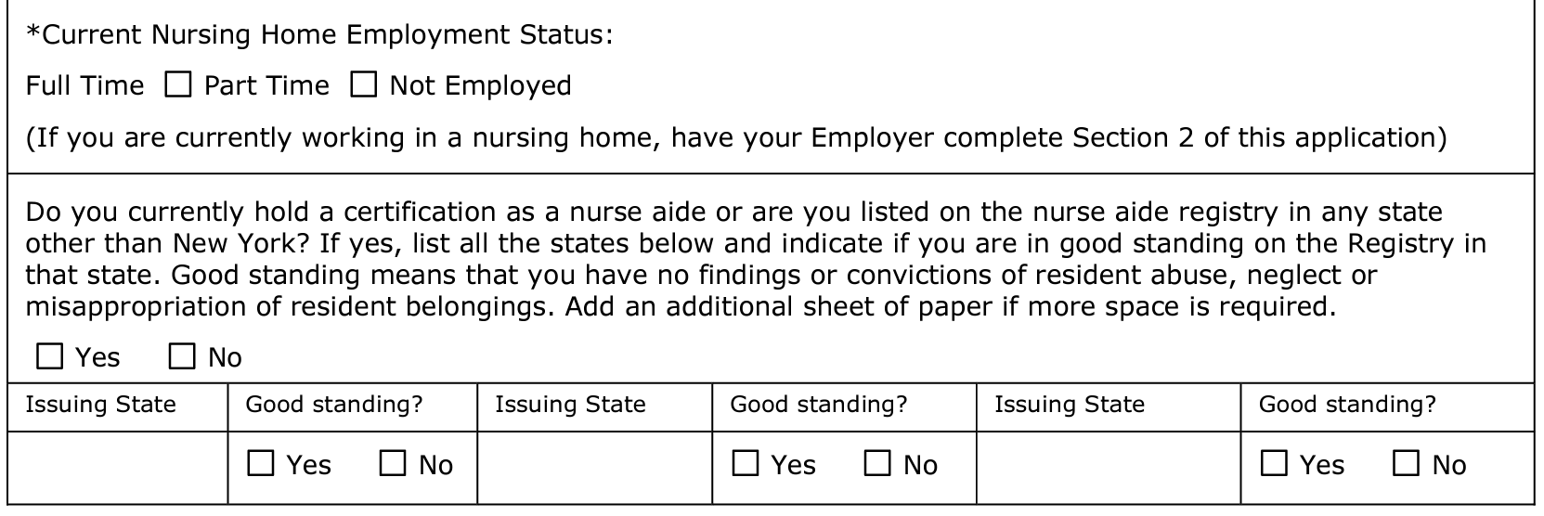

- You will then go to the “Certification Option/Eligibility” section of page 2 and check off “Route 1 – New Nurse Aides”. Under “Test Site Information” on page 4, check off the “Testing at your Facility” option to test at TIA.
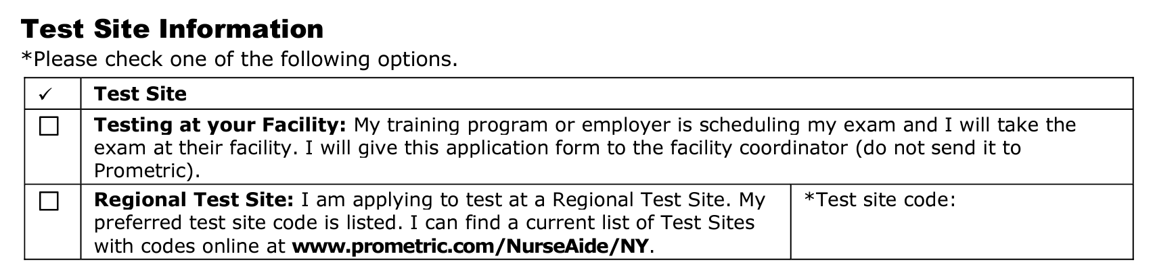

- You will then go straight to the “Exam Selection and Processing/Exam Fees” where you will check off “Clinical Skills Test and Written Test” for a total of $115 under “First – Time Tester.” Then check off “Money Order” and input the number of the money order you purchased. On page 5, fill out your signature and the date at the bottom where indicated.
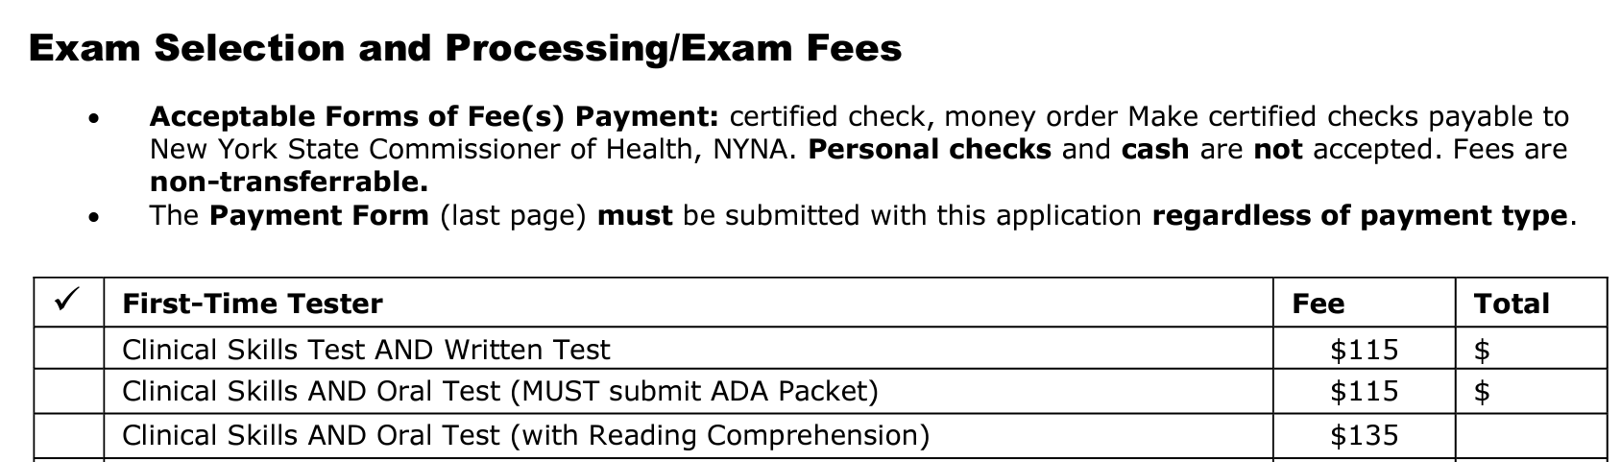
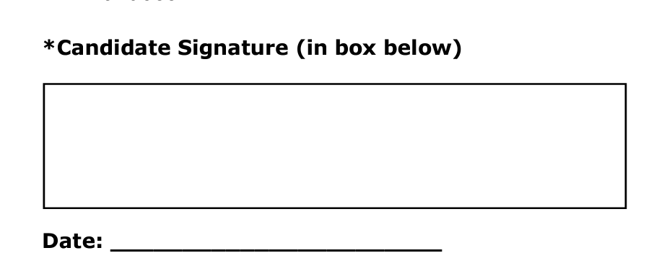

- Fill out your name and date of birth on page 6. Check off “Money Order” and include the numbers below.
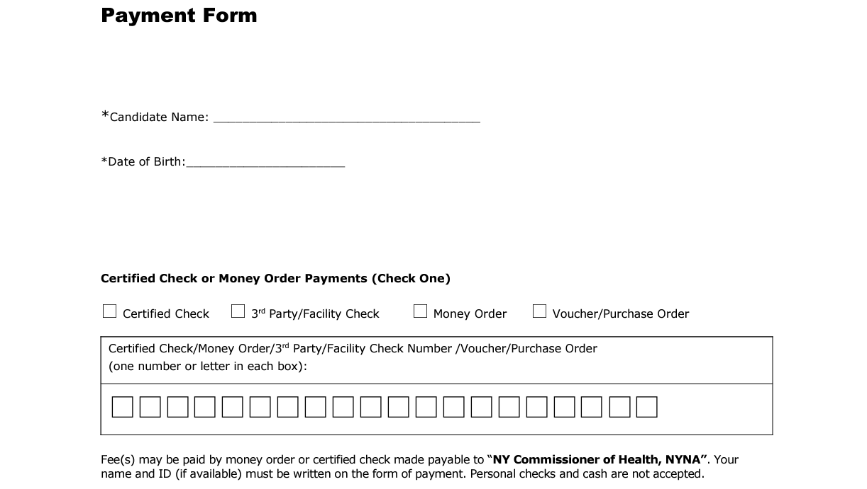

- Submit your hard copy application and money order ($115) to your instructor at TIA in order to schedule your exam at the school. Money orders are made payable to: NY Commissioner of Health, NYNA. Please arrive with printed application and money order. The school is not responsible for printing applications for students. See below for an example of a filled out money order:

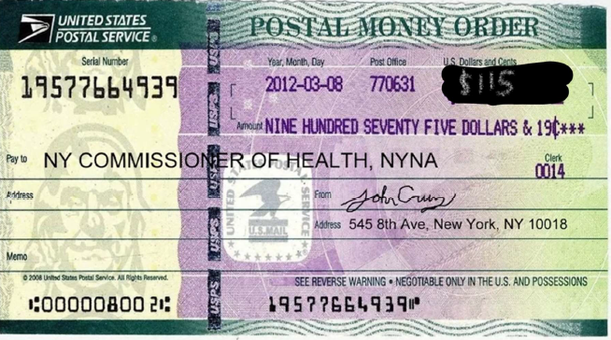

- You can see the available exam dates at https://cna.tiamedical.com/. Requests are not guaranteed, and are confirmed on a first come, first serve basis. It may take up to 2 weeks for an email confirmation to be sent.

First Exam $115.00
Retake Clinical Exams-$68.00
Retake Written Exam-$57.00
Retake Written & Clinical Exams-$125.00

Retake Exam:
Students must provide a new Prometric application and money order of the retake fee. Please see the above instructions.

