Our Magical Statistics Adventure
Barbra and Lisa
2026-03-17

Research Question
We examine how healthcare expenses are associated with patient age, gender, and healthcare utilization, measured as the number of encounters.
Our main research question is:
How are healthcare expenses associated with age, gender, and healthcare utilization (number of encounters)?
We also explore three related sub-questions:
- How do healthcare expenses vary across age groups?
- Are there differences in healthcare expenses between male and female patients?
- Is the number of healthcare encounters associated with healthcare expenses across genders?

Descriptive Statistics
Characteristic | Overall N = 6,851¹ | F N = 3,458¹ | M N = 3,393¹ | p-value²
age | 42 (22, 62) | 41 (21, 60) | 43 (23, 64) | <0.001
n_encounters | 96 (43, 180) | 124 (46, 213) | 80 (40, 141) | <0.001
healthcare_expenses | 103,689 (22,444, 260,417) | 152,023 (23,258, 421,262) | 85,742 (21,343, 171,986) | <0.001
¹Median (Q1, Q3)
²Wilcoxon rank sum test
- Approximately equal number of males and females
- Age is balanced between genders
- Encounters for women are higher
- Medical expenses for women are higher

Barchart of Expenses by Age and Gender
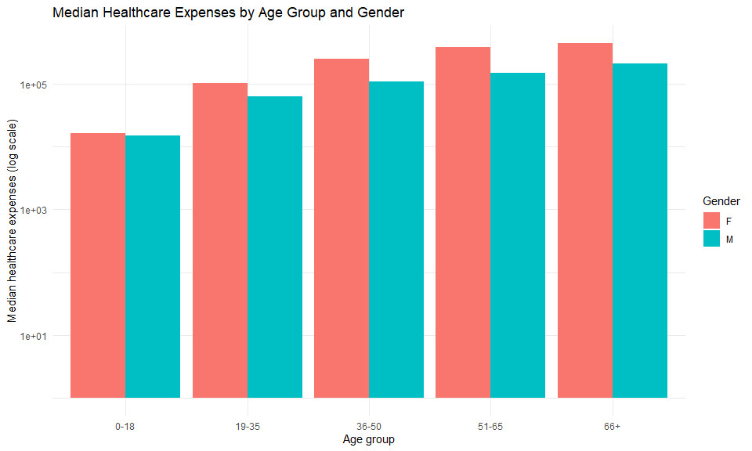
- Even though age and gender were evenly distributed, expenses for women are clearly higher.
- As age increases, so do expenses for both genders.

Scatterplot of Encounters to Expenses Compared Between Genders
`geom_smooth()` using formula = 'y ~ x'
`geom_smooth()` using formula = 'y ~ x'
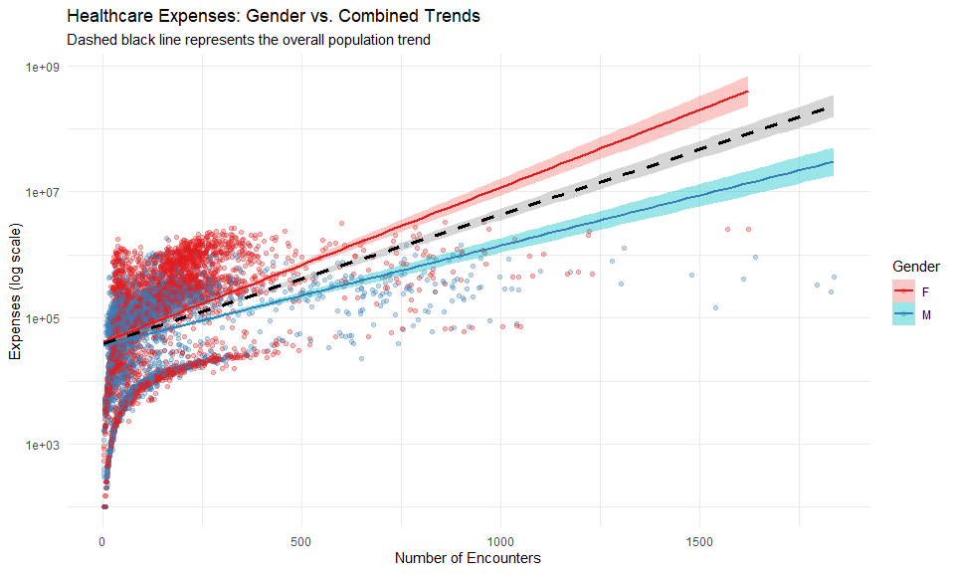
- Both genders have increased cost for increased encounters.
- The increase is steeper for women than men.

Linear Regression
# Since regression_results is a raw 'lm' object,
# we use tbl_regression to make it look pretty like the rest!
#| echo: false
library(gtsummary)
tar_read(regression_results) |>
tbl_regression()
Characteristic | Beta | 95% CI | p-value
age | 0.04 | 0.04, 0.04 | <0.001
gender
F | — | —
M | -0.60 | -0.67, -0.54 | <0.001
n_encounters | 0.00 | 0.00, 0.00 | <0.001
Abbreviation: CI = Confidence Interval
log(1 + healthcare_expenses) ~ age + gender + n_encounters
- Increasing age leads to increasing expenses
- Being male decreases expenses
- Increasing encounters increases expenses
All are significant

Thank you! 💖

