EL9: Big data

Big data
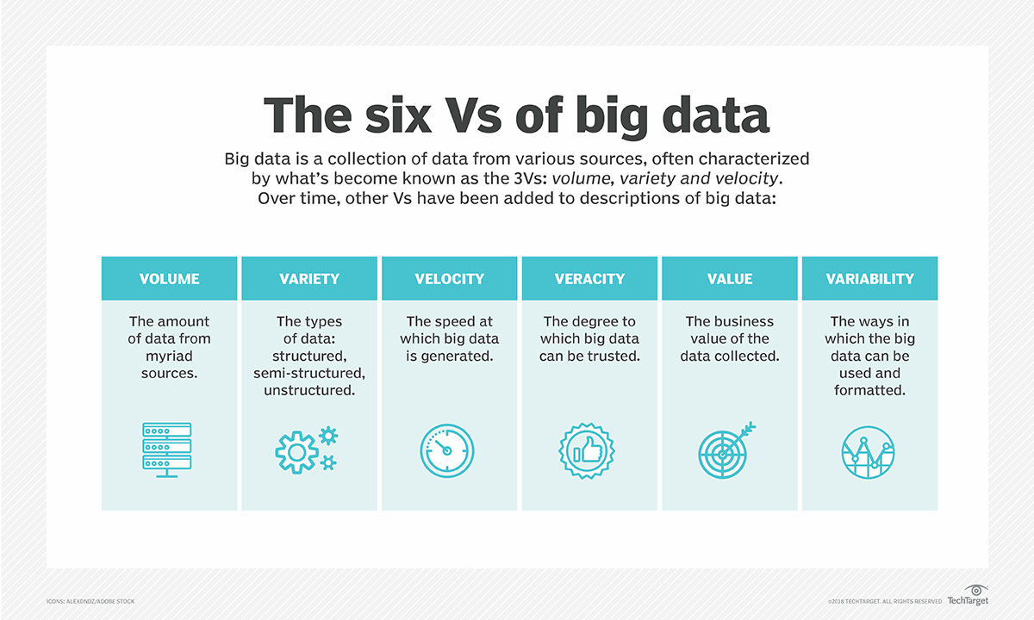

Biggish data
My definition:
- Only tabular data
- Original data might fit into physical RAM but …
- might be multiplied due to temporary necessity
- physical RAM might be constrained due to other processes/settings
- things might just take too much time … and life is short …

Software
- SAS for big data files from register holders
- R for everything else
- Database?

File format

File storage
- Avoid reading big files over ethernet connection
  - data stored on network drive
- Usually faster to first copy file to local SSD drive
  - fs::file_copy(path, new_path)
  - (“libuv provides a wide variety of cross-platform sync and async file system operations.”)
  - obviously only if “local drive” is also in the (same) secure environment
- work with the project on disk
- move back
- Although not always possble with very large files it seems

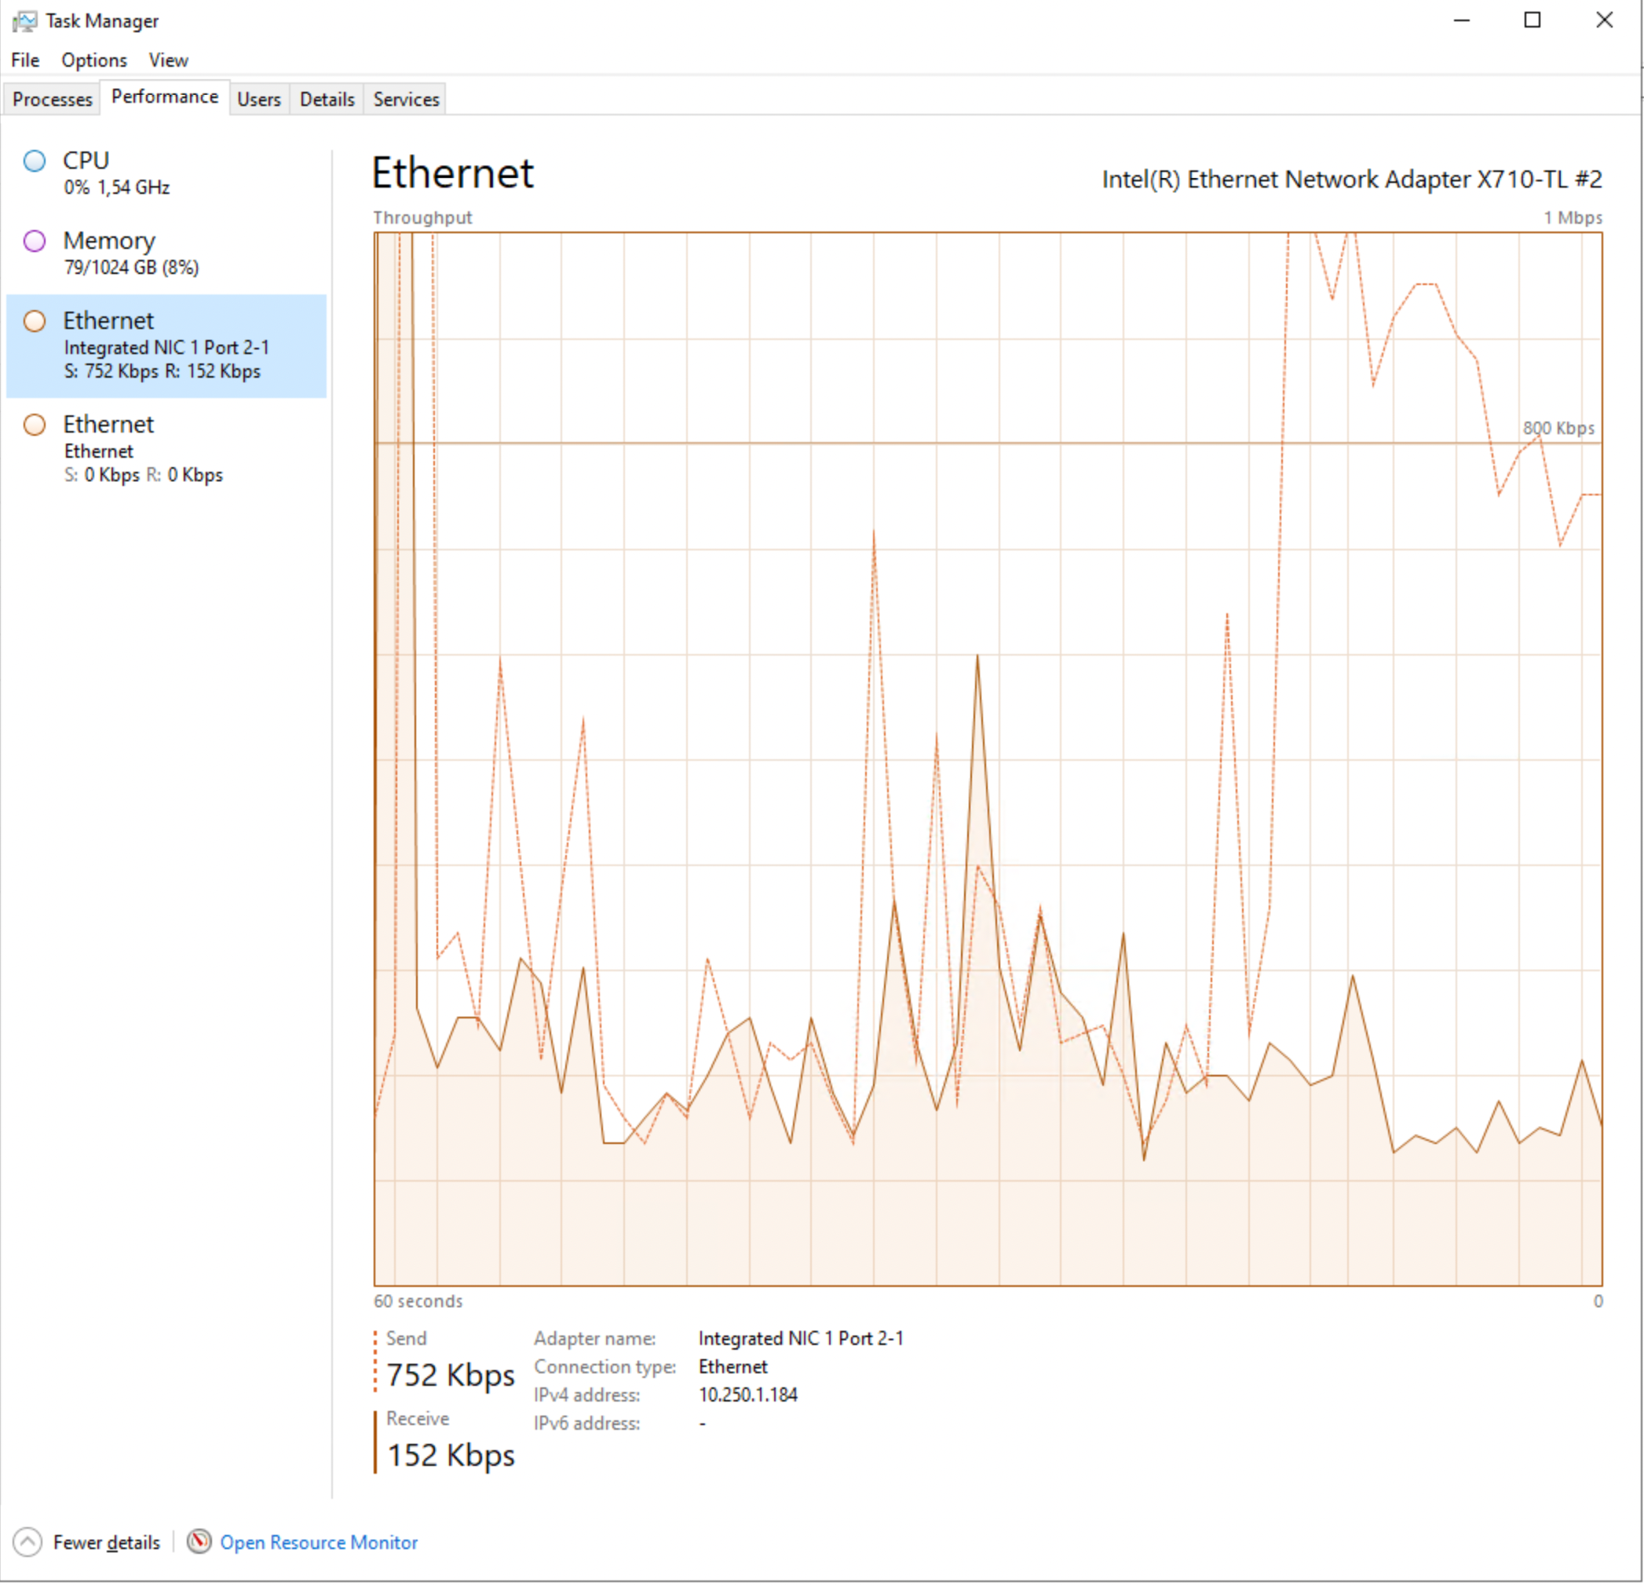

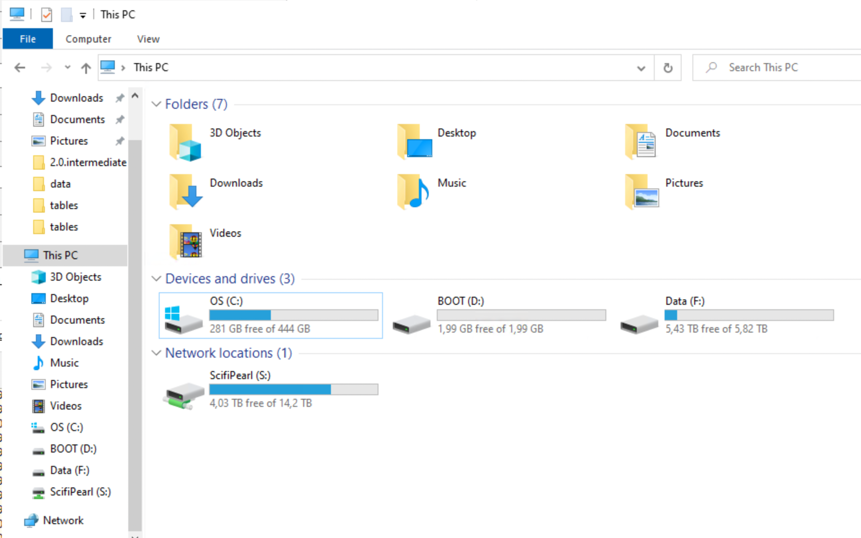

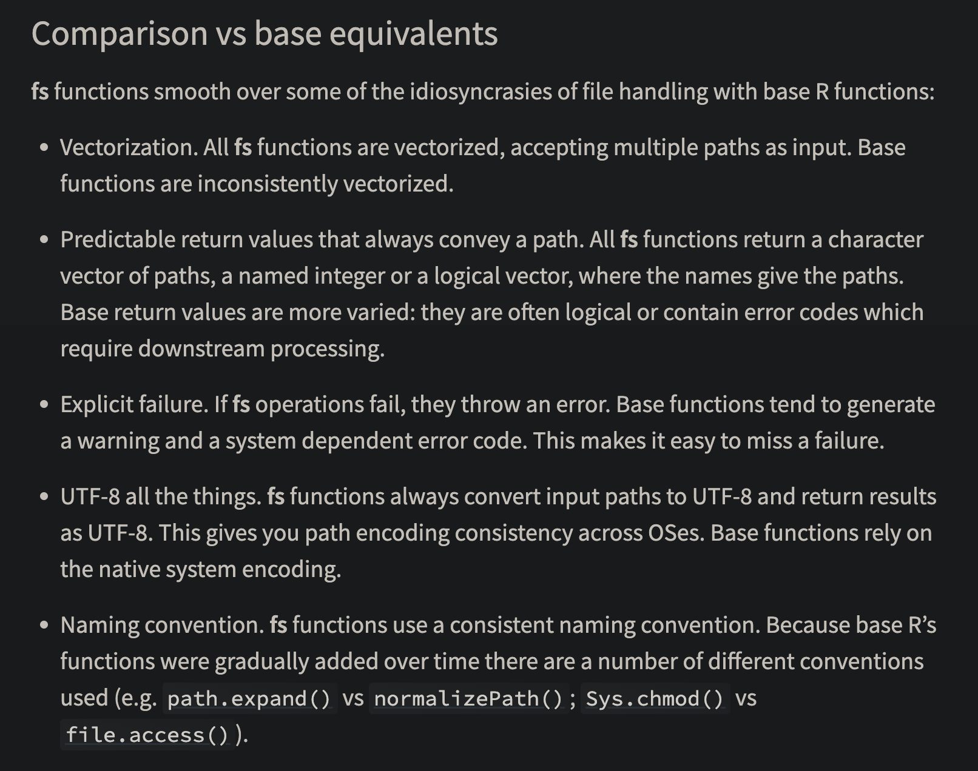

sync_project()
- I have a function sync_project() in my .Rprofile
  - usethis::edit_r_profile()
- However, I don’t include all data files in each individual project
- “Chek out” all files from network storage to disk
- Work with it
- Sync back to allow back-ups and common folder structure
- Git-repo kept for the network storage

sync_project <- function (from, to)
{
loc_dirs <- c("S:/Projects/", "F:/xbuler/")
loc_dirs_exp <- paste(loc_dirs, collapse = "|")
proj <- gsub(loc_dirs_exp, "", getwd())
locations <- paste0(loc_dirs, proj)
locations_exp <- paste(paste0(locations, "/"), collapse = "|")
stopifnot(getwd() %in% locations)
from <- if (missing(from))
getwd()
to <- if (missing(to))
setdiff(locations, from)
ans <- askYesNo(paste("Sync from:\n ", from, "\n To: \n",
to))
stopifnot(ans)
if (!fs::dir_exists(to)) {
fs::dir_create(to)
message("Target folder did not exist but has been created!")
}
fr <- dplyr::mutate(dplyr::select(fs::dir_info(from, all = TRUE,
recurse = TRUE, regexp = ".git", invert = TRUE), path,
type, size, modification_time), file = gsub(locations_exp,
"", path), path_to = paste(to, file, sep = "/"))
t <- dplyr::mutate(dplyr::select(fs::dir_info(to, all = TRUE,
recurse = TRUE), path, type, size, modification_time),
file = gsub(locations_exp, "", path))
new <- dplyr::anti_join(fr, t, "file")
new_dirs <- dplyr::filter(new, type == "directory")
if (nrow(new_dirs)) {
print(dplyr::select(new_dirs, file), n = Inf)
ans <- askYesNo(paste(nrow(new_dirs), " dir(s) not in 'to'. Should I create these?"))
if (ans)
fs::dir_create(new_dirs$path_to)
}
new_files <- dplyr::filter(new, type == "file")
if (nrow(new_files)) {
print(dplyr::select(new_files, file), n = Inf)
ans <- askYesNo(paste(nrow(new_files), " file(s) not in 'to'. Should I copy them?"))
if (ans)
purrr::walk2(new_files$path, new_files$path_to, fs::file_copy,
.progress = TRUE)
}
diff_mod <- dplyr::filter(dplyr::left_join(fr, t, "file",
suffix = c("_from", "_to")), type_from == "file", modification_time_to !=
modification_time_from)
if (nrow(diff_mod)) {
print(dplyr::select(diff_mod, file, tidyselect::matches("modification_time|size")),
n = Inf)
ans <- askYesNo(paste(nrow(diff_mod), " file(s) have been updated. Should I replace the older version?"))
if (ans) {
purrr::walk2(diff_mod$file, diff_mod$path_to, fs::file_copy,
overwrite = TRUE, .progress = TRUE)
}
}
dlt <- dplyr::filter(dplyr::anti_join(t, fr, "file"), !startsWith(file,
".git"))
if (nrow(dlt)) {
print(dlt, n = Inf)
ans <- askYesNo(paste(nrow(dlt), " file(s) have been deleted in 'from'. Should I delete them in 'to'?"))
if (ans) {
purrr::walk(dlt$path, fs::file_delete, .progress = TRUE)
}
}
}

👎 Reading SAS files in R
- Common to get large register files in SAS-format (SoS, SCB)
- 👍 SAS can handle that (files on disk) 😀
- 👎 I am a terrible SAS user 🙁
- 👎 Seems to be no easy way to read only parts of SAS-files into R directly
- haven::read_sas()?

haven::read_sas()
- 👍 May work if big enough RAM …
- 👎 Whole file is first read into RAM (readr::datasource(data_file))
- 👎 Most time spent on df_parse_sas_file()
- (Same for .dta-files [Stata])
haven::read_sas
function (data_file, catalog_file = NULL, encoding = NULL, catalog_encoding = encoding,
col_select = NULL, skip = 0L, n_max = Inf, cols_only = deprecated(),
.name_repair = "unique")
{
if (lifecycle::is_present(cols_only)) {
lifecycle::deprecate_warn("2.2.0", "read_sas(cols_only)",
"read_sas(col_select)")
stopifnot(is.character(cols_only))
col_select <- quo(c(!!!cols_only))
}
else {
col_select <- enquo(col_select)
}
if (is.null(encoding)) {
encoding <- ""
}
cols_skip <- skip_cols(read_sas, !!col_select, data_file,
encoding = encoding)
n_max <- validate_n_max(n_max)
spec_data <- readr::datasource(data_file)
if (is.null(catalog_file)) {
spec_cat <- list()
}
else {
spec_cat <- readr::datasource(catalog_file)
}
switch(class(spec_data)[1], source_file = df_parse_sas_file(spec_data,
spec_cat, encoding = encoding, catalog_encoding = catalog_encoding,
cols_skip = cols_skip, n_max = n_max, rows_skip = skip,
name_repair = .name_repair), source_raw = df_parse_sas_raw(spec_data,
spec_cat, encoding = encoding, catalog_encoding = catalog_encoding,
cols_skip = cols_skip, n_max = n_max, rows_skip = skip,
name_repair = .name_repair), cli_abort("This kind of input is not handled."))
}
<bytecode: 0x104f6f1a0>
<environment: namespace:haven>

👍 Export from SAS to csv
- I use SAS code to export only nececary data to csv
- I might use a prefiltering list exported from R to limit the data
- SAS Viya more flexible (I’ve heard) but not SAS 9.4
- Use (set=1000) etc for tests and then run over night
- csv-files exported to local SSD drive (and then synced back to storage folder)

ChatGPT
Jag har exporterat en csv-fil från R som innehåller en lista med löpnummer på individer. Jag vill nu använda SAS. Först vill jag läsa in CSV-filen. Sedan vill jag filtrera ett dataset i SAS (vi kan kalla det pelle) som har en kolumn med samma löpnummer som i CSV-filen (jag vill bara ha med de fall där det finns en match). Därefter vill jag exportera resultatet till en ny csv-fil. Jag vill att detta ska ske på ett effektivt och snabbt sätt. Hjälp med med SAS-syntax för detta

/* Läs in CSV-filen i SAS */
/* Läs in filen med löpnummer till ett SAS-dataset (vi kallar det `individer`) */
proc import datafile="din_sökväg_till_csv_filen.csv"
out=individer>
dbms=csv
replace;
getnames=yes; /* Sätt till no om csv-filen saknar rubriker */
run;
/* Om CSV-filen saknar rubrik kan du lägga till följande steg för att namnge kolumnen manuellt */
data individer;
set individer(rename=(var1=löpnummer)); /* Byt "var1" till korrekt variabelnamn */
run;
/* Filtrera datasetet `pelle` baserat på löpnummer */
/* Vi använder en hash-lookup för att göra filtreringen effektiv. Hash-lookup är snabbare än traditionella merge-metoder. */
data pelle_filtered;
if _n_ = 1 then do;
declare hash h(dataset: "individer");
h.definekey("löpnummer");
h.definedone();
end;
set pelle;
if h.find() = 0; /* Endast matchande löpnummer */
run;
/* Exportera det filtrerade datasetet till en ny CSV-fil */
/* Använd proc export för att spara resultatet */
proc export data=pelle_filtered
outfile="din_sökväg_till_ny_csv_fil.csv"
dbms=csv
replace;
run;
/* Effektivitetsoptimering:
Om både `individer` och `pelle` är mycket stora,
kan du sortera båda och använda data step merge
istället för hash-lookup. Hash-metoden är dock
generellt snabbare om det är många rader i båda
tabellerna. */

IDE
- RStudio displays object info from the global environment
- This is inefficient for big data
- Whole session can hang and/or crash
- I recommend Positron
  - Optimezed View() pane etc
  - Active and enthusiastic development
- Sometimes needed to ditch the IDE completely (even RGui)
  - Run R from the terminal

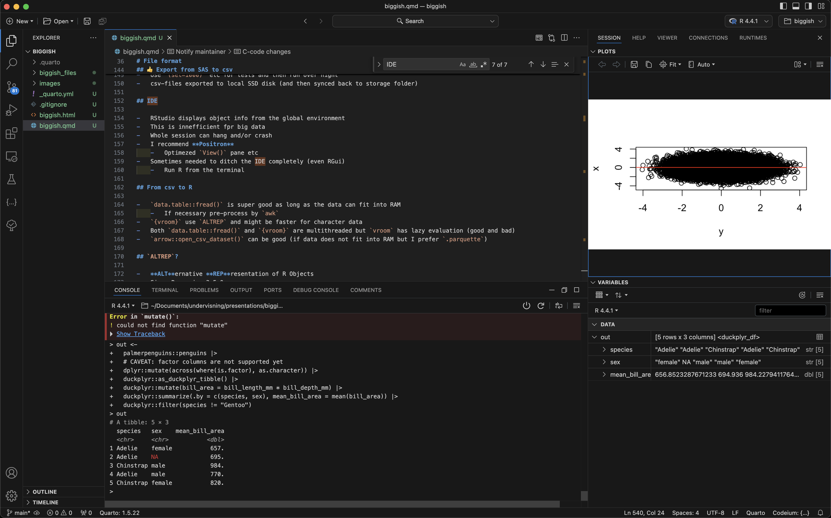

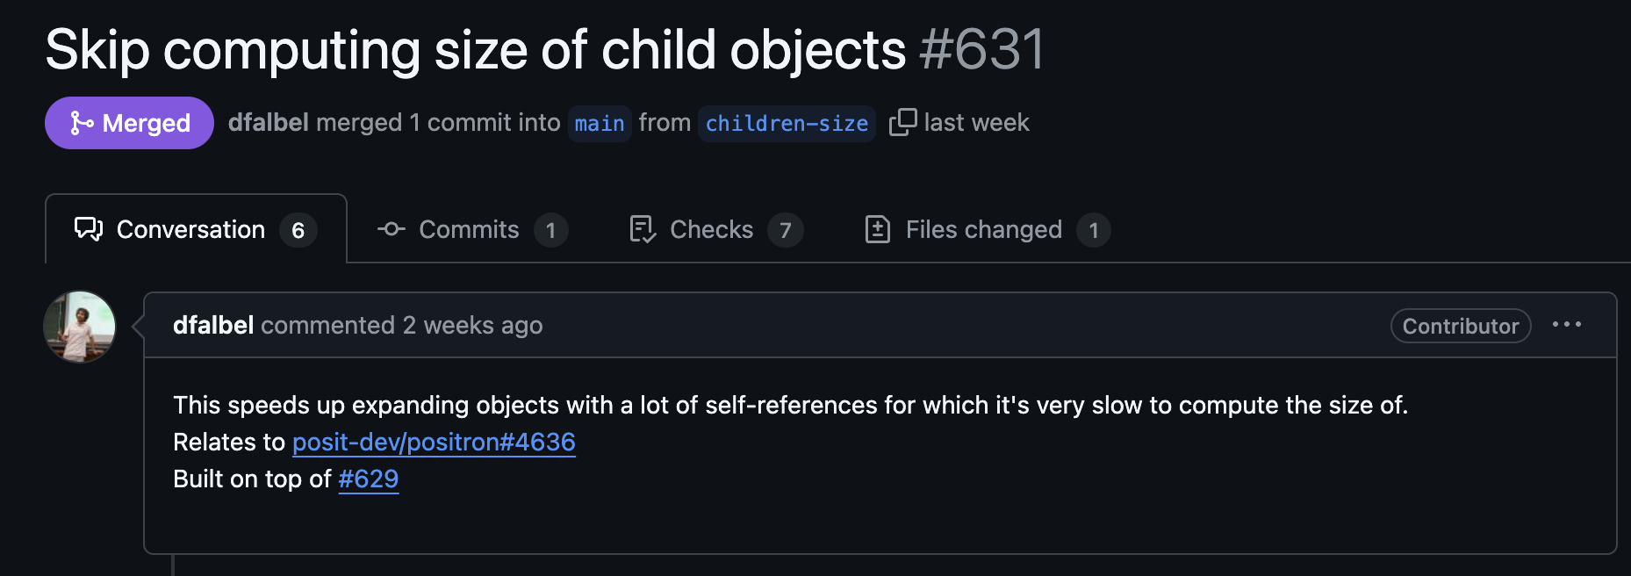

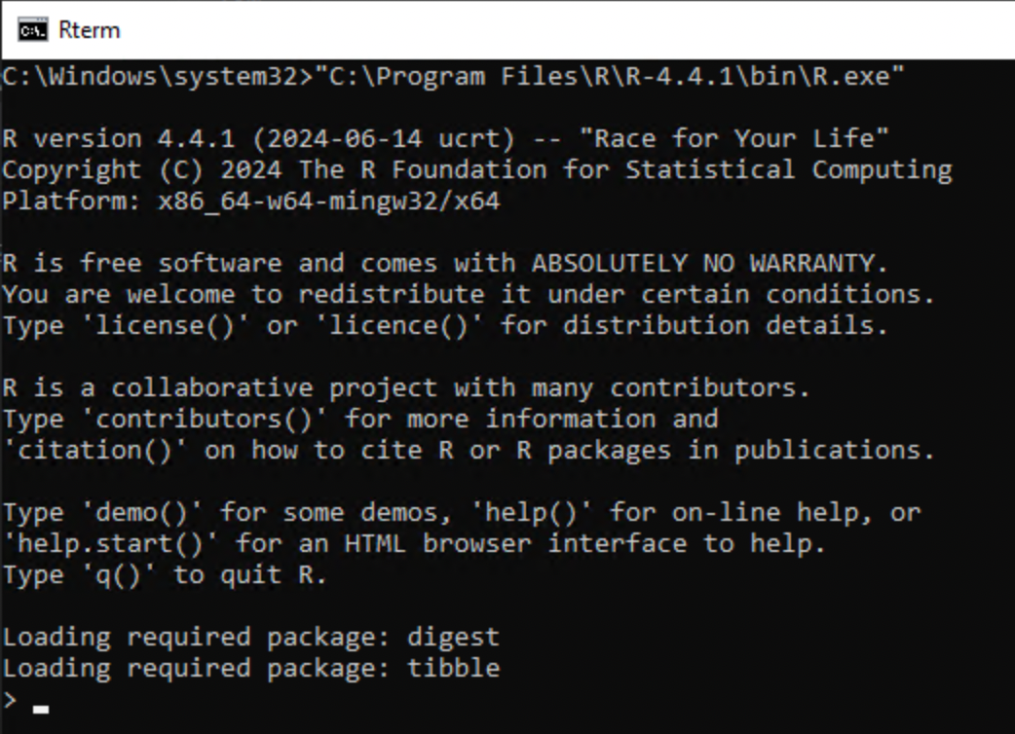

From csv to R
- data.table::fread() is super good as long as the data can fit into RAM
  - If necessary pre-process by awk
- {vroom} use ALTREP and might be faster for character data
- Both data.table::fread() and {vroom} are multithreaded but vroom has lazy evaluation (good and bad)
- arrow::open_csv_dataset() can be good (if data does not fit into RAM but I prefer .parquette if so)

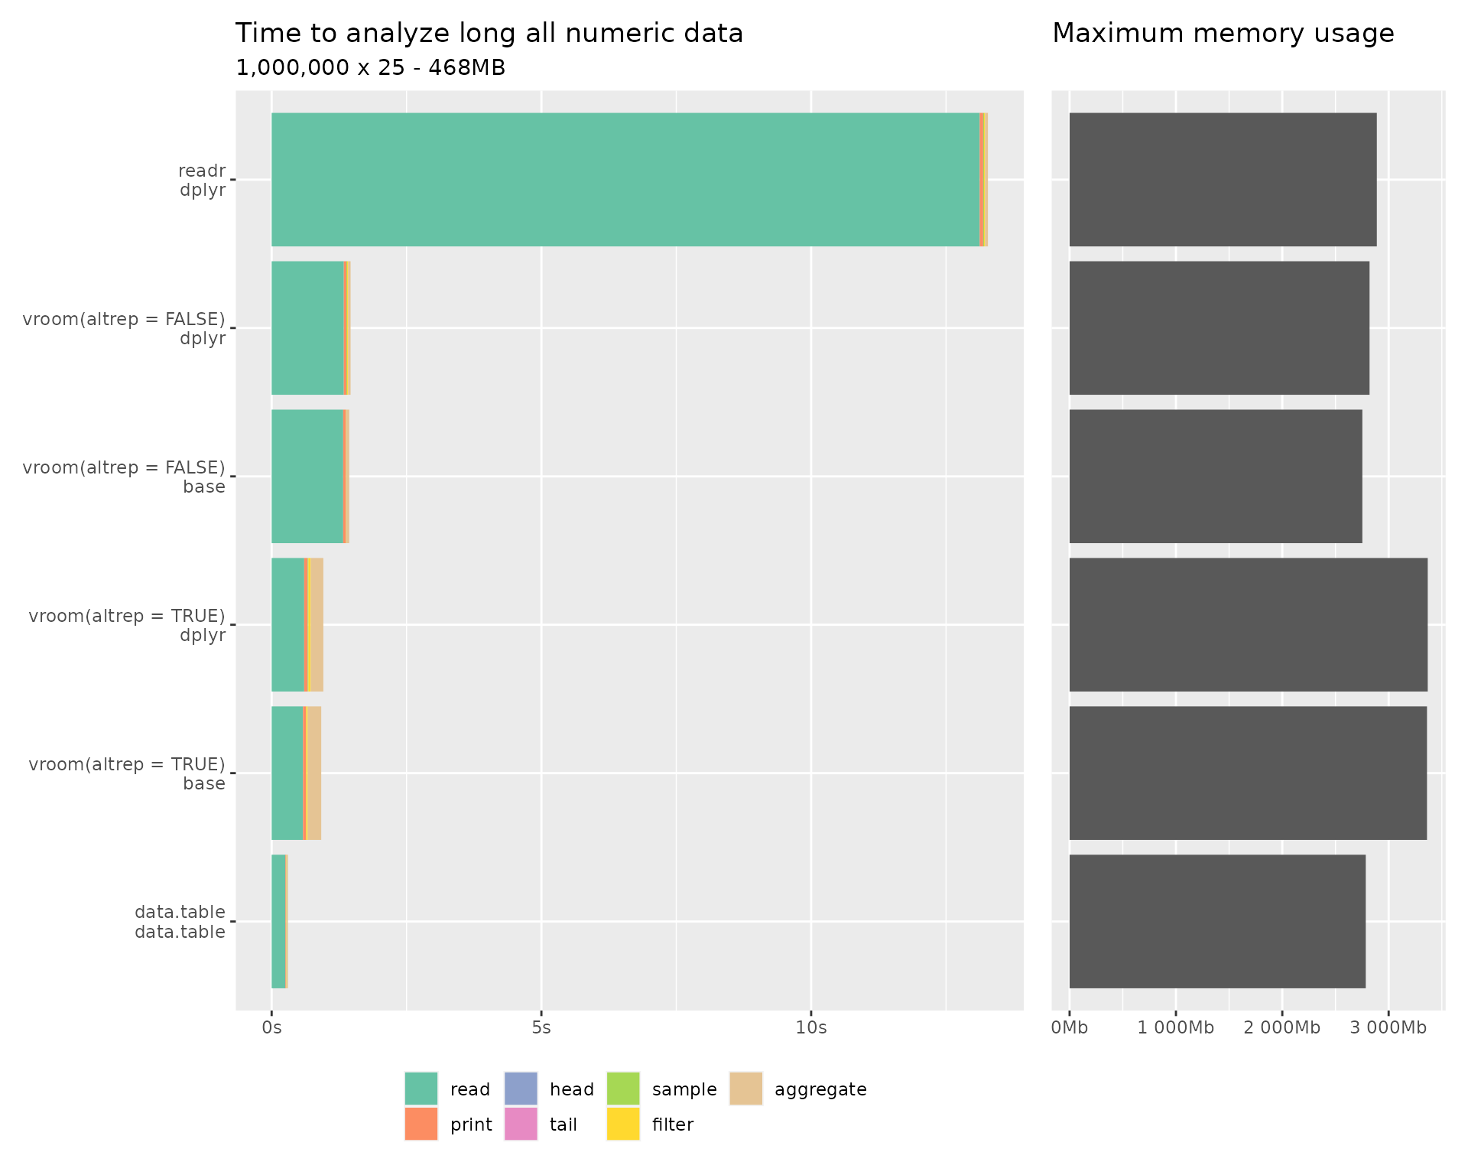

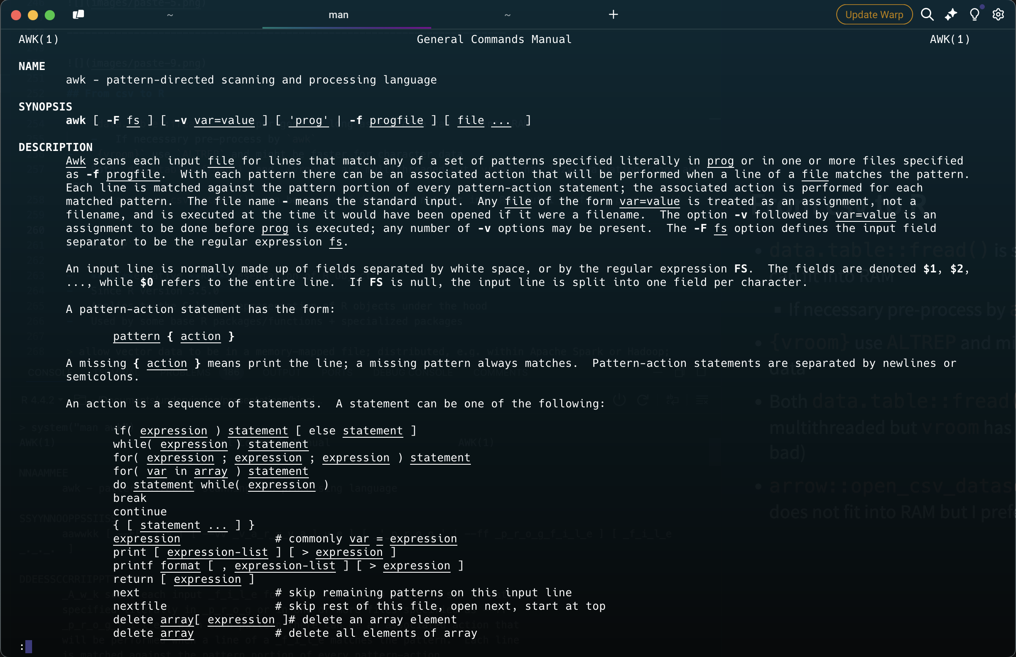

ALTREP?
- ALTernative REPresentation of R Objects
- Since R version 3.5.0
- Applies to the C-level representation of R objects under the hood
- Used by some base R packages/functions + specialized packages
allow vector data to be in a memory-mapped file; distributed, e.g. within Apache Spark or Hadoop; shared with other applications, e.g. with Apache Arrow; allow compact representation of arithmetic sequences; allow adding meta-data to objects; allow computations/allocations to be deferred; support alternative representations of environments.

Database?

Database?
- I don’t want to administer Microsoft SQL Server myself!
  - (They had R support for a couple of years but not any more)
- SQLight is easy to use …
- but (as SQL server) it is row based 🙁
- Some complicated ones are column based 😀 (Snowflake, Google Big Query)
  - … but I don’t want to administer those either …
- DuckDB comes for rescue!
 Indices
Never forget to set proper indices if needed!

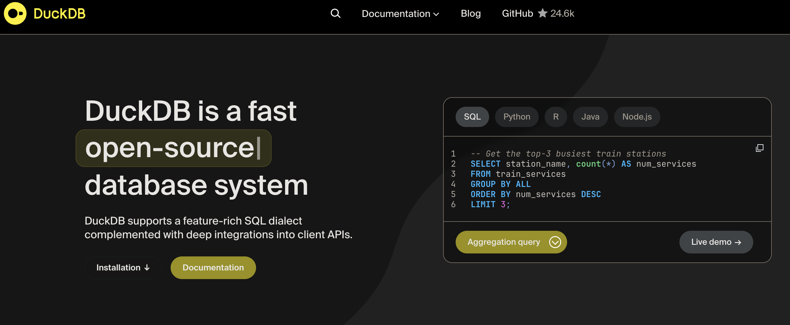

DuckDB
- Free and open source (backed by foundation)
- Column based
- Very easy to set up
- Very efficient!
- Integration with tidyverse in R
- Can be used both with disk data and data in RAM
- … but I had some bad experience and now I am scared 😢

From CSV to Parquet
- CSV is not very nice 🙁
  - No meta data
  - Sensitive to errors (missing values, decimal point, numbers with leading 0 etc, although fread can take care of this)
  - Encoding, BOM, whatever …
- Write to Parquet files
- I don’t think it is possible to convert csv to parquett on disk (first read csv, then write parquette)
  - But it can be done in chunks (read portion of csv and write to individual parquet file which are later “combined”)

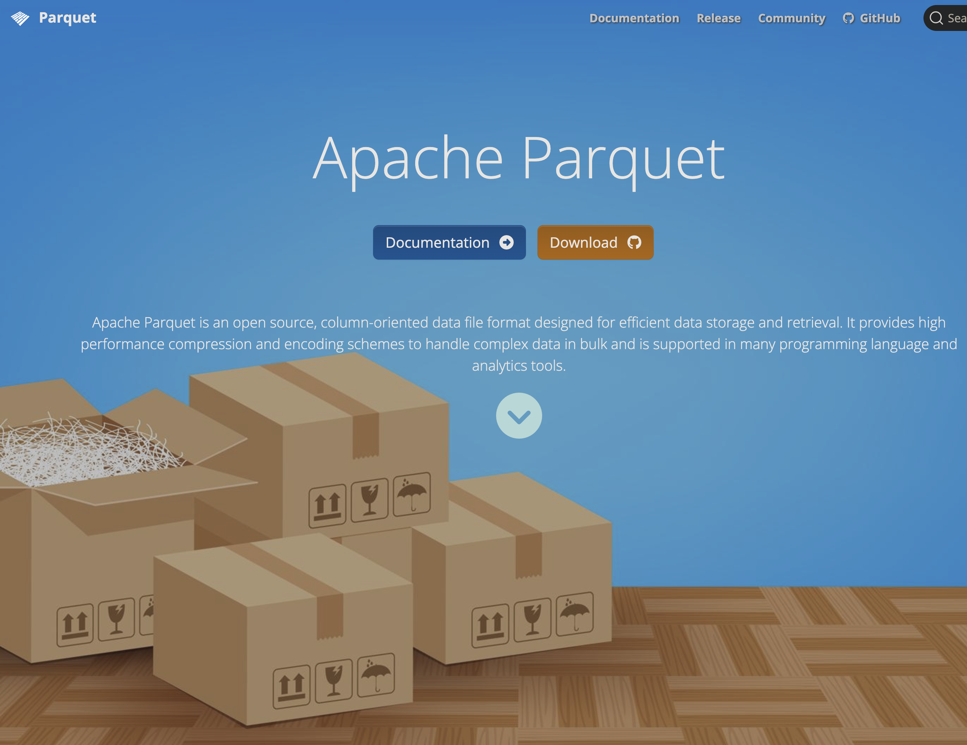

Parquet
- From Apache Arrow
- Open format
- flat files with possible hierarchical structure by transparent structure of folders and filenames
- Integrates with DuckDB (which integrates with R/tidyverse)
- See example later!

R specific data files?
- I use .qd-files (previously .qs) to cache non-tabular or intermediate data objects
{qs2}: a framework for efficient serialization … The qs2 format directly uses R serialization (via the R_Serialize/R_Unserialize C API) while improving underlying compression and disk IO patterns.
- .RData is terribly slow!
- .rds should now be much faster than before (serialized)
- .fst might be better in some cases but .qd/.qs is more generic (I think)

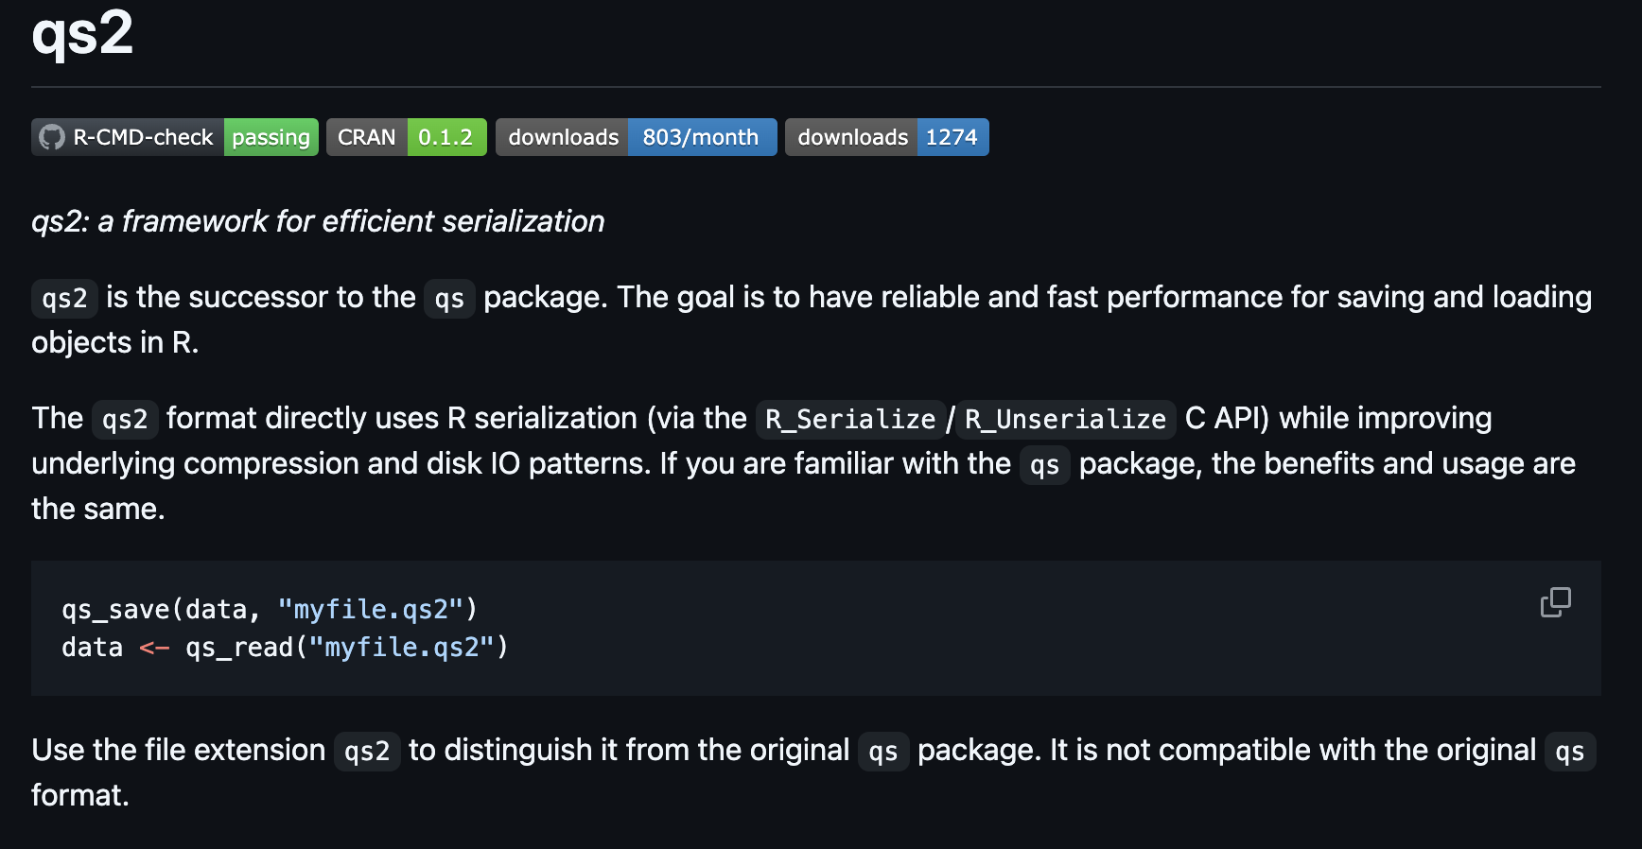

Data management
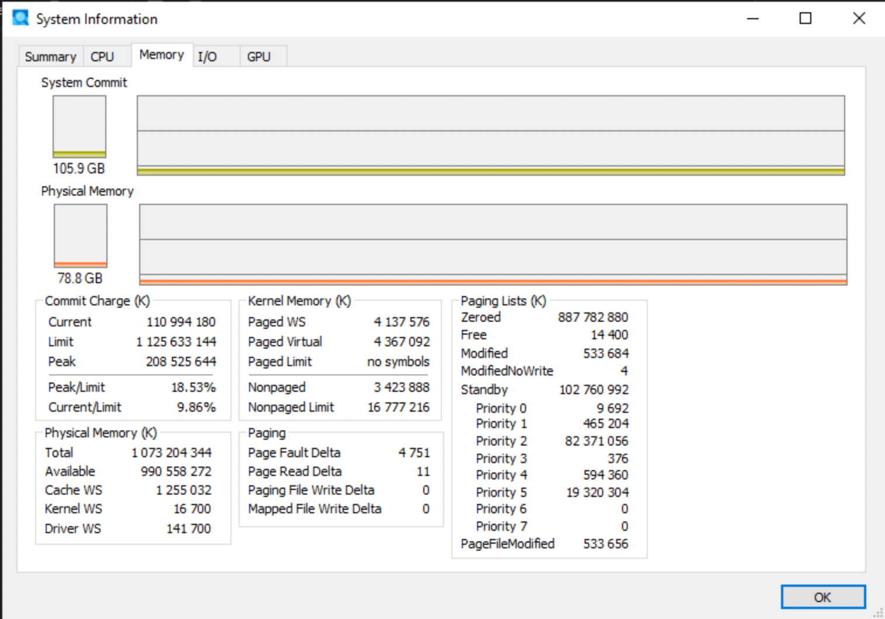

- Let’s say data fits into RAM
- base R and tidyverse works … but might be terribly slow …
- {data.table}! 😀

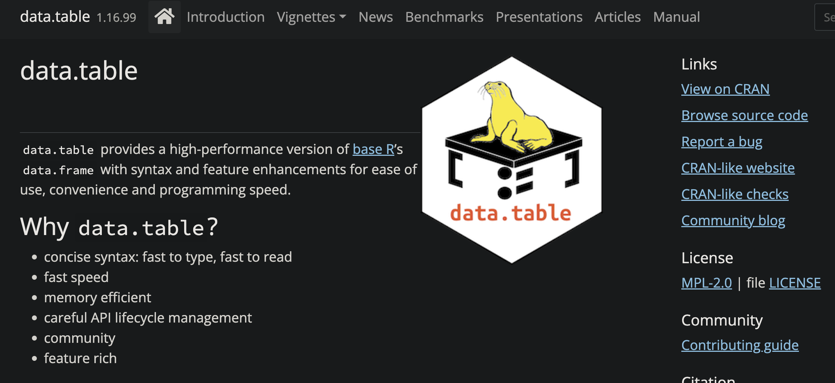

{data.table}
- Share basic properties with data frames (dt[i, j]; merge())
- Print method inspired by {tibble}
- Some old friends from {reshape2}: melt(), dcast()
- Has been around since 2006 (stable and well used, older than tidyverse)
- faster alternatives to base: fifelse(), fcase(), forder(), fread(), fcoalesce(), as.IDate(), %chin%
- C and GForce (some difficulties on Mac …)
- integer based keys and indices (compare data bases)
- Reference semantics (no need to copy on modification)
- Very flexible and compact (but perhaps unusual) syntax

Example
library(data.table)
dt <- iris
setDT(dt)
setkey(iris)
iris
Key: <Sepal.Length, Sepal.Width, Petal.Length, Petal.Width, Species>
Sepal.Length Sepal.Width Petal.Length Petal.Width Species
<num> <num> <num> <num> <fctr>
1: 4.3 3.0 1.1 0.1 setosa
2: 4.4 2.9 1.4 0.2 setosa
3: 4.4 3.0 1.3 0.2 setosa
4: 4.4 3.2 1.3 0.2 setosa
5: 4.5 2.3 1.3 0.3 setosa
---
146: 7.7 2.6 6.9 2.3 virginica
147: 7.7 2.8 6.7 2.0 virginica
148: 7.7 3.0 6.1 2.3 virginica
149: 7.7 3.8 6.7 2.2 virginica
150: 7.9 3.8 6.4 2.0 virginica
dt[, .N, Species]
Species N
<fctr> <int>
1: setosa 50
2: versicolor 50
3: virginica 50
dt[, date := as.IDate(Sys.Date()) + .GRP, Species][]
Sepal.Length Sepal.Width Petal.Length Petal.Width Species date
<num> <num> <num> <num> <fctr> <IDat>
1: 4.3 3.0 1.1 0.1 setosa 2026-02-19
2: 4.4 2.9 1.4 0.2 setosa 2026-02-19
3: 4.4 3.0 1.3 0.2 setosa 2026-02-19
4: 4.4 3.2 1.3 0.2 setosa 2026-02-19
5: 4.5 2.3 1.3 0.3 setosa 2026-02-19
---
146: 7.7 2.6 6.9 2.3 virginica 2026-02-21
147: 7.7 2.8 6.7 2.0 virginica 2026-02-21
148: 7.7 3.0 6.1 2.3 virginica 2026-02-21
149: 7.7 3.8 6.7 2.2 virginica 2026-02-21
150: 7.9 3.8 6.4 2.0 virginica 2026-02-21
dt[, names(.SD) := lapply(.SD, as.character), .SDcols = is.factor][]
Sepal.Length Sepal.Width Petal.Length Petal.Width Species date
<num> <num> <num> <num> <char> <IDat>
1: 4.3 3.0 1.1 0.1 setosa 2026-02-19
2: 4.4 2.9 1.4 0.2 setosa 2026-02-19
3: 4.4 3.0 1.3 0.2 setosa 2026-02-19
4: 4.4 3.2 1.3 0.2 setosa 2026-02-19
5: 4.5 2.3 1.3 0.3 setosa 2026-02-19
---
146: 7.7 2.6 6.9 2.3 virginica 2026-02-21
147: 7.7 2.8 6.7 2.0 virginica 2026-02-21
148: 7.7 3.0 6.1 2.3 virginica 2026-02-21
149: 7.7 3.8 6.7 2.2 virginica 2026-02-21
150: 7.9 3.8 6.4 2.0 virginica 2026-02-21

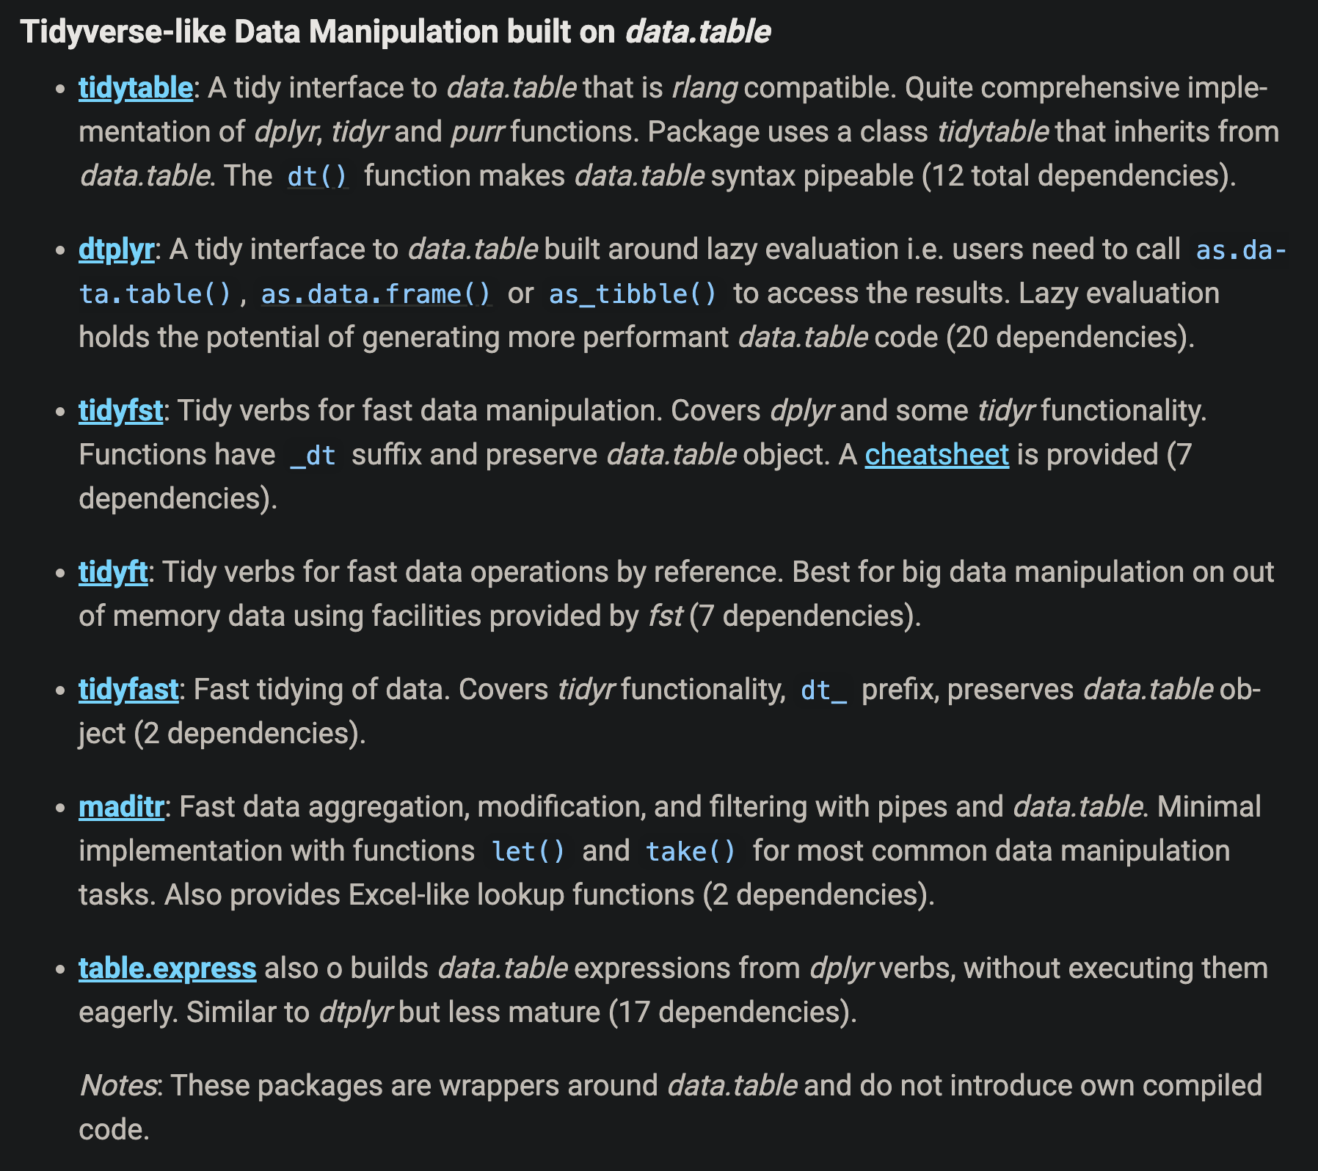

If it doesn’t fit?
- Connect to parquet file.
- Use DuckDB to process the data (while still on disk)
- Use {dplyr} to translate its syntax into SQL code
- Process data on disk
- Only read the results into memory

Example
library(tidyverse)
db1 <-
arrow::open_dataset("file1.parquet") |>
arrow::to_duckdb() |>
select(col1:col3) |>
filter(...) |>
pivot_wider(..)
db2 <-
arrow::open_dataset("file2.parquet") |>
arrow::to_duckdb() |>
count(x, y) |>
filter(...)
df <-
db1 |>
left_join(db2) |>
collect() # Only the resulting part should be collected!

Pros 👍
- Lazy: nothing evaluated until it is actually needed (collected)
- Many basic functions are translated from R to SQL
- DuckDB is parallelized ({data.table} is mostly sequential)
- Familiar syntax from tidyverse

Cons 👎
- tidyverse -> SQL translation not perfect (non optimized)
- might be relatively slow if intermediate steps are not cached and needs to be performed repeatedly

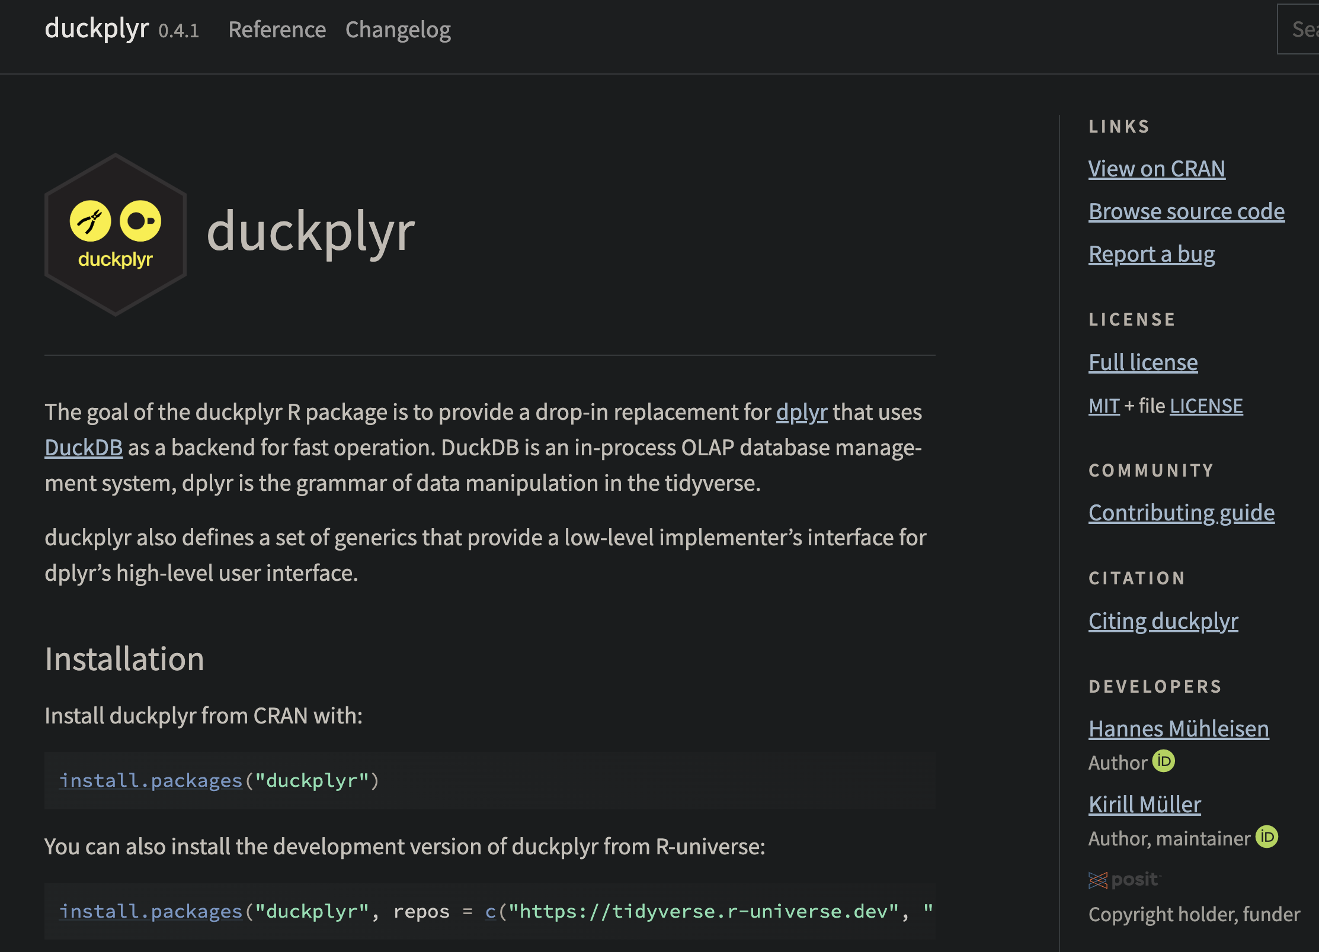

DuckPlyr
- New package with API-calls to DuckDB (no standard SQL code in between … I think)
- Drop-in-replacement of {dplyr}
- Automatically fail-safe to collect and use standard {dplyr} if needed
- Uptimized engine to not touch more data than necessary!
- Although very limited functionality so far (but wait and see!)

out <-
palmerpenguins::penguins %>%
# CAVEAT: factor columns are not supported yet
mutate(across(where(is.factor), as.character)) %>%
duckplyr::as_duckplyr_tibble() %>%
mutate(bill_area = bill_length_mm * bill_depth_mm) %>%
summarize(.by = c(species, sex), mean_bill_area = mean(bill_area)) %>%
filter(species != "Gentoo")
out %>%
explain()
#> ┌---------------------------┐
#> │ ORDER_BY │
#> │ -------------------- │
#> │ dataframe_42_42 │
#> │ 42.___row_number ASC │
#> └-------------┬-------------┘
#> ┌-------------┴-------------┐
#> │ FILTER │
#> │ -------------------- │
#> │ "r_base::!="(species, │
#> │ 'Gentoo') │
#> │ │
#> │ ~34 Rows │
#> └-------------┬-------------┘
#> ┌-------------┴-------------┐
#> │ PROJECTION │
#> │ -------------------- │
#> │ #0 │
#> │ #1 │
#> │ #2 │
#> │ #3 │
#> │ │
#> │ ~172 Rows │
#> └-------------┬-------------┘
#> ┌-------------┴-------------┐
#> │ STREAMING_WINDOW │
#> │ -------------------- │
#> │ Projections: │
#> │ ROW_NUMBER() OVER () │
#> └-------------┬-------------┘
#> ┌-------------┴-------------┐
#> │ ORDER_BY │
#> │ -------------------- │
#> │ dataframe_42_42 │
#> │ 42.___row_number ASC │
#> └-------------┬-------------┘
#> ┌-------------┴-------------┐
#> │ HASH_GROUP_BY │
#> │ -------------------- │
#> │ Groups: │
#> │ #0 │
#> │ #1 │
#> │ │
#> │ Aggregates: │
#> │ min(#2) │
#> │ mean(#3) │
#> │ │
#> │ ~172 Rows │
#> └-------------┬-------------┘
#> ┌-------------┴-------------┐
#> │ PROJECTION │
#> │ -------------------- │
#> │ species │
#> │ sex │
#> │ ___row_number │
#> │ bill_area │
#> │ │
#> │ ~344 Rows │
#> └-------------┬-------------┘
#> ┌-------------┴-------------┐
#> │ PROJECTION │
#> │ -------------------- │
#> │ #0 │
#> │ #1 │
#> │ #2 │
#> │ #3 │
#> │ │
#> │ ~344 Rows │
#> └-------------┬-------------┘
#> ┌-------------┴-------------┐
#> │ STREAMING_WINDOW │
#> │ -------------------- │
#> │ Projections: │
#> │ ROW_NUMBER() OVER () │
#> └-------------┬-------------┘
#> ┌-------------┴-------------┐
#> │ PROJECTION │
#> │ -------------------- │
#> │ species │
#> │ sex │
#> │ bill_area │
#> │ │
#> │ ~344 Rows │
#> └-------------┬-------------┘
#> ┌-------------┴-------------┐
#> │ R_DATAFRAME_SCAN │
#> │ -------------------- │
#> │ data.frame │
#> │ │
#> │ Projections: │
#> │ species │
#> │ bill_length_mm │
#> │ bill_depth_mm │
#> │ sex │
#> │ │
#> │ ~344 Rows │
#> └---------------------------┘

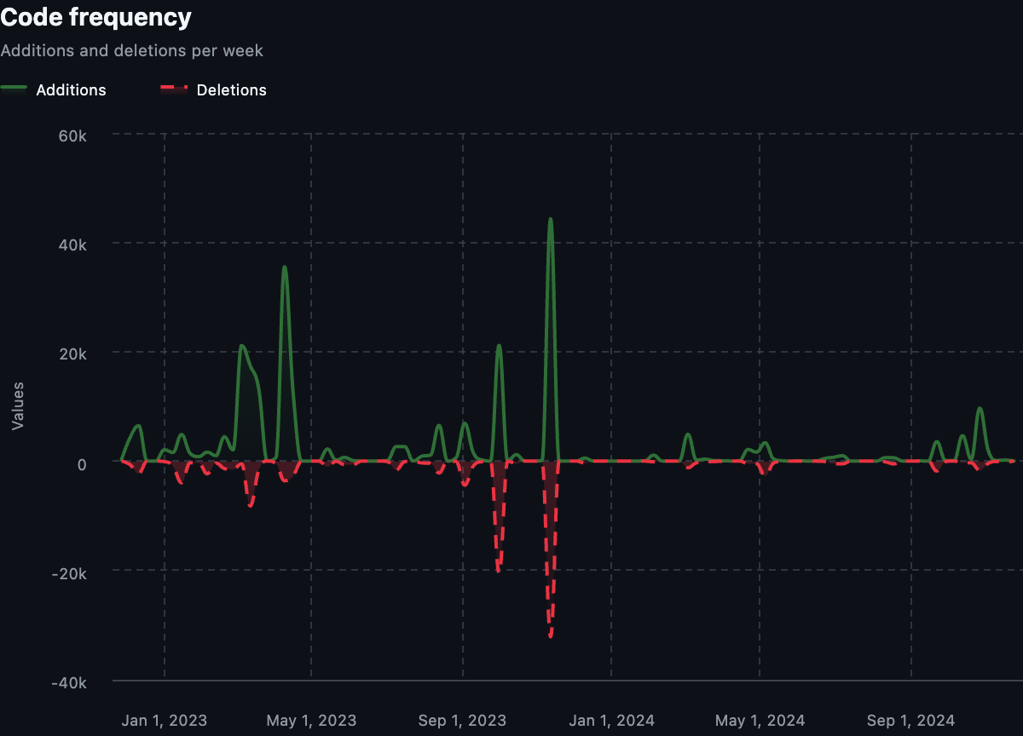

Dates
- Use as.IDate() instead of as.Date() if using {data.table}. Integer based.
- Use {anytime} (or maybe {fasttime}) if conversion is needed (ALTREP)

String manipulation
- Character manipulation in base R can be quite slow (does not use ALTREP and only single core by default)
  - For example regular expressions (grep(), gsub() etc)
- {stringfish} use multithreads and ALTREP - much faster!

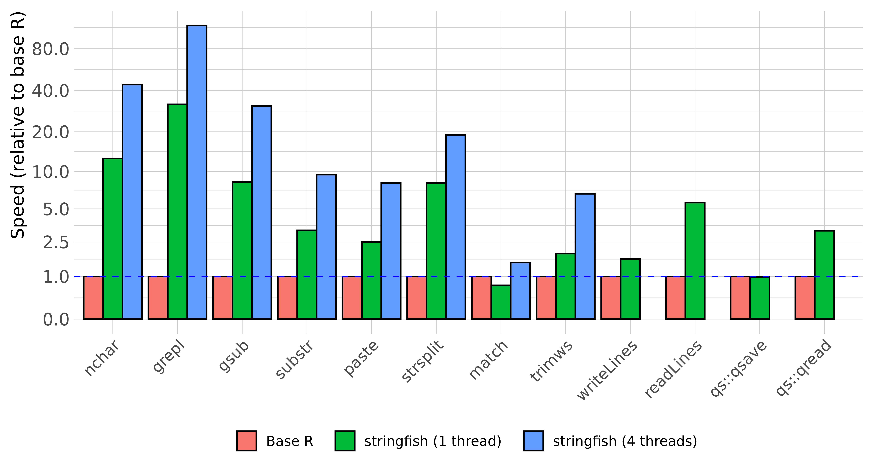

Paralellization
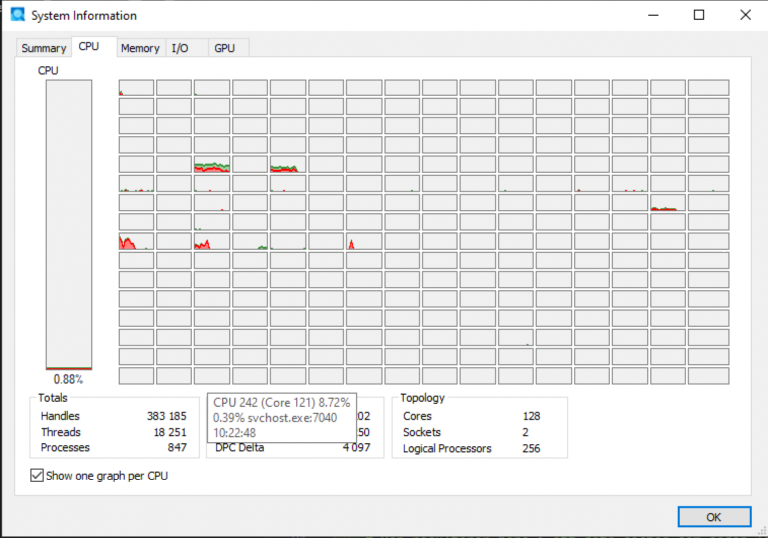

Paralellization
- R is single threaded by default
- Some packages and functions may use multithreading by default
- Some functions might have arguments such as nthreads, ncores etc
- To handle multicore/thread computations can be (very) difficult (I’ve heard)
- Easy if data can be divided and conquered (split-apply-combine)
- {futureverse} is my favorite (Henrik Bengtsson)
  - {furrr} is a a drop-in replacement for {purrr}

{furrr}
# How many cores do we have?
parallel::detectCores()
[1] 12
library(furrr)
Loading required package: future
# Save at least one for OS etc
plan(multisession, workers = parallel::detectCores() - 1)
1:10 |>
future_map(rnorm, n = 10, .options = furrr_options(seed = 123)) |>
future_map_dbl(mean)
[1] 1.180279 2.140442 2.909823 3.692207 5.058100 6.653926 7.065630 7.960713
[9] 9.105674 9.766827

{mirai}
- Suposed to be up to 1,000 times “faster” compared to {furrr}(according to some metric …)
- should not block the main process while executing (haven’t tried)
Designed for simplicity, a ‘mirai’ evaluates an R expression asynchronously in a parallel process, locally or distributed over the network, with the result automatically available upon completion.
library(mirai)
daemons(11, dispatcher = "thread") # "thread" still experimental
# data.table with 1 billion rows:
dt <- data.table(x = seq_len(1e9), y = rnorm(1e9))
# row sums (row wise )
mirai_map(dt, sum)[.flat]
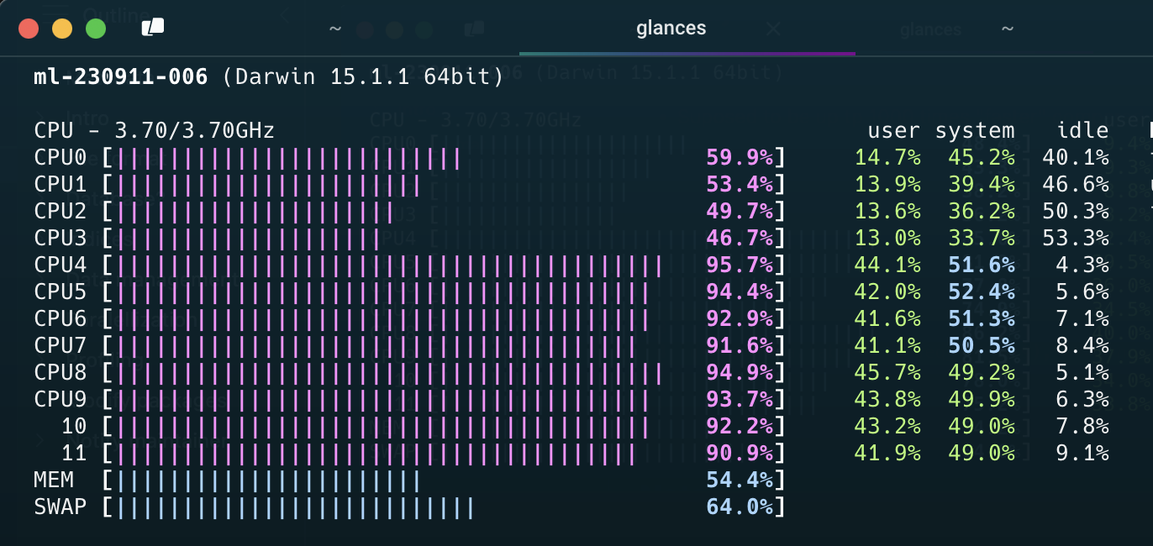

Note
- Data must be copied for each paralell worker
- If all data is needed for each worker, it will be multiplied in memory
  - This might not be possible for big data
  - It also takes time
- Hence, there is no guarantee that the over all time will decrease
- Often a tradeof between no of workers/threads/deamons/cores and efficiency etc
- “Standard” computations in {data.table} is optimized for single core
- Message handling and progress bar etc is complicated

Caching
- I use {ProjectTemplate} to organize R projects into different steps
- It has an inbuilt cache mechanism through ProjectTemplate::cache()
- I have my own cache-functions in my .Rprofile
# OBS kollar inte att det verkligen finns cache-folder etc
cache_dt <- function(x, name = deparse(substitute(x)), nthreads = 5) {
qs2::qd_save(x, glue::glue("cache/{name}.qd"), nthreads = nthreads)
invisible(x)
}
decache_dt <- function(name, nthreads = 5) {
x <- qs2::qd_read(glue::glue("cache/{name}.qd"), TRUE, nthreads = nthreads)
if (data.table::is.data.table(x)) {
data.table::setDT(x)
}
assign(name, x, envir = .GlobalEnv)
invisible(x)
}

Intermediate caching
- For long running function calls (hours, days)
- Divide task into smaller pieces and execute each part in paralell if feasable
- Use wrapper function with some index/grouping variable to indicate which part is currently processed
- Cache intermediate object as soon as possible (with name based on the grouping variable)
- If process is disrupted and must be restarted, parts which are already executed are just retrieved from from cache
cache_wrapper <- function(dt_part, name, ...) {
if (fs::file_exists(glue::glue("cache/{name}.qd"))) {
decache_dt(name)
} else {
x <- do_what_should_be_done()
cache_dt(x, name, ...)
x
}
}

Profiling
- First version of R script might be inneficient
- Optimazation is difficult
- Might be suboptimal if made ad hoc
- {profvis} visualise time and memory usage for each step
- improve the most important step first
  - For example change {base} and {tidyverse} code to {data.table}
  - set keys
  - Efficient handling of dates and strings
- itterate
- Integrated in RStudio (but not yet Positron)

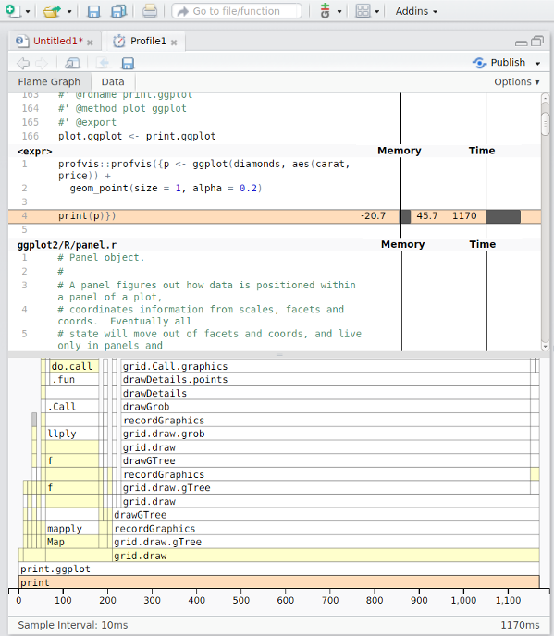

Modify packages

Modify packages
- Functions from packages might be inefficient
- Profile those as well
- Clone package from GitHub if available or download source code from CRAN
- Improve
- Just load the modified function in global environment
  - might need to modify internal calls to :::-accesed functions
- Or rebuild/install the package if more convenient
 Notify maintainer
If you find ways to improve a package, the maintainer might be eager to hear! Suggest pull request or open GitHub issue!

C-code changes
- If the package use C-code it is probably already very fast
- If not, and you can fix it, the package must be re-compiled
- OS dependent
- Might be tricky if using restricted environments (TRE?)
- Can still be done by rhub (might need to change maintainer-e-mail temporarily)

