
Co-developed as a joint venture with Metlonics
SPACEGEN AVIATION AEROSPACE AND DEFENCE PRIVATE LIMITED
Chandigarh Drone Facility
Facility Design, Drones & Counter-UAS Market and 10-Year Sales Plan
Combined report – Facility Design Report (Rev 2) and Market & Sales Plan, in the order of the investor presentation

India drone + C-UAS spend FY26-27 (est.) | ≈ ₹12,300 Cr
Chandigarh-addressable market FY27-28 → FY36-37 | ₹1,578 → ₹6,945 Cr
Chandigarh sales Year 1 (FY27-28), Base | ₹21.8 Cr
Chandigarh sales Year 10 (FY36-37), Base | ₹140 Cr
10-year sales CAGR (Base) | 23%
Facility operating cost Year 1 → Year 10 | ₹2.9 → ₹17.7 Cr
Share of Chandigarh-addressable market, Year 10 | 2%
Facility capital cost (incl. simulator zone) | ₹1.74 Cr
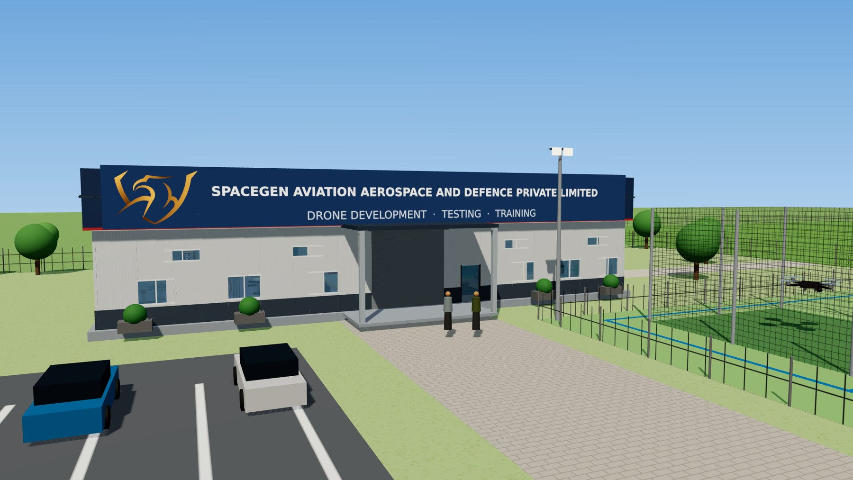
Technical Area – front view with SpaceGen signboard (3D impression)
October 2026 · Rev 3 (combined) · Confidential

Document Control
Item | Details
Organisation | SpaceGen Aviation Aerospace and Defence Private Limited
Document | Chandigarh Drone Facility – Combined Report: Facility Design, Market and 10-Year Sales Plan
Location | Chandigarh, Punjab – SpaceGen Northern Sector Drone Facility (reports to Hyderabad HQ)
Revision | Rev 3 – combines the Facility Design Report (Rev 2) and the Market & 10-Year Sales Plan, in the order of the investor presentation
Date | October 2026
Estimated cost | ₹ 1,74,04,000 (≈ ₹ 1.74 crore, excl. GST)
Status | Concept-level design – indicative; subject to survey, structural design and vendor quotations

Contents
1. Executive Summary
2. Why Now – India Is Buying Drones and C-UAS at Record Pace
3. Market and Budget Allocation
4. SpaceGen Today – Capability Base
5. The Chandigarh Hub – Summary of the Facility
6. Site Layout
7. Technical Area – Prefabricated Shelter
8. Elevations and Side View
9. Drone Flying Arena & Obstacle Course
10. Bill of Quantities – All Items with Cost and Remarks
11. Cost Summary, Budget and Regulatory & Safety Notes
12. Review of the Enablers for Scaling Up
13. Ten-Year Sales Projection – Chandigarh
14. Year-on-Year Scale-Up Drivers
15. Procurement Signals that Matter for SpaceGen
16. Financial View – Operating Cost of the Chandigarh Facility
17. Scenarios
18. Market Share
19. Product Mix
20. Funding Plan
21. Risks and Mitigation
22. Assumptions and Basis of the Numbers

Parts: Market (Sections 1–4) · The Chandigarh facility (Sections 5–11) · Business plan (Sections 12–22).

1. Executive Summary
India is now spending on drones and counter-drone (C-UAS) systems at a pace not seen before. The FY 2026-27 defence budget raised capital acquisition (modernisation) by 24.6% to ₹1,85,467 crore, of which 75% is earmarked for domestic industry. Since Operation Sindoor (May 2025) the forces have used emergency and fast-track routes heavily for drones, loitering munitions and C-UAS; every infantry battalion now has an ‘Ashni’ drone platoon. The northern sector – J&K, Ladakh, Punjab, Himachal Pradesh and the Punjab/Jammu border – is the most drone-active theatre, and Punjab’s ‘Baaz Akh’ anti-drone grid starts at Chandigarh.
This plan covers only the SpaceGen Chandigarh Drone Facility. Chandigarh is SpaceGen’s northern-sector hub: a ₹1.74 crore campus with a technical area, simulator zone (RPTO classroom), netted arena, obstacle course and open flying field, run by a 6-person team reporting to Hyderabad HQ. It drives five of SpaceGen’s eleven enablers (1–5). The other six – central procurement (6), PMF and civil departments (7), DPSU partnering (8), expos and exports (9), joint development with the Army (10) and integrated MUM-T / swarm-defence solutions (11) – need more expertise, dedicated technical teams and long cycles, so they are led and booked at Hyderabad HQ and are not counted here.
On this basis the Base case grows Chandigarh sales from ₹21.8 crore in Year 1 (FY 2027-28) to ₹140 crore in Year 10 (FY 2036-37) – a 23% CAGR – while Chandigarh’s share of the northern-sector market it addresses rises from 1.4% to 2%. The facility’s operating cost grows from ₹2.9 crore in Year 1 to ₹17.7 crore in Year 10 (about 12–13% of sales), ₹99.8 crore over ten years; ₹0.89 crore of the Year-1 cost is fixed (team, admin, HQ visits, demos, induction move). A Conservative case reaches about ₹91 crore and an Upside case about ₹182 crore by Year 10.

Key conclusions
- Right location: Northern and Western Command, BSF Punjab and Jammu Frontiers and Punjab Police are within a day’s drive of Chandigarh – the cheapest place to demonstrate, train and support SpaceGen drones and C-UAS.
- Chandigarh-led revenue: existing customers, demos at the facility and in forward areas, the RPTO and GeM orders (enablers 1–5) give ₹21.8 crore in Year 1 and grow to ₹140 crore by Year 10.
- Hyderabad HQ enablers: PMF and civil departments, DPSU partnering and expos / exports (enablers 7–9) now sit with Hyderabad HQ, together with 6, 10 and 11; Chandigarh supports them with demos, but none of their sales or costs are counted in this plan.
- Products: Drones specific to the Northern sector will be considered for shifting to Chandigarh on Technical Ownership Transfer, at transfer cost; the product details will be explained by Capt Vego separately.
- Funding: ₹2–3 crore seed covers the ₹1.74 crore facility, the first year of fixed running cost (≈ ₹0.89 crore) and a demo fleet; later expansion (₹1.0 crore in Year 4, ₹1.5 crore in Year 7) is funded from internal accruals.

2. Why Now – India Is Buying Drones and C-UAS at Record Pace
Since Operation Sindoor (May 2025), the forces have moved drones and counter-drone systems to the top of their buying list. The figures below show the scale.
Figure | What it is
₹1,85,467 Cr | Defence modernisation budget FY 2026-27, +24.6%; 75% reserved for Indian industry
≈ ₹30,000 Cr | Emergency and fast-track buys incl. drones, loitering munitions, C-UAS, EW
≈ ₹20,000 Cr | Army plan for drones & surveillance; a further tactical-drone order of over ₹20,000 Cr expected
≈ ₹52,000 Cr | DAC approvals (Jul 2026) incl. anti-drone and kamikaze drones – RFPs to follow
≈ 380 | Infantry battalions with an ‘Ashni’ drone platoon; ~5,000 drones per command
44,000+ | DGCA remote-pilot certificates issued – training demand keeps rising
Sources: MP-IDSA, Indian Express, Reuters / DFI, Channel IAM, IANS, DGCA data (2026).

3. Market and Budget Allocation

3.1 Defence budget (Ministry of Defence)
Head (₹ crore) | 2025-26 BE | 2026-27 BE | Change
Total MoD budget | 6,81,210 | 7,84,678 | +15.2%
Capital outlay – defence services | 1,80,000 | 2,19,306 | +21.8%
Modernisation (capital acquisition) | 1,48,839 | 1,85,467 | +24.6%
Of which earmarked for domestic industry | — | 1,39,100 (75%) | —
Defence services revenue | 3,11,732 | 3,65,479 | +17.2%
Source: MP-IDSA analysis of MoD Budget Estimates 2026-27. ‘Unmanned Aerial Vehicles, Drones, etc.’ are listed among forthcoming capital acquisitions.

3.2 Home Affairs – paramilitary (PMF / CAPF)
Head (₹ crore) | 2025-26 RE | 2026-27 BE
Total MHA | 2,41,485 | 2,55,234
All CAPFs | 1,12,636 | 1,16,789
BSF | 29,568 | 29,568
CRPF | 37,251 | 38,518
ITBP | 9,869 | 11,324
Assam Rifles | 8,376 | 8,797
Modernisation of Police Forces | 3,280 | 4,061
Border infrastructure | 5,472 | 5,577
Source: PRS Legislative Research, Demand for Grants 2026-27 – Home Affairs. Punjab separately sanctioned ₹51.4 crore for 9 ‘Baaz Akh’ anti-drone systems from Chandigarh to Fazilka (Aug 2025).

3.3 Market size and growth (published estimates)
Market | Size | Forecast | CAGR | Source
India drone (UAV) market | US$0.47 bn (2025) | US$1.39 bn (2030) | 24.4% | MarketsandMarkets
India anti-drone market | US$197.5 mn (2025) | US$983.7 mn (2030) | 37.9% | MarketsandMarkets
– of which military & defence | US$163.8 mn | US$783.1 mn | 36.7% | MarketsandMarkets
– homeland security | US$13.6 mn | US$75.5 mn | 41.0% | MarketsandMarkets
India drones + anti-drones (all) | ≈ US$1.27 bn (2026) | — | — | DroneIntelligence
India C-UAS addressable (5 yrs) | ≈ ₹12,000 Cr (≈1,200 systems) | — | ≈28% | Motilal Oswal / DD News
Indian drone industry turnover | ₹60 Cr (2021) → ₹3,000–4,000 Cr (2025) | ₹19–20k Cr (‘coming years’) | — | Drone Federation of India
Global military drones | US$34.9 bn (2026) | US$109.2 bn (2031) | 25.7% | MarketsandMarkets
Global counter-UAS | US$9.2 bn (2026) | US$29.7 bn (2031) | 26.5% | MarketsandMarkets

3.4 Year-on-year budget for drones & C-UAS – Defence, PMF and Civil (estimate, ₹ crore)
No single public figure gives India’s yearly spend on drones and C-UAS, so the table below is a triangulated estimate. FY 2026-27 is anchored on the ≈US$1.27 bn (≈₹10,800 crore) combined market estimate, the ₹30,000 crore post-Sindoor emergency buys spread over 2–3 years, and the MoD and MHA budgets above. Growth rates start near the published CAGRs (24–38%) and taper as the market matures. The last column is the part the Chandigarh facility can address.
Year | Defence – drones | Defence – C-UAS | PMF / CAPF & police | Civil Govt & enterprise | Total | YoY | SpaceGen-addressable (national)* | Chandigarh-addressable (northern sector)**
FY26-27 | 6,000 | 2,500 | 800 | 3,000 | 12,300 | — | 4,910 | 1,220
FY27-28 | 7,500 | 3,375 | 1,040 | 3,660 | 15,575 | 26.6% | 6,293 | 1,578
FY28-29 | 9,300 | 4,455 | 1,331 | 4,465 | 19,551 | 25.5% | 7,976 | 2,011
FY29-30 | 11,346 | 5,702 | 1,664 | 5,358 | 24,070 | 23.1% | 9,897 | 2,508
FY30-31 | 13,615 | 7,128 | 2,030 | 6,430 | 29,203 | 21.3% | 12,071 | 3,068
FY31-32 | 16,066 | 8,696 | 2,436 | 7,587 | 34,785 | 19.1% | 14,443 | 3,678
FY32-33 | 18,637 | 10,261 | 2,874 | 8,801 | 40,573 | 16.6% | 16,892 | 4,307
FY33-34 | 21,246 | 11,800 | 3,334 | 10,121 | 46,501 | 14.6% | 19,380 | 4,938
FY34-35 | 24,008 | 13,334 | 3,801 | 11,538 | 52,681 | 13.3% | 21,948 | 5,586
FY35-36 | 26,889 | 14,934 | 4,257 | 13,038 | 59,118 | 12.2% | 24,611 | 6,256
FY36-37 | 29,847 | 16,577 | 4,725 | 14,603 | 65,752 | 11.2% | 27,351 | 6,945
*SpaceGen-addressable = the part of each domain that matches SpaceGen’s product classes: 35% / 60% / 70% / 25% of defence drones / defence C-UAS / PMF / civil. **Chandigarh-addressable = the northern-sector part of that: 30% / 30% / 25% / 0% (Northern & Western Command, BSF Punjab/Jammu, J&K and Punjab police; civil departments are HQ-led and excluded).
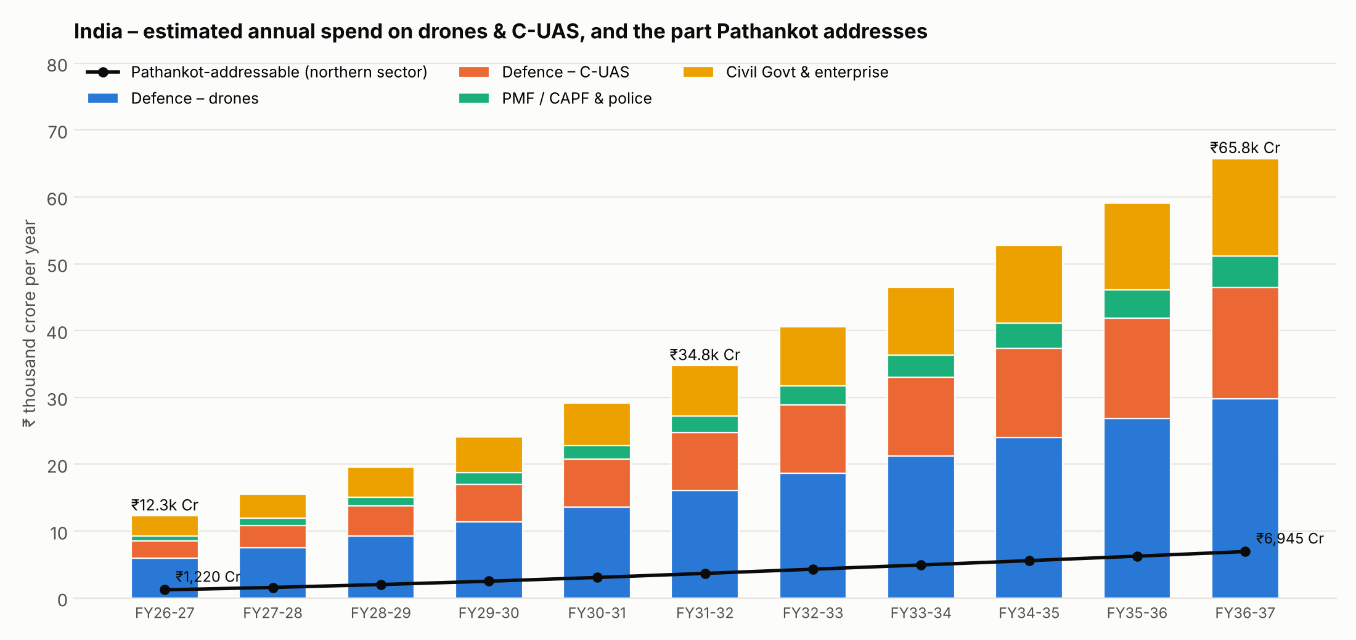
Figure A – Estimated annual drone & C-UAS spend in India by domain, and the Chandigarh-addressable part

3.5 Where to invest – sector view
Sector | Growth | Fit with SpaceGen products | Priority
Defence C-UAS (Army AD, IAF bases, formations) | Very high (30%+) | Sentinel, Scout, Shield, MITYA, interceptors, net/foam drones | 1 – lead segment
Army tactical drones (FPV, ISR VTOL, logistics) | High (20–25%) | FPV range, Aniketra/Samharak, transport drones, payloads | 1 – lead segment
Training & simulation (RPTO, Ashni platoons) | High | RPTO at Chandigarh, Sky Commander simulator, FPV training | 2 – low capital, steady cash
PMF / CAPF / border-state police | High (25%+) | Tethered drones, handheld detectors, jammers, VTOL ISR | 2
Civil govt – roads, power, oil & gas | Medium-high (18–22%) | Fixed-wing / VTOL mapping, LiDAR, inspection; C-UAS for refineries & airports | 3 – diversifies away from defence cycles
Exports (friendly countries) | Medium, lumpy | C-UAS, interceptors, FPV | 3 – from Year 3 after expos

4. SpaceGen Today – Capability Base

4.1 Product portfolio (from company brochures)
Family | Products | Key capability | Main buyers
FPV & strike drones | 4" digital attack FPV; 5" analog & digital grenade-dropper FPV | 150 km/h, 15–24 min, DJI air unit long range; FPV military training | Army infantry & Ashni platoons, special forces
VTOL ISR / mapping | ANIKETRA (tricopter V-tail), SAMHARAK (4+1 flying wing), pusher & swept-wing long-range VTOL | 3.5 kg MTOW, 2.5 kg payload, 4 h, 60+ km, BLOS, GPS-denied nav; ISR, laser designation, logistics, LiDAR mapping | Army, PMF, NHAI / power / oil & gas survey
Interceptor drones | LAKSHYA, ARJUNA, ARJUN VYUHA, ARJUN KAVACH | Up to 500+ km/h, 20 km, 3,000 m ceiling; kinetic/hard-kill interception | Army Air Defence, IAF bases, critical infrastructure
Counter-UAS | SpaceGen Scout (handheld, 7 km), Sentinel (35 km, 450-model AI library, 400 MHz–6 GHz), Shield (spoofer + jammer, 3 km), MITYA GNSS spoofer (4 constellations, MIL-STD-461E, IP67), handheld RF jammer, detection app | Detect, classify friend/foe, jam and spoof; swarm neutralisation | Army, IAF, BSF, state police, VIP security, airports, refineries
Non-kinetic capture | Net-thrower drone, foam-spraying drone | Capture intact drones for forensics | Police, CAPF, airports
Persistent surveillance | Tethered drone system (EO/IR, 120 m, 24×7); 5 kg tethered drone | Unlimited endurance surveillance | Border posts, CAPF, events, industry
Logistics & payloads | Transport drones 70–150 kg; smoke launchers 38/60/80 mm; weapon dropper; OFC anti-interference; portable helipad (Army-tested) | Forward resupply and tactical payloads | Army, armed police
Training | Sky Commander fixed-wing flight simulator; FPV military training | Simulator-based pilot training | Army units, RPTO trainees

4.2 Customers and credentials
- Customers: 18+ Army units supplied, including 20 Bihar, 16 Bihar, 13 Dogra, 12 JAK LI, 23 Rashtriya Rifles, 68 / 93 / 94 / 293 Medium Regiments and 173 Infantry Brigade; plus 17 BSF, Tamil Nadu Police (CM Security Branch), TN Police Intelligence and GITAM University.
- CEO: ex-Army, instructor in drones, counter-drones and SDR at MCEME for 3 years; former students are deployed across Northern Command (J&K) and Western and Central Commands – a ready network of informed users and buyers. Rich experience in handling projects in all niche domains at larger scale and end to end management of projects and its serviceability.
- GeM: registered on GeM (ID 4RRO250013676721).
- New facility: Chandigarh Drone Facility – ₹1.74 crore capital, ₹85.6 lakh a year to run, with technical area, simulator zone, obstacle course, open flying field and RPTO.
- Hub-and-HQ model: Hyderabad HQ designs and builds the products, holds the technical ownership and leads enablers 6–11 – central procurement, PMF and civil, DPSU partnering, exports, joint development and integrated solutions; Chandigarh sells, demonstrates, trains and supports in the northern sector.

5. The Chandigarh Hub – Summary of the Facility
Chandigarh is SpaceGen’s demonstration, test and training base next to the most drone-active theatres. Its purpose is to bring Northern and Western Command formations, BSF and state police to see, fly and buy SpaceGen drones and C-UAS, and to train their pilots.
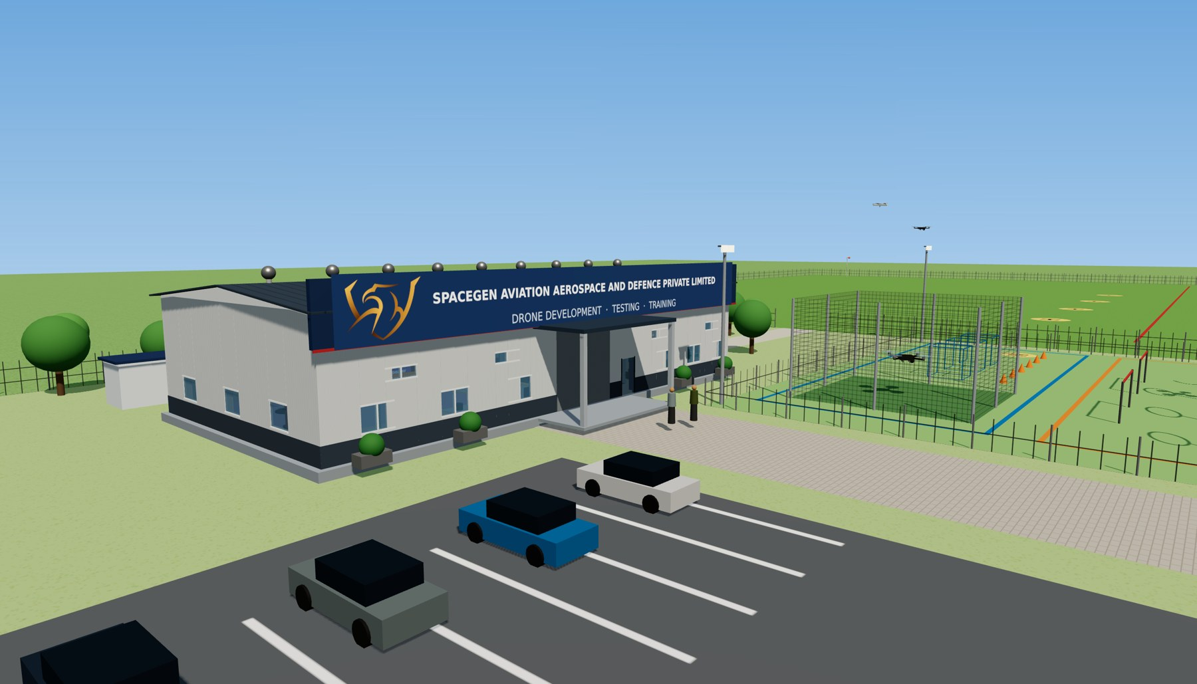
Figure 0 – 3D impression of the Chandigarh facility

5.1 Summary of items
Aspect | Nomenclature
Budget | ≈ ₹1.74 crore (₹1.59 crore facility + ₹15 lakh simulator zone)
Buildings | One combined prefab Technical Area of 5,000 sq ft (100 × 50 ft), 20 ft high
Software & hardware | 3 computers with tables & chairs + 2 × 3D printers (rear right corner)
Testing & evaluation | 3 ESD drone benches with soldering & instruments, 2 round tables, racks (front right)
Capability display | 8 round revolving display tables + 8 LED backlit boards (left side, tables in centre)
Test & calibration equipment | 3-DOF rig, vibration analyser, 20 kg thrust stand, payload gimbal test – front left
Simulator zone | 4 flight-simulator stations + Sky Commander fixed-wing station, instructor console – right of the aisle as you enter, ₹15 lakh
Obstacle course | Basic / Intermediate / Advanced course right of passage, ₹13.67 lakh incl. 4 flood lights
Site sequence | Gate → passage (parking LEFT, flying arena RIGHT) → Technical Area

6. Site Layout
The site keeps the 2-acre technical campus (90 × 90 m) and the adjoining 5-acre open flying training area (150 × 135 m). On entering through the main gate, visitors drive or walk up an 8 m wide paver-block passage. Parking is on the LEFT of the passage and the netted drone flying arena with the obstacle course is on the RIGHT. The passage ends at the portico and main door of the Technical Area. Behind the hall are the toilet cabin, DG set and water tank, and a track on the east side leads through a gate to the 5-acre field, which is kept for flying training of existing drones.
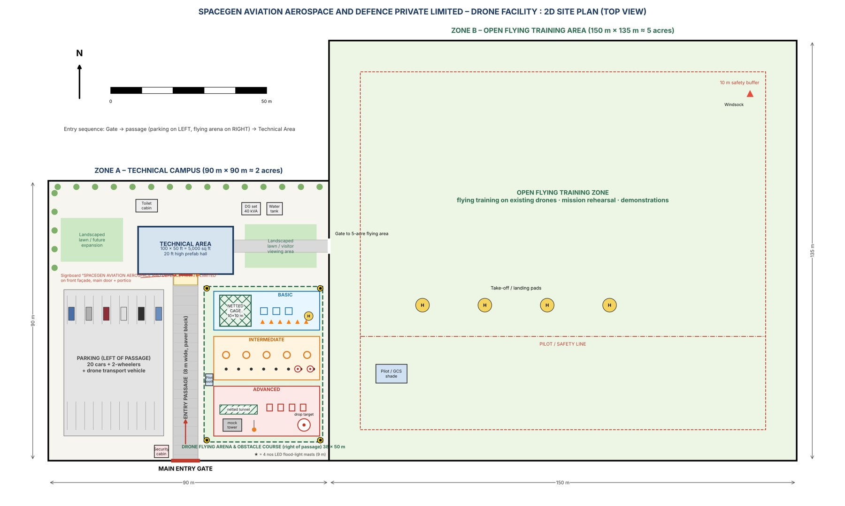
Figure 1 – 2D site plan (top view)
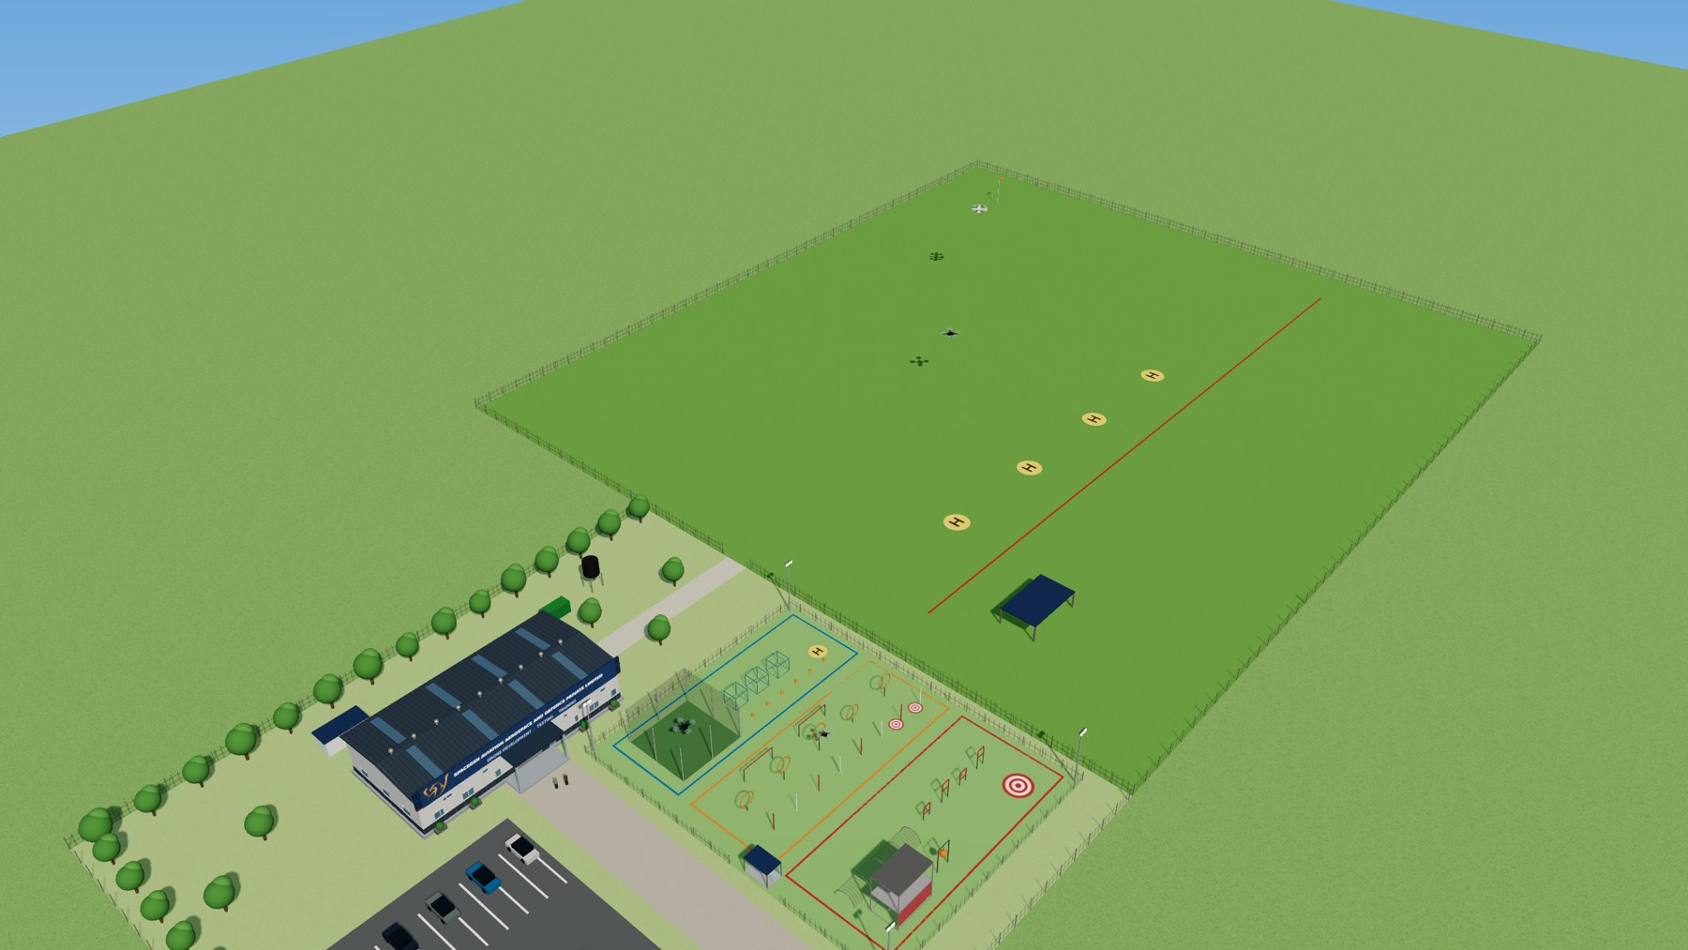
Figure 2 – 3D panoramic view of the complete area
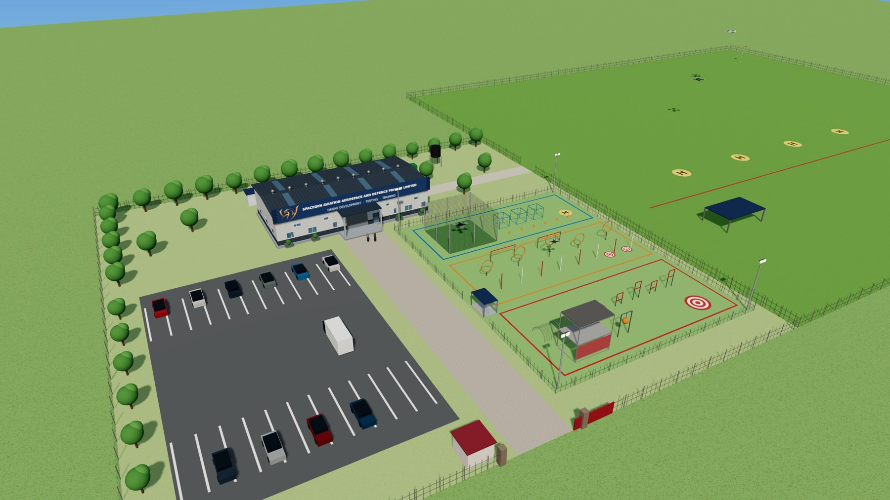
Figure 3 – 3D aerial view of the technical campus: parking (left), passage, flying arena (right), Technical Area

7. Technical Area – Prefabricated Shelter
Feature | Specification
Covered area | 5,000 sq ft (100 ft × 50 ft = 30.5 m × 15.2 m), single open-plan hall
Height | 20 ft eave height, ≈ 22.5 ft at ridge / top of front fascia
Structure | Pre-engineered steel portal frames; 50 mm PUF-insulated colour-coated sandwich panels for walls and roof – fast to install (≈ 6–8 weeks after foundation), expandable and relocatable
Big entrance door | Motorised rolling shutter 14 ft wide × 14 ft high, centred on the front wall under a portico
Small door | 4 × 7 ft steel-glass door with biometric access, right of the main shutter, for regular access; rear emergency exit
Windows | 16 aluminium sliding windows 5 × 4 ft (6 front, 4 rear, 3 on each side) + 4 high-level ventilator louvres
Ventilation | Cross-ventilation through windows, 10 roof turbo ventilators, 6 exhaust fans, polycarbonate skylight strips
Lighting | 18 × 150 W LED high-bay lights + 16 LED task panels over benches, computers and display; 16 spot lights on display tables
Fans & ACs | 2 HVLS big ceiling fans + 8 wall fans; 8 × 2 TR inverter split ACs (spread across all zones)
Floor | 450 mm RCC plinth with epoxy coating, colour-coded by zone with yellow walkway lines
Aesthetics | Light-grey ribbed panels with dark-grey dado band, navy ACP front fascia with red accent line, 3D LED signboard “SPACEGEN AVIATION AEROSPACE AND DEFENCE PRIVATE LIMITED”, portico and planters

7.1 Zone arrangement (as you enter by the main door, facing inward)
- Capability Display Zone – LEFT half of the hall. The 8 round display tables (Ø4 ft on Ø2 ft base with revolving castor wheels) are in the centre in two rows of four with drones displayed on them; the 8 LED backlit boards (3 × 4 ft) on drones and C-UAV equipment are on the left wall and rear wall, with a 75" display.
- Drone Testing & Calibration Equipment – FRONT LEFT, along the front and side walls: 20 kg thrust stand in a polycarbonate safety cage, 3-DOF test rig, vibration analyser bench and payload gimbal test bench.
- Software & Hardware Development Zone – RIGHT-MOST CORNER OPPOSITE THE DOOR (rear right), behind a glass partition: 3 computers with tables and chairs and 2 × 3D printers.
- Drone Testing & Evaluation Lab – RIGHT DOWN CORNER (front right): 3 ESD drone benches with soldering/rework stations and instruments (2 chairs each), 2 round tables with 4 chairs each, 2 component racks and 2 battery storage racks next to the small door.
- Simulator Zone – RIGHT of the central aisle as you enter by the main door (≈ 300 sq ft, glass-partitioned): 4 flight-simulator stations, a Sky Commander fixed-wing station, an instructor console and a 65" debrief display. It doubles as the RPTO classroom required for DGCA remote-pilot training. The two round tables of the testing lab move further right to make space.
- Central aisle – a central aisle from the main door to the rear emergency exit keeps visitors on a clear walkway between the display side and the work side.
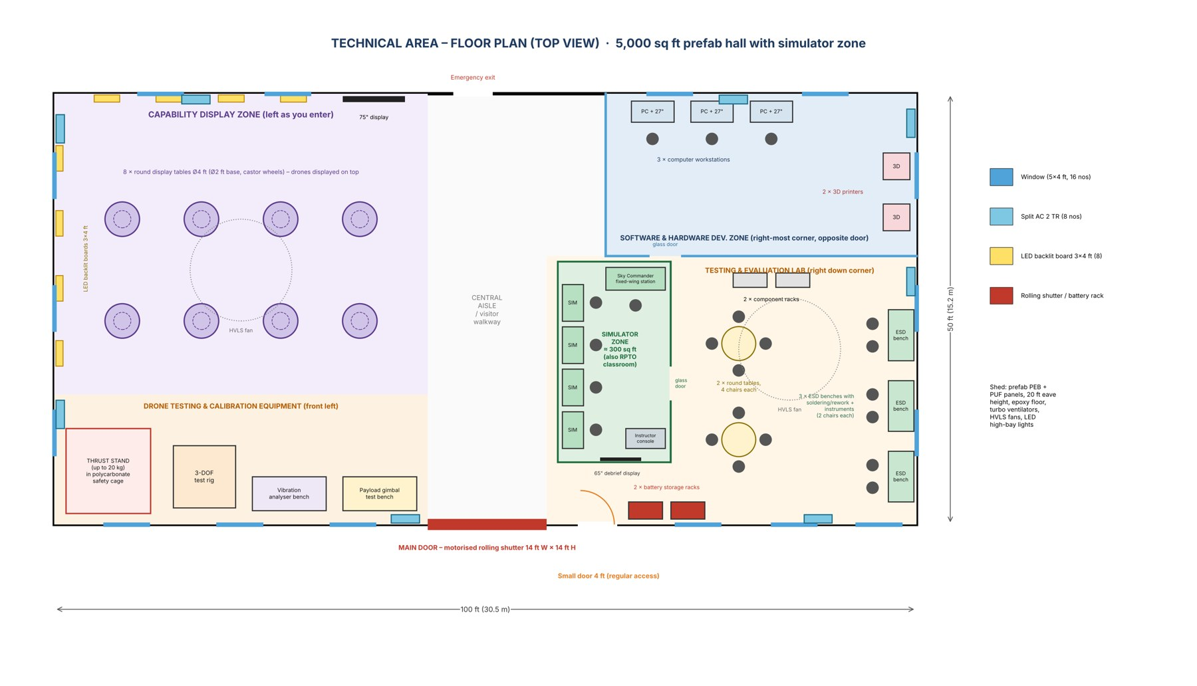
Figure 4 – Technical Area floor plan (2D top view) with simulator zone
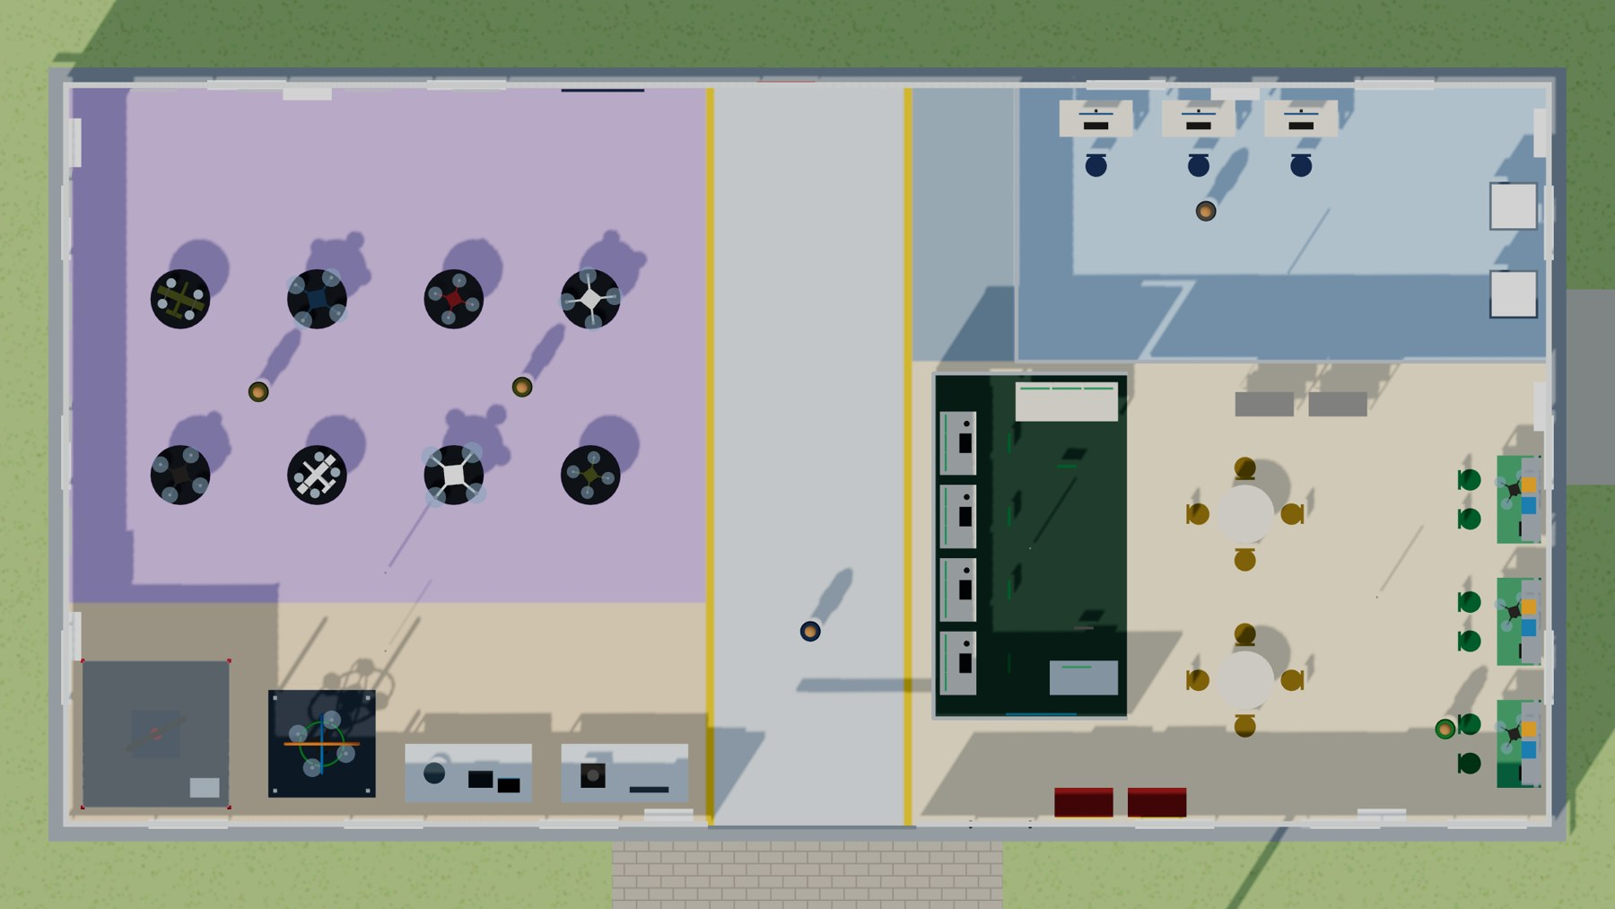
Figure 5 – Technical Area 3D top view (roof removed)
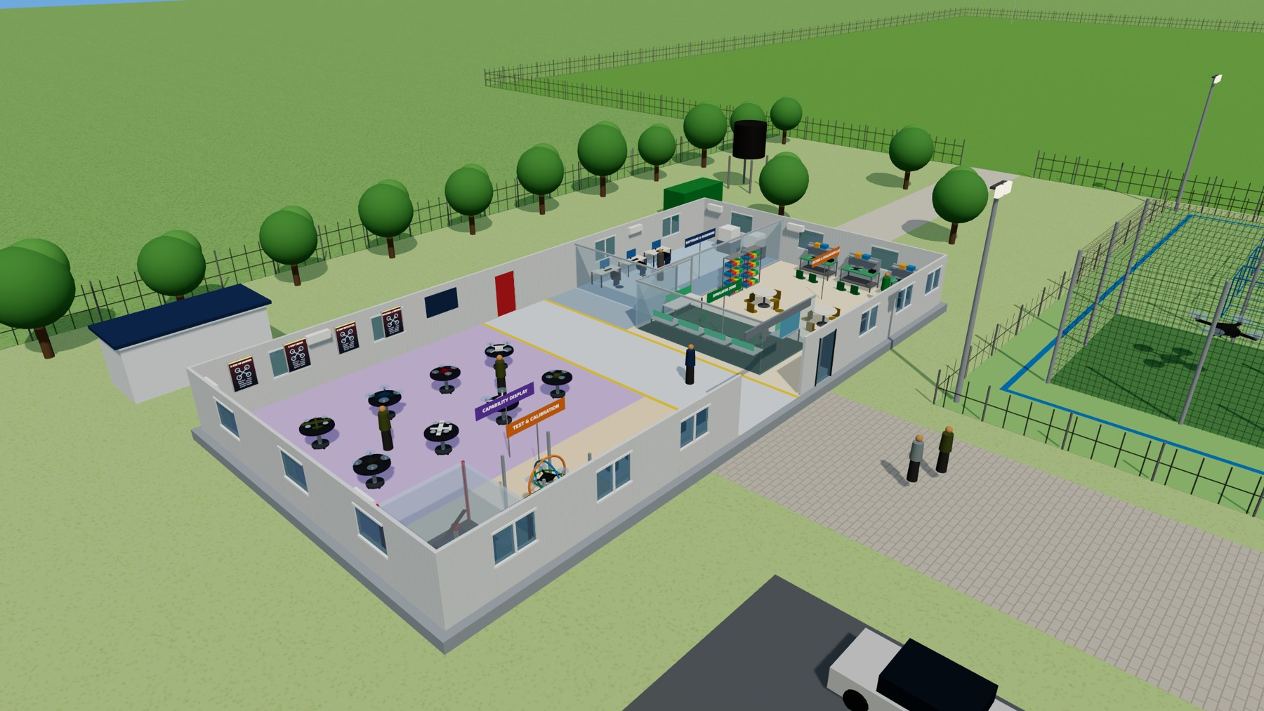
Figure 6 – 3D panoramic view of Technical Area from front-left (cut-away)
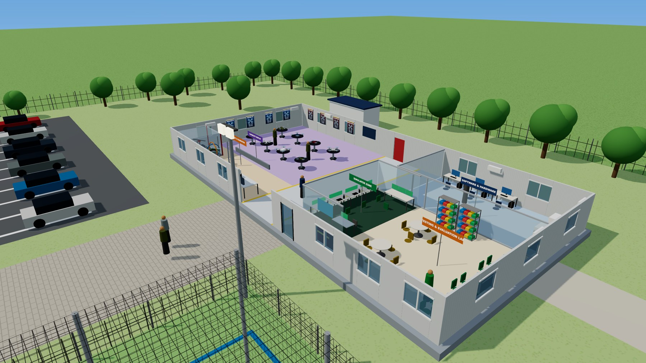
Figure 7 – 3D panoramic view from front-right (cut-away) showing the simulator zone

8. Elevations and Side View
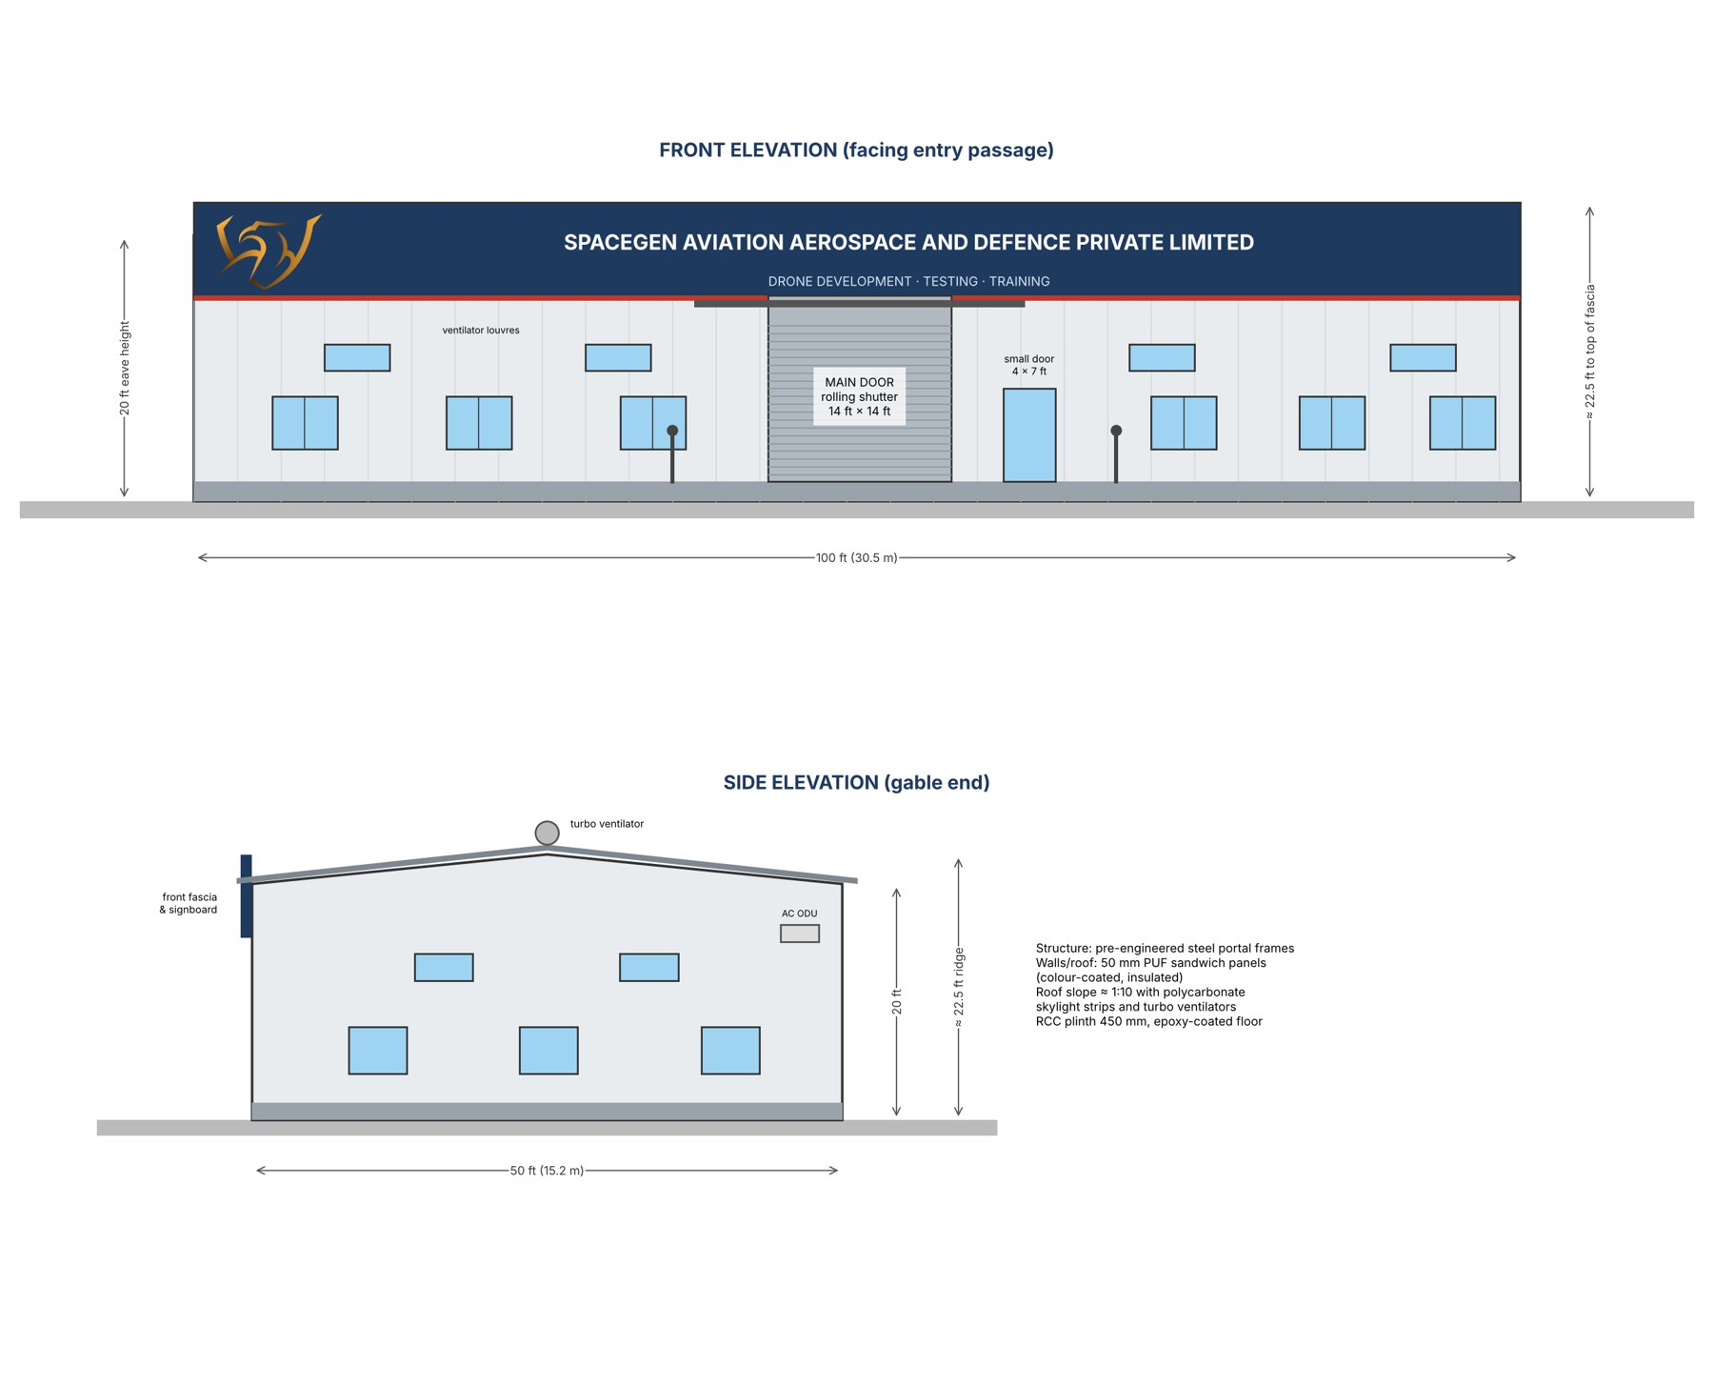
Figure 8 – Front and side elevations (2D) showing 20 ft height and signboard
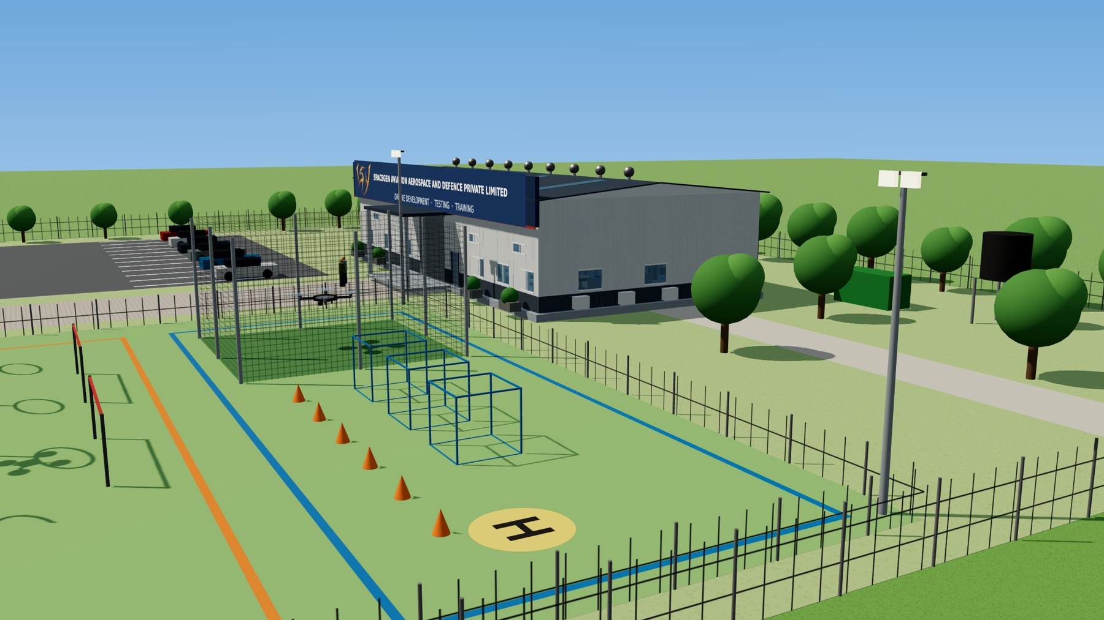
Figure 9 – 3D side view of Technical Area with flying arena in foreground

9. Drone Flying Arena & Obstacle Course
The flying arena (38 × 50 m) lies to the right of the entry passage and is laid out in three lanes so trainees progress from Basic to Advanced. The full course, including the 10 × 10 m netted cage and four 400 W LED flood lights on 9 m masts at the corners, is estimated at ₹ 13,67,000 – within the ₹10–15 lakh target.
Level | Elements | Training objective
Basic | Netted cage 10 × 10 × 6 m, 3 hover boxes, cone slalom, H-pad | Take-off / landing, stable hover, yaw, orientation – safe for beginners
Intermediate | 5 hoop gates at varying heights, 8 slalom poles, 2 altitude bars, 2 landing targets | Precision, speed and altitude control, spot landing
Advanced | Netted tunnel Ø3 × 12 m, 4 window frames, 2-level mock tower, swinging obstacle, payload-drop target | Confined-space, urban / ISR scenarios, dynamic obstacles, payload drops
Lighting & safety | 4 × 400 W LED flood lights on 9 m masts, pilot booth, arena fence, windsock, signage | Evening / low-light training and safe operations

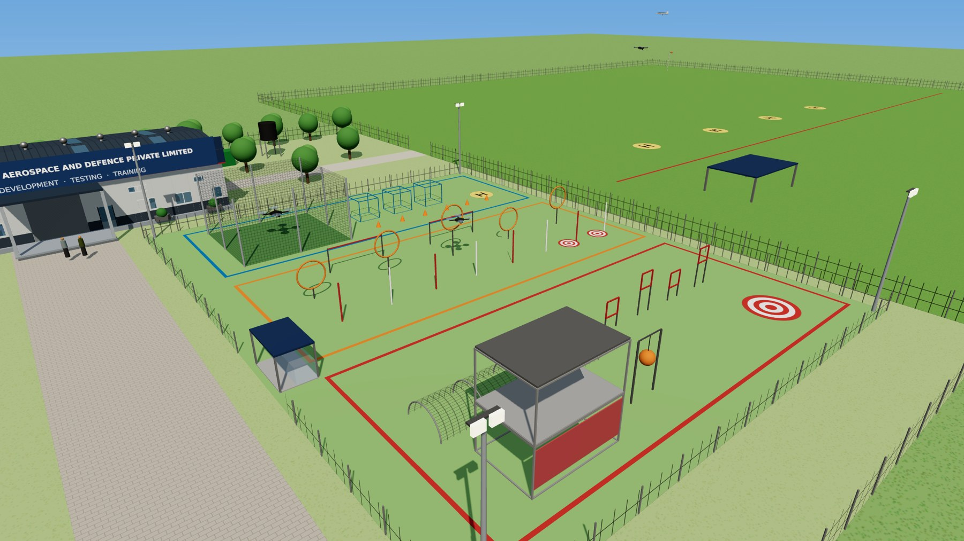
Figure 10 – 3D view of the flying arena: netted cage, three training lanes, flood lights and the 5-acre field beyond

10. Bill of Quantities – All Items with Cost and Remarks
Approximate budgetary costs in Indian Rupees (2026 market rates), excluding GST. Final prices depend on brand, specification and vendor quotations.
S.No | Item | Qty | Unit cost (₹) | Total (₹) | Remarks (use)
A. Technical Area – Prefabricated Shelter & Building Services (5,000 sq ft, 20 ft high)
1 | Site preparation, foundations & 450 mm RCC plinth with VDF floor | 5,000 sq ft | 180 | 9,00,000 | Level, load-bearing base on which the prefab shed is erected
2 | Pre-engineered steel structure with 50 mm PUF-insulated roof & wall panels, 20 ft eave height (100 × 50 ft) | 5,000 sq ft | 760 | 38,00,000 | Main prefab shelter – quick to erect (approx. 6–8 weeks), insulated, can be expanded or relocated
3 | Front ACP façade cladding & fascia band | 1 lot | 3,00,000 | 3,00,000 | Aesthetic front elevation that carries the company signboard
4 | 3D LED-lit signboard “SPACEGEN AVIATION AEROSPACE AND DEFENCE PRIVATE LIMITED” with logo | 1 no | 1,50,000 | 1,50,000 | Company identity on the front façade, visible from the entry passage
5 | Portico canopy over main entrance (7.6 × 3.4 m) | 1 no | 1,00,000 | 1,00,000 | Covered drop-off & welcome point for visitors / defence delegations
6 | Main entrance – motorised rolling shutter 14 ft W × 14 ft H | 1 no | 1,60,000 | 1,60,000 | Big door for moving large drones, equipment and vehicles in/out
7 | Small door 4 × 7 ft (steel-glass) with biometric access control | 1 no | 45,000 | 45,000 | Regular day-to-day access for staff and visitors
8 | Emergency exit door (rear) with panic bar | 1 no | 30,000 | 30,000 | Fire-safety exit at the back of the hall
9 | Aluminium sliding windows 5 × 4 ft with toughened glass & mesh | 16 nos | 16,000 | 2,56,000 | Natural light and cross-ventilation (6 front, 4 rear, 3 on each side)
10 | High-level ventilator louvres | 4 nos | 8,000 | 32,000 | Lets hot air escape at upper level of the 20 ft shed
11 | Polycarbonate skylight strips in roof | 1 lot | 80,000 | 80,000 | Daylight inside the hall, reduces lighting load
12 | Roof turbo ventilators | 10 nos | 5,000 | 50,000 | Wind-driven, zero-power exhaust of hot air from ridge
13 | Exhaust fans (heavy duty) | 6 nos | 6,000 | 36,000 | Forced ventilation, especially at soldering / 3D-printing / battery areas
14 | Epoxy floor coating with zone colour marking | 5,000 sq ft | 50 | 2,50,000 | Dust-free, easy-to-clean floor; marks the zones and walkway
15 | Aluminium-frame glass partition for S/W & H/W zone (with glass door) | 1 lot | 1,80,000 | 1,80,000 | Separates the computer / 3D-printer zone for dust and AC efficiency while staying visible
16 | Internal electrical wiring, DBs, MCBs, 3-phase supply, earthing, sockets | 1 lot | 4,00,000 | 4,00,000 | Power to all zones, benches, test equipment and ACs
17 | LED high-bay lights 150 W | 18 nos | 6,500 | 1,17,000 | General lighting of the 20 ft high hall
18 | LED panel / task lights at work zones | 16 nos | 2,000 | 32,000 | Extra light over benches, computers and display
19 | HVLS (big) ceiling fans, 12–16 ft dia | 2 nos | 1,80,000 | 3,60,000 | Air circulation across the large hall at low running cost
20 | Wall-mounted fans | 8 nos | 4,500 | 36,000 | Spot cooling at benches and display zone
21 | Split air-conditioners 2 TR, inverter, 5-star | 8 nos | 55,000 | 4,40,000 | Cooling of work zones, computers, test equipment and visitor area
22 | Online UPS 6 kVA with battery bank | 1 no | 1,20,000 | 1,20,000 | Clean backup power for computers, instruments and network
23 | Fire alarm, smoke detectors & fire extinguishers (ABC, CO₂, Class-D) | 1 lot | 1,20,000 | 1,20,000 | Fire safety incl. lithium battery fires
24 | CCTV (8 cameras + NVR) & visitor access control | 1 lot | 1,20,000 | 1,20,000 | Security of drones and equipment; logging of defence visitors
25 | Networking – router, firewall, switch, Wi-Fi access points | 1 lot | 60,000 | 60,000 | Internet, file sharing and GCS connectivity
Sub-total A |  |  |  | ₹ 81,74,000
B. Software & Hardware Development Zone (rear right corner)
26 | Computer workstations (Core i7, 32 GB RAM, RTX-class GPU, 1 TB SSD, 27" monitor) | 3 nos | 1,30,000 | 3,90,000 | Drone design (CAD), firmware coding, simulation and flight-log analysis
27 | Computer tables (modular workstation 1.5 m with cable tray) | 3 nos | 15,000 | 45,000 | To keep the computers
28 | Ergonomic office chairs | 3 nos | 9,000 | 27,000 | Seating for developers
29 | 3D printers (enclosed, large-bed, carbon-fibre filament capable) | 2 nos | 1,00,000 | 2,00,000 | Prototyping of frames, mounts, brackets and spares
30 | 3D printer stands with filament storage | 2 nos | 10,000 | 20,000 | Stable base and dry storage of filament
31 | Software licences (CAD / design tools, 3 seats, 1 year) | 1 lot | 1,20,000 | 1,20,000 | Mechanical design and drawings; GCS & simulation software are open-source
Sub-total B |  |  |  | ₹ 8,02,000
C. Drone Testing & Evaluation Lab (front right corner)
32 | Round tables (4 ft dia) | 2 nos | 15,000 | 30,000 | Discussion, test planning and briefing
33 | Chairs for round tables | 8 nos | 4,500 | 36,000 | Four chairs per round table
34 | Drone ESD work benches (6 × 3 ft, ESD top, shelves, power strip, lamp, ESD mat & wrist straps) | 3 nos | 45,000 | 1,35,000 | Drone inspection, assembly, repair and testing
35 | Soldering & SMD rework stations (soldering + hot-air) | 3 nos | 25,000 | 75,000 | Soldering of ESCs, motors, connectors; PCB rework – one per bench
36 | Digital storage oscilloscope 100 MHz, 4-channel | 3 nos | 35,000 | 1,05,000 | Instrumentation per bench – checks PWM/DShot signals, power rails, sensor buses
37 | Programmable DC bench power supply 0–30 V / 30 A | 3 nos | 20,000 | 60,000 | Instrumentation per bench – safely powers drones/boards during testing
38 | Digital multimeter + clamp meter set | 3 sets | 8,000 | 24,000 | Instrumentation per bench – voltage, current, continuity checks
39 | Precision tool kit (hex drivers, crimpers, prop balancer) | 3 sets | 8,000 | 24,000 | Routine assembly and maintenance at each bench
40 | ESD chairs for drone benches | 6 nos | 6,000 | 36,000 | Two chairs per drone bench
41 | Component racks with storage bins (6 ft) | 2 nos | 15,000 | 30,000 | Storage of motors, ESCs, propellers, connectors, fasteners
42 | Battery storage racks – metal, with fire-retardant LiPo boxes | 2 nos | 40,000 | 80,000 | Safe storage of drone batteries near the exit door
43 | Smart LiPo battery chargers (multi-port, balance) | 2 nos | 25,000 | 50,000 | Charging and storage-charging of drone batteries
Sub-total C |  |  |  | ₹ 6,85,000
D. Capability Display Zone (left as you enter – tables in the centre)
44 | Round display tables Ø4 ft on Ø2 ft round base with lockable revolving castor wheels | 8 nos | 30,000 | 2,40,000 | Display of SpaceGen drones; tables can be moved and rotated for viewing
45 | LED backlit information boards 3 × 4 ft (with printed graphics) | 8 nos | 20,000 | 1,60,000 | Information on drones and C-UAV equipment for visitors and defence users
46 | Track / spot lights over display tables | 16 nos | 3,500 | 56,000 | Highlights each drone on display
47 | 75-inch 4K display with wall mount & media player | 1 no | 1,20,000 | 1,20,000 | Company video, mission footage and presentations to visitors
Sub-total D |  |  |  | ₹ 5,76,000
E. Drone Testing & Calibration Equipment (front left, along the sides)
48 | 3-DOF (roll/pitch/yaw) drone attitude test rig | 1 no | 2,50,000 | 2,50,000 | Tethered testing of stabilisation and PID tuning without flying
49 | Vibration analyser with triaxial accelerometers & software | 1 no | 2,50,000 | 2,50,000 | Measures frame/motor vibration; finds imbalance and resonance
50 | Thrust measurement stand – up to 20 kg thrust (load cells, RPM, current, voltage, torque) | 1 no | 4,00,000 | 4,00,000 | Load testing of motors and propellers up to 20 kg; efficiency curves
51 | Polycarbonate safety cage for thrust stand (3 × 3 × 2.2 m) | 1 no | 60,000 | 60,000 | Protects staff from propeller / motor failure during thrust tests
52 | Payload gimbal testing set-up (gimbal bench, calibration targets, monitor, power) | 1 no | 1,50,000 | 1,50,000 | Testing and calibration of camera / EO-IR gimbals and payloads
53 | Heavy-duty equipment tables / platforms | 4 nos | 20,000 | 80,000 | Stable mounting of test rigs and analysers
Sub-total E |  |  |  | ₹ 11,90,000
F. Drone Flying Arena & Obstacle Course (right of passage) – Basic / Intermediate / Advanced
54 | Ground levelling, grassing & marking of arena (38 × 50 m) | 1 lot | 1,50,000 | 1,50,000 | Even, dust-free flying surface with lane markings for the three levels
55 | BASIC – Netted cage 10 × 10 × 6 m (GI pipe frame, HDPE net on 4 sides + top) | 1 no | 3,50,000 | 3,50,000 | Safe first flights for beginners; protects drones from damage
56 | BASIC – Hover boxes (2 × 2 × 2 m frames) | 3 nos | 6,000 | 18,000 | Stable hover, altitude hold, 360° yaw practice
57 | BASIC – Traffic cones (slalom) + takeoff/landing H-pad | 1 lot | 25,000 | 25,000 | Low-level slalom, take-off and landing drills
58 | INTERMEDIATE – Hoop gates Ø2.2 m at varying heights | 5 nos | 8,000 | 40,000 | Precision transit through gates
59 | INTERMEDIATE – Slalom poles 3 m | 8 nos | 3,000 | 24,000 | Coordinated turns and speed control
60 | INTERMEDIATE – Altitude bars (fly-under / flyover) | 2 sets | 15,000 | 30,000 | Altitude control while moving
61 | INTERMEDIATE – Precision landing targets | 2 nos | 6,000 | 12,000 | Spot-landing accuracy scoring
62 | ADVANCED – Netted tunnel Ø3 m × 12 m | 1 no | 1,20,000 | 1,20,000 | Confined-space and GNSS-weak flying
63 | ADVANCED – Window frames 1.2 × 1.2 m at offset heights | 4 nos | 12,000 | 48,000 | Tight-gap transits
64 | ADVANCED – Mock tower (2-level scaffold, 6 × 4 × 6 m) | 1 no | 1,50,000 | 1,50,000 | Roof landing, window entry and urban / ISR scenarios
65 | ADVANCED – Swinging obstacle | 1 no | 35,000 | 35,000 | Dynamic obstacle avoidance
66 | ADVANCED – Payload-drop target | 1 no | 10,000 | 10,000 | Accuracy of payload / supply drops
67 | LED flood lights 400 W on 9 m galvanised masts, incl. cabling & control | 4 nos | 55,000 | 2,20,000 | Lights the complete obstacle course for evening / low-light training
68 | Pilot booth (polycarbonate shield, roof) | 1 no | 75,000 | 75,000 | Protected pilot / instructor position
69 | Arena fencing (1.5 m), windsock, safety signage | 1 lot | 60,000 | 60,000 | Keeps people out of the arena during flights
Sub-total F |  |  |  | ₹ 13,67,000
G. Site Works & Utilities
70 | Main entry gate (sliding) with pillars | 1 no | 1,50,000 | 1,50,000 | Controlled entry to the facility
71 | Prefab security cabin | 1 no | 1,20,000 | 1,20,000 | Guard post and visitor registration at gate
72 | Entry passage – paver block road, 8 m wide × 60 m | 480 m² | 700 | 3,36,000 | Passage from gate to the technical area
73 | Parking (left of passage) – WBM with paver / bitumen top, ≈ 1,200 m² | 1,200 m² | 400 | 4,80,000 | Parking for about 20 cars, two-wheelers and drone transport vehicle
74 | Boundary chain-link fencing – 2-acre campus (≈ 360 m) | 360 m | 900 | 3,24,000 | Secures the technical campus
75 | Chain-link fencing & rough levelling – 5-acre flying area | 1 lot | 3,50,000 | 3,50,000 | Secures and prepares the open flying training area for existing drones
76 | Prefab toilet cabin (2 WC + wash basins) | 1 no | 2,50,000 | 2,50,000 | Staff and visitor amenities
77 | Water supply – borewell, tank, plumbing | 1 lot | 2,00,000 | 2,00,000 | Water for toilets and fire safety
78 | Power connection & external cabling, street lights | 1 lot | 3,00,000 | 3,00,000 | Electricity to the campus
79 | DG set 40 kVA (silent) with AMF panel | 1 no | 5,00,000 | 5,00,000 | Backup power for the technical area and flood lights
80 | Landscaping & plantation | 1 lot | 1,00,000 | 1,00,000 | Green, dust-free and pleasant campus
Sub-total G |  |  |  | ₹ 31,10,000
H. Simulator Zone (right of aisle as you enter)
81 | Flight simulator stations – PC, 3 × 24" monitors, RC transmitter, sim software (multirotor/FPV) | 4 nos | 1,50,000 | 6,00,000 | Basic-to-advanced pilot training before live flying; RPTO syllabus
82 | Sky Commander fixed-wing / VTOL simulator station | 1 no | 2,00,000 | 2,00,000 | Fixed-wing and VTOL mission training; SpaceGen product
83 | FPV goggle training kits with radios | 4 sets | 40,000 | 1,60,000 | FPV attack-drone training on simulator
84 | Instructor console with 65" debrief display | 1 lot | 1,50,000 | 1,50,000 | Instructor monitoring, replay and debrief
85 | Simulator desks and ergonomic seats | 5 sets | 20,000 | 1,00,000 | Trainee seating at stations
86 | Glass partition, door and acoustic panels (≈ 300 sq ft) | 1 lot | 1,20,000 | 1,20,000 | Quiet, enclosed classroom inside the hall
87 | Split AC 2 TR (inverter) for simulator zone | 1 no | 55,000 | 55,000 | Cooling for PCs and trainees
88 | UPS 3 kVA online with batteries | 1 no | 60,000 | 60,000 | Uninterrupted training sessions
89 | Electrical points, LAN and Wi-Fi for zone | 1 lot | 55,000 | 55,000 | Power and network to all stations
Sub-total H |  |  |  | ₹ 15,00,000
GRAND TOTAL (excl. GST) |  |  |  | ₹ 1,74,04,000 | ≈ ₹ 1.74 crore

11. Cost Summary, Budget and Regulatory & Safety Notes
Head | Description | Amount (₹) | In lakh
A | Technical Area – Prefabricated Shelter & Building Services (5,000 sq ft, 20 ft high) | 81,74,000 | 81.74 lakh
B | Software & Hardware Development Zone (rear right corner) | 8,02,000 | 8.02 lakh
C | Drone Testing & Evaluation Lab (front right corner) | 6,85,000 | 6.85 lakh
D | Capability Display Zone (left as you enter – tables in the centre) | 5,76,000 | 5.76 lakh
E | Drone Testing & Calibration Equipment (front left, along the sides) | 11,90,000 | 11.90 lakh
F | Drone Flying Arena & Obstacle Course (right of passage) – Basic / Intermediate / Advanced | 13,67,000 | 13.67 lakh
G | Site Works & Utilities | 31,10,000 | 31.10 lakh
H | Simulator Zone (right of aisle as you enter; also RPTO classroom) | 15,00,000 | 15.00 lakh
 | GRAND TOTAL (excl. GST) | ₹ 1,74,04,000 | ₹ 1.74 Cr

11.1 Budget notes
- Revised total: the facility itself stays at ₹1.59 crore (heads A–G, inside the earlier ₹1.50–1.65 crore band). Adding the ₹15 lakh simulator zone (head H) takes the total infrastructure budget to ₹1.74 crore. The simulator zone is what lets Chandigarh run RPTO courses and unit training from day one.
- GST: GST (mostly 18%) is not included; if the budget must include GST, the shelter rate, AC count and DG size are the main levers to bring it back into range.
- Biggest item: the prefab shelter (head A) is about half the cost; PEB + PUF rates vary roughly ₹700–1,000 per sq ft with steel prices and panel thickness, so get 3 vendor quotes.
- Flying areas: the obstacle course (head F) is within ₹10–15 lakh and the flying area uses existing land with only fencing and levelling costed.

11.2 Regulatory & safety notes
- Airspace: check the site is in a green zone on the DGCA Digital Sky airspace map before construction.
- Training: certified remote-pilot training requires authorisation as a Remote Pilot Training Organisation (RPTO) under the Drone Rules, 2021; check current DGCA requirements before finalising the training layout.
- Battery safety: keep LiPo batteries in the fire-retardant racks near the exit, with Class-D extinguisher and sand bucket at hand.

12. Review of the Enablers for Scaling Up
Each of SpaceGen’s eleven enablers was checked for who leads it, how practical it is, when it starts to earn revenue, what it needs and what could slow it. The table is colour-coded:
Enablers 1–5 – Chandigarh facility (counted in this plan) | Enablers 6–11 – Hyderabad HQ (7, 8, 9 moved to HQ; not counted in this plan)

# | Enabler | Led by | Practicality | Revenue starts | What it needs | Main risk | Y5 ₹ Cr | Y10 ₹ Cr
1 | Existing customers & referrals (18+ Army units, BSF, police) | Chandigarh | High | Immediate | Field-trial experts, demo kit; referral incentives | Over-dependence on few units' local budgets | 21 | 36
2 | Demos at Chandigarh facility (Northern & Western Command) | Chandigarh | High | Immediate (from facility opening) | 6-person Chandigarh team; demo fleet; visitor programme | Permission and security procedures for visitors | 17 | 28
3 | Demos in forward areas to Army units | Chandigarh | High | Immediate | Leased SUV, 3-person demo team; formation permissions | Weather, road access; unit budget timing | 14 | 24
4 | RPTO – DGCA certification & unit training | Chandigarh | High | Year 1 (after DGCA authorisation) | 2 Remote Pilot Instructors, simulator zone (≈300 sq ft, 4 + 1 simulators) | RPTO approval time; price competition | 6.5 | 14
5 | GeM listing & regular RFPs / open tenders | Chandigarh | High | Year 1 | Product listings on GeM with OEM/IDDM declarations; bid desk at Chandigarh | L1 price pressure; EMD/PBG blocking cash | 18 | 38
6 | Central procurement (RFI → RFP, FTP / EP / capital) | Hyderabad HQ | Medium | Year 2–3 (first orders), large from Year 4 | DGQA/user trials, AS9100D, MIL-STD-810/461 reports, BG limits – HQ-led | Long cycles (18–36 months); capital-heavy | HQ | HQ
7 | PMF & civil departments (fixed-wing / VTOL: roads, power, oil & gas) | Hyderabad HQ | Medium-high | Year 1–2 | Fixed-wing/VTOL survey payloads, DGCA type certificates; HQ-led | Tender-driven; slow payments from some departments | HQ | HQ
8 | DPSU partnering (BEL, HAL, BDL – sub-systems / Tier-2) | Hyderabad HQ | Medium | Year 2–3 | Vendor registration with BEL/HAL/BDL; QA system – HQ-led | DPSU margins are thin; long qualification | HQ | HQ
9 | Expos & seminars → exports (friendly foreign countries) | Hyderabad HQ | Medium | Leads Year 1; export orders Year 3+ | Expo budget; export authorisation (SCOMET) – HQ-led | Export licensing; lumpy orders | HQ | HQ
10 | Joint development with Army – problem statements, iDEX, joint IP | Hyderabad HQ | Medium-high | Year 1–2 (grants), production Year 3+ | Joint problem statements with formations/ADB; iDEX/ADITI; IP agreements – HQ-led | IP sharing terms; development risk | HQ | HQ
11 | Integrated solutions – MUM-T, zone protection, swarm defence | Hyderabad HQ | Medium (long-term high) | Pilots Year 3; scale Year 5+ | Systems-engineering team, C2 software, sensor fusion, test range – HQ-led | Highest technical and funding need | HQ | HQ
Y5 / Y10 values are Chandigarh Base-case sales (Section 13). Enablers 6–11 are in Hyderabad HQ’s plan and are not counted here.

Notes on the Chandigarh enablers
- 1–3 Army network, Chandigarh and forward demos: the fastest and cheapest revenue. Former MCEME students now in units of Northern and Western Command know the problem and the products; commanding officers can buy under delegated financial and emergency powers, and each satisfied unit generates referrals within its formation.
- 4 RPTO: low capital, steady cash, and it puts every trainee in front of SpaceGen products. DGCA requires at least 2 Remote Pilot Instructors per batch of 20, a ~300 sq ft classroom, 2 drones and 2 simulators – the ₹15 lakh simulator zone provides this.
- 5 GeM and RFPs: GeM listing (already registered) plus bidding on Army, CAPF and state-police tenders in the northern sector gives a regular order flow.
- 6–11 – Hyderabad HQ: central procurement (6), PMF and civil departments (7), DPSU partnering (8), expos and exports (9), joint development (10) and integrated solutions (11) need more expertise, dedicated technical teams and long cycles. Chandigarh supports them with demos and field trials, but their revenue and costs are booked at HQ.

13. Ten-Year Sales Projection – Chandigarh, Base Case
Year 1 is FY 2027-28, the first full year with the Chandigarh facility, simulator zone and RPTO running; FY 2026-27 is the set-up year. Figures are net sales in ₹ crore, excluding GST. Rows are the five enablers Chandigarh drives (1–5); enablers 6–11 belong to Hyderabad HQ and are excluded. Operating cost follows Section 16.
Enabler / revenue stream | Y1 FY27-28 | Y2 FY28-29 | Y3 FY29-30 | Y4 FY30-31 | Y5 FY31-32 | Y6 FY32-33 | Y7 FY33-34 | Y8 FY34-35 | Y9 FY35-36 | Y10 FY36-37
1. Existing customers & referrals (18+ Army units, BSF, police) | 9 | 12 | 15 | 18 | 21 | 24 | 27 | 30 | 33 | 36
2. Demos at Chandigarh facility (Northern & Western Command) | 5 | 8 | 11 | 14 | 17 | 20 | 22 | 24 | 26 | 28
3. Demos in forward areas to Army units | 3 | 5 | 8 | 11 | 14 | 16 | 18 | 20 | 22 | 24
4. RPTO – DGCA certification & unit training | 0.8 | 2 | 3.5 | 5 | 6.5 | 8 | 9.5 | 11 | 12.5 | 14
5. GeM listing & regular RFPs / open tenders | 4 | 7 | 10 | 14 | 18 | 22 | 26 | 30 | 34 | 38
TOTAL SALES – CHANDIGARH, enablers 1–5 (₹ crore) | 21.8 | 34 | 47.5 | 62 | 76.5 | 90 | 102.5 | 115 | 127.5 | 140
YoY growth | — | 56% | 39.7% | 30.5% | 23.4% | 17.6% | 13.9% | 12.2% | 10.9% | 9.8%
Operating cost – Chandigarh facility (₹ crore) | 2.85 | 4.19 | 5.71 | 7.37 | 9.07 | 10.74 | 12.37 | 14.06 | 15.82 | 17.66
Increase in operating cost | — | 1.34 | 1.52 | 1.66 | 1.70 | 1.67 | 1.63 | 1.69 | 1.76 | 1.84
Operating cost as % of sales | 13.1% | 12.3% | 12% | 11.9% | 11.9% | 11.9% | 12.1% | 12.2% | 12.4% | 12.6%
Share of Chandigarh-addressable market | 1.4% | 1.7% | 1.9% | 2% | 2.1% | 2.1% | 2.1% | 2.1% | 2% | 2%
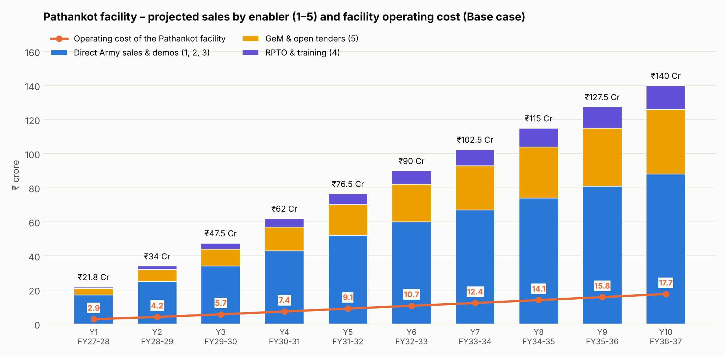
Figure 12 – Chandigarh Base-case sales by enabler group, with the facility’s operating cost

14. Year-on-Year Scale-Up Drivers – Chandigarh
Year | Sales ₹ Cr | YoY | Op. cost ₹ Cr | Head-count | Facilities & capability at Chandigarh | Reach | Participation (demos, bids, expos) | Investment
Y1  FY27-28 | 21.8 | — | 2.85 | 6 | Facility live: technical area, simulator zone, arena, obstacle course (₹1.74 Cr); 6-person team; RPTO application | Northern Command (J&K) + Western Command (Punjab), BSF Punjab & Jammu Frontiers, Punjab Police | 24 demo trips; 30 GeM bids; RPTO first batches | ₹2–3 Cr seed: capex ₹1.74 Cr + Year-1 running cost + demo fleet
Y2  FY28-29 | 34 | 56% | 4.19 | 8 | RPTO DGCA-authorised; 2nd demo vehicle; spares & repair bay | + Himachal Pradesh, Haryana; IAF stations Chandigarh, Adampur, Halwara | 30 demos; 45 bids | Internal accruals; share of HQ ₹5 Cr bank working capital
Y3  FY29-30 | 47.5 | 39.7% | 5.71 | 10 | Northern-sector drones moved to Chandigarh on Technical Ownership Transfer; local integration & QA | + Ladakh (14 Corps), ITBP; J&K Police | 36 demos; 60 bids | Internal accruals
Y4  FY30-31 | 62 | 30.5% | 7.37 | 12 | Expansion ₹1.0 Cr – integration & MRO shed; night-flying lights upgrade | + South Western Command demos (Rajasthan border) | 40 demos; 70 bids | ₹1.0 Cr expansion from accruals
Y5  FY31-32 | 76.5 | 23.4% | 9.07 | 14 | 2nd RPTO batch line; C-UAS demo range agreements with formations | + CAPF units and state police across the north | 45 demos; 80 bids | Internal accruals
Y6  FY32-33 | 90 | 17.6% | 10.74 | 16 | Sustainment & MRO for installed base in J&K / Punjab / HP | Northern sector – all formations | 50 demos; repeat orders | Internal accruals
Y7  FY33-34 | 102.5 | 13.9% | 12.37 | 18 | Expansion ₹1.5 Cr – C-UAS test & integration bay; field test-range tie-ups | Same | 50+ demos | ₹1.5 Cr expansion from accruals
Y8  FY34-35 | 115 | 12.2% | 14.06 | 20 | Product refresh demos (next-gen interceptors, C-UAS) | Same | Same, plus C-UAS trials with formations | Internal accruals
Y9  FY35-36 | 127.5 | 10.9% | 15.82 | 22 | Mature northern hub; refresher training for all Ashni platoons in sector | Same | Same | Internal accruals
Y10  FY36-37 | 140 | 9.8% | 17.66 | 24 | Full-service northern hub – sales, training, MRO | Same | Same | Internal accruals
Headcount is Chandigarh only (6-person Rev 2 team in Year 1, adding about 2 a year – engineers, pilot instructors, bid desk, MRO technicians). Manufacturing and design stay at Hyderabad HQ.

14.1 What drives the growth each year

Year 1 (FY27-28) – sales ₹21.8 crore, operating cost ₹2.9 crore
- Existing Army units in the north re-order and refer neighbouring units (₹9 Cr).
- Demos at the new Chandigarh facility bring Northern & Western Command formations to see the drones fly (₹5 Cr).
- First GeM orders (₹4 Cr) and first forward-area demos (₹3 Cr); RPTO starts (₹0.8 Cr).
- Operating cost ₹2.9 Cr, of which ₹0.89 Cr is fixed running cost.

Year 2 (FY28-29) – sales ₹34 crore (+56%), operating cost ₹4.2 crore
- RPTO is DGCA-authorised: civil courses and Army unit packages (₹2 Cr).
- Repeat GeM orders (₹7 Cr) and more forward demos (₹5 Cr).
- Existing customers ₹12 Cr; facility demos ₹8 Cr.
- Headcount 8; operating cost ₹4.2 Cr (+1.3 Cr).

Year 3 (FY29-30) – sales ₹47.5 crore (+39.7%), operating cost ₹5.7 crore
- Northern-sector drones transferred to Chandigarh (Technical Ownership Transfer at transfer cost) – faster delivery and support.
- GeM ₹10 Cr; forward demos ₹8 Cr.
- RPTO ₹3.5 Cr as unit packages grow.
- Operating cost ₹5.7 Cr (+1.5 Cr).

Year 4 (FY30-31) – sales ₹62 crore (+30.5%), operating cost ₹7.4 crore
- ₹1.0 Cr integration & MRO shed lets Chandigarh service the installed base.
- Existing customers ₹18 Cr; forward demos ₹11 Cr.
- Demos extend to South Western Command.
- Headcount 12; operating cost ₹7.4 Cr.

Year 5 (FY31-32) – sales ₹76.5 crore (+23.4%), operating cost ₹9.1 crore
- 2nd RPTO batch line (₹6.5 Cr training).
- GeM ₹18 Cr; existing customers ₹21 Cr.
- CAPF and state-police orders through GeM tenders.
- Operating cost ₹9.1 Cr.

Year 6 (FY32-33) – sales ₹90 crore (+17.6%), operating cost ₹10.7 crore
- MRO and sustainment contracts across J&K, Punjab and HP.
- Facility demos ₹20 Cr; GeM ₹22 Cr.
- Sales reach ₹90 Cr.
- Headcount 16; operating cost ₹10.7 Cr.

Year 7 (FY33-34) – sales ₹102.5 crore (+13.9%), operating cost ₹12.4 crore
- ₹1.5 Cr C-UAS test & integration bay.
- GeM ₹26 Cr; existing customers ₹27 Cr.
- Growth settles near 11–14% as the base grows.
- Operating cost ₹12.4 Cr.

Year 8 (FY34-35) – sales ₹115 crore (+12.2%), operating cost ₹14.1 crore
- Product refresh demos keep C-UAS ahead of new threats.
- Existing customers ₹30 Cr; GeM ₹30 Cr.
- RPTO ₹11 Cr.
- Headcount 20; operating cost ₹14.1 Cr.

Year 9 (FY35-36) – sales ₹127.5 crore (+10.9%), operating cost ₹15.8 crore
- Refresher training for Ashni platoons across the sector (RPTO ₹12.5 Cr).
- GeM ₹34 Cr; existing customers ₹33 Cr.
- Share of addressable market ≈ 2%.
- Operating cost ₹15.8 Cr.

Year 10 (FY36-37) – sales ₹140 crore (+9.8%), operating cost ₹17.7 crore
- Full-service northern hub: sales, training and MRO.
- Chandigarh enablers 1–5 reach ₹140 Cr.
- Share of Chandigarh-addressable market 2%.
- Headcount 24; operating cost ₹17.7 Cr.

15. Procurement Signals that Matter for SpaceGen
Recent buying decisions show where the money is going and what each one means for the Chandigarh facility.
Signal | What it means
≈ ₹30,000 Cr emergency / fast-track buys after Op Sindoor (drones, loitering munitions, C-UAS, EW) | Forces will buy quickly from vendors with field-proven kit and trials done
Army plans ≈ ₹20,000 Cr for drones & surveillance; ₹1,577 Cr loitering-munition contracts (Aug 2026) | Large central orders – need DGQA trials, certifications and BG capacity
DFI: next tactical-drone order may exceed ₹20,000 Cr (US$2 bn), delivery in 18–24 months | Window for Tier-1/Tier-2 roles with primes and DPSUs – HQ-led (enabler 8)
DAC ≈ ₹52,000 Cr AoN incl. anti-drone (AKASH TARANG), kamikaze drones (Jul 2026) | RFPs follow; HQ partners DPSUs (BEL, BDL); Chandigarh runs field trials
Ashni drone platoon in every infantry battalion (≈380 battalions); Army chief: ~5,000 drones per command | Recurring demand for FPV drones, spares, training and simulators – SpaceGen’s core
BEL IDDIS anti-drone ≈ ₹572 Cr; Zen ₹332 Cr C-UAS order; BSF Drone Warfare School (Aug 2025) | C-UAS buying is real and recurring across Army, IAF and BSF
44,000+ Remote Pilot Certificates, 39,000+ drones registered (Jun 2026); 145 RPTOs (Dec 2024) | Training demand keeps rising; few RPTOs in J&K / north Punjab
iDEX ADITI: up to ₹25 Cr grant per challenge (50% of product budget) | Funds joint problem statements and joint IP with the Army

16. Financial View – Operating Cost of the Chandigarh Facility (Base case)

16.1 Ten-year operating cost
₹ crore | Y1 | Y2 | Y3 | Y4 | Y5 | Y6 | Y7 | Y8 | Y9 | Y10
Salaries | 0.46 | 0.67 | 0.90 | 1.17 | 1.47 | 1.81 | 2.21 | 2.65 | 3.14 | 3.70
Admin & facility running | 0.26 | 0.31 | 0.37 | 0.44 | 0.51 | 0.59 | 0.68 | 0.77 | 0.88 | 0.99
HQ support visits | 0.05 | 0.05 | 0.06 | 0.06 | 0.07 | 0.07 | 0.07 | 0.08 | 0.08 | 0.09
Demonstration tours | 0.08 | 0.09 | 0.11 | 0.12 | 0.14 | 0.16 | 0.18 | 0.21 | 0.24 | 0.28
One-time induction move | 0.03 | — | — | — | — | — | — | — | — | —
Selling & marketing (3% of sales) | 0.65 | 1.02 | 1.43 | 1.86 | 2.29 | 2.70 | 3.08 | 3.45 | 3.83 | 4.20
HQ technical support (4% of sales) | 0.87 | 1.36 | 1.90 | 2.48 | 3.06 | 3.60 | 4.10 | 4.60 | 5.10 | 5.60
Warranty & field support (2% of sales) | 0.44 | 0.68 | 0.95 | 1.24 | 1.53 | 1.80 | 2.05 | 2.30 | 2.55 | 2.80
Total operating cost | 2.85 | 4.19 | 5.71 | 7.37 | 9.07 | 10.74 | 12.37 | 14.06 | 15.82 | 17.66
Increase in operating cost | — | 1.34 | 1.52 | 1.66 | 1.70 | 1.67 | 1.63 | 1.69 | 1.76 | 1.84
Operating cost as % of sales | 13.1% | 12.3% | 12% | 11.9% | 11.9% | 11.9% | 12.1% | 12.2% | 12.4% | 12.6%
Memo: depreciation (not in operating cost) | 0.17 | 0.17 | 0.17 | 0.27 | 0.27 | 0.27 | 0.42 | 0.42 | 0.42 | 0.42
Headcount (Chandigarh) | 6 | 8 | 10 | 12 | 14 | 16 | 18 | 20 | 22 | 24
Operating cost is the running cost of the Chandigarh facility. It starts from the Rev 2 manpower and operating budget (₹85.59 lakh a year + ₹3.02 lakh one-time move), grows with headcount (6 → 24) and inflation, and adds selling (3%), HQ technical support (4%) and warranty (2%) as a share of Chandigarh sales. Depreciation of the ₹1.74 Cr facility and the ₹1.0 Cr (Y4) and ₹1.5 Cr (Y7) expansions is shown separately. Excludes GST.
The facility’s operating cost rises from ₹2.9 crore in Year 1 to ₹17.7 crore in Year 10, a total of ₹99.8 crore over ten years. In Year 1, ₹0.89 crore is fixed running cost and the rest moves with sales.

16.2 Year-1 operating costs at Chandigarh
Cost head | Year 1 (₹ lakh) | Basis
Salaries | 46.32 | Rev 2 team of 6 (₹46.32 lakh/yr), growing to 24 staff by Year 10; 8% annual raise
Admin & facility running | 26.10 | Rev 2 admin budget ₹26.10 lakh/yr + ₹1.8 lakh per added head; 6% inflation
HQ support visits | 5.18 | 4 visits a year from Hyderabad HQ (Rev 2)
Demonstration tours | 7.99 | 24 demos a year in J&K, Punjab, HP, Haryana (Rev 2); +15% a year
Selling & marketing (3%) | 65.40 | Trials, literature, travel for tenders – 3% of Chandigarh sales
HQ technical support / transfer charge (4%) | 87.20 | Design, software and engineering support from Hyderabad HQ – 4% of sales
Warranty & field support (2%) | 43.60 | Spares and field repairs under warranty – 2% of sales
One-time induction move | 3.02 | Year 1 only – move of team and equipment from Hyderabad (Rev 2)
Total operating costs – Year 1 | 284.81 | Excludes depreciation

17. Scenarios – Chandigarh (₹ crore)
Scenario | Y1 | Y2 | Y3 | Y4 | Y5 | Y6 | Y7 | Y8 | Y9 | Y10 | 10-yr total
Conservative – sales | 14.2 | 22.1 | 30.9 | 40.3 | 49.7 | 58.5 | 66.6 | 74.8 | 82.9 | 91 | 531
Conservative – operating cost | 2.2 | 3.1 | 4.2 | 5.4 | 6.7 | 7.9 | 9.1 | 10.4 | 11.8 | 13.3 | 74.1
Base – sales | 21.8 | 34 | 47.5 | 62 | 76.5 | 90 | 102.5 | 115 | 127.5 | 140 | 816.8
Base – operating cost | 2.9 | 4.2 | 5.7 | 7.4 | 9.1 | 10.7 | 12.4 | 14.1 | 15.8 | 17.7 | 99.8
Upside – sales | 25.1 | 39.1 | 61.8 | 80.6 | 99.5 | 117 | 133.2 | 149.5 | 165.8 | 182 | 1,053.6
Upside – operating cost | 3.1 | 4.7 | 7.0 | 9.0 | 11.1 | 13.2 | 15.1 | 17.2 | 19.3 | 21.4 | 121.2
Conservative = 65% of Base (slower demos, RPTO approval delayed, fewer GeM orders). Upside = Base +15% in Years 1–2 and +30% from Year 3 (faster transfer of northern-sector products, more GeM and repeat Army orders). Operating cost keeps the same fixed costs in every case; only the 9% sales-linked costs change.
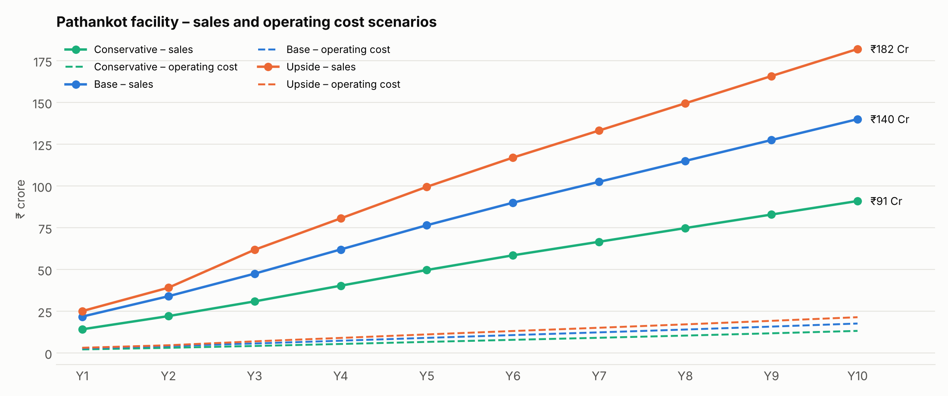
Figure 13 – Chandigarh sales and operating cost scenarios

18. Market Share – Chandigarh
The plan needs only about 2% of the northern-sector market Chandigarh serves: 1.4% in Year 1, 2.1% in Year 5 and 2% in Year 10.
₹ crore | FY27-28 (Y1) | FY31-32 (Y5) | FY36-37 (Y10)
India drone + C-UAS spend (all domains) | 15,575 | 34,785 | 65,752
SpaceGen-addressable (national) | 6,293 | 14,443 | 27,351
Chandigarh-addressable (northern sector) | 1,578 | 3,678 | 6,945
Chandigarh sales (Base) | 21.8 | 76.5 | 140
Chandigarh share of its addressable market | 1.4% | 2.1% | 2%
Chandigarh-addressable = the northern-sector part of SpaceGen’s addressable segment (Northern & Western Command, BSF Punjab/Jammu, J&K and Punjab police; civil is HQ-led). See Section 3.4.

19. Product Mix at Chandigarh (share of sales)
Product family | Year 1 | Year 5 | Year 10
FPV attack / grenade-dropper drones & payloads | 37% | 26% | 20%
Counter-UAS – detectors, jammers, MITYA spoofer, Shield | 32% | 30% | 30%
Interceptor drones – Lakshya, Arjuna, Arjun Kavach | 8% | 13% | 15%
VTOL ISR – Aniketra, Samharak (Army ISR) | 9% | 13% | 16%
Tethered surveillance, transport drones, helipad | 8% | 10% | 11%
Simulators & training (RPTO, Sky Commander) | 6% | 8% | 8%
Note: drones specific to the Northern sector will be considered for shifting to the Chandigarh facility. Their names will be explained by Capt Vego, and they will be transferred to the Chandigarh facility on Technical Ownership Transfer, at transfer cost. Integrated MUM-T / zone & swarm-defence packages stay with Hyderabad HQ and are not in the Chandigarh mix.

20. Funding Plan – Chandigarh Facility
A ₹2–3 crore seed builds and runs the facility in Year 1; later expansion (₹1.0 crore in Year 4, ₹1.5 crore in Year 7) is funded from internal accruals.
Use of the ₹2–3 crore seed | ₹ crore | Notes
Facility capital cost (heads A–H) | 1.74 | Technical area, simulator zone, arena & obstacle course, site works
Year-1 fixed running cost | 0.89 | Salaries, admin & facility running, HQ visits, demos, one-time move (Rev 2)
Demo fleet & training drones | 0.30 | Display and demonstration units for the northern sector
Total | 2.93 | Within the ₹2–3 crore seed; order working capital from the HQ bank line (₹5 Cr)

21. Risks and Mitigation – Chandigarh
Risk | Effect | Mitigation
Slow transfer of northern-sector products from HQ | Chandigarh sells only what HQ ships; longer delivery | Agree the product list (Capt Vego) and Technical Ownership Transfer terms in Year 1; keep demo stock at Chandigarh
RPTO approval delay | Training revenue (enabler 4) slips | Apply as soon as the simulator zone is ready; run unit training packages meanwhile
Visitor permissions & security | Fewer demos at the facility | Pre-cleared visitor programme with formations; forward-area demos as a parallel channel
Working capital for orders | Cannot take larger GeM / PMF orders | Use HQ’s ₹5 Cr bank line; milestone advances (20–30%)
Fast-changing drone threat | C-UAS products become dated | SDR-based, software-upgradable designs from HQ; feedback from northern users to HQ
Concentration on Army in one sector | Budget swings hit sales | Grow training, GeM, CAPF and police sales; PMF, civil and export work (enablers 7–9) sits with Hyderabad HQ
Key-person dependence (CEO network, Centre Head) | Slower demos and conversion | Field-trial team of ex-defence experts; documented customer relationships; deputy Centre Head from Year 3
Weather & terrain (winter, monsoon) | Fewer flying days | Indoor simulator zone and netted arena; schedule forward demos by season

22. Assumptions and Basis of the Numbers
- Timing: Year 1 = FY 2027-28; all values ₹ crore, excluding GST; constant 2026 prices.
- Scope: Chandigarh books enablers 1–5 only; enablers 6–11 (including 7, 8 and 9) are Hyderabad HQ’s.
- Operating cost: the facility’s operating cost is its running cost – team, admin & facility running, HQ visits, demos, plus selling (3%), HQ technical support (4%) and warranty (2%) of Chandigarh sales; depreciation is shown separately.
- Addressable market: the northern-sector share (30% of defence drones and C-UAS, 25% of PMF; civil is HQ-led) is an estimate based on the share of formations, BSF frontiers and state forces in J&K, Ladakh, Punjab, HP and Haryana.
- Budget estimates: the domain spend table is an estimate built from published market reports and budgets; it is not an official allocation.
- Execution: growth assumes the manpower, facilities and approvals in Section 14 are delivered on time.

Contact
SpaceGen Aviation Aerospace and Defence Private Limited
Chandigarh Drone Facility – Chandigarh, Punjab
HQ: Terminal Building, Begumpet Airport, Hyderabad 500016
+91 93929 91904 · spacegenaviation@gmail.com · www.spacegenaviation.com · GeM ID 4RRO250013676721
Disclaimer: this is a planning document. Market figures are third-party estimates; projections are indicative and depend on funding, approvals and procurement outcomes. It is not investment advice.

