Partial Solution

Last compiled: May 25, 2020

**Exercise 1.**

# Exercise 1.  
# read in data  
covid_data_pop <- read_csv("./data/covid_data_pop.csv")  
covid_data <- read_csv("./data/covid_data.csv")

**Exercise 2.**

# Exercise 2.  
covid_data %>%   
 group_by(date) %>%   
 summarise(dead = sum(dead)) %>%   
 ggplot(aes(x = date, y = dead)) +  
 geom_line(color = 'orange') +  
 geom_point(color = "orange", size = 1) +   
 theme_bw() +   
 scale_y_log10()

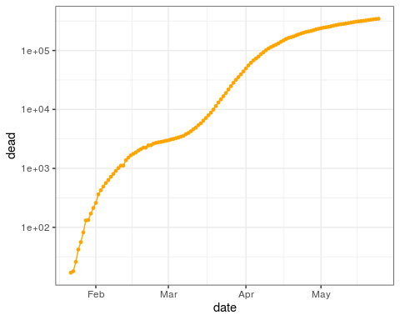

Figure 1: World wide reported COVID-19 deaths (logarithmic base 10 scale) by date

**Exercise 3.**

# Exercise 3.  
covid_data %>%   
 ggplot(aes(x = date, y = new_cases)) +  
 geom_bar(stat="identity", fill = "orange") +   
 labs(y = "New Cases") +  
 theme_bw()

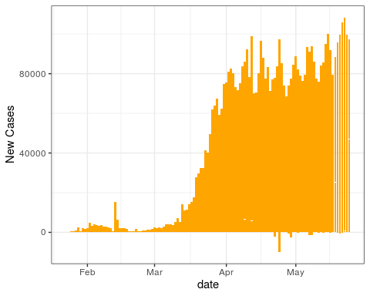

Note that some of the New Cases are negative! We will fix that next.

# Exercise 3. Final Solution  
covid_data %>%   
 mutate(new_cases = ifelse(new_cases < 0, 0, new_cases)) %>%   
 ggplot(aes(x = date, y = new_cases)) +  
 geom_bar(stat="identity", fill = "orange") +   
 labs(y = "New Cases") +  
 theme_bw()

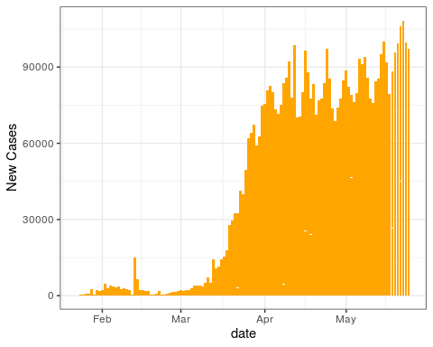

Figure 2: New Cases by date

**Exercise 4.**

Here we practice citing the work of [1] and discuss how [2,3] wax eloquently.

## References

[1] B.B. Lahey, Public health significance of neuroticism, The American Psychologist. (2009). <https://login.proxy006.nclive.org/login?url=http://search.ebscohost.com/login.aspx?direct=true&db=edsbig&AN=edsbig.A201211471&site=eds-live&scope=site> (accessed May 10, 2020).

[2] W.J. Gehring, R.T. Knight, Prefrontal-cingulate interactions in action monitoring, Nature Neuroscience. (2000) 516. <https://login.proxy006.nclive.org/login?url=http://search.ebscohost.com/login.aspx?direct=true&db=edsgsc&AN=edsgcl.185568919&site=eds-live&scope=site> (accessed May 10, 2020).

[3] J.B. Savitz, R.S. Ramesar, Personality: Is it a viable endophenotype for genetic studies of bipolar affective disorder?, Bipolar Disorders. 8 (2006) 322–337. <https://doi.org/10.1111/j.1399-5618.2006.00309.x>.