STT 5XXX Syllabus - Example

Spring 2017

**Instructor:** Dr. Alan T. Arnholt  
**Office:** Walker Hall 340  
**Office Hours:** 10:00 a.m. - 11:30 a.m. M, W, and F

Make an appointment to see me by clicking <https://arnholtat.youcanbook.me/>.

Questions related to the class should be addressed with the [piazza account for STT 5812](https://piazza.com/appstate/spring2017/stt/home).

**Course Description:**

This course covers elements of data management, descriptive statistics, and inferential statistics. The course also examines the variance-bias tradeoff, linear regression, cross-validation, bootstrapping, subset selection, ridge and lasso regression, and choosing optimal models.

**Course Objectives:**

1. Students will use a reproducible research work flow.
2. Students will improve their technology expertise.
3. Students will learn to apply statistical learning techniques.

**Course Text:**

[*An Introdution to Statistical Learning with Applications in R*](http://www-bcf.usc.edu/~gareth/ISL/) by Gareth James, Daniela Witten, Trevor Hastie and Robert Tibshirani

**Optional References:**

[*Reproducible Research with R and RStudio, Second Edition*](https://github.com/christophergandrud/Rep-Res-Book) by Christopher Gandrud

[*The Elements of Statistical Learning*](http://web.stanford.edu/~hastie/ElemStatLearn/) by Trevor Hastie, Robert Tibshirani, and Jerome Friedman

[*R Graphics Cookbook*](http://www.amazon.com/R-Graphics-Cookbook-Winston-Chang/dp/1449316956) by Winston Chang - Available via SafariBooksOnline through the Appalachian State University [library](http://library.appstate.edu/).

**Course Grading:**

* 39% of the course grade will come from quizzes (13).
* 21% of the grade will come from labs (3)
* 25% of the grade will come from two projects (10% first project, 15% second project)
* 15% of the course grade will come from participation (attendance, participation in discussion in-class and/or online).
* Up to 10 points may be added to your final course average for an excellent compilation of all assignments (quizzes, labs, projects) and class notes in a single hyperlinked *.html document.

**Piazza:**

This term we will be using Piazza for class discussion. The system is highly catered to getting you help fast and efficiently from classmates and myself. Rather than emailing questions to the teaching staff, I encourage you to post your questions on Piazza. If you have any problems or feedback for the developers, email [team@piazza.com](mailto:team@piazza.com).

Find our class page at: <https://piazza.com/appstate/spring2017/stt/home>

**How To Get Unstuck**

If you have a course related question, please ask your question on [piazza](https://piazza.com/appstate/spring2017/stt/home). Your classmates may have the same question or may answer your question before I can provide an answer. Well constructed questions will elicit answers more rapidly than poorly constructed questions. This [video](https://www.youtube.com/watch?v=ZFaWxxzouCY&list=PLjTlxb-wKvXNSDfcKPFH2gzHGyjpeCZmJ&index=3) provides some background on asking questions. This stackoverflow thread details how to create a [minimal R reproducible example](http://stackoverflow.com/questions/5963269/how-to-make-a-great-r-reproducible-example/5963610#5963610). Please read [How To Ask Questions The Smart Way](http://www.catb.org/~esr/faqs/smart-questions.html) by Eric Raymond and Rick Moen and heed their advice.

**University Policies**

This course conforms with all Appalachian State University policies with respect to academic integrity, disability services, and class attendance. The details of the policies may be found at <http://academicaffairs.appstate.edu/resources/syllabi>.

**Computers and Software**

This course will use the RStudio server (<https://mathr.math.appstate.edu/>) that has the programs listed below and more installed.

* [R](http://cran.r-project.org)
* [Git](http://git-scm.com/downloads)
* [RStudio](http://www.rstudio.com/products/rstudio/download/)
* [LaTeX](http://www.ctan.org/starter)

You must have an active internet connection and be registered in the course to access the server. To access the server, point any web browser to <https://mathr.math.appstate.edu/>. Use your Appstate Username and Password to access the server. A screen shot of the RStudio server is shown below.

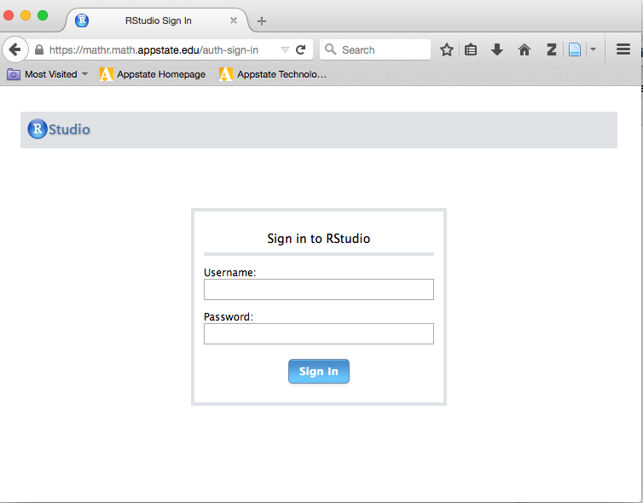

If you have problems with your Appstate Username or Password visit [IT Support Services](http://support.appstate.edu/) or call 262-6266.