library(gapminder)

## Warning: package 'gapminder' was built under R version 3.3.2

gapminder

## # A tibble: 1,704 x 6  
## country continent year lifeExp pop gdpPercap  
## <fct> <fct> <int> <dbl> <int> <dbl>  
## 1 Afghanistan Asia 1952 28.8 8425333 779.  
## 2 Afghanistan Asia 1957 30.3 9240934 821.  
## 3 Afghanistan Asia 1962 32.0 10267083 853.  
## 4 Afghanistan Asia 1967 34.0 11537966 836.  
## 5 Afghanistan Asia 1972 36.1 13079460 740.  
## 6 Afghanistan Asia 1977 38.4 14880372 786.  
## 7 Afghanistan Asia 1982 39.9 12881816 978.  
## 8 Afghanistan Asia 1987 40.8 13867957 852.  
## 9 Afghanistan Asia 1992 41.7 16317921 649.  
## 10 Afghanistan Asia 1997 41.8 22227415 635.  
## # ... with 1,694 more rows

attach(gapminder)

##Information dense summary of tbl data.

##Information dense summary of tbl data.   
  
dplyr::glimpse(gapminder)

## Observations: 1,704  
## Variables: 6  
## $ country <fct> Afghanistan, Afghanistan, Afghanistan, Afghanistan, ...  
## $ continent <fct> Asia, Asia, Asia, Asia, Asia, Asia, Asia, Asia, Asia...  
## $ year <int> 1952, 1957, 1962, 1967, 1972, 1977, 1982, 1987, 1992...  
## $ lifeExp <dbl> 28.801, 30.332, 31.997, 34.020, 36.088, 38.438, 39.8...  
## $ pop <int> 8425333, 9240934, 10267083, 11537966, 13079460, 1488...  
## $ gdpPercap <dbl> 779.4453, 820.8530, 853.1007, 836.1971, 739.9811, 78...

summary(gapminder)

## country continent year lifeExp   
## Afghanistan: 12 Africa :624 Min. :1952 Min. :23.60   
## Albania : 12 Americas:300 1st Qu.:1966 1st Qu.:48.20   
## Algeria : 12 Asia :396 Median :1980 Median :60.71   
## Angola : 12 Europe :360 Mean :1980 Mean :59.47   
## Argentina : 12 Oceania : 24 3rd Qu.:1993 3rd Qu.:70.85   
## Australia : 12 Max. :2007 Max. :82.60   
## (Other) :1632   
## pop gdpPercap   
## Min. :6.001e+04 Min. : 241.2   
## 1st Qu.:2.794e+06 1st Qu.: 1202.1   
## Median :7.024e+06 Median : 3531.8   
## Mean :2.960e+07 Mean : 7215.3   
## 3rd Qu.:1.959e+07 3rd Qu.: 9325.5   
## Max. :1.319e+09 Max. :113523.1   
##

##Is it a data.frame, a matrix, a vector, a list?  
  
str(gapminder)

## Classes 'tbl_df', 'tbl' and 'data.frame': 1704 obs. of 6 variables:  
## $ country : Factor w/ 142 levels "Afghanistan",..: 1 1 1 1 1 1 1 1 1 1 ...  
## $ continent: Factor w/ 5 levels "Africa","Americas",..: 3 3 3 3 3 3 3 3 3 3 ...  
## $ year : int 1952 1957 1962 1967 1972 1977 1982 1987 1992 1997 ...  
## $ lifeExp : num 28.8 30.3 32 34 36.1 ...  
## $ pop : int 8425333 9240934 10267083 11537966 13079460 14880372 12881816 13867957 16317921 22227415 ...  
## $ gdpPercap: num 779 821 853 836 740 ...

##What is its class?  
class(gapminder)

## [1] "tbl_df" "tbl" "data.frame"

##How many variables/columns?  
ncol(gapminder)

## [1] 6

##How many rows/observations?  
nrow(gapminder)

## [1] 1704

##Can you get these facts about “extent” or “size” in more than one way?   
dim(gapminder)

## [1] 1704 6

length(pop)

## [1] 1704

length(lifeExp)

## [1] 1704

##What data type is each variable?  
names(gapminder)

## [1] "country" "continent" "year" "lifeExp" "pop" "gdpPercap"

typeof(country)

## [1] "integer"

class(country)

## [1] "factor"

typeof(pop)

## [1] "integer"

class(pop)

## [1] "integer"

typeof(lifeExp)

## [1] "double"

class(lifeExp)

## [1] "numeric"

typeof(continent)

## [1] "integer"

class(continent)

## [1] "factor"

typeof(year)

## [1] "integer"

class(year)

## [1] "integer"

typeof(gdpPercap)

## [1] "double"

class(gdpPercap)

## [1] "numeric"

#Exploration of the variable lifeExp

range(lifeExp)

## [1] 23.599 82.603

sample(lifeExp, size = 4)

## [1] 73.100 62.155 64.266 79.696

mean(lifeExp)

## [1] 59.47444

quantile((lifeExp), c(0.2, 0.5, 0.8))

## 20% 50% 80%   
## 45.8992 60.7125 72.0288

summary(lifeExp)

## Min. 1st Qu. Median Mean 3rd Qu. Max.   
## 23.60 48.20 60.71 59.47 70.85 82.60

table(year,continent)

## continent  
## year Africa Americas Asia Europe Oceania  
## 1952 52 25 33 30 2  
## 1957 52 25 33 30 2  
## 1962 52 25 33 30 2  
## 1967 52 25 33 30 2  
## 1972 52 25 33 30 2  
## 1977 52 25 33 30 2  
## 1982 52 25 33 30 2  
## 1987 52 25 33 30 2  
## 1992 52 25 33 30 2  
## 1997 52 25 33 30 2  
## 2002 52 25 33 30 2  
## 2007 52 25 33 30 2

hist(lifeExp, col='red', main=NULL, xlab = 'Life Expectance',  
freq = FALSE)

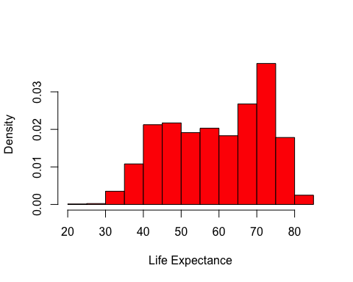

boxplot(lifeExp)

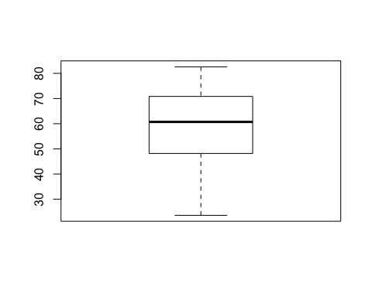

##This graph shows the typical layout of a box-whisker plot.The stripe shows the median, the box represents the upper and lower hinges, and the whiskers show the maximum and minimum values.

plot(gdpPercap ~ lifeExp, xlab = 'Year', ylab = 'life expetancy',pch = 18, cex = 2, col = 'gray50')  
   
abline(lm(gdpPercap ~ year), lty = 'dotted', lwd = 2, col = 'gray50')

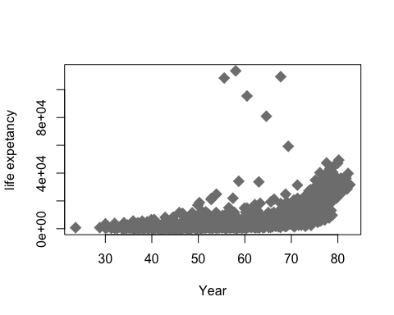

library(gapminder)  
library(tidyverse)

## ── Attaching packages ───────────────────────────────────────────────── tidyverse 1.2.1 ──

## ✔ ggplot2 3.0.0 ✔ purrr 0.2.5  
## ✔ tibble 1.4.2 ✔ dplyr 0.7.6  
## ✔ tidyr 0.8.1 ✔ stringr 1.3.1  
## ✔ readr 1.1.1 ✔ forcats 0.3.0

## Warning: package 'readr' was built under R version 3.3.2

## ── Conflicts ──────────────────────────────────────────────────── tidyverse_conflicts() ──  
## ✖ dplyr::filter() masks stats::filter()  
## ✖ dplyr::lag() masks stats::lag()

##Putting continent and country first and everything() after that.  
  
select(gapminder,continent,country,everything())

## # A tibble: 1,704 x 6  
## continent country year lifeExp pop gdpPercap  
## <fct> <fct> <int> <dbl> <int> <dbl>  
## 1 Asia Afghanistan 1952 28.8 8425333 779.  
## 2 Asia Afghanistan 1957 30.3 9240934 821.  
## 3 Asia Afghanistan 1962 32.0 10267083 853.  
## 4 Asia Afghanistan 1967 34.0 11537966 836.  
## 5 Asia Afghanistan 1972 36.1 13079460 740.  
## 6 Asia Afghanistan 1977 38.4 14880372 786.  
## 7 Asia Afghanistan 1982 39.9 12881816 978.  
## 8 Asia Afghanistan 1987 40.8 13867957 852.  
## 9 Asia Afghanistan 1992 41.7 16317921 649.  
## 10 Asia Afghanistan 1997 41.8 22227415 635.  
## # ... with 1,694 more rows

##Select columns country, pop,lifeExp from the gapminder data, in that order.  
  
select(gapminder,country,pop,lifeExp)

## # A tibble: 1,704 x 3  
## country pop lifeExp  
## <fct> <int> <dbl>  
## 1 Afghanistan 8425333 28.8  
## 2 Afghanistan 9240934 30.3  
## 3 Afghanistan 10267083 32.0  
## 4 Afghanistan 11537966 34.0  
## 5 Afghanistan 13079460 36.1  
## 6 Afghanistan 14880372 38.4  
## 7 Afghanistan 12881816 39.9  
## 8 Afghanistan 13867957 40.8  
## 9 Afghanistan 16317921 41.7  
## 10 Afghanistan 22227415 41.8  
## # ... with 1,694 more rows

##Select all variables, from continent to pop  
  
select(gapminder,continent:pop)

## # A tibble: 1,704 x 4  
## continent year lifeExp pop  
## <fct> <int> <dbl> <int>  
## 1 Asia 1952 28.8 8425333  
## 2 Asia 1957 30.3 9240934  
## 3 Asia 1962 32.0 10267083  
## 4 Asia 1967 34.0 11537966  
## 5 Asia 1972 36.1 13079460  
## 6 Asia 1977 38.4 14880372  
## 7 Asia 1982 39.9 12881816  
## 8 Asia 1987 40.8 13867957  
## 9 Asia 1992 41.7 16317921  
## 10 Asia 1997 41.8 22227415  
## # ... with 1,694 more rows

##Select all columns except year  
  
select(gapminder,-year)

## # A tibble: 1,704 x 5  
## country continent lifeExp pop gdpPercap  
## <fct> <fct> <dbl> <int> <dbl>  
## 1 Afghanistan Asia 28.8 8425333 779.  
## 2 Afghanistan Asia 30.3 9240934 821.  
## 3 Afghanistan Asia 32.0 10267083 853.  
## 4 Afghanistan Asia 34.0 11537966 836.  
## 5 Afghanistan Asia 36.1 13079460 740.  
## 6 Afghanistan Asia 38.4 14880372 786.  
## 7 Afghanistan Asia 39.9 12881816 978.  
## 8 Afghanistan Asia 40.8 13867957 852.  
## 9 Afghanistan Asia 41.7 16317921 649.  
## 10 Afghanistan Asia 41.8 22227415 635.  
## # ... with 1,694 more rows

##Select columns whose name starts with a character string.   
  
select(gapminder,starts_with("life"))

## # A tibble: 1,704 x 1  
## lifeExp  
## <dbl>  
## 1 28.8  
## 2 30.3  
## 3 32.0  
## 4 34.0  
## 5 36.1  
## 6 38.4  
## 7 39.9  
## 8 40.8  
## 9 41.7  
## 10 41.8  
## # ... with 1,694 more rows

##Select columns whose name matches a regular expression.   
  
select(gapminder,matches(".l."))

## # A tibble: 1,704 x 0

##Select columns whose name contains a character string.   
  
select(gapminder,contains("."))

## # A tibble: 1,704 x 0

##Select columns whose name starts with a character string.   
  
select(gapminder,ends_with("p"))

## # A tibble: 1,704 x 3  
## lifeExp pop gdpPercap  
## <dbl> <int> <dbl>  
## 1 28.8 8425333 779.  
## 2 30.3 9240934 821.  
## 3 32.0 10267083 853.  
## 4 34.0 11537966 836.  
## 5 36.1 13079460 740.  
## 6 38.4 14880372 786.  
## 7 39.9 12881816 978.  
## 8 40.8 13867957 852.  
## 9 41.7 16317921 649.  
## 10 41.8 22227415 635.  
## # ... with 1,694 more rows

##Select columns whose names are in a group of names.   
  
select(gapminder, one_of(c("country", "continent")))

## # A tibble: 1,704 x 2  
## country continent  
## <fct> <fct>   
## 1 Afghanistan Asia   
## 2 Afghanistan Asia   
## 3 Afghanistan Asia   
## 4 Afghanistan Asia   
## 5 Afghanistan Asia   
## 6 Afghanistan Asia   
## 7 Afghanistan Asia   
## 8 Afghanistan Asia   
## 9 Afghanistan Asia   
## 10 Afghanistan Asia   
## # ... with 1,694 more rows

## arrange() function  
  
arrange(gapminder,year)

## # A tibble: 1,704 x 6  
## country continent year lifeExp pop gdpPercap  
## <fct> <fct> <int> <dbl> <int> <dbl>  
## 1 Afghanistan Asia 1952 28.8 8425333 779.  
## 2 Albania Europe 1952 55.2 1282697 1601.  
## 3 Algeria Africa 1952 43.1 9279525 2449.  
## 4 Angola Africa 1952 30.0 4232095 3521.  
## 5 Argentina Americas 1952 62.5 17876956 5911.  
## 6 Australia Oceania 1952 69.1 8691212 10040.  
## 7 Austria Europe 1952 66.8 6927772 6137.  
## 8 Bahrain Asia 1952 50.9 120447 9867.  
## 9 Bangladesh Asia 1952 37.5 46886859 684.  
## 10 Belgium Europe 1952 68 8730405 8343.  
## # ... with 1,694 more rows

arrange(gapminder,desc(lifeExp))

## # A tibble: 1,704 x 6  
## country continent year lifeExp pop gdpPercap  
## <fct> <fct> <int> <dbl> <int> <dbl>  
## 1 Japan Asia 2007 82.6 127467972 31656.  
## 2 Hong Kong, China Asia 2007 82.2 6980412 39725.  
## 3 Japan Asia 2002 82 127065841 28605.  
## 4 Iceland Europe 2007 81.8 301931 36181.  
## 5 Switzerland Europe 2007 81.7 7554661 37506.  
## 6 Hong Kong, China Asia 2002 81.5 6762476 30209.  
## 7 Australia Oceania 2007 81.2 20434176 34435.  
## 8 Spain Europe 2007 80.9 40448191 28821.  
## 9 Sweden Europe 2007 80.9 9031088 33860.  
## 10 Israel Asia 2007 80.7 6426679 25523.  
## # ... with 1,694 more rows

arrange(gapminder,pop,lifeExp)

## # A tibble: 1,704 x 6  
## country continent year lifeExp pop gdpPercap  
## <fct> <fct> <int> <dbl> <int> <dbl>  
## 1 Sao Tome and Principe Africa 1952 46.5 60011 880.  
## 2 Sao Tome and Principe Africa 1957 48.9 61325 861.  
## 3 Djibouti Africa 1952 34.8 63149 2670.  
## 4 Sao Tome and Principe Africa 1962 51.9 65345 1072.  
## 5 Sao Tome and Principe Africa 1967 54.4 70787 1385.  
## 6 Djibouti Africa 1957 37.3 71851 2865.  
## 7 Sao Tome and Principe Africa 1972 56.5 76595 1533.  
## 8 Sao Tome and Principe Africa 1977 58.6 86796 1738.  
## 9 Djibouti Africa 1962 39.7 89898 3021.  
## 10 Sao Tome and Principe Africa 1982 60.4 98593 1890.  
## # ... with 1,694 more rows

## Piping, `%>%`  
  
gapminder %>%   
 select(year,lifeExp,country) %>%   
 arrange(year,lifeExp)

## # A tibble: 1,704 x 3  
## year lifeExp country   
## <int> <dbl> <fct>   
## 1 1952 28.8 Afghanistan   
## 2 1952 30 Gambia   
## 3 1952 30.0 Angola   
## 4 1952 30.3 Sierra Leone   
## 5 1952 31.3 Mozambique   
## 6 1952 32.0 Burkina Faso   
## 7 1952 32.5 Guinea-Bissau  
## 8 1952 32.5 Yemen, Rep.   
## 9 1952 33.0 Somalia   
## 10 1952 33.6 Guinea   
## # ... with 1,694 more rows

## filter()  
  
filter(gapminder, pop > 7)

## # A tibble: 1,704 x 6  
## country continent year lifeExp pop gdpPercap  
## <fct> <fct> <int> <dbl> <int> <dbl>  
## 1 Afghanistan Asia 1952 28.8 8425333 779.  
## 2 Afghanistan Asia 1957 30.3 9240934 821.  
## 3 Afghanistan Asia 1962 32.0 10267083 853.  
## 4 Afghanistan Asia 1967 34.0 11537966 836.  
## 5 Afghanistan Asia 1972 36.1 13079460 740.  
## 6 Afghanistan Asia 1977 38.4 14880372 786.  
## 7 Afghanistan Asia 1982 39.9 12881816 978.  
## 8 Afghanistan Asia 1987 40.8 13867957 852.  
## 9 Afghanistan Asia 1992 41.7 16317921 649.  
## 10 Afghanistan Asia 1997 41.8 22227415 635.  
## # ... with 1,694 more rows

##Extract rows that meet logical criteria.

mean(lifeExp)

## [1] 59.47444

gapminder %>%   
filter(lifeExp>mean(lifeExp) )

## # A tibble: 895 x 6  
## country continent year lifeExp pop gdpPercap  
## <fct> <fct> <int> <dbl> <int> <dbl>  
## 1 Albania Europe 1962 64.8 1728137 2313.  
## 2 Albania Europe 1967 66.2 1984060 2760.  
## 3 Albania Europe 1972 67.7 2263554 3313.  
## 4 Albania Europe 1977 68.9 2509048 3533.  
## 5 Albania Europe 1982 70.4 2780097 3631.  
## 6 Albania Europe 1987 72 3075321 3739.  
## 7 Albania Europe 1992 71.6 3326498 2497.  
## 8 Albania Europe 1997 73.0 3428038 3193.  
## 9 Albania Europe 2002 75.7 3508512 4604.  
## 10 Albania Europe 2007 76.4 3600523 5937.  
## # ... with 885 more rows

gapminder %>%   
 select(country,continent) %>%   
 filter(year>=1960 & year<1970 )

## # A tibble: 284 x 2  
## country continent  
## <fct> <fct>   
## 1 Afghanistan Asia   
## 2 Afghanistan Asia   
## 3 Albania Europe   
## 4 Albania Europe   
## 5 Algeria Africa   
## 6 Algeria Africa   
## 7 Angola Africa   
## 8 Angola Africa   
## 9 Argentina Americas   
## 10 Argentina Americas   
## # ... with 274 more rows

gapminder %>%   
 filter((country=="Afganistan"| country=="Canada") & gdpPercap>=10000 & year<22000 )

## # A tibble: 12 x 6  
## country continent year lifeExp pop gdpPercap  
## <fct> <fct> <int> <dbl> <int> <dbl>  
## 1 Canada Americas 1952 68.8 14785584 11367.  
## 2 Canada Americas 1957 70.0 17010154 12490.  
## 3 Canada Americas 1962 71.3 18985849 13462.  
## 4 Canada Americas 1967 72.1 20819767 16077.  
## 5 Canada Americas 1972 72.9 22284500 18971.  
## 6 Canada Americas 1977 74.2 23796400 22091.  
## 7 Canada Americas 1982 75.8 25201900 22899.  
## 8 Canada Americas 1987 76.9 26549700 26627.  
## 9 Canada Americas 1992 78.0 28523502 26343.  
## 10 Canada Americas 1997 78.6 30305843 28955.  
## 11 Canada Americas 2002 79.8 31902268 33329.  
## 12 Canada Americas 2007 80.7 33390141 36319.

gapminder %>%   
 filter(country %in% c("India","Angola"), year>=1950, year<1980)

## # A tibble: 12 x 6  
## country continent year lifeExp pop gdpPercap  
## <fct> <fct> <int> <dbl> <int> <dbl>  
## 1 Angola Africa 1952 30.0 4232095 3521.  
## 2 Angola Africa 1957 32.0 4561361 3828.  
## 3 Angola Africa 1962 34 4826015 4269.  
## 4 Angola Africa 1967 36.0 5247469 5523.  
## 5 Angola Africa 1972 37.9 5894858 5473.  
## 6 Angola Africa 1977 39.5 6162675 3009.  
## 7 India Asia 1952 37.4 372000000 547.  
## 8 India Asia 1957 40.2 409000000 590.  
## 9 India Asia 1962 43.6 454000000 658.  
## 10 India Asia 1967 47.2 506000000 701.  
## 11 India Asia 1972 50.7 567000000 724.  
## 12 India Asia 1977 54.2 634000000 813.

## Scatterplot

A *scatterplot* of gdpPercap vs. year.

|  |  |
| --- | --- |
| Grammar Component | Specification |
| **data** | gapminder |
| **aesthetic mapping** | x and y |
| **geometric object** | point |
| scale | linear |
| statistical transform | none |
| coordinate system | rectangular |
| facetting | none |

ggplot(gapminder,aes(x=year,y=gdpPercap))+  
 geom_point(color="orange")

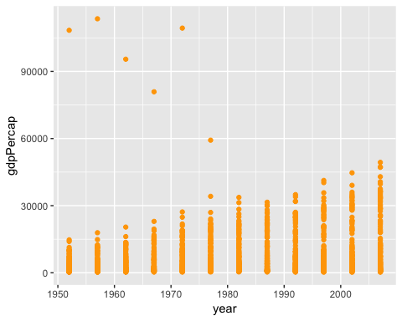

a<- ggplot(gapminder,aes(lifeExp))+  
 scale_y_log10()  
a+geom_histogram(bins=50,color="red")

## Warning: Transformation introduced infinite values in continuous y-axis

## Warning: Removed 3 rows containing missing values (geom_bar).

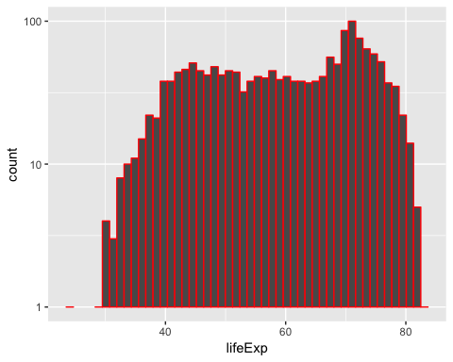

b<- ggplot(gapminder,aes(continent,lifeExp))+  
 scale_y_log10()  
b

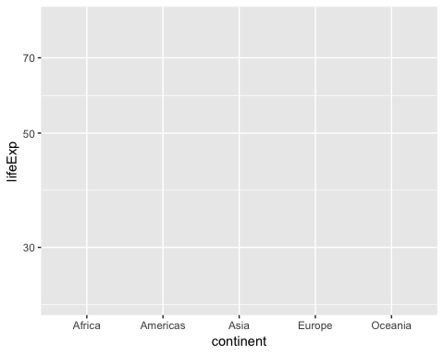

b+geom_violin()

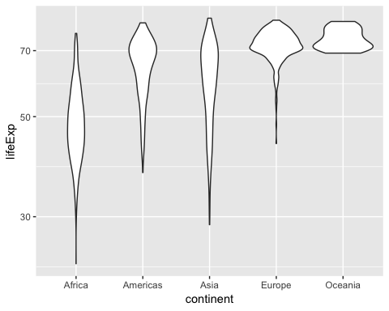

b+geom_violin()+  
 geom_jitter(alpha=0.5)

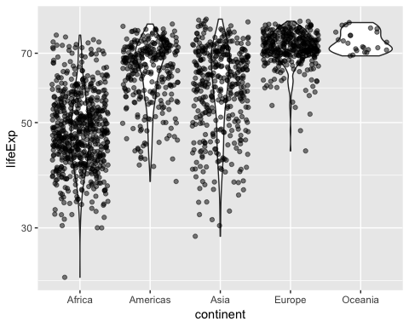

gapminder %>%   
 filter(country=="India") %>%   
 ggplot(aes(year,gdpPercap)) +  
 geom_line()+  
 geom_point(color="blue")

