HW 7

* 1. In this basic data set (repeatedMeasures slide 11), there are no “explanatory variables”, just repeatedly measuring the same subject 3 times across 6 subjects
* a. Write down a (mixed) model that is reasonable for this data set ignoring the correlation
* b. Fit this model to the data using PROC GLM and extract the residuals. What is the relevant SAS code and what are the estimated means?
* c. We want to use the residuals to get an estimated covariance. Use the following SAS code to accomplish that, assuming the output from the PROC GLM looks like “OUTPUT OUT = glmout r=resid;”

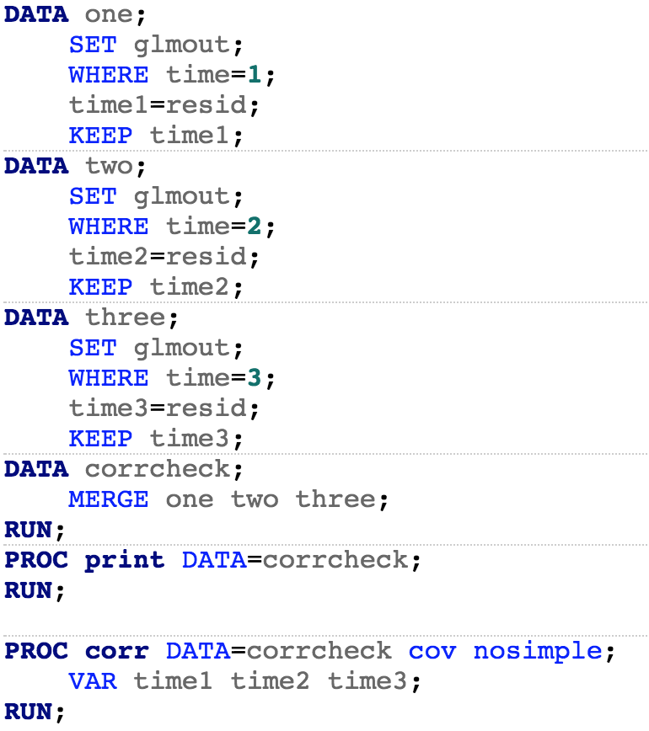

What is the estimated covariance matrix? What “type” of covariance structure is this?

d. Now run a PROC GLIMMIX mixed model, incorporating the correlation as an R-side effect with the same type of covariance as the previous question. Show that you get the same estimated covariance structure using both approaches.

e. Let’s assume some structure in the covariance. In particular, let’s assume that the compound symmetry model. Show that the estimated compound symmetry model is the same as taking the average of the diagonal entries for the variance and the average of the off-diagonal entries for the covariance (note: this only works due to the balanced design)

f. Fit repeated measures with the AR(1) model.

g. Choose amongst these 3 models by selecting the model with smallest AICC. What model did you select and what is the AICC?