**TECHNICAL UNIVERSITY OF MOLDOVA**



Laborator 5

**DISCIPLINA:** Baze de date

**Student :** Bandalac Sergiu

**Grupa :** FAF-193

Chișinău 2020

**Condiții preliminare:**

SQL SERVER 2017(Dev. Edition)

**Sarcini:**

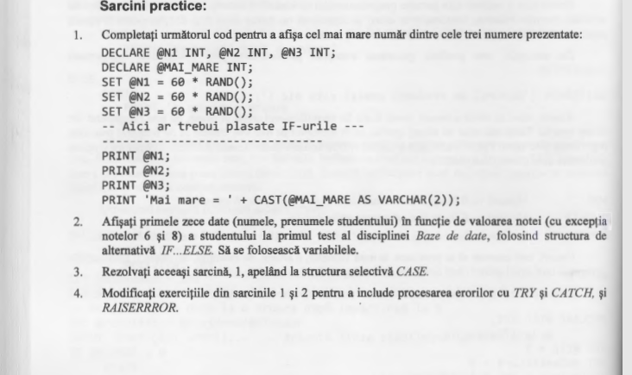

**Query:**

--Laborator Nr.5 Bandalac Sergiu FAF-193

-- sarcina 1

DECLARE @N1 INT, @N2 INT, @N3 INT;

DECLARE @MAI_MARE INT;

SET @N1 = 60 * RAND();

SET @N2 = 60 * RAND();

SET @N3 = 60 * RAND();

IF (@N1>@N2) AND (@N1>@N3)

SET @MAI_MARE = @N1;

ELSE

IF (@N2>@N1) AND (@N2>@N3)

SET @MAI_MARE = @N2;

ELSE

IF (@N3>@N1) AND (@N3>@N2)

SET @MAI_MARE = @N3;

PRINT @N1;

PRINT @N2;

PRINT @N3;

PRINT 'Mai mare = ' + CAST(@MAI_MARE AS VARCHAR(2));

GO

-- sarcina 2

use universitatea

go

DECLARE @var INT;

DECLARE @nume varchar(20);

DECLARE @prenume varchar(20);

DECLARE @count INT;

SET @count = 1;

DECLARE @count1 INT;

SET @count1 = 1;

WHILE (@count!=11)

BEGIN

SELECT TOP(@count1) @var = Nota, @nume = Nume_Student, @prenume = Prenume_Student

FROM studenti_reusita

inner join studenti on studenti.Id_Student = studenti_reusita.Id_Student

inner join discipline on discipline.Id_Disciplina = studenti_reusita.Id_Disciplina

where Disciplina like '%Baze de date%' and Tip_Evaluare like 'Testul 1'

IF (@var != 6) and (@var != 8)

BEGIN

PRINT @nume + ' ' + @prenume +' ' + CAST(@var as varchar);

SET @count =@count + 1;

END

SET @count1 =@count1 + 1;

END

--verificare sarcina 2

SELECT TOP(10) Nume_Student, Prenume_Student, Nota from studenti

inner join studenti_reusita on studenti.Id_Student = studenti_reusita.Id_Student

inner join discipline on discipline.Id_Disciplina = studenti_reusita.Id_Disciplina

where Disciplina like '%Baze de date%' and Tip_Evaluare like 'Testul 1' and Nota!=6 and Nota!=8

--sarcina 3

DECLARE @N1 INT, @N2 INT, @N3 INT;

DECLARE @MAI_MARE INT;

SET @N1 = 60 * RAND();

SET @N2 = 60 * RAND();

SET @N3 = 60 * RAND();

SET @MAI_MARE = (SELECT

CASE

WHEN @N1>=@N2 AND @N1>=@N3 THEN @N1

WHEN @N2>=@N1 AND @N2>=@N3 THEN @N2

WHEN @N3>=@N2 AND @N3>=@N1 THEN @N3

END)

PRINT @N1;

PRINT @N2;

PRINT @N3;

PRINT 'Mai mare = ' + CAST(@MAI_MARE AS VARCHAR(2));

GO

-- sarcina 4

-- sracina 1 modificata cu try catch

BEGIN TRY

DECLARE @N1 INT, @N2 INT, @N3 INT;

DECLARE @MAI_MARE INT;

SET @N1 = 60 * RAND();

SET @N2 = 60 * RAND();

SET @N3 = 60 * RAND();

IF (@N1>=@N2) AND (@N1>=@N3)

SET @MAI_MARE = @N1;

ELSE

IF (@N2>=@N1) AND (@N2>=@N3)

SET @MAI_MARE = @N2;

ELSE

IF (@N3>=@N1) AND (@N3>=@N2)

SET @MAI_MARE = @N3;

PRINT @N1;

PRINT @N2;

PRINT @N3;

PRINT 'Mai mare = ' + CAST(@MAI_MARE AS VARCHAR(2));

END TRY

BEGIN CATCH

PRINT ERROR_NUMBER()

PRINT ERROR_SEVERITY()

PRINT ERROR_STATE()

PRINT ERROR_PROCEDURE()

PRINT ERROR_LINE()

PRINT ERROR_MESSAGE()

END CATCH

-- sarcina 1 modificata cu raiseerror

SET @N1 = 60 * RAND();

SET @N2 = 60 * RAND();

SET @N3 = 60 * RAND();

IF (@N1>=@N2) AND (@N1>=@N3)

SET @MAI_MARE = @N1;

ELSE

IF (@N2>=@N1) AND (@N2>=@N3)

SET @MAI_MARE = @N2;

ELSE

IF (@N3>=@N1) AND (@N3>=@N2)

SET @MAI_MARE = @N3;

ELSE

RAISERROR ('Numerele nu corespund', 12, 1)

PRINT @N1;

PRINT @N2;

PRINT @N3;

PRINT 'Mai mare = ' + CAST(@MAI_MARE AS VARCHAR(2));

-- sarcina 2 modificata cu try catch

BEGIN TRY

use universitatea

DECLARE @var INT;

DECLARE @nume varchar(20);

DECLARE @prenume varchar(20);

DECLARE @count INT;

SET @count = 1;

DECLARE @count1 INT;

SET @count1 = 1;

WHILE (@count!=11)

BEGIN

SELECT TOP(@count1) @var = Nota, @nume = Nume_Student, @prenume = Prenume_Student

FROM studenti_reusita

inner join studenti on studenti.Id_Student = studenti_reusita.Id_Student

inner join discipline on discipline.Id_Disciplina = studenti_reusita.Id_Disciplina

where Disciplina like '%Baze de date%' and Tip_Evaluare like 'Testul 1'

IF (@var != 6) and (@var != 8)

BEGIN

SELECT Nume_Student, Prenume_Student, Nota from studenti

inner join studenti_reusita on studenti.Id_Student = studenti_reusita.Id_Student

inner join discipline on discipline.Id_Disciplina = studenti_reusita.Id_Disciplina

where Disciplina like '%Baze de date%' and Tip_Evaluare like 'Testul 1' and Nota = @var and Nume_Student = @nume and Prenume_Student = @prenume

SET @count =@count + 1;

END

SET @count1 =@count1 + 1;

END

END TRY

BEGIN CATCH

PRINT ERROR_NUMBER()

PRINT ERROR_SEVERITY()

PRINT ERROR_STATE()

PRINT ERROR_PROCEDURE()

PRINT ERROR_LINE()

PRINT ERROR_MESSAGE()

END CATCH

**Result:**

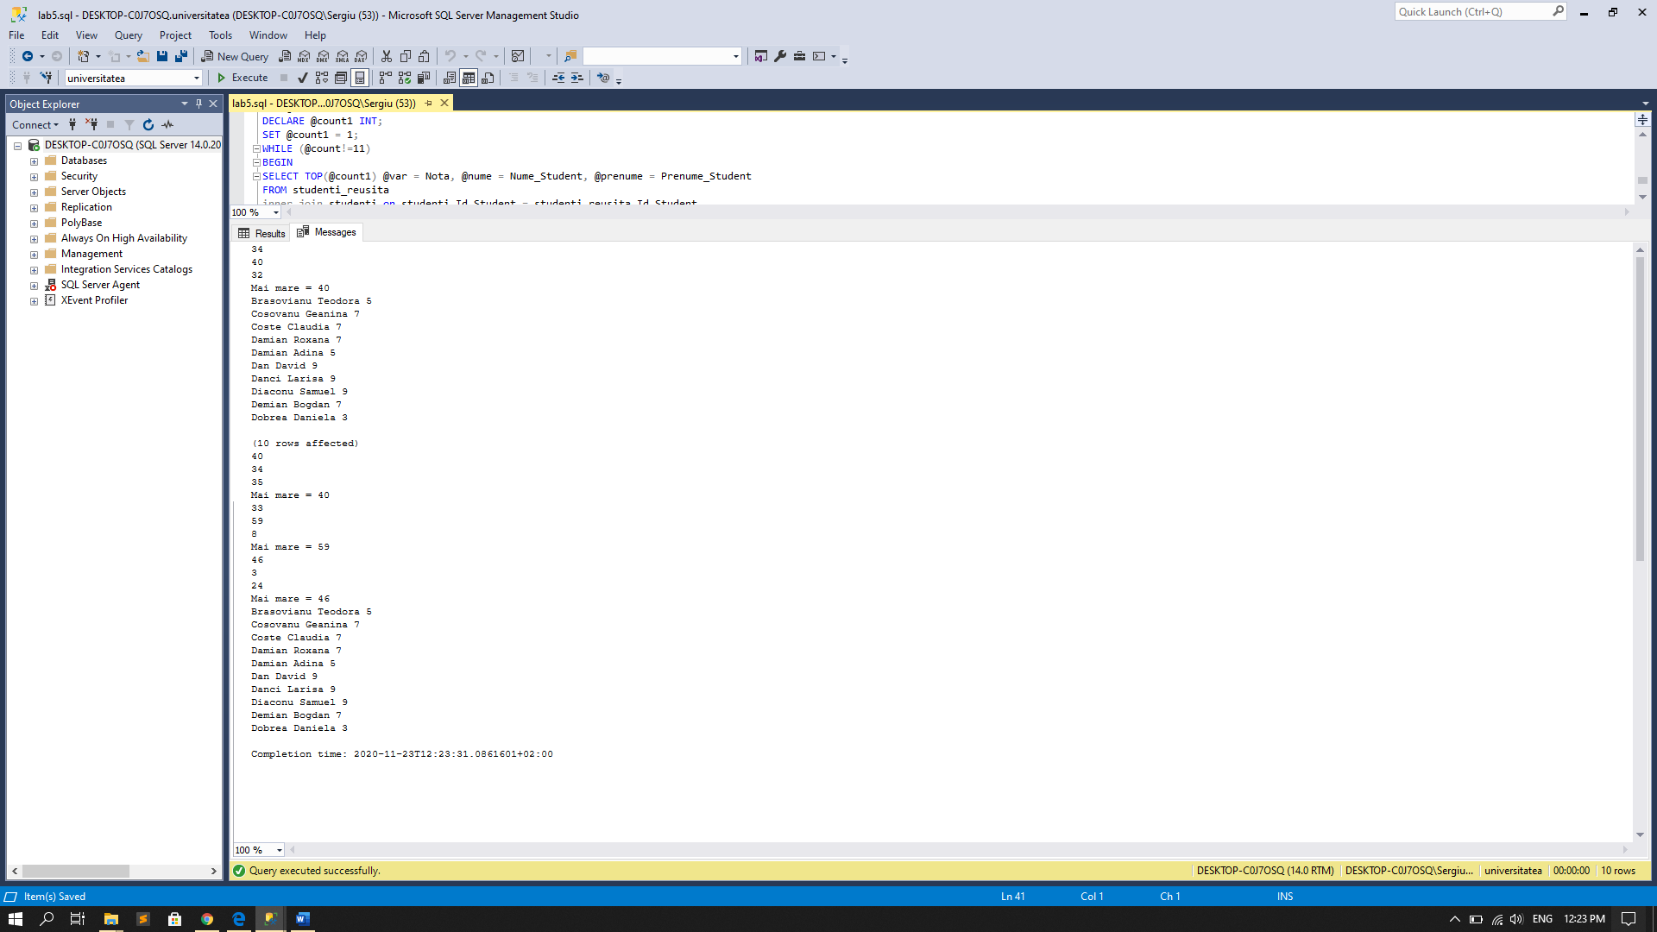

**Concluzii**

În această lucrare de laborator am practicat lucrul cu variabilele si instructiunile de conditie if si case. Am format deprinderi in declararea, atribuirea variabilelor, la fel si integrarea acestora in select-uri complexe.