Wang123

fake flag is faker than real flag, so what is the real flag?

This is the file given.

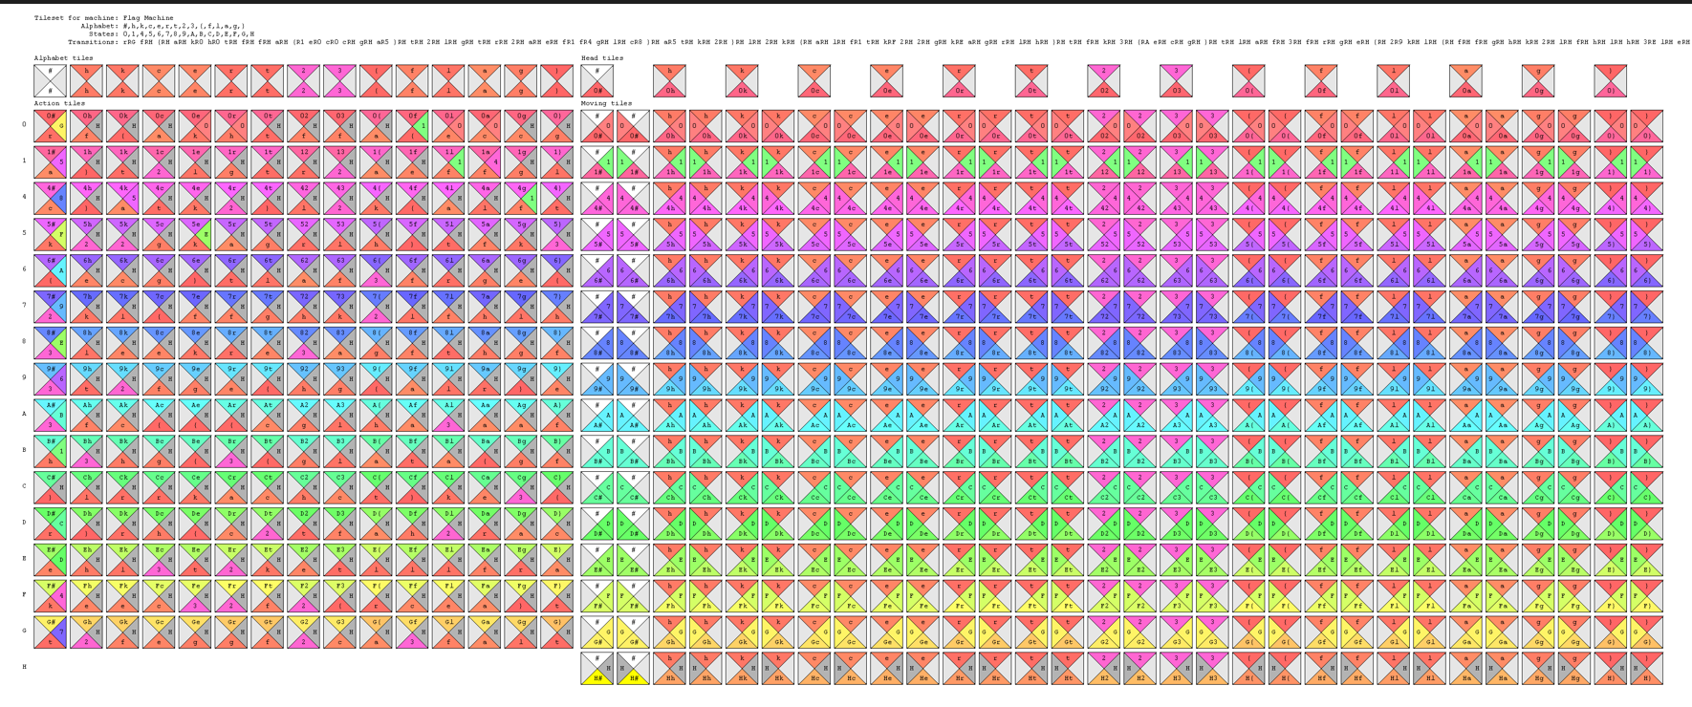

There are tiles

Below is the sample of tiles starting from “fake”

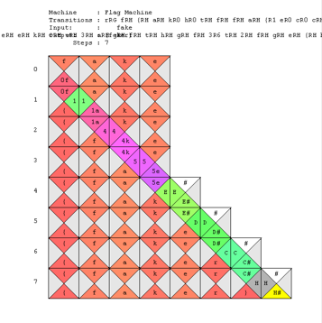

From the description of the question. It can be easily known that the flag starts with “real”

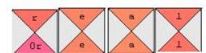

So I started with the following

From the given tiles, there is only one tile with 0r as the top：

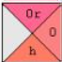 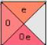

The tile with e as the top and 0 at the right is↑

With the same logic, we can get

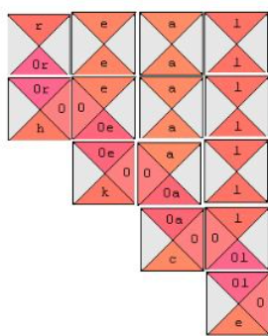

Then we need to start to get tiles from the “moving tiles”

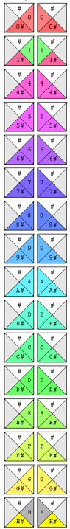 and get this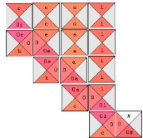

By the same method, it can be easily completed

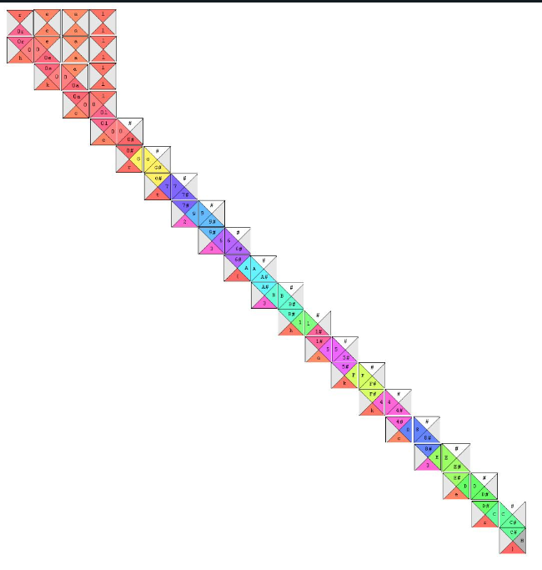

Therefore, the flag is hkcert23{3hakkc3er}