PROBLEM 1

Let (X,Y) be a bidimensional random variable, with joint pdf given by

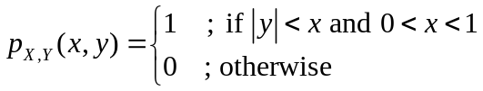

Find:

- The marginal distributions of Y and X
- The conditional distributions
- Pearson’s correlation coefficient

PROBLEM 2

The joint pdf of random variables X₁ and X₂ is given by

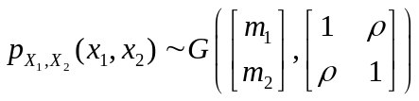

Obtain the pdf of r.v. Y = X₁ + X₂.

PROBLEM 3

X₁ and X₂ represent two independent random variables with exponential distributions:

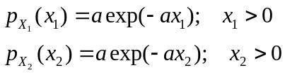

Obtain the pdf of r.v. Y = X₁ + X₂.

PROBLEM 4

Knowing that X is a random variable with uniform distribution between 0 and 1 (U(0,1)), obtain the analytical expression for the pdf of Y = X² and Z = 1 / X.

