1. pwn/baby_heap

Warm up!

nc 13.125.233.58 7331

Files: Dockerfile, babyheap.xinetd, docker-compose.yml, share/chall

Note: Screenshots will not have consistant ASLR and PIE addresses. I don’t want to take them all in one run of the bniary.

**Overview**

We are given 2 files of importance, the dockerfile and the challenge binary. The libc and linker can be retrieved from building the docker and copying the files over from /lib/x86_64-linux-gnu/, and then the binary can be patched with these libraries using pwninit. After inspection of the binary, it appears to be a CRUD operation heap challenge. The CRUD operations work as following:

1. add: the create option, checks if the function has been called over 16 times (16 allocations), and if not takes a chunk size (<200) and chunk data (len <= chunk size) from stdin. What was surprising and confusing at first was that the way the chunks are tracked – with another chunk of size 0x18 that had the following structure:

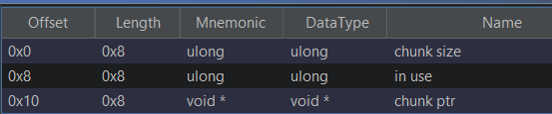

These chunk structures are stored in an array in .bss.

1. free: the delete option, takes a chunk index from stdin, checks if it is <= the highest chunk index but not >= 0 and is not a null pointer, goes to the pointer, which should be a chunk structure, and checks that the in use and the chunk ptr of the chunk structure is != 0. It finally frees the chunk and the chunk structure in order.
2. modify: the update option, takes a chunk index from stdin, has the same checks as free, and then reads 0x28 bytes from stdin to the chunk structures chunk ptr value.
3. view, the read option, takes an index from stdin, has essentially the same checks as free and modify, then writes a chunk size amount of bytes from chunk ptr.

The vulnerabilities of this challenge lie in modify’s fixed read size, the implementation of the chunk structure, and the out-of-bounds read to array indexes < 0.

**Safe-linking and Heap Leak**

For modify, heap chunk sizes can be under 0x28 (to 0x10), and this allows for the chunk size of the next chunk to be overwritten, and since view uses this value to determine how many bytes to read, if a chunk after the chunk being viewed is freed, the safe linking and heap can be leaked.

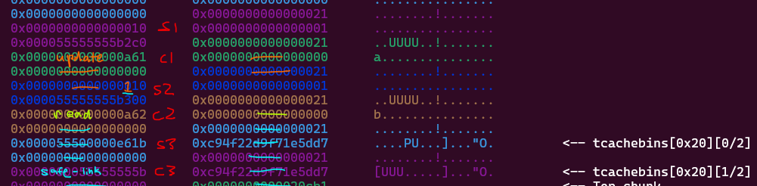

**Tcache Poisoning**

This modify OOB also allows for the fd pointer of the freed chunk structure to be overwritten, allowing for arbitrary chunk allocation.

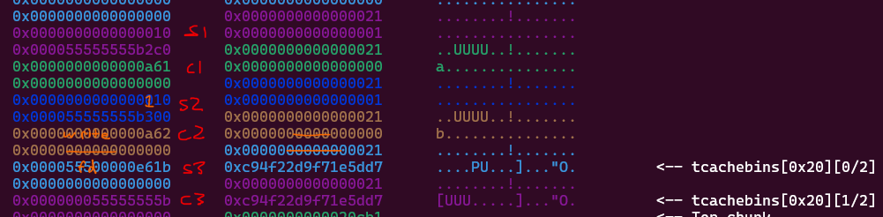

**Libc Leak**

Because view can read negative array indexes and because the chunk array is in .bss, the read option can leak a libc address using the file descriptors in .bss.

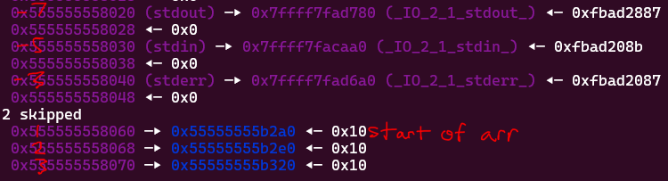

These file descriptors pass the checks for view.

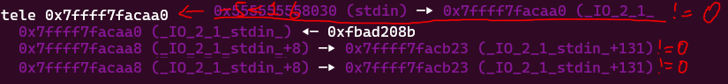

So, calling view with index -5 will print 0xfbad208b bytes of data (or till newline) from the stdin pointer, resulting in a libc leak.

**Easy arbitrary chunk allocation**

With tcache poisoning and the safe linking and heap leak from earlier, the tcache metadata can be controlled by simply allocating a chunk in the metadata and updating it as needed. It is worth noting that the tcache needs to think there are chunks in the respective sized bins, which can be done by allocating a chunk of that size, freeing it, then finally overwriting the tcache. In this challenge, the tcache pointers were stored at the start of heap + 0x90.

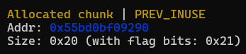



As we can see, the tcache bins are filled with these cyclic “pointers”.

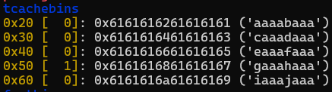

**Stack Leak**

A stack address can be leaked using the tcache control and the libc leak. I found this information from a writeup of the challenge “heapify” from angstromCTF 2024, which just happened recently.

From angstromCTF Discord: <https://discord.gg/Dduuscw>

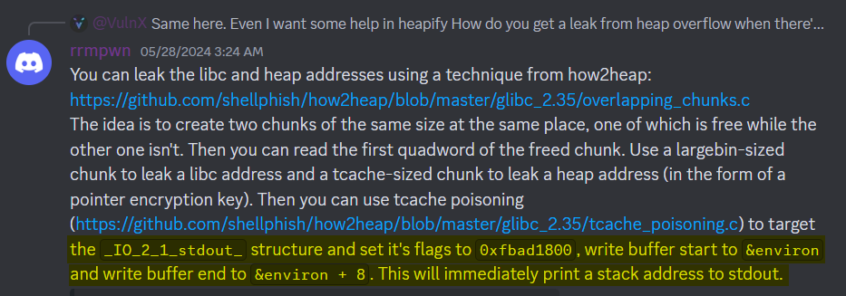

It took me a little bit to figure out what he meant, but after a bit of research this is what I found.

The _IO_2_1_stdout_ structure is the _IO_FILE structure for the stdout file descriptor. Each file descriptor uses an _IO_FILE structure for its IO operations. The structure has an int for flags, then several pointers for IO operations. That is all that matters for this challenge, as far as I am concerned. Furthermore, the read pointers do not matter for stdin, and buffering is disabled by the binary, so the buffer pointers do not matter either. That means the only values that do matter are the flags, _IO_write_base, _IO_write_ptr, and _IO_write_end values.



<https://sites.uclouvain.be/SystInfo/usr/include/libio.h.html>

Now, from the writeup above, the author said to set flags to 0xfbad1800. Looking into this, it turns out that the 0xfbad portion of flags is simply a magic number, defined by _IO_MAGIC. The 0x1800 portion, on the other hand, is the _IO_IS_APPENDING and _IO_CURRENTLY_PUTTING flags (0x1000 and 0x0800 respectively -> 0x1000|0x800=0x1800), which tells the file descriptor it has data to write, and needs to write it.

The three write pointers I am still confused about, but what worked for me was setting _IO_write_base to the start of the area, then _IO_write_end and _IO_write_ptr to the end of the area I want to leak. The pointer I wanted to leak was the environ pointer in libc, which contains a stack address.

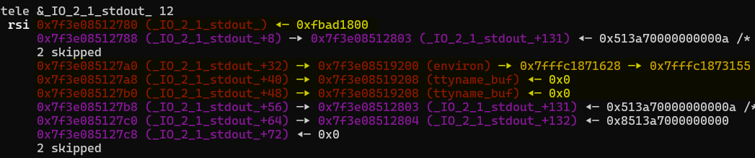

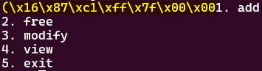

Using this method, the stack address should be printed in stdout. We can get the offset from the stack leak to a return address, and ROP to system(“/bin/sh”).



**ROP**

Now that we have a return address, a chunk can be allocated at the return address, and the system function and all the gadgets we need will be in libc. So, after overwriting tcache once again to the return address (-8 because of chunk alignment), we can allocate a chunk with our ROP payload, and a shell should be popped, and we can print the flag.

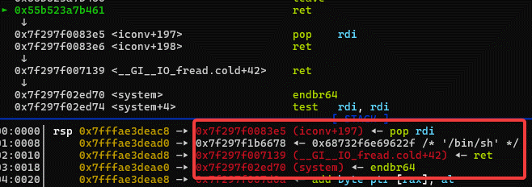

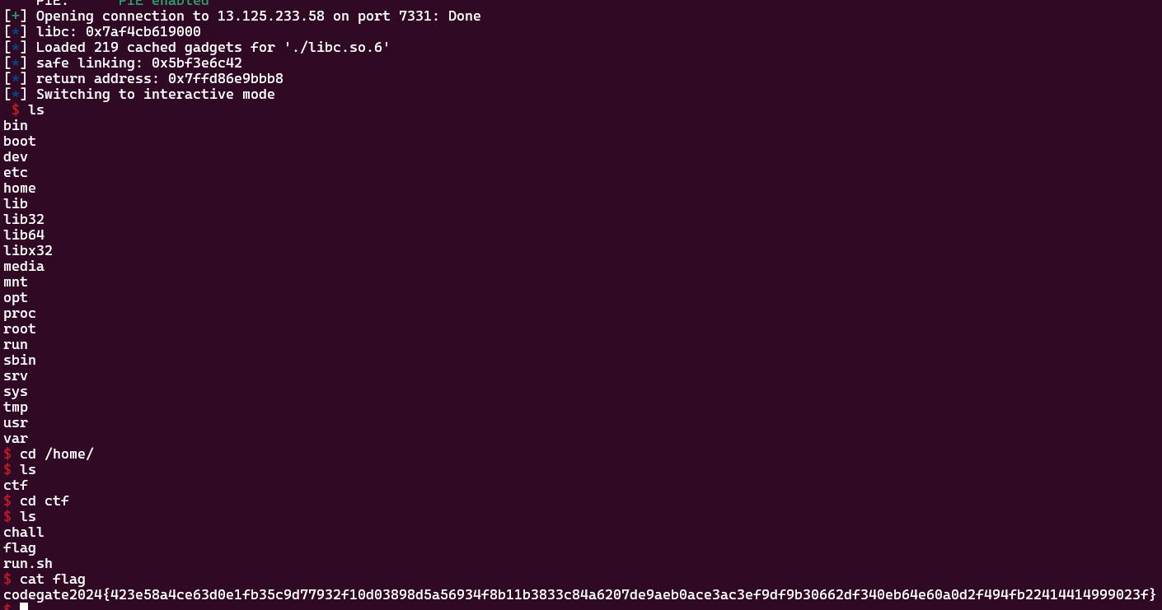

codegate2024{423e58a4ce63d0e1fb35c9d77932f10d03898d5a56934f8b11b3833c84a6207de9aeb0ace3ac3ef9df9b30662df340eb64e60a0d2f494fb22414414999023f}

**Concepts Tried**

For this challenge, I tried a few things that didn’t work, and I just wanted to document them.

* **House of Tangerine**

Before I realized the read operation could go negative and that the file descriptors could leak libc pointers, I tried to use the house of tangerine to free the wilderness chunk to do… something (I don’t know anymore), but this didn’t work because even if the wilderness chunk size is overwritten so the bytes after the first two are zeroed, there are not enough chunks, even with max size, to be able to implement the house.

* **Libc GOT Overwrite**

I tried to find a libc GOT pointer to overwrite to a one gadget, but none of these pointers had the registers set up correctly for me to be able to call a one gadget, at least not to my knowledge.

* **Arbitrary Chunk at __libc_stack_end**

I tried to allocate a chunk at __libc_stack_end, which is also a stack address, but is not writable, unlike environ. Even though this is pretty insignificant, I wanted to include this because I think I could have leaked stack with this method with environ instead of __libc_stack_end, instead of going on that file structure adventure. Oops.