1. web/master_of_calculator

traditional calculator challenge

<http://3.34.253.4:3000/>

Files: docker-compose.yml, server/*

We are given a folder that contains the files for what appears to be a Ruby on Rails website. Upon inspection of the dockerfile, the flag appears to have random bytes appended to the end of the filename, following the flag-.* regex, meaning we will need to find the filename as well before printing the flag. When visiting, the website allows us to input leverage, entry price, exit price, and quantity (quentity?), then returns 3 variables ROI, PnL, and Margin. It took me quite a bit of time, but eventually I found the file that handled these calculations, server/app/controllers/home_controller.rb. I had never worked with Ruby before, but ChatGPT would be able to analyze the code for me and find the vulnerabilty, which lied in the program using user input for a format string, similar to python’s exec function.

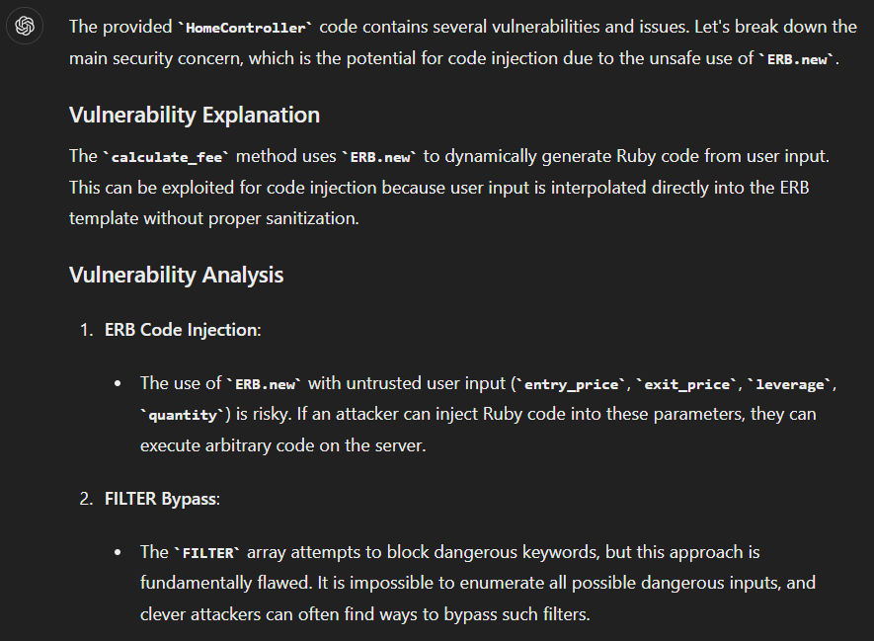

So, the challenge seems to be similar to the misc/ai_warmup challenge – basically a jail of some sorts with some blacklist, but this challenge only returned the output of a variable that used the 4 inputs and did not provide an interactive console. This time ChatGPT could not produce a solution that worked, so I was on my own.

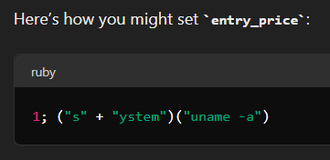



I used an online Ruby compiler to figure out what I could do - <https://onecompiler.com/ruby>. I started by figuring out how the user input led to code execution, and I found that the implementation of the ERB class takes user inputs as format strings, which the ERB stores as a string, and then evaluates.



So, using this, we can execute our own code to somehow leak the filename and print the flag. Functions in Ruby do not require parentheses, so my first idea was to just use the open function with a string constructed with numbers and the chr function (this was before I read the Dockerfile, so I thought the flag would be stored in flag.txt). I used this python code to generate the string.



And this was somewhat similar to my first attempt:



I used a different file on the online compiler, and returned a File object for the file I tried to open.

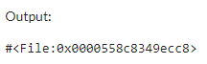

Now my next hurdle was trying to call the read function on this file. I found that variable declaration in Ruby returns a value, and therefore can be used inside eval.

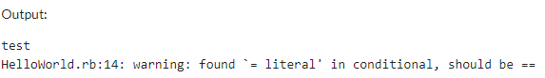

So, the payload looks something like this.



This should theoretically read the flag, but as mentioned earlier, the flag matched the flag-.* regex. After some research, I found that that there is another function which evaluates strings into functions – send. It can call functions with the send(function, arg, arg, …) syntax. So, I changed my payload to this to call system(“ls”) using split to split the function into an array, since commas are blocked.



Two issues arose from this implementation. The website does not print stdout, so calling system(“ls”) is useless. I found a resolution for this quickly though, as open(“|ls”).read will return the system(“ls”) stdout.



The second issue was the program only returns response, which was a combination of PnL, ROI, and Margin. This can be fixed by as setting one of the variables used for response to the desired output, and it will include the output in response. After fixing this issue, we have our final two payloads, where the second payload’s string is retrieved from the output of the first payload.



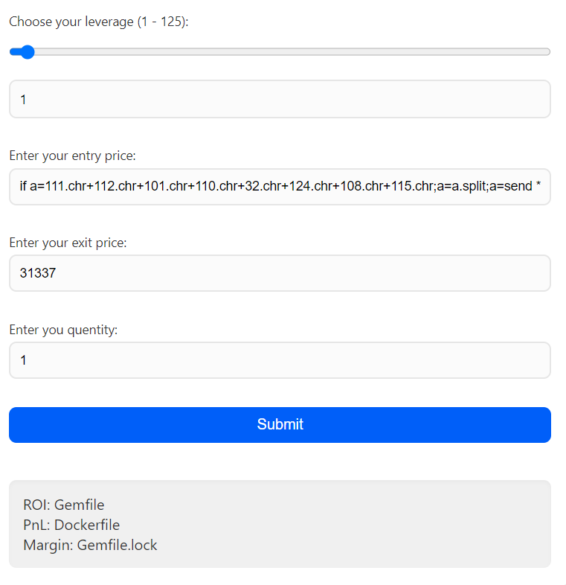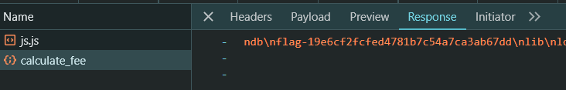



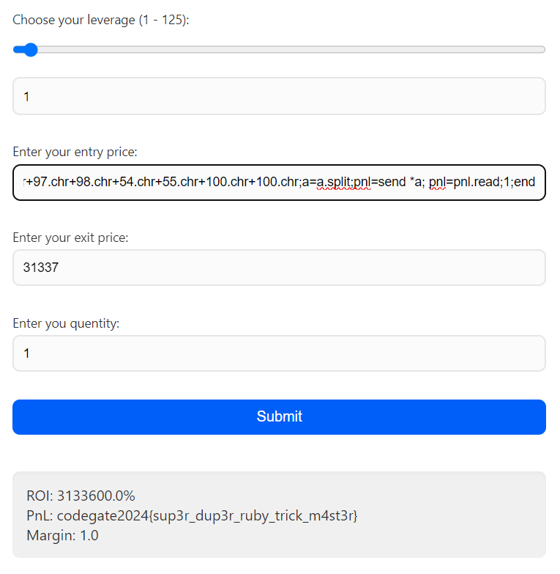

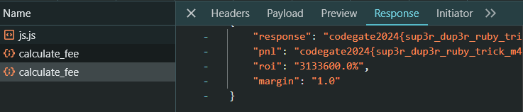

codegate2024{sup3r_dup3r_ruby_trick_m4st3r}

Looking back, since open was not a blocked word, the challenge could have been solved with this much shorter payload.

