Getting started with accessible maths

Emma Cliffe, Skills Centre: MASH, University of Bath

JISC Accessibility drop-in clinic, June 2022

Table of Contents

# Getting started with accessible maths

* What is the problem?
* What do we convert ***to***?
* How do we get started?

# What is the problem?

## Could we solve it by…?

You might ask, can we not solve this by ensuring that the PDF is accessible? Unfortunately, the answer is no. The act of creating the PDF destroys information about the structure of the mathematical expression.

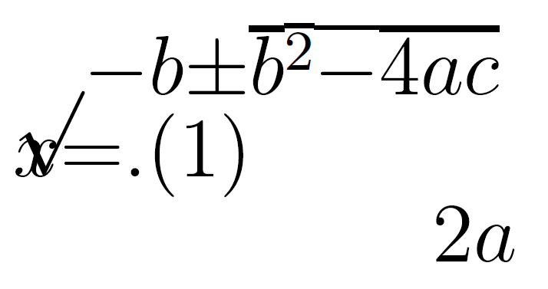

Reflowing a PDF visually destroys the maths

## Computers for reading and writing maths

* Computers rely on structural integrity to process maths:
  + PDF, print, handwriting and E-books using images of maths cannot be processed
    - They are inaccessible and inflexible on, for instance, small screen devices. They are lossy formats for maths!
  + Word, HTML based formats and EPub3 have structural integrity for maths and are accessible to many assistive technologies (AT)
    - But not all AT can access maths all formats - right now we probably need to produce as much choice as possible
  + PowerPoint 365 is theoretically accessible but most AT won’t work with it yet and it can’t be transformed
* Using a computer with or without assistive technology to write mathematics is a specialist skill!
* Using AT effectively for maths requires authors to produce accessible materials
  + This is challenging due to how mathematicians and scientists typically produce text and documents.

## From retrofitting to inclusive design?

I have spent the last 18 years trying to retrofit accessible interfaces to the entirely natural community evolved handwritten, typeset and old software based maths learning environments.

It is important to understand that this is a side effect of a more general difficulty - mathematicians continue to hand write and then, maybe, typeset for a reason!

But, we relied on expertise at the intersection of higher level maths, programming and access. Retrofitting is an expensive, inefficient compromise reliant on rare skill sets, research output organically grown tools and, to be honest, serendipity!

## Could we convert the LaTeX?

* It depends on the LaTeX…
* The past: use [tools which may or may not work and that cannot tell you, in general why something doesn’t work created and driven by specialists](https://hub.docker.com/r/bathmash/mathaltnotes)
* The future? [lwarp](https://ctan.org/pkg/lwarp?lang=en) but beware of some hard work (documentation currently 1237 pages) - what happens depends on what you are doing in LaTeX and how and you have to work that out and test for accessibility for yourself.
* It is **not possible** to convert LaTeX to html in the general case.

## Could we convert the mathematicians?!

Any new document preparation system needs to ***enable*** the writer by providing the key features of mathematical/scientific document preparation. And these features make things complex.

* Software is catching up and in flux.
* Nothing is easy to learn.

Increasingly we have converted the mathematicians, but they need appropriate institutional infrastructure, support, workload time allocation and training. Without this it is unreasonable.

# What do we convert ***to***?

From a technical point of view there are only three formats of mathematical text which are accessible:

* Word
* HTML using MathJax to render the mathematics
* EPub3

Whatever **other** formats you supply you **must** supply at least one or, ideally, all of these (some technology can only access one format, EPub3 has least software support).

**But** you also need to supply PDF!

* Not all accessibility is about technical access - for some a clear or large print PDF is best
* Clear print is selected most often by disabled students in the Department of Mathematical Sciences.

# How do we get started?

## Word 365: Accessibility checker + Equation editor

* Use the inbuilt Word Accessibility Checker and information on [Making your Word documents accessible](https://support.office.com/en-gb/article/make-your-word-documents-accessible-to-people-with-disabilities-d9bf3683-87ac-47ea-b91a-78dcacb3c66d)
* Write *all* mathematical text written using the Word 365 equation editor. For instance, if you are writing about the variable $x$ or $θ$ it should be written as an equation. If you are writing $x^{2}$ it should be written as an equation.
  + Never use insert symbol.
  + Never write superscripts, subscripts, fractions etc. using font or style changes and standard keyboard input alone
  + Never use an image of an equation.
* Use Review -> Read Aloud (Alt + Ctrl + Space) to check the maths

More information and tools at [Using Word to write an accessible mathematical document workshop resources](https://stem-enable.github.io/WordWorkshop/) and [effective keyboard-only typing of mathematical expressions](https://bathmash.github.io/gettingstarted/Word/index.html).

## Sounds solved to me?

Some students will require MathType format

* Because their AT vendor has not implemented the interface to Word but the AT does work with MathType. Test everything and contact the vendors!
* Materials should be prepared as above and then a ***copy*** converted to MathType as automatic conversion of all expressions cannot be reversed.

Also… this generally won’t work for the mathematicians and some scientists.

* Word is not a scientific document preparation system.
* For those who use LaTeX we need a different plan.

## Web: WCAG 2.1 AA + MathJax!

* Check it meets the legal requirement of WCAG 2.1 Level AA with e.g. [Accessibility Insights for Web plugin for Chrome](https://accessibilityinsights.io/docs/en/web/overview)
* Check it is MathJax… Right click!
 $$x=\frac{−b±\sqrt{b^{2}−4ac}}{2a}$$

 + Provides/enables: navigation, chunking, zoom, copy/paste, colour, size and layout changes…
  + Structural integrity enables assistive technology including text-to-speech, screenreaders, electronic Braille
  + Fallback for ARIA-aware AT without native support
  + AT providers without native support and not ARIA aware are a problem but not your problem.

Some VLEs enable you to create pages which meet these requirements using LaTeX for the equations e.g. Moodle but they do not provide the necessary features of a mathematical/scientific document preparation system.

* This is the most accessible end format for a mathematical or scientific document but we need a way to prepare the document

## Converting the mathematician?

There are other methods and we are not perscriptive. We support staff with (R)Markdown.

* (R)Markdown incorporates LaTeX for equations and a simple markup language for the rest of the document.
* Authors are confined to a transformable subset with a quick compile loop and a supportive GUI.
* The output has known accessibility features.
* The typesetting is still extensible, just more reasonably so.

More information on getting started with RMarkdown see [Using R as a basis for writing an accessible mathematical document](https://stem-enable.github.io/RMarkdownWorkshop/)

* For certain functionality important in mathematical communication (theorems, intradocument referencing) you will eventually need [Bookdown](https://bookdown.org/)
* For additional functionality important in pure mathematics (more complex control of theorems, referencing) you may need [Clavertondown](https://bathmash.github.io/clavertondown/) which is provided without warranty and aimed at those who work on Claverton Down!

This document is written using [Clavertondown](https://bathmash.github.io/clavertondown/). You can download any of the auto-transformed formats from the top toolbar at [Getting started with accessible maths](https://stem-enable.github.io/Getting-started-with-accessible-maths/index.html).

## Mathematical diagrams, software and interactive/dynamic elements

* Check that the software/system meets WCAG 2.1 level AA - ask the vendor, procure on this basis
  + Be aware that many mathematical and statistical analysis systems are still not accessible
* Check that mathematics is rendered via MathJax
* Start to use emerging tools which have known accessibility status for creation of dynamic elements:
  + Desmos, BrailleR, Geogebra (with care)
  + Numbas, Stack
* If you made a diagram using data or code or some textbased input mechanism then provide that text or link to it somehow.
* Learn to describe diagrams which can’t currently be replaced:
  + DIAGRAM Center (<http://diagramcenter.org/>):
    - Poet Image Description Training Tool
    - Image description guidelines
    - Sample book
    - Webinar: <http://diagramcenter.org/diagramwebinars.html#compleximages>
  + UKAAF has guidance on accessible images: <https://www.ukaaf.org/accessible-images/>
  + NCAM (Old site) has guidelines and examples: <http://ncamftp.wgbh.org/ncam-old-site/experience_learn/educational_media/stemdx.html>

### Example: Desmos

Desmos is screenreader accessible and also produces tactile diagrams. If you can redraw the graph in Desmos then do that! 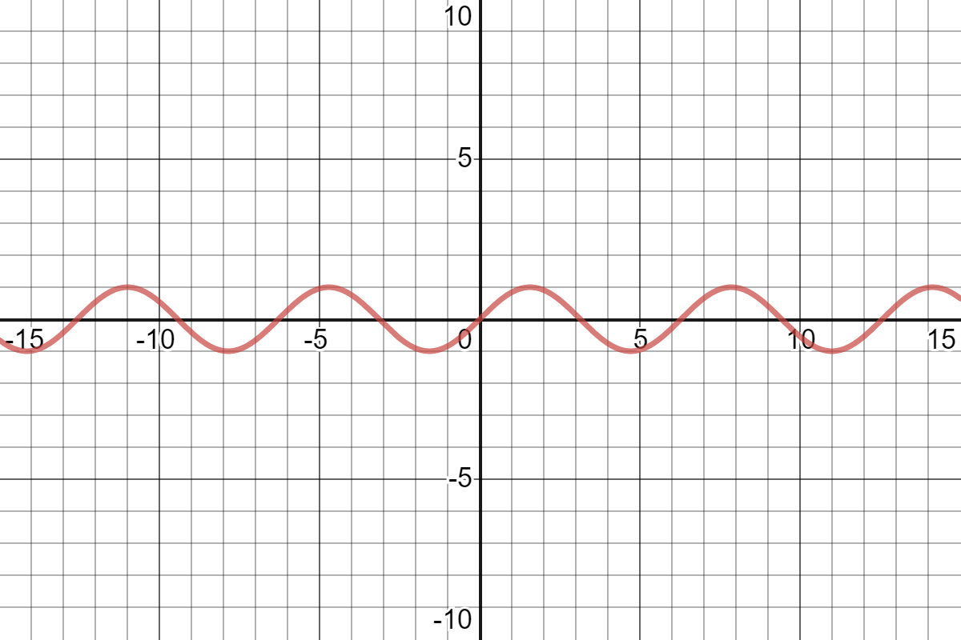

### Example: BrailleR

If you are making some sorts of statistical graphs and you know how to use R (fairly well) then there is a [BrailleR](https://github.com/ajrgodfrey/BrailleR) package which can create descriptions of some sorts of graphs automatically.

# Thanks for listening and watching

* This document is available at [Getting started with accessible maths](https://stem-enable.github.io/Getting-started-with-accessible-maths/index.html)
* My email address is [E.H.Cliffe@bath.ac.uk](mailto:E.H.Cliffe@bath.ac.uk)