Quick Introduction to Accessible Maths
  - Science & Engineering Faculty, University of Limerick
Emma Cliffe
August 25, 2026
Table of contents

Plan
- Why worry about maths access?
- What is the maths specific problem?
- What do solutions look like?
- How do you get started?
Live document: https://stem-enable.github.io/Quick-introduction-to-accessible-maths-2026/

Why worry about maths access?

The legal
Accessibility is a legal requirement… I am not a lawyer. Seek advice.
- Equal access:
  - England, Scotland, Wales: Equality Act 2010
  - Northern Ireland: Disability Discrimination Act 1995, (as amended), including SENDO 2005
  - Ireland: Equal Status Acts 2000 - 2018
- Accessible digital content (including university websites, web services and most VLE content):
  - UK: Public Sector Bodies (Websites and Mobile Applications) (No. 2) Accessibility Regulations 2018
  - Ireland: European Union (Accessibility of Websites and Mobile Applications of Public Sector Bodies) Regulations 2020

But we should care anyway…
We want students to spend their effort engaging with concepts, not overcoming barriers in our resources.
Students with print disabilities or difficulties with reading, note-taking, memory or concentration may expend significant effort accessing information before learning can begin.
As educators, we should make information accessible in multiple ways.
- Rich, interactive resources can benefit all students.
- Poorly designed resources create practical and technical barriers:
  - Notation inaccessible via speech, magnification, Braille or small screens
  - Difficult keyboard-only navigation
  - Meaning conveyed by colour alone
  - Poorly scalable graphics

What is the maths specific problem?

Structured text can be unexpectedly inaccessible
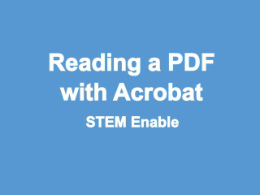
Video demonstration

Could we solve it by…?
Can we not solve this by ensuring that the PDF is accessible? Unfortunately, the answer is no. The act of creating the PDF destroys the structure of mathematical, and similar, expressions. Reflow on a small screen produces…
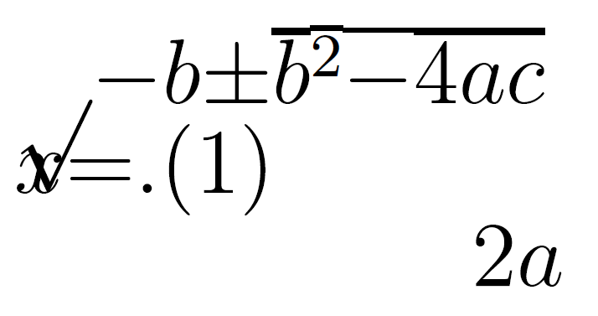

What do solutions look like?

Structure + software
Being able to adapt how text is presented, whether for small screens or via assistive software requires:
- Authors to produce accessible materials which maintains the encoding of the structured text
- Readers to have software and assistive technology which can manipulate the specific format
Only four formats of mathematical text are technically accessible:
- HTML using MathJax to render the mathematics
- Word/PowerPoint using the inbuilt equation editor
- Word/PowerPoint using MathType
- EPub3 using MathML
You must supply at least one to meet the public bodies requirement.
- Supply your full course content ‘spine’ in this format.

So, job done?
Afraid not…
Not all reader assistive technology can access maths all formats!
- Equal access acts mean we must meet individual needs - so may need to produce other formats.
- Some cannot not be transformed easily to others
For authors using Word/PowerPoint, standard accessiblity guidance is not enough.
For authors using the LaTeX scientific document preparation system none of the above formats are native outputs. And if a student can’t make their own clear print and print it you also may need to supply variants on inaccessible PDF!
- Not all accessibility is about technical access
- Clear print PDF is selected most often by disabled students in the Department of Mathematical Sciences at the University of Bath.

How do you get started?

Word/PowerPoint 365
- Use the inbuilt Accessibility Checker and information on e.g. Making your Word documents accessible
- Write all mathematical text written using the MS 365 equation editor. E.g. if you are writing about the variable (x) or () it should be written as an equation. If you are writing (x^2) it should be written as an equation.
  - Never use insert symbol.
  - Never write superscripts, subscripts, fractions etc. using font or style changes and standard keyboard input alone
  - Never use an image of an equation.
- Use Review -> Read Aloud (Alt + Ctrl + Space) to check the maths
- Quick example

Word/PowerPoint transforms and tools
EHC: CAN CAR CONVERT MATHTYPE BACK TO NORMAL WORD?
- Effective (keyboard-only) input of maths in Word.
- Transform Word to other formats
- Transform to MathType
At the time of writing transforming from (any) PowerPoint is trickier. Best not to use this as a source format.

HTML (WCAG 2.2 AA) + MathJax!
- Check it meets the legal requirement of WCAG 2.2 Level AA with e.g. Accessibility Insights for Web plugin for Chrome
- Check it is MathJax… Right click!
$$x=\frac{−b±\sqrt{b^{2}−4ac}}{2a}$$
  - Provides/enables: navigation, chunking, zoom, copy/paste, colour, size and layout changes…
  - Structural integrity enables assistive technology including text-to-speech, screenreaders, electronic Braille
  - Fallback for ARIA-aware AT without native support
  - AT providers without native support and not ARIA aware are a problem but not your problem.
We recommend using MathJax 2.7.9 or MathJax 4.* as MathJax 3.x does not enable reflow on zoom.

Scientific document preparation systems
- Attempt to transform the LaTeX to HTML with MathJax using Chirun or lwarp
  - What happens depends on what you are doing in LaTeX
  - Keep your preamble clean, start with a minimal document, add in sections recompiling to all required output formats after each addition
  - Some documents cannot be converted
  - No known Beamer solution at time of writing
- Work in a Markdown format, using LaTeX for equations, with HTML has the primary output (can also output LaTeX/PDF); can create slides and single-source slides and documents (like Beamer)
  - Quarto is recommended in most cases
    - Bookdown continues to be fine but start new projects in Quarto
  - RMarkdown can be a helpful starting point for those completely new
  - Clavertondown, built on top of RMarkdown and Bookdown; should only be used if the other formats can’t meet needs

Non-text elements
- Graphical elements
  - Desmos was designed to work and tested with screenreaders and written to conform to WCAG 2.1
  - Geogebra aims to meet WCAG 2.1 AA
  - Project Beyond alt text between Bath and Coventry produced guidelines
  - BrailleR is a project by and for blind statisticians who use R
  - DIAGRAM Center has some great resources for those new to diagram description:
    - Poet Image Description Training Tool
    - Image description guidelines
    - Sample book
    - Webinar on complex images
- Maths e-assessment
  - Numbas aims to meet WCAG 2.1 AA
  - Stack aims to meet WCAG 2.1 AA

Next steps
The ideal can feel a long way off…
- Pick a place to start which feels achievable and start!
- The journey is less lonely if we share experiences and learn from each other
  - Consider setting up an institution community of practice, after 6 years our Markdown/Bookdown/ClavertonDown/Quarto CoP answers many questions between themselves without help from me, my team or the specialist STEM learning technologists (who we are very lucky to have)
  - In the UK there is the JISC Accessibility Community Maths Working Group.
    - Is there anything similar in Ireland?
    - It may be worth exploring whether links can be made with them from Ireland
Want to see how I built this single-source, multiple-outputs document? Github repository

I will use the word maths as a shorthand for all mathematical and statistical content used across any STEM degree. Although I won’t be talking about specialist chemical notations and diagrams the same issues apply.
Legislation is cited for awareness only and this does not constitute legal advice. Specific legal questions should be referred to your University legal team.
Work is ongoing to create a version of LaTeX, extra encoding within an adapted PDF and software which works with the extra encoding. In the meantime we need to either convert the LaTeX to other formats or switch to a different scientific document preparation system. It is not possible to convert LaTeX to html in the general case. It is easy to ‘fall out’ of the convertible subset without realising or knowing why, the addition of a package, change of preamble order, use of a seemingly innocent command…
Adhering as closely as possible to RNIB clear print guidelines
Last year we had to assist an author to create a printable PDF for a disabled student after the author had made a whole (and completely technically accessible) course using ProTeXt - but couldn’t get PDF working and the HTML produced poor print output…

