Example

Emma Cliffe

2022

Table of Contents

# Alternative formats

It is recommended that you [read this resource on the web](./arclengthInR.html) but you can also download [this resource as a PDF](./arclengthInR.pdf) or download [this resource as a Word document](./arclengthInR.docx).

# Arc length

We often need to know the length of a curve between two points, e.g. what is the length of the ropes holding Clifton suspension bridge (see Exercise Sheet 3).

## Visualisation

Given a curve $y=y\left(x\right)$

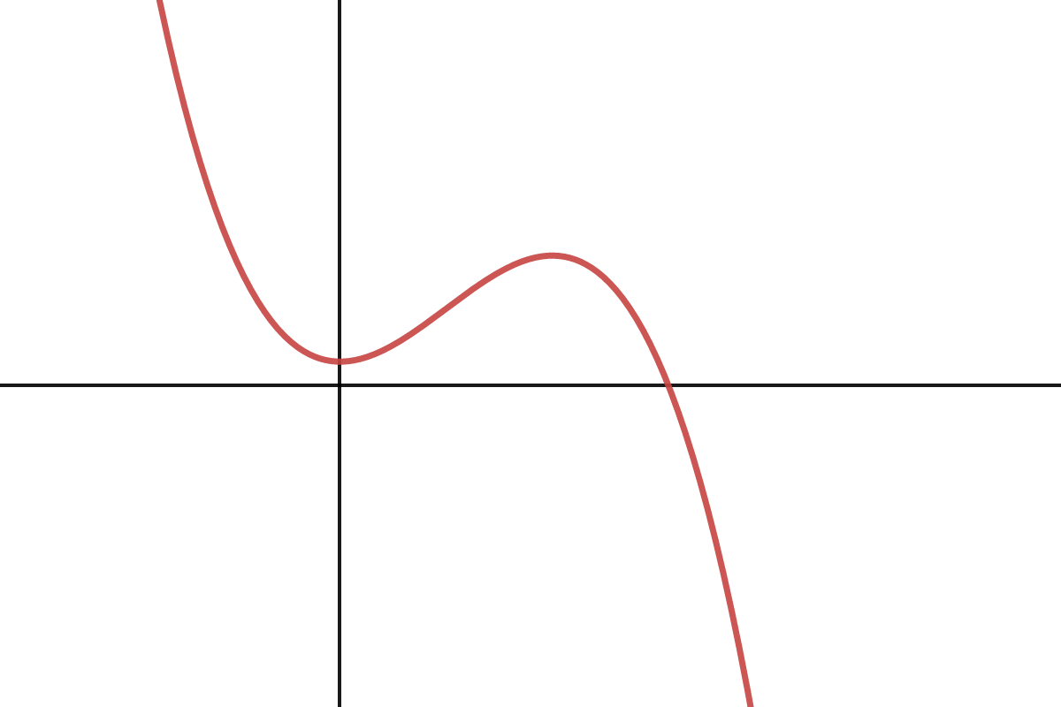

Accessible interactive graph at <https://www.desmos.com/calculator/t8dz6vlmnz>

Let $S$ be the arc length and $ΔS$ a short section of it.

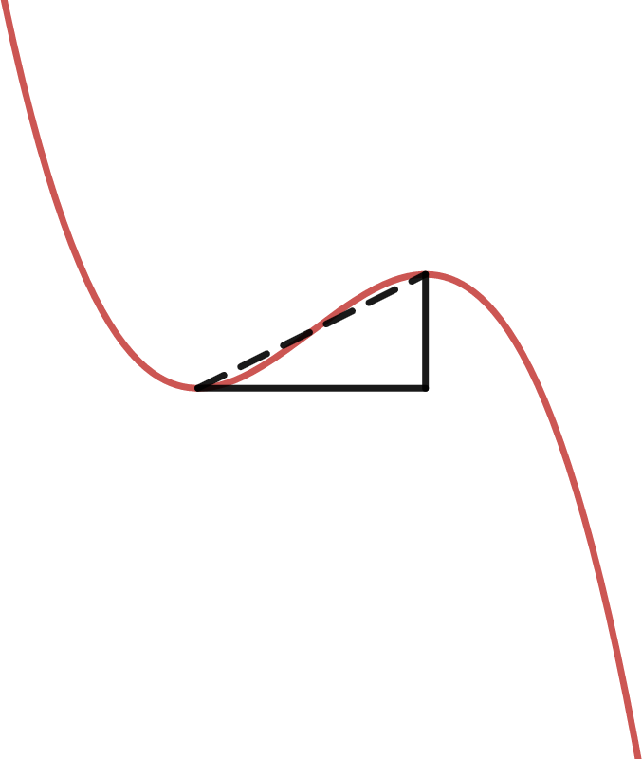

Accessible interactive graph at <https://www.desmos.com/calculator/g5duc4kmfp>

## Derivation of Arc Length

By Pythagoras’ Theorem,

$$ΔS^{2}≈Δx^{2}+Δy^{2} ⇒ {\left(\frac{ΔS}{Δx}\right)}^{2}≈1+{\left(\frac{Δy}{Δx}\right)}^{2}$$

As $Δx→0$ this becomes an identity

$${\left(\frac{dS}{dx}\right)}^{2}=1+{\left(\frac{dy}{dx}\right)}^{2} ⇒ \frac{dS}{dx}=\sqrt{1+{\left(\frac{dy}{dx}\right)}^{2}}$$

The arclength between $x=a$ and $x=b$ is then

$$\begin{matrix}S\left(a,b\right) & =\int_{a}^{b}{\frac{dS}{dx}}dx \\ & =\int_{a}^{b}{\sqrt{1+{\left(\frac{dy}{dx}\right)}^{2}}}dx.\end{matrix}$$