RMarkdown, Bookdown or Clavertondown?

Emma Cliffe, Skills Centre: MASH

Table of Contents

# An introduction

* Requirements
* Formats and transforms
* RMarkdown
* Bookdown
* Clavertondown

# Requirements

* Public Sector Bodies (Websites and Mobile Applications) (No. 2) Accessibility Regulations requires at least one of:
  + [Web: WCAG 2.1 AA](https://accessibilityinsights.io/docs/en/web/overview) + [MathJax!](https://docs.mathjax.org/en/v2.7-latest/misc/accessibility-features.html)
  + [Word 365: Accessibility checker + Equation editor](https://support.office.com/en-gb/article/make-your-word-documents-accessible-to-people-with-disabilities-d9bf3683-87ac-47ea-b91a-78dcacb3c66d)
  + [PowerPoint 365: Accessibility checker + Equation editor](https://support.microsoft.com/en-us/office/make-your-powerpoint-presentations-accessible-to-people-with-disabilities-6f7772b2-2f33-4bd2-8ca7-dae3b2b3ef25)
  + [EPub3 with MathML](https://docs.mathjax.org/en/v2.7-latest/misc/epub.html)
* Equality Act 2010
  + Authors may need to provide additional formats to meet the needs of a specific student

# Formats and transforms

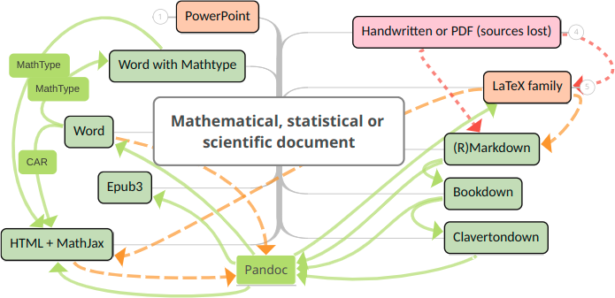

Figure 2.1: Accessible and interactive map at <https://www.mindomo.com/mindmap/document-transforms-2d8186b662758e26ccf50ef82a3828b2>

# RMarkdown

* Simple one page documents
  + Accessible: HTML, Word
  + Accessible if no mathematical content: ODT, RTF
  + Inaccessible: LaTeX/PDF
* Slides
  + Possibly accessible: PowerPoint, HTML using ioslides, reveal.js, Slidy
  + Inaccessible: LaTeX/Beamer

# Bookdown

* Designed to enable authors of **books** or longer structured documents
* Needed for:
  + Parts and appendices
  + Finer control of figures
  + Automatic numbering and cross-referencing of figures, tables with captions
  + Cross referencing of pieces of text
  + Equation numbering and referencing
  + Theorem and proof environments with numbering and referencing
  + Definition of custom environments
  + Citation management via Pandoc, biblatex or natbib
  + Embedding of web pages and HTML widgets
* Output to HTML book, LaTeX/PDF and EPub3 only

# ClavertonDown

* Designed to enable authors of **lecture notes** to meet the diverse needs of students by production of a coherent **set** of formats
* Needed for:
  + Flexible theorem-like environments akin to newtheorem in LaTeX including styling, numbering and classification of type to enable structured colour
    - Numbering system of inbuilt Bookdown theorems can be changed
    - It is possible to reference other environments within theorem names
    - Unnumbered theorem environments
    - Shared numbering e.g. between theorem and proposition
    - Newtheorem-type definition of theorem-like environments
    - Repeating theorem-like environments
  + Inclusion of figures in WHATSIT custom blocks
  + Limited control over visual presentation to enable a coherent set of notes with
    - Known accessibility features
    - Clear visual markers of structure
* Output as a mini-linked site of a set of formats which can include HTML book, HTML page, Word, EPub3, standard PDF, clear print PDF and large print PDF

# More information

* [ClavertonDown](https://bathmash.github.io/clavertondown/)
* [MASH Accessible Maths project](https://www.bath.ac.uk/projects/mathematics-accessibility/)