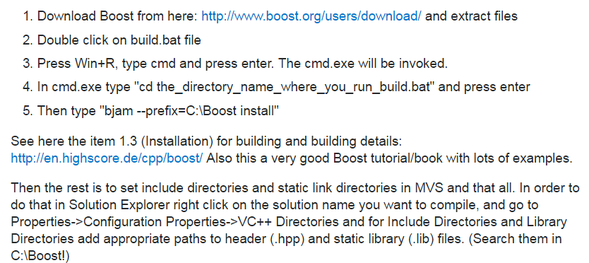

Source :

<http://stackoverflow.com/questions/9094886/setup-boost-and-use-with-visual-studio-2010-express>