“easyPick” is the main algorithm. Here is how to setup the project:

1. Open a New Project (Win32 Console Application). Make sure it’s organized as below:

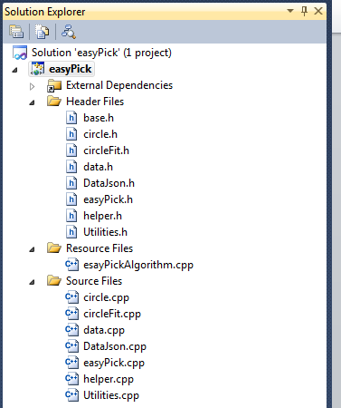

1. Setup 3rd party libraries including opencv, boost and rapidjson. (Refer to the setup documentations in the folder “3rdPartyLib”). Make sure it’s configured in both “Debug” and “Release” mode.
2. If in “Debug” mode, press Ctrl + F5 to run the program. Result images as well as json file for each image will be generated. If in “Release” mode, choose Build -> Build Solution, you will see easyPick.lib generated in Release folder.