Liver Cancer Forecast

HarvardX Data Science, Machine Learning

C.T. Dinh March 04, 2023

Introduction

Liver Cancer Data

Prepare Required Packages

1. Load the Data
2. Decompose the Data
3. Check Data for Stationary
4. Partition Time Series Data
5. Create & Evaluate Models Model 1 - auto.arima Model 2 - ARIMA(0,0,1)

Model 3 - ARIMA(0,0,0) with Fourier Term Model 4 - ARIMA(0,0,0) with Transformed Data Model 5 - Single Exponential Smoothing (SES)

Model 6 - Neural Netwrok Auto-Regressive Time sEries Forcast

1. Validate the Best Fitted Model
2. Conclusion

Additional Work Lesson Learned References

# Introduction

Although cancer incidence and mortality overall are declining in all population groups in the United States, certain groups continue to be at increased risk of developing or dying from particular cancers including breast, prostate, kidney, liver, and lung.

These disparities are frequently seen in people from low-socioeconomic groups, certain racial/ethnic populations, and those who live in geographically isolated areas.

higher rates of liver cancer among Asian and Pacific Islanders than other racial/ethnic groups as stated by [Cancer Health](https://www.cancer.gov/research/areas/disparities) [Disparities Research at NCI](https://www.cancer.gov/research/areas/disparities).

Cancer liver has been listed in the [Top 20 Disease Sites for Newly Registered](https://cancercenters.cancer.gov/DT/DT3) in the last 10 years. For the above mentioned reasons, Liver Cancer Forecast is selected for this project.

The question is not whether cancer mortality rate can be reduced by 50% in 25 years, but rather at what diminishing rate per given year would be optimal in order to meet the cancer reduction goal set by President Biden.

The objectives of this project is to predict liver cancer trend based on historical data by taking advantage of the auto and custom selection algorithm of ARIMA, Simple Exponential Smoothing (SES), and Neural Network time series forecasts to manipulate time series data and get it ready for modeling and forecasting

ARIMA is an acronym for Auto Regressive (AR) Integrated (I) Moving Average (MA):   
 [Brief explanation of the components](https://towardsdatascience.com/time-series-analysis-with-auto-arima-in-r-2b220b20e8ab) [of ARIMA](https://towardsdatascience.com/time-series-analysis-with-auto-arima-in-r-2b220b20e8ab)

# Liver Cancer Data

Data on the liver cancer incidence data was obtained from (OCC, 2023) The data contains 790 rows of observations from the annual fiscal year 2009 to 2012. The data will be sorted in chronological order, partitioned according to time into two datasets training data and validation (final_holdout_test) datasets. The modeling approaches will be developed and evaluated using the train and Finally, the model with the best accuracy will be tested using the validation set (final_holdout_test).

Several ARIMA models with different autocorrelation terms will be formulated and chosen one which provided for an accurate fit of the data based on the Akaike information criteria (AIC). A lower AIC would indicate a better model fit. Based on the final selected model, the annual number of cases expected to be registered in the U.S. from 2022 to 2027 will be forecast. The 95% confidence intervals (CIs) will be automatically calculated from the mean square errors of the model.

In summary, this project contains 790 liver cancer cases registered from 2009 to 2021. Model generation will be based on the data from 2009 to 2015 (training dataset) and model validation is based on the dataset 2016 to 2022 (validation dataset). Thereafter,the forecast annual values will be from 2023 to 2027.

Required steps include:

1. Load and Perform exploratory data analysis (EDA)

format dataset ISO date, sort, and plot the data and examine its patterns and irregularities clean any outliers using tsclean(), if necessary impute any missing values

An article on [Data Cleaning in R Made Simple] ([https://towardsdatascience.com/data-cleaning-in-r-made-](https://towardsdatascience.com/data-cleaning-in-r-made-simple-1b77303b0b17) [simple-1b77303b0b17](https://towardsdatascience.com/data-cleaning-in-r-made-simple-1b77303b0b17)).

1. Decompose the data to see trends and patterns including seasonality in the data.

Use decompose() and

if there are seasonal signal in the data use stl(), a Season Trend Decomposition using Loess. Note that stl() only has additive seasonal signal and not multiplicative. [For more details on multiplicative vs additive time](https://www.youtube.com/watch?v=iG9pOaQmvJs) [series decompostion](https://www.youtube.com/watch?v=iG9pOaQmvJs).

1. Check whether the observed data is stationary

Use adf.test, tsdisplay(), and lag.plot()

1. Partition the data into train & validation according to time

Plot the two data series

1. Create auto and custom best fitted ARIMA models for forecasting

Examine the results of various model fitting using tools such as summary(), tsdispaly(), ACF(), PACF() for any lags/gaps

Visually examine the fitted model against the observed data via plot.

Evaluate each model for errors or residuals and accuracy using tools such as checkresiduals(), tsdisplay(residuals()), or ets()

repeat the whole process

1. Forecast the best fitted model against the validation data series (hold-out-set).
2. Conclusion

Lessons Learned

Future or additional work

## Prepare Required Packages

*# Required packages for analysis*

pkg <- c(

"caret", "tidyverse", "knitr", "styler", "broom", "data.table", "dplyr", "ggplot2", "gghighlight", "kableExtra", "pagedown", "readr", "stringr", "scales", "gridExtra", "tseries", "lubridate", "formattable", "smooth", "ggfortify", "grid"

)

*# Check if packages are not installed and assign the names of the packages not installed to th e variable new.pkg*

new.pkg <- pkg[!(pkg %**in**% installed.packages())]

*# If there are any packages in the list that aren't installed, install them*

**if** (length(new.pkg)) {

install.packages(new.pkg, repos = ["http://cran.rstudio.com"](http://cran.rstudio.com/))

}

*# Load the libraries*

**library**(caret) *# createTimeSlices*

**library**(knitr) *# for knit, kable, lightweight API's designed to give users full control of the output without heavy coding work.*

**library**(tidyverse)

**library**(styler) *# cleanup messy code with the styler addin* **library**(broom) *# broom and kableExtra packages produce beautiful tables* **library**(data.table)

**library**(dplyr) *# for data manipulation (eg inner_join, merge)*

**library**(gghighlight) **library**(ggplot2) **library**(ggthemes)

**library**(kableExtra) *# for beautifying HTML output* **library**(pagedown) *# for converting from html to pdf* **library**(readr) *# for read_csv*

**library**(stringr)

**library**(scales) *# for converting y/x axis label with scientific notation or comma separator*

**library**(gridExtra) *# for providing useful extensions to the grid system, i.e. add a table grid inside a ggplot*

**library**(ggfortify) *# for autoplot(), extends ggplto2 for plotting*

**library**(forecast) *# For ARIMA() function*

**library**(tseries) *# for time series partitioning and objects* **library**(lubridate) *# for fast and user friendly parsing of date-time data* **library**(formattable) *# for formatting decimal places*

# Load the Data

Load the data and perform exploratory data analysis (EDA) process includes format, sort,and examine the data structurally and visually. Instructions on how to get raw data from github, see this [link](https://rpubs.com/kylewbrown/github-csv-r).

*# set working dir*

setwd(dir = "C:/Chi/HarvardXCYO/")

*# All defaults*

img_path <- "C:/Chi/HarvardXCYO/images/"

*# download the data (liver cases) file from github:*

urlfile <- "https://raw.githubusercontent.com/STEMenerChi/DataScience/main/HarvardXCYOProject/ regByLiver.csv"

*# set stringsAsFactors = FALSE so that the string won't get converted into factor*

dataL <- read.csv(urlfile, stringsAsFactors = FALSE)

*# download data (liver cases by fy)*

urlfile2 <- "https://raw.githubusercontent.com/STEMenerChi/DataScience/main/HarvardXCYOProject

/regByFY.csv"

dataByFY <- read.csv(urlfile2, stringsAsFactors = FALSE)

*# Convert FY into ISO date format*

dataL$as.date <- as.Date(as.character(dataL$fy), format = "%Y")

*# It is important to sort the data in a chronological order before convert it into a time seri es (TS) object*

*# the date does not go into the TS object, only 3 parameters: begin date, end date and frequen cy.*

dataL <- dataL[order(dataL$as.date), ]

Examine data structure. The data contains 790 rows of observations from the annual fiscal year 2009 to 2021 and 5 variables, as described below:

1. fy - fiscal year start from 2009 to 2021
2. id - data source identification number
3. cancersite - cancer disease sites, for this project it's "liver" cancer
4. regpatient - number of registered patients (dependent variable)
5. as.date - converted fy into as.date for time series

fy and regpatient will be the focal points in this project.

str(dataL)

## 'data.frame':

790 obs. of 5 variables:

## ## ## ##

##

$ fy

$ id

: int

: int

$ cancersite: chr

$ regpatient: int

2009 2009 2009 2009 2009 2009 2009 2009 2009 2009 ...

1 2 3 4 6 7 8 9 11 13 ...

"Liver" "Liver" "Liver" "Liver" ...

200 29 110 137 39 70 81 130 125 69 ...

$ as.date

: Date, format: "2009-03-04" "2009-03-04" ...

There are 13 fiscal years (FY):

unique(dataL$fy)

## [1] 2009 2010 2011 2012 2013 2014 2015 2016 2017 2018 2019 2020 2021

List first 7 and last 7 rows of data:

dataL %>%

{

rbind(head(., 7), tail(., 7))

} %>%

kbl(caption = "First and Last 7 Rows of Data") %>% kable_classic_2(full_width = F, c("striped", "hover"))

First and Last 7 Rows of Data

|  |  |  |  |  |  |
| --- | --- | --- | --- | --- | --- |
|  | fy | id | cancersite | regpatient | as.date |
| 1 2009 | 1 | Liver | 200 | 2009-03-04 |
| 2 2009 | 2 | Liver | 29 | 2009-03-04 |
| 3 2009 | 3 | Liver | 110 | 2009-03-04 |
| 4 2009 | 4 | Liver | 137 | 2009-03-04 |
| 5 2009 | 6 | Liver | 39 | 2009-03-04 |
| 6 2009 | 7 | Liver | 70 | 2009-03-04 |
| 7 2009 | 8 | Liver | 81 | 2009-03-04 |
| 784 2021 | 65 | Liver | 107 | 2021-03-04 |
| 785 2021 | 66 | Liver | 176 | 2021-03-04 |
| 786 2021 | 68 | Liver | 230 | 2021-03-04 |
| 787 2021 | 72 | Liver | 101 | 2021-03-04 |
| 788 2021 | 79 | Liver | 206 | 2021-03-04 |
| 789 2021 | 85 | Liver | 49 | 2021-03-04 |
| 790 2021 | 87 | Liver | 95 | 2021-03-04 |

|  |  |  |  |  |  |
| --- | --- | --- | --- | --- | --- |
| Examine liver cancer cases per FY: |  |  |  |  |  |

dataByFY %>%

kbl(caption = "Cases per FY") %>% kable_classic_2(full_width = F, c("striped", "hover"))

Cases per FY

|  |  |
| --- | --- |
| fy | Liver_ase |
| 2009 | 5267 |
| 2010 | 5524 |
| 2011 | 6026 |
| 2012 | 6809 |
| 2013 | 7223 |
| 2014 | 7948 |
| 2015 | 9124 |
| 2016 | 9023 |
| 2017 | 9443 |
| 2018 | 9821 |
| 2019 | 9549 |
| 2020 | 9908 |
| 2021 | 9297 |

Visually examine liver cancer case time series

par(col = "#008000")

plot.ts(dataL$regpatient, main = "Actual Observed Liver Cancer Cases Series")

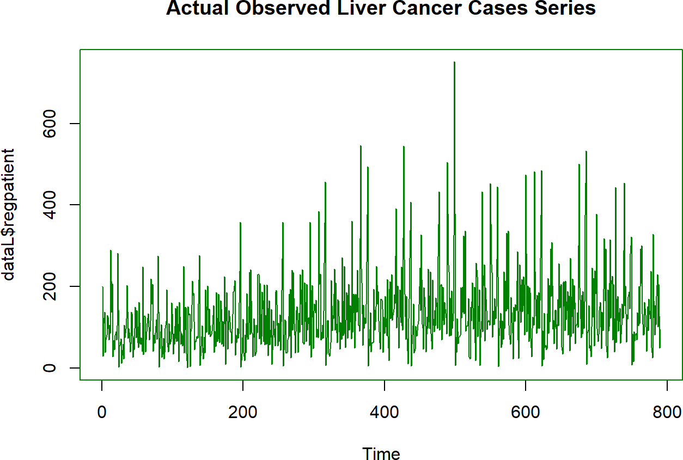

*# cases count by year*

plt <- dataByFY %>%

ggplot(aes(x = fy, y = regpatient)) + geom_line(color = "darkgreen", lwd = 1) + geom_point(color = "orange", lwd = 2) + theme_bw() +

ggtitle("Cancer Liver Cases from 2009 to 2021") + xlab("FY") +

ylab("Case Count") + scale_x_continuous(breaks = 2009:2021)

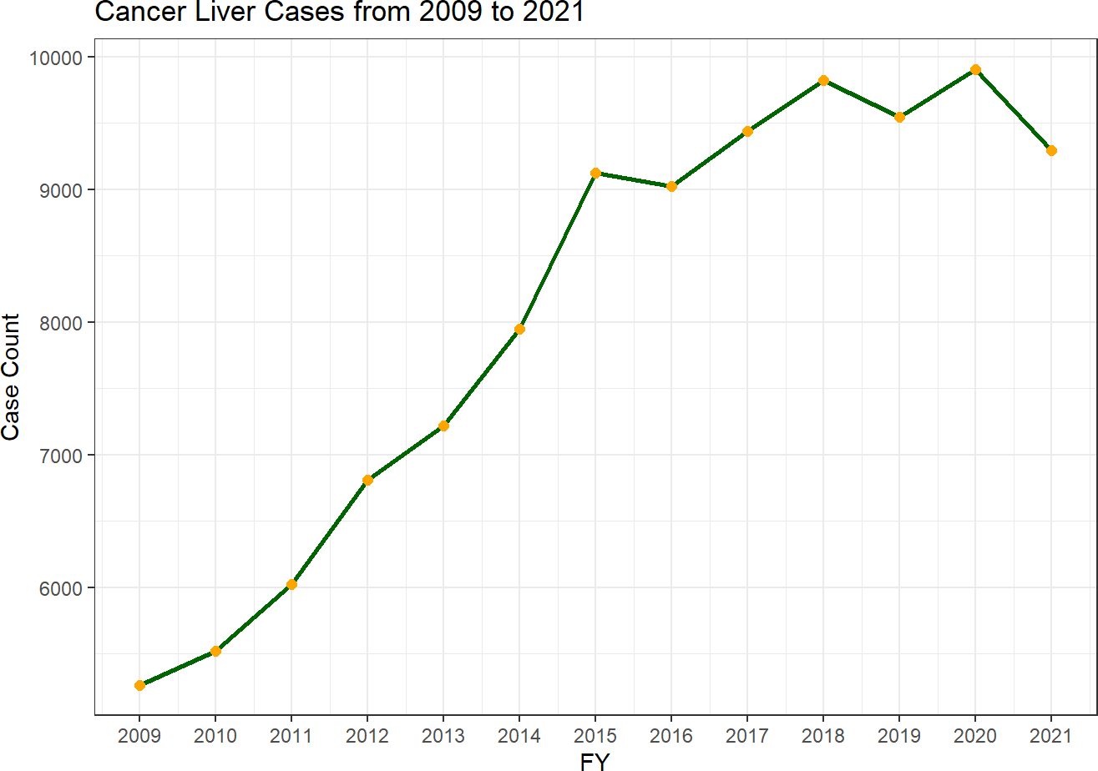

The number of liver cancer cases progressively increased over the years, except there are dips in 2016, 2019, and 2021. The table below shows the overview of the number of cases, average count, and percentage of case changes from year to year:

Liver Cancer Cases Overview

|  |  |  |  |
| --- | --- | --- | --- |
| fy | case_count | avg_count | percent_change |
| 2009 | 5267 | 92.4 | NA |
| 2010 | 5524 | 95.2 | 4.9 |
| 2011 | 6026 | 103.9 | 9.1 |
| 2012 | 6809 | 113.5 | 13.0 |
| 2013 | 7223 | 118.4 | 6.1 |
| 2014 | 7948 | 134.7 | 10.0 |
| 2015 | 9124 | 147.2 | 14.8 |
| 2016 | 9023 | 147.9 | -1.1 |
| 2017 | 9443 | 154.8 | 4.7 |
| 2018 | 9821 | 158.4 | 4.0 |
| 2019 | 9549 | 151.6 | -2.8 |
| 2020 | 9908 | 154.8 | 3.8 |
| 2021 | 9297 | 145.3 | -6.2 |

# Decompose the Data

Using decompose () function from base R to visually examine trends and patterns including seasonality in the data in four individual O, T, S, and R components:

The first graph is the **O**bserved data,

the second is the **T**rend which is the moving average (MA),

the third is **S**easonal signals without the irregular fluctuations involved, and

the last graph is the **R**andom signals those are general fluctuations in the data that cannot be accounted for.

*# convert data into time series object*

dataL.ts <- (ts(dataL$regpatient, start = c(2009, 1), end = c(2021, 12), freq = 12))

*# decompose data*

par(col = "darkgreen")

decomp_add <- decompose(dataL.ts, type = "additive") plot(decomp_add)

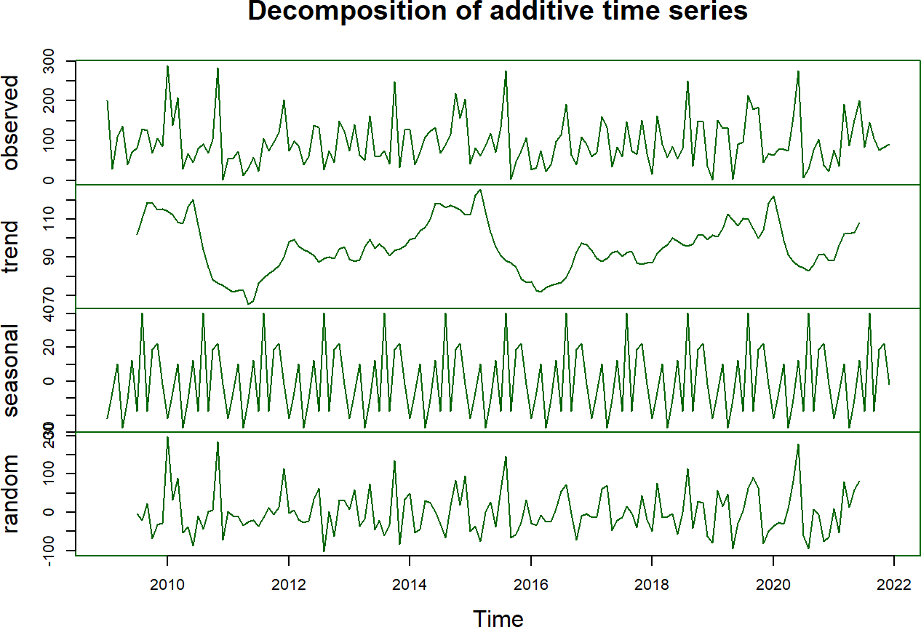

# Check Data for Stationary

Stationarity is an important concept in the field of time series (TS) analysis with tremendous influence on how the data is perceived and predicted. When forecasting or predicting the future, each point is independent of one another in most TS models. The augmented dickey fuller (ADF) test is a common test in statistics and is used to check whether a given TS is stationary or at rest if it doesn’t have any trend and depicts a constant variance over time and follows autocorrelation structure over a period constantly. The more negative magnitude of the ADF number is, the stronger the rejection of the hypothesis that there is a unit root at some level of confidence.

adf.test(dataL.ts)

##

## Augmented Dickey-Fuller Test ##

## data: dataL.ts

## Dickey-Fuller = -5.9906, Lag order = 5, p-value = 0.01 ## alternative hypothesis: stationary

Dickey-Fuller returns negative value confirms that TS is stationary. In addition, the p-value is less than 0.05 is typically considered to be statistically significant, in which case the null hypothesis should be rejected, concluded that this TS is stationary. The data series is ready to be analyzed.

forecast::tsdisplay(dataL.ts, col = "darkgreen")

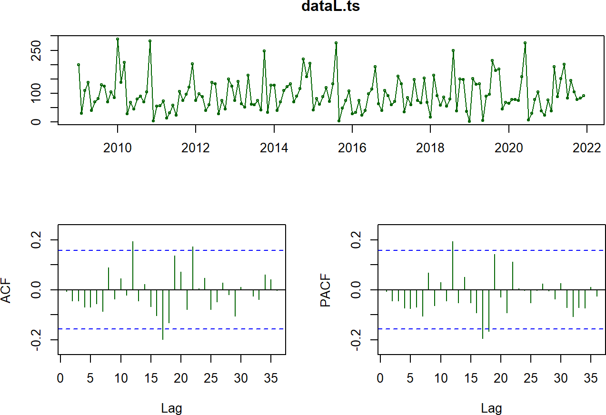

The ACF plots the correlation coefficient against the lag, which is measured in terms of a number of periods or units. The blue dashed lines represent an approximate confidence interval (CI) for what is produced by white noise, by default the lines are displaying the 95 CI. Anything displays above the blue line is notably strong; anything displays below is not distinguishable from zero.

If we have strong peeks that means we definitely have autocorrelation structure in our data. From visual assessment, our time plots do not show trends or seasonality which is considered stationary.

Based on the ACF graph, there are lags at time step 12 and 22, these lags will be addressed later in ARIMA models. The partial autocorrelation function (PACF) confirms that there is a lag at time step 12.

# Partition Time Series Data

Now that it’s confirmed that the data is stationary. The time series data will be evenly split according to time into training from 2009-2015 and validation from 2015-2021. The ‘start’ and ‘end’ arguments specifies the time of the first and the last observation, respectively. The argument ‘frequency’ specifies the number of observations per unit of time. In case it’s 12 months.

*# check for min and max date* min_date <- min(dataL$as.date) max_date <- max(dataL$as.date)

*# Build a time series data*

dataL.ts <- ts(dataL$regpatient, start = c(2009, 1), end = c(2021, 12), freq = 12)

*# dataL.ts*

*# Evenly Split the data series into train and test sets according to time # Both train and valid contain 2015 data*

trainL.ts <- window(dataL.ts, start = c(2009, 1), end = c(2015, 12), freq = 12)

validL.ts <- window(dataL.ts, start = c(2015, 1), end = c(2021, 12), freq = 12)

trainL.ts

|  |  |  |  |  |  |  |  |  |  |  |  |  |
| --- | --- | --- | --- | --- | --- | --- | --- | --- | --- | --- | --- | --- |
| ## | Jan | Feb | Mar | Apr | May | Jun | Jul | Aug | Sep | Oct | Nov | Dec |
| ## | 2009 200 | 29 | 110 | 137 | 39 | 70 | 81 | 130 | 125 | 69 | 105 | 85 |
| ## | 2010 289 | 138 | 207 | 28 | 68 | 45 | 80 | 90 | 69 | 104 | 282 | 2 |
| ## | 2011 54 | 56 | 72 | 12 | 31 | 58 | 23 | 106 | 75 | 96 | 121 | 203 |
| ## | 2012 74 | 98 | 88 | 40 | 59 | 138 | 133 | 27 | 75 | 45 | 149 | 124 |
| ## | 2013 75 | 141 | 63 | 51 | 162 | 61 | 59 | 75 | 41 | 248 | 33 | 128 |
| ## | 2014 127 | 40 | 70 | 109 | 123 | 133 | 69 | 89 | 116 | 219 | 157 | 205 |
| ## | 2015 41 | 81 | 61 | 87 | 119 | 71 | 133 | 275 | 3 | 47 | 74 | 107 |

validL.ts

|  |  |  |  |  |  |  |  |  |  |  |  |  |
| --- | --- | --- | --- | --- | --- | --- | --- | --- | --- | --- | --- | --- |
| ## | Jan | Feb | Mar | Apr | May | Jun | Jul | Aug | Sep | Oct | Nov | Dec |
| ## | 2015 41 | 81 | 61 | 87 | 119 | 71 | 133 | 275 | 3 | 47 | 74 | 107 |
| ## | 2016 27 | 33 | 74 | 23 | 39 | 98 | 115 | 192 | 63 | 40 | 110 | 91 |
| ## | 2017 59 | 71 | 160 | 133 | 34 | 84 | 59 | 147 | 74 | 66 | 152 | 67 |
| ## | 2018 16 | 162 | 91 | 58 | 86 | 55 | 80 | 250 | 37 | 150 | 148 | 36 |
| ## | 2019 1 | 151 | 131 | 133 | 4 | 90 | 96 | 214 | 179 | 184 | 45 | 67 |
| ## | 2020 64 | 78 | 78 | 74 | 158 | 276 | 6 | 29 | 77 | 104 | 38 | 23 |
| ## | 2021 76 | 37 | 192 | 88 | 151 | 201 | 83 | 145 | 105 | 77 | 83 | 91 |

Training data series plot:

*# Plot the train data series:*

plot(trainL.ts, col = "#00B7C7", ylab = "Observed Liver Cancer Cases", main = "Train data seri es from 2009 to 2016")

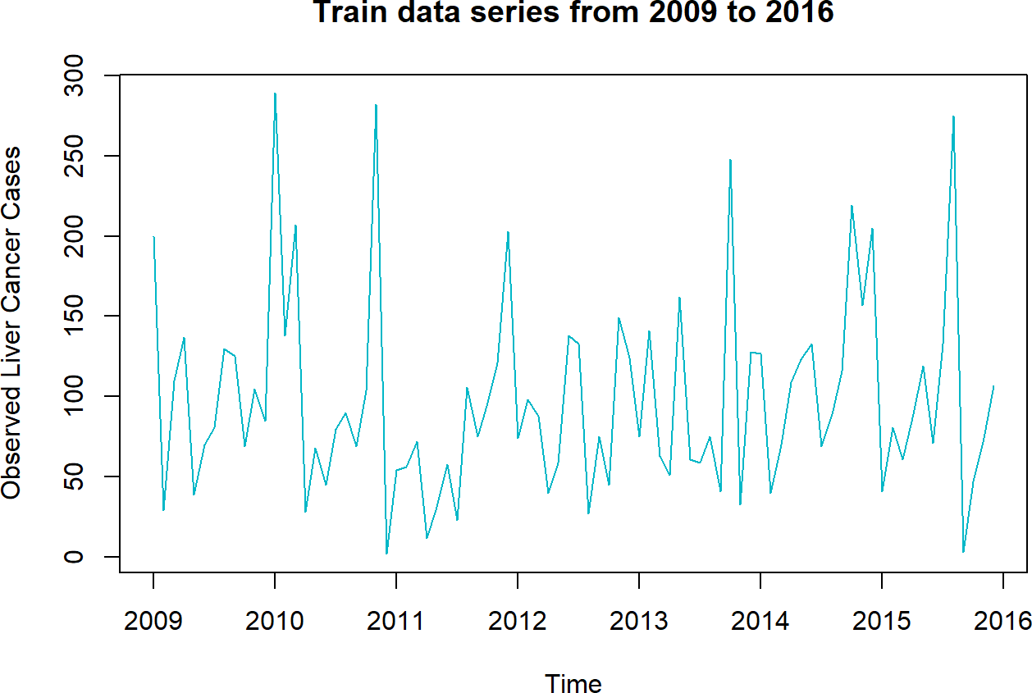

Both training (from 2009-2015) and validation (2015-2021) data series plot:

*# Plot both the train and validation data series*

autoplot(cbind(trainL.ts, validL.ts)) +

ggtitle("Train (2009-2016) and Validation (2017-2021) Data Series") + guides(colour = guide_legend(title = "Data series")) + scale_colour_manual(values = c("#00B7C7", "#dc0ab4"))

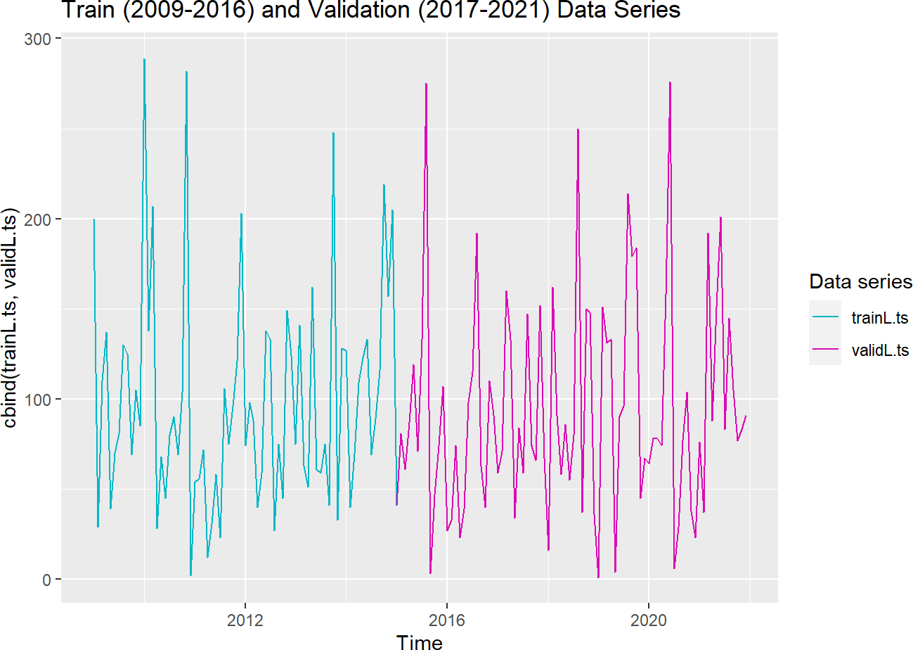

# Create & Evaluate Models

Several models including ARIMA (auto and custom) will be fitted and evaluated.

An autoregressive integrated moving average (ARIMA) is a statistical analysis model that predicts future values based on past values. The default auto.arima() shows non-seasonal and seasonal:

**For nonseasonal= c(p, d, q)** a lowercase p for autoregressive component a lowercase d for differencing component a lowercase q for MA component.

Uppercase P, D, Q are used for seasonal = c(P, D, Q). Max default values for seasonal is c(2,1,2) for **nonseasonal is c(5,2,5)**.

A seasonal pattern occurs when a time series is affected by seasonal factors such as the time of the year or the day of the week. Seasonality is always of a fixed and known frequency. Since there is no seasonal signals or pattern in our data, we will only focus on ARIMA(p,d,q) parameterization in our model selection.

The residuals in ARIMA models tell a story about the performance of the model and should be taken into consideration when evaluating them. The functions such as checkresiduals, ACF and PACF will be used to keep track of the information left behind in the residuals by the model.

Using the **training ts**, iterate through these steps:

* 1. Fit the model
  2. Plot the model
  3. Check for coefficients and error measures in the model using summary()
  4. Check for p-value of the model using checkresiduals()
  5. Forecast the model
  6. Plot the forecast model on the observed ts
  7. Check for lags, examine ACF and PACF using tsdisplay()
  8. select another model

repeat steps a-h.

Initialize the forecast term to 5 years (60 months)

term <- 60

## Model 1 - auto.arima

The first model auto.arima will present us with the best model with the lowest AIC.

*# set seasonal = FALSE since there's no seasonal signals in our data series*

autoarima.Model1 <- auto.arima(trainL.ts, ic = "aic", trace = TRUE, seasonal = FALSE, stepwise

= FALSE)

|  |  |  |  |  |  |  |  |
| --- | --- | --- | --- | --- | --- | --- | --- |
| ## |  | | | | | | |
| ## | ARIMA(0,0,0) |  |  | with | zero mean | : | 1038.405 |
| ## | ARIMA(0,0,0) |  |  | with | non-zero | mean : | 933.8726 |
| ## | ARIMA(0,0,1) |  |  | with | zero mean | : | 1012.902 |
| ## | ARIMA(0,0,1) |  |  | with | non-zero | mean : | 935.7065 |
| ## | ARIMA(0,0,2) |  |  | with | zero mean | : | 997.1395 |
| ## | ARIMA(0,0,2) |  |  | with | non-zero | mean : | 937.6647 |
| ## | ARIMA(0,0,3) |  |  | with | zero mean | : | 991.0892 |
| ## | ARIMA(0,0,3) |  |  | with | non-zero | mean : | 939.0451 |
| ## | ARIMA(0,0,4) |  |  | with | zero mean | : | 988.1105 |
| ## | ARIMA(0,0,4) |  |  | with | non-zero | mean : | 940.1819 |
| ## | ARIMA(0,0,5) |  |  | with | zero mean | : | 984.7808 |
| ## | ARIMA(0,0,5) |  |  | with | non-zero | mean : | 942.1556 |
| ## | ARIMA(1,0,0) |  |  | with | zero mean | : | 983.6068 |
| ## | ARIMA(1,0,0) |  |  | with | non-zero | mean : | 935.6991 |
| ## | ARIMA(1,0,1) |  |  | with | zero mean | : | Inf |
| ## | ARIMA(1,0,1) |  |  | with | non-zero | mean : | 937.6131 |
| ## | ARIMA(1,0,2) |  |  | with | zero mean | : | Inf |
| ## | ARIMA(1,0,2) |  |  | with | non-zero | mean : | 939.5918 |
| ## | ARIMA(1,0,3) |  |  | with | zero mean | : | Inf |
| ## | ARIMA(1,0,3) |  |  | with | non-zero | mean : | 940.2665 |
| ## | ARIMA(1,0,4) |  |  | with | zero mean | : | Inf |
| ## | ARIMA(1,0,4) |  |  | with | non-zero | mean : | 942.1234 |
| ## | ARIMA(2,0,0) |  |  | with | zero mean | : | 966.9016 |
| ## | ARIMA(2,0,0) |  |  | with | non-zero | mean : | 937.6491 |
| ## | ARIMA(2,0,1) | with | zero | mean | : Inf |  |  |
| ## | ARIMA(2,0,1) |  |  | with | non-zero | mean : | 939.5988 |
| ## | ARIMA(2,0,2) |  |  | with | zero mean | : | Inf |
| ## | ARIMA(2,0,2) |  |  | with | non-zero | mean : | Inf |
| ## | ARIMA(2,0,3) |  |  | with | zero mean | : | Inf |
| ## | ARIMA(2,0,3) |  |  | with | non-zero | mean : | 938.3046 |
| ## | ARIMA(3,0,0) |  |  | with | zero mean | : | 963.7751 |
| ## | ARIMA(3,0,0) |  |  | with | non-zero | mean : | 939.2568 |
| ## | ARIMA(3,0,1) |  |  | with | zero mean | : | Inf |
| ## | ARIMA(3,0,1) |  |  | with | non-zero | mean : | 940.2337 |
| ## | ARIMA(3,0,2) | with | zero | mean | : Inf |  |  |
| ## | ARIMA(3,0,2) |  |  | with | non-zero | mean : | Inf |
| ## | ARIMA(4,0,0) |  |  | with | zero mean | : | 963.1107 |
| ## | ARIMA(4,0,0) |  |  | with | non-zero | mean : | 940.2656 |
| ## | ARIMA(4,0,1) |  |  | with | zero mean | : | Inf |

## ## ## ## ## ##

##

ARIMA(4,0,1)

ARIMA(5,0,0)

ARIMA(5,0,0)

with non-zero mean : 941.9804

with zero mean

: 961.5915

with non-zero mean : 942.1781

Best model: ARIMA(0,0,0)

with non-zero mean

plot(trainL.ts, main = "An ARIMA (0,0,0) model") lines(fitted(autoarima.Model1), col = "#dc0ab4", lwd = 2)

legend("topright", c("Observed", "auto ARIMA(0,0,0)"), lty = 8, col = c("darkgreen", "#dc0ab4"

), cex = 0.8)

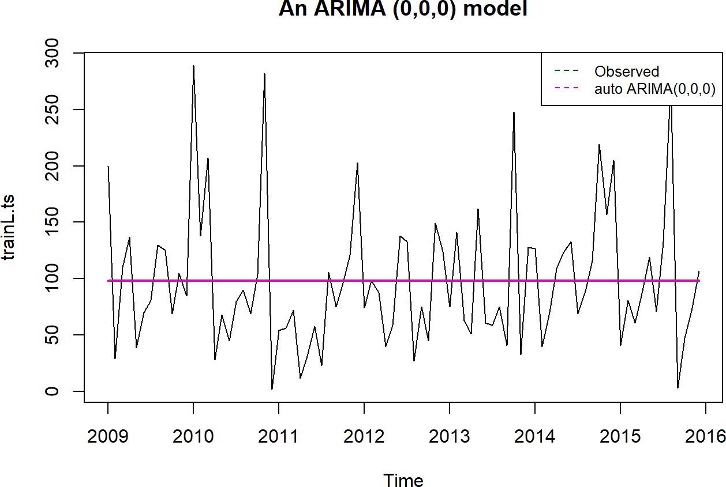

An ARIMA(0,0,0) model is pretty flat.

Examine model 1 residuals

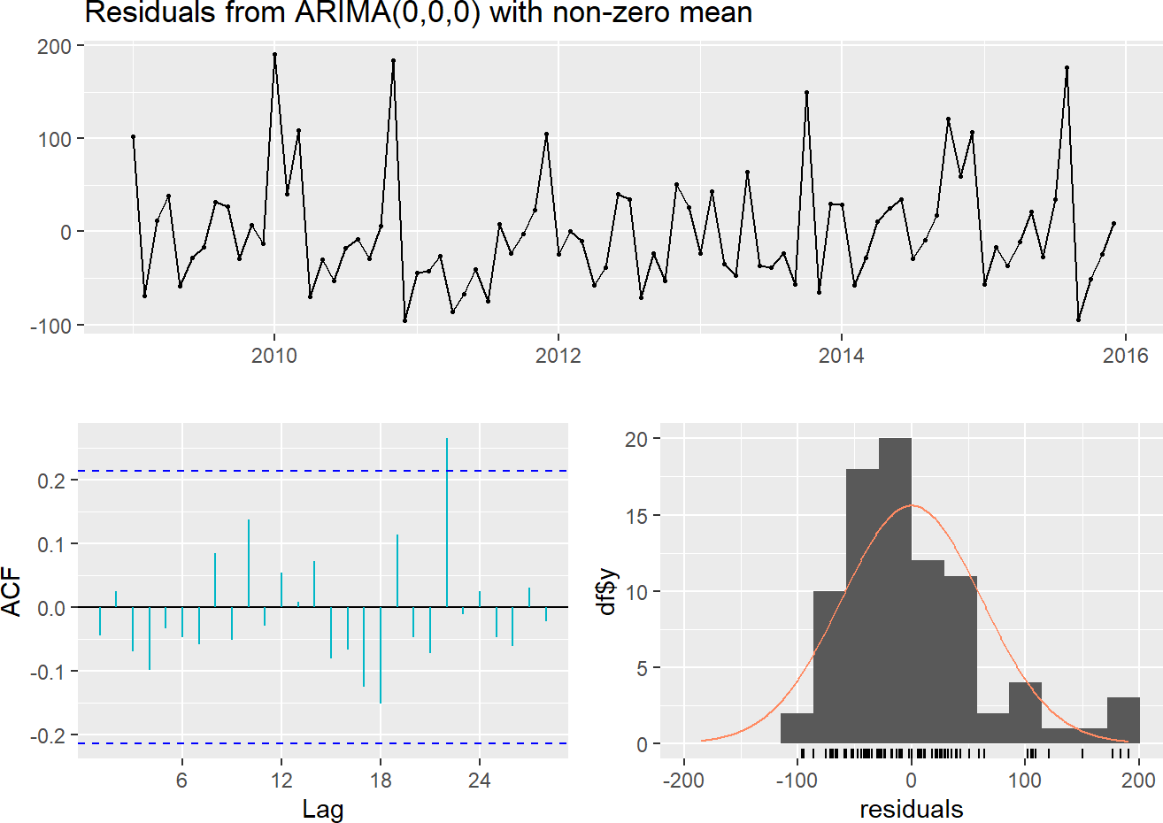

forecast::checkresiduals(autoarima.Model1, col = "#00B7C7")

##

## Ljung-Box test ##

## data: Residuals from ARIMA(0,0,0) with non-zero mean ## Q* = 8.6454, df = 17, p-value = 0.9507

##

## Model df: 0. Total lags used: 17

**Observed graph:** The first graph shows the residuals of the observed data series.\

**ACF plot:** The residuals of our first (auto.arima) model are not that autocorrelated which is good. There’s only one peak, a lag on time step 22, that goes beyond the 95% limits of ACF values. We’ll address the lag on the next model. Note that autocorrelation refers to a problem in data collected repeatedly over time.\

**Residual histogram:** The residuals doesn’t quite follow a normal distribution, it has a couple of bins with very high concentration of cases and other low bins which distort the normal distribution.\

Initialize the forecast term to 60 months (5 years), forecast Model 1, and plot it.

*# h is the forecast horizon value, set it to the defined term; otherwise it defaults to 2 year s forecast.*

autoarima.Model1.Fcast <- forecast(autoarima.Model1, h = term) plot(autoarima.Model1.Fcast, col = "#00B7C7")

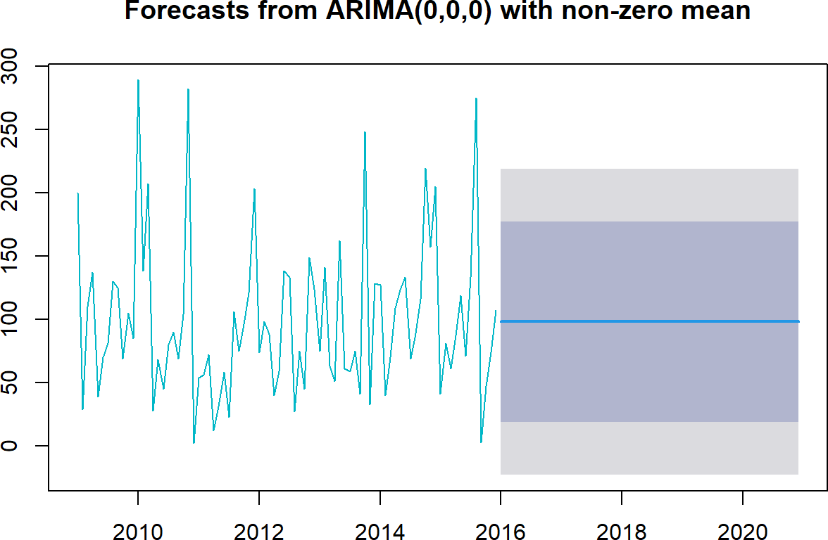

The plot shows observed and forecast data series, the prediction is just a flat line at

fcast.mean <- autoarima.Model1.Fcast$mean[1:1] formattable(fcast.mean, digits = 2, format = "f")

## [1] 98.00

It’s a worthy to note about these two terms:\ fcast$fitted is the result of the fit (the model fitted to observation)\ fcast$mean is the result of the forecast (the application of the model to the future).\

These two terms have a different length for a given h. Check how well Model 1 forecast

*# Check how accurate the forecast is*

autoarima.Model1.Fcast.em <- forecast(autoarima.Model1, h = term) %>% accuracy(validL.ts)

*# Evaluate TS forecast with regression evaluation metrics:*

round(autoarima.Model1.Fcast.em[, c("RMSE", "MAPE")], 2)

##

RMSE MAPE

## Training set 61.31 161.45

## Test set 60.54 301.40

Examine Model 1 coefficients

|  |  |  |  |  |  |  |  |  |
| --- | --- | --- | --- | --- | --- | --- | --- | --- |
| ## | Training | set | error measures: |  | | | | |
| ## |  |  | ME | RMSE | MAE | MPE | MAPE | MASE |

Akaike information criteria (AIC) is a mathematical method for evaluating how well a model fits the data it was generated from.\ AIC shows us how good a model is relative to the other models.\ Root mean square error (RMSE) tells us how many units our model is wrong on average.\ Mean absolute percentage error (MAPE) tells us how wrong our forecasts are percentage-wise.\ The lower the AIC/RMSE the better the model, likewise, the lower the MAPE the more accurate the forecast is. \

## Series: trainL.ts

## ARIMA(0,0,0) with non-zero mean ##

## Coefficients:

## mean

## 98.00

## s.e. 6.69 ##

## sigma^2 = 3805: log likelihood = -464.94

## AIC=933.87

##

AICc=934.02

BIC=938.73

## Training set 1.353617e-14 61.31457 46.92857 -136.1746 161.4497 0.7166187 ## ACF1

## Training set -0.04492774

We’ll keep track of AIC and RMSE and store them in an error measure (em) table for comparison with other models as we progressively fit.

*# Format the coefficient into an integer*

model1.AIC <- formattable(stats::AIC(autoarima.Model1), digits = 1, format = "f")

model1.RMSE <- formattable(autoarima.Model1.Fcast.em[1, c("RMSE")], digits = 1, format = "f")

*# rm(em_results)*

em_results <- tibble(

Method = "Model 1 - auto.arima ARIMA(0,0,0)", AIC = model1.AIC,

RMSE = model1.RMSE

)

em_results %>%

kbl(caption = "Models Performance Table") %>% kable_classic_2(full_width = F, c("striped", "hover"))

Models Performance Table

Method AIC RMSE

Model 1 - auto.arima ARIMA(0,0,0) 933.9 61.3

## Model 2 - ARIMA(0,0,1)

Previously in the ACF plot on figure ** Residuals from ARIMA(0,0,0) ** shows a spike at lag 22 but no other significant spikes; this suggests that the model may better with a different specification, such as p=22 or q=22.

ARIMA can be identified as the order of AR, I, MA terms. An ARIMA model has three component functions: The order of the non-seasonal auto-regressive (AR) terms. If p = NULL, an optimal number of lags will be selected for a linear AR(p) model via AIC. I(d) is the difference in the nonseasonal observations; and MA(q) is the size of the moving average window.

ARIMA (0,0,22) was fitted and evaluated; There was a noticeably huge difference in the RMSE between the two data sets. The model may had been overfitted.

Training set 50.04 and Test set 60.66.   
The model was modified from ARIMA (0,0,22) to ARIMA(0,0,1).

For the second model, we identify AR = 0, I=0, and MA=1 or simply called it an ARIMA model for a first order of MA process. We can repeat the fitting process allowing for the MA(1) component and examine diagnostic and plot.

MA1.model2 <- forecast::Arima(trainL.ts, c(0, 0, 1)) plot(trainL.ts, col = "#00B7C7", main = "Fitted Models") lines(fitted(autoarima.Model1), col = "green", lwd = 2) lines(fitted(MA1.model2), col = "#ffa300", lwd = 2)

legend("topright", c("Observed", "auto ARIMA(0,0,0)", "ARIMA(0,0,1)"), lty = 8, col = c("#00B7 C7", "green", "#FFA300"), cex = 0.8)

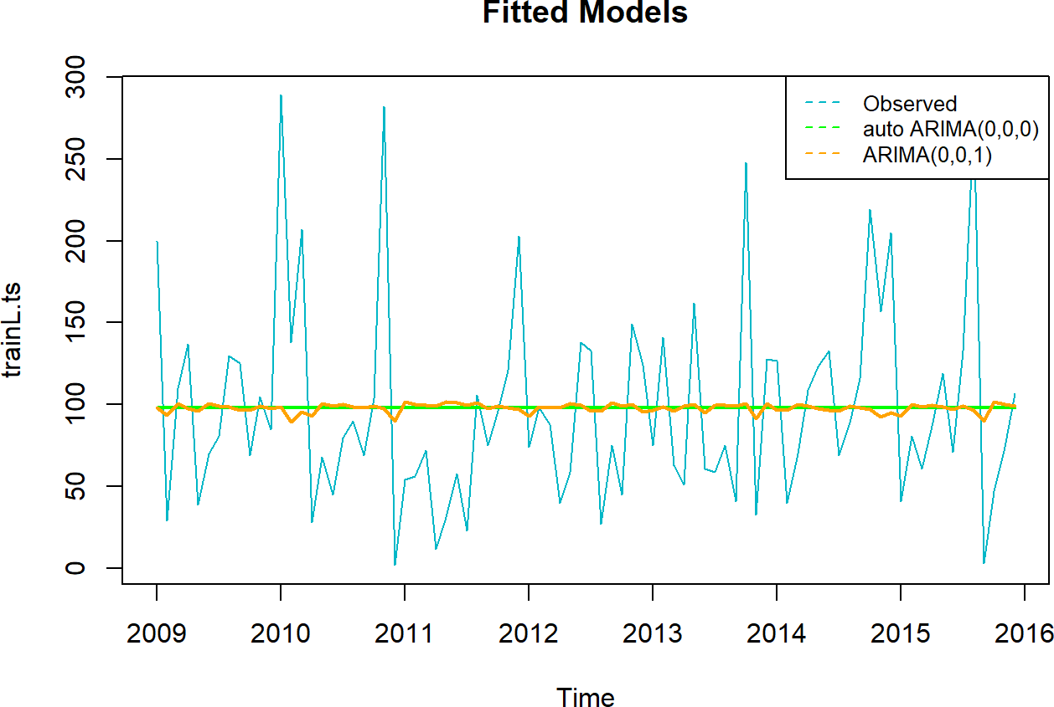

Visually Model 1 and 2 look very similar. Let’s explore how model 2 is fitting.

## Series: trainL.ts

## ARIMA(0,0,1) with non-zero mean ##

## Coefficients:

## ##

## s.e.

##

ma1

-0.0441

0.1083

mean 97.9440

6.3936

## sigma^2 = 3843: log likelihood = -464.85

## AIC=935.71

##

AICc=936.01

BIC=943

## Training set 0.05296268 61.25327 46.99669 -128.2694 153.5474 0.7176589 ## ACF1

## Training set 2.937896e-05

|  |  |  |  |  |  |  |  |  |
| --- | --- | --- | --- | --- | --- | --- | --- | --- |
| ## | Training | set | error measures: |  | | | | |
| ## |  |  | ME | RMSE | MAE | MPE | MAPE | MASE |

Model 2 residuals plots

forecast::checkresiduals(MA1.model2, col = "#00B7C7")

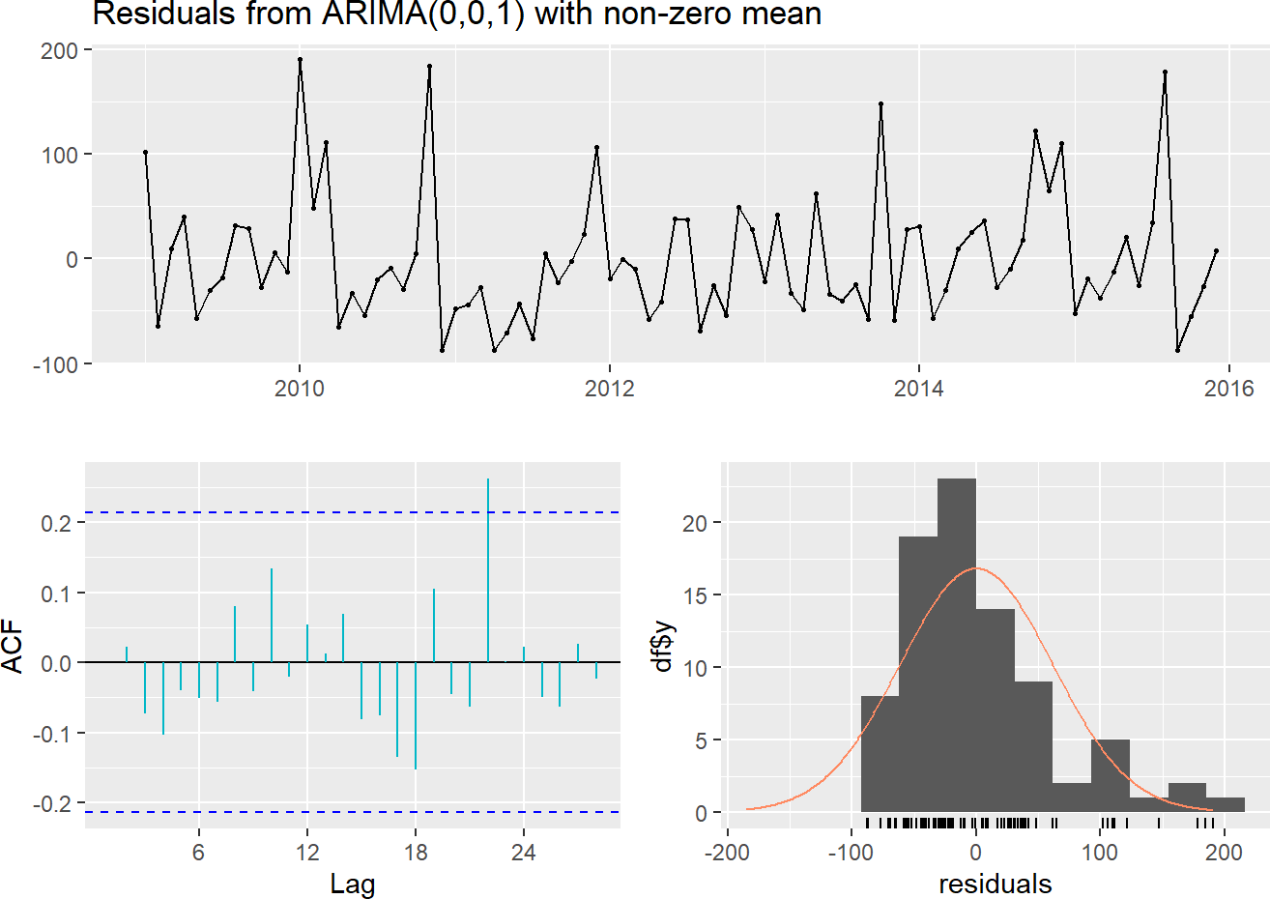

##

## Ljung-Box test ##

## data: Residuals from ARIMA(0,0,1) with non-zero mean ## Q* = 8.7871, df = 16, p-value = 0.9219

##

## Model df: 1. Total lags used: 17

**Observed graph:** The residuals of the observed data. **ACF plot:** There is a spike at time step 22 and everything else seems to be within acceptable range.

**Residual histogram:** The residuals still doesn’t follow a normal distribution, it has a couple of bins with very high concentration of live cancer cases then cascade down to the other lower bins on the right which distort the normal distribution.

Forecast from Model 2

MA1.model2.Fcast <- forecast(MA1.model2, h = term) plot(MA1.model2.Fcast, col = "#00B7C7")

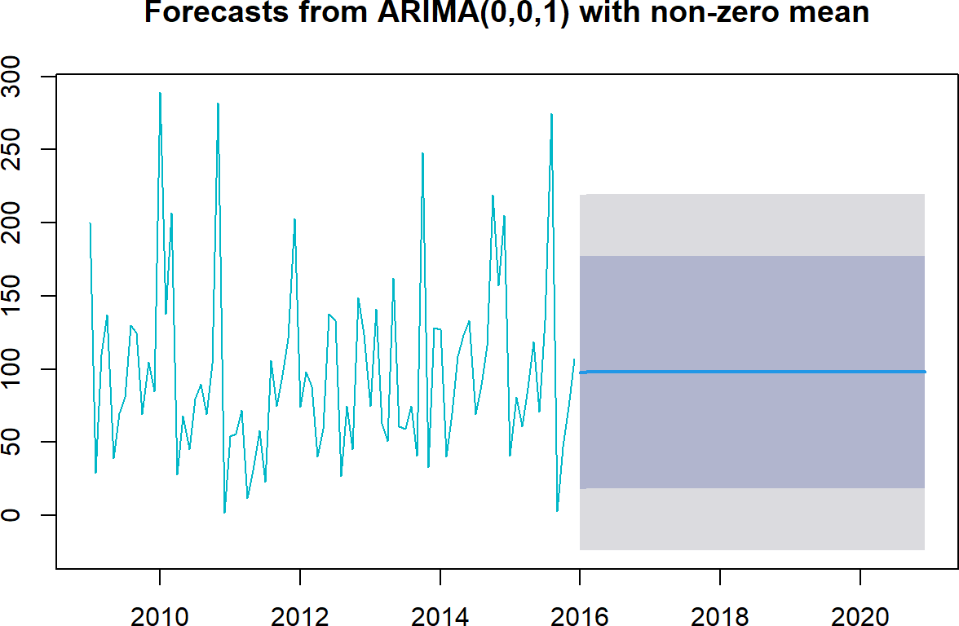

Model 2 forecast shows a flat lined prediction at

## [1] 97.6

Check how well Model 2 forecast

*# Evaluate TS forecast with regression evaluation metrics: # Check how accurate the forecast is*

MA1.model2.Fcast.em <- forecast(MA1.model2, h = term) %>% accuracy(validL.ts)

*# Check TS forecast accuracy with regression evaluation metrics:*

MA1.model2.Fcast.em[, c("RMSE", "MAPE")]

##

RMSE

MAPE

## Training set 61.25327 153.5474

## Test set 60.52440 301.1880

Record our findings.

|  |  |  |
| --- | --- | --- |
| Models Performance Table |  | |
| Method | AIC | RMSE |
| Model 1 - auto.arima ARIMA(0,0,0) | 933.9 | 61.3 |
| Model 2 - ARIMA(0,0,1) | 935.7 | 61.3 |

AIC measures how well the model will fit new data, not the existing data. Lower AIC means that a model should have improved prediction. Frequently adding more variables decreases predictive accuracy and in that case the model with higher RMSE will have a higher (worse) AIC.

The AIC quantifies the goodness of fit and simplicity of the model into a single statistic. When comparing two models, the one with the lower AIC is considered to be better; however, the RMSE is a frequently used measure of the differences between values predicted by a model or an estimator and the values observed. The lower the RMSE the better when calculating the accuracy of predictions of a model. (Tracyenee 2022)

Even though both AIC and RMSE are being tracked, the model with the lowest RMSE will be selected due to the objective of this project, accurate forecasting.

## Model 3 - ARIMA(0,0,0) with Fourier Term

Using an ARIMA model alone does not sufficiently capture the long-term patterns, the Fourier term is introduced into the model.

[Ludlow & Enders (2000, IJF)](https://stats.stackexchange.com/questions/215865/fourier-terms-to-model-seasonality-in-arima-models)

K - every periodic function can be approximated by sums of sin and cos terms for large enough K. The best way to select K is to try a few different values and select the model that gives the lowest AIC values. Choose K to minimize the AIC start with K =1 and slowly increase it until the AICs value stops decreasing.

Check which K term is best for our 4th model

*############################################*

*# Model 3*

*# Approaches to TS data with weak seasonality. ###########################################*

*# Comparing with plots*

plots <- list()

**for** (i **in** seq(4)) { fit <- trainL.ts %>%

auto.arima(xreg = fourier(trainL.ts, K = i), seasonal = FALSE, lambda = "auto")

plots[[i]] <- autoplot(forecast(fit, xreg = fourier(trainL.ts, K = i, h = term))) + xlab(paste("K=", i, " AIC=", round(fit[["aic"]], 2))) +

ylab("") + theme_light()

}

gridExtra::grid.arrange( plots[[1]], plots[[2]],

plots[[3]], plots[[4]], nrow = 2

)

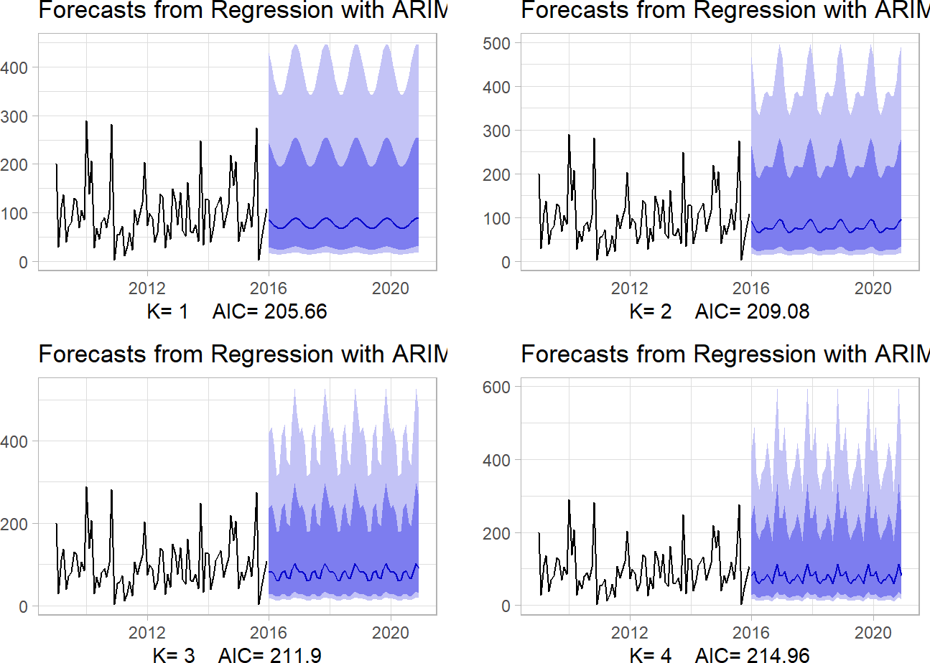has the lowest AIC value. Fit model 3 with K=1 and plot it with the other fitted models.

It seems K=1

*# Modeling with Fourier Regression*

fit.fourier.model3 <- trainL.ts %>%

auto.arima(xreg = fourier(trainL.ts, K = 1), seasonal = FALSE, lambda = "auto")

*# Plot fitted models*

plot(trainL.ts, col = "#00B7C7", main = "Fitted Models") lines(fitted(autoarima.Model1), col = "green", lwd = 2) lines(fitted(MA1.model2), col = "#ffa300", lwd = 2) lines(fitted(fit.fourier.model3), col = "purple", lwd = 2)

legend("topright", c("Observed(train)", "ARIMA(0,0,0)", "ARIMA(0,0,1)", "ARIMA(0,0,0) Fourier w/ K=1"), lty = 8, col = c("#00B7C7", "green", "#FFA300", "purple"), cex = 0.8)

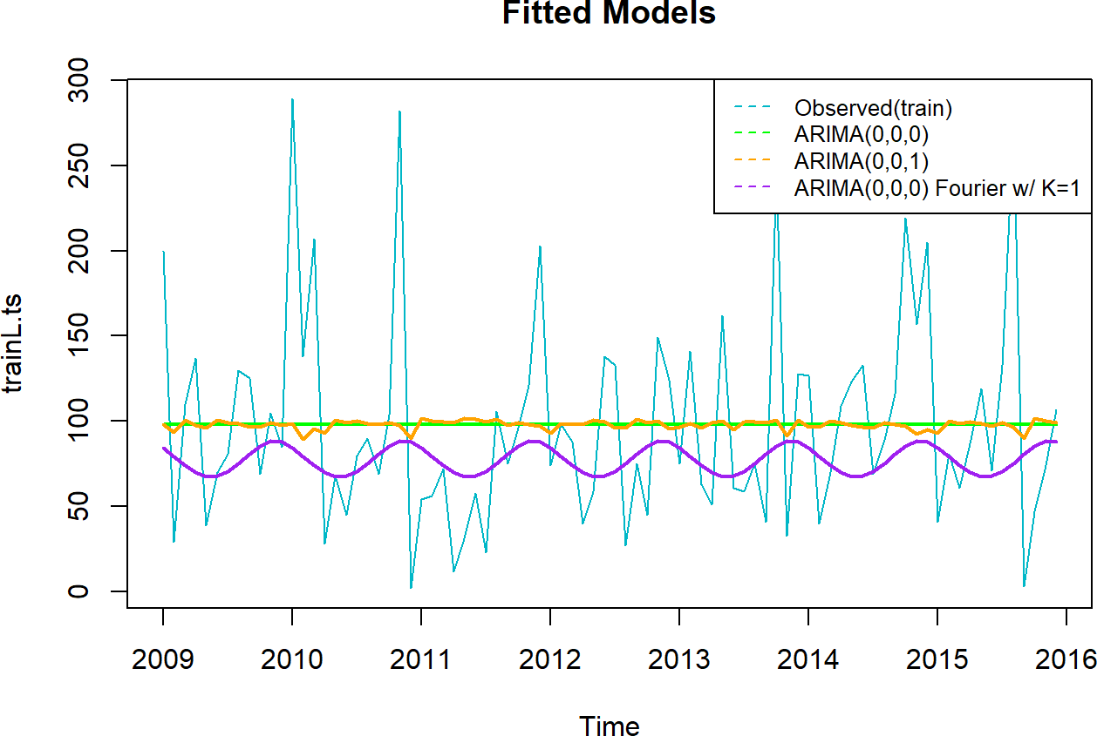

summary(fit.fourier.model3)

## Series: .

## Regression with ARIMA(0,0,0) errors

## Box Cox transformation: lambda= -0.006889242 ##

## Coefficients:

## ##

## s.e.

##

intercept

4.2826

0.0856

S1-12 C1-12

-0.0410 0.1255

0.1211 0.1211

## sigma^2 = 0.6386: log likelihood = -98.83

## AIC=205.66

##

AICc=206.17

BIC=215.38

## Training set error measures:

## ME RMSE MAE MPE MAPE MASE ## Training set 20.38854 63.18001 44.25446 -92.12438 131.2875 0.6757839 ## ACF1

## Training set -0.08790084

Noticeably drop of Model 3 AIC value

forecast::checkresiduals(fit.fourier.model3, col = "#00B7C7")

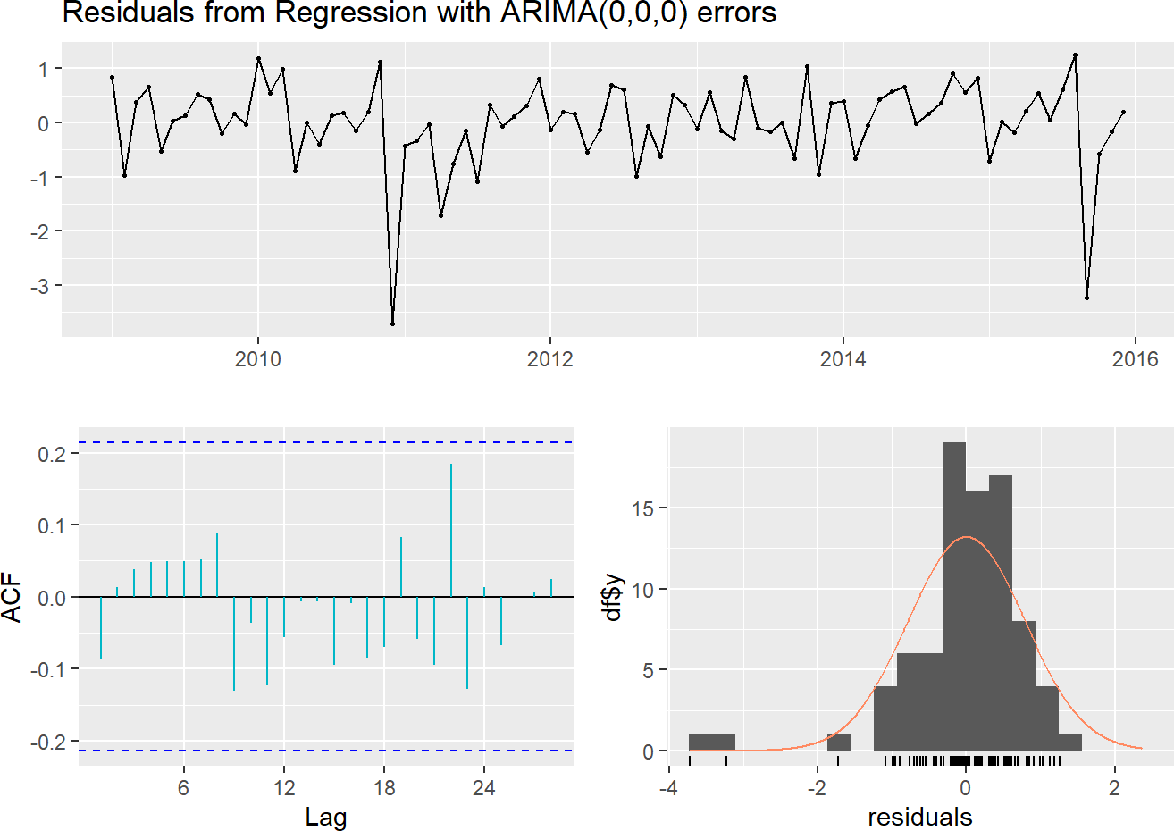

##

## Ljung-Box test ##

## data: Residuals from Regression with ARIMA(0,0,0) errors ## Q* = 7.7345, df = 17, p-value = 0.9719

##

## Model df: 0. Total lags used: 17

**ACF plot:** The residuals of Model 3 seem to be within acceptable range.

**Residual histogram:** The residuals doesn’t quite follow a normal distribution, it has bins with very high concentration of cases then a couple of trail off lower bins on the left which again distort the normal distribution.

Check how well our 3rd fitted model fair between training and test set (Validation).

##

RMSE MAPE

## Training set 63.2 131.3

## Test set 63.0 244.4

The results look very compatible between the two data sets. Plot Model 3 Fourier Regression forecast

*# Plot of the Fourier Regression Model 3 forecast, train.ts fit and valid.ts* fit.fourier.model3.fcast <- forecast(fit.fourier.model3, xreg = fourier(trainL.ts, K = 1, h = term))

autoplot(fit.fourier.model3.fcast) +

theme_light() + ylab("")

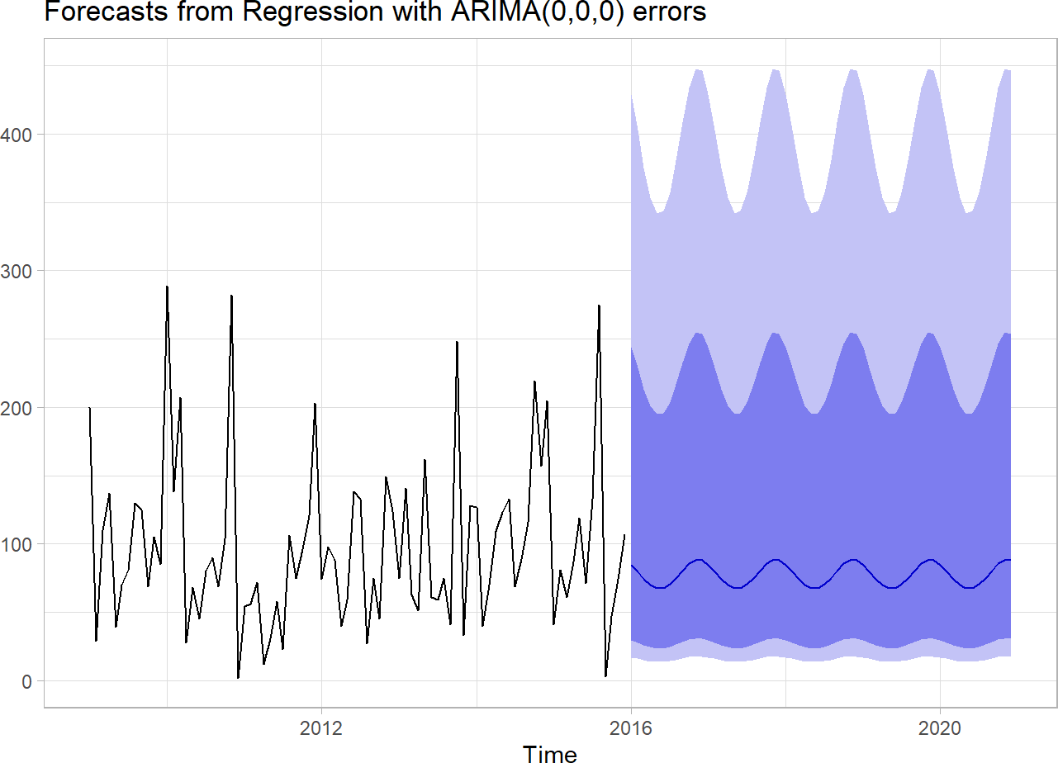

Our data don’t have any trend or seasonality; however this forecast and predicted data (below) seems to tell a different story.

|  |  |  |  |  |  |  |  |  |  |  |  |  |
| --- | --- | --- | --- | --- | --- | --- | --- | --- | --- | --- | --- | --- |
| ## | Jan | Feb | Mar | Apr | May | Jun | Jul | Aug | Sep | Oct | Nov | Dec |
| ## | 2016 84.6 | 79.5 | 74.1 | 69.8 | 67.6 | 67.9 | 70.5 | 75.1 | 80.6 | 85.5 | 88.3 | 87.9 |
| ## | 2017 84.6 | 79.5 | 74.1 | 69.8 | 67.6 | 67.9 | 70.5 | 75.1 | 80.6 | 85.5 | 88.3 | 87.9 |
| ## | 2018 84.6 | 79.5 | 74.1 | 69.8 | 67.6 | 67.9 | 70.5 | 75.1 | 80.6 | 85.5 | 88.3 | 87.9 |
| ## | 2019 84.6 | 79.5 | 74.1 | 69.8 | 67.6 | 67.9 | 70.5 | 75.1 | 80.6 | 85.5 | 88.3 | 87.9 |
| ## | 2020 84.6 | 79.5 | 74.1 | 69.8 | 67.6 | 67.9 | 70.5 | 75.1 | 80.6 | 85.5 | 88.3 | 87.9 |

Record Model 3 performance

|  |  |  |
| --- | --- | --- |
| Models Performance Table |  | |
| Method | AIC | RMSE |
| Model 1 - auto.arima ARIMA(0,0,0) | 933.9 | 61.3 |
| Model 2 - ARIMA(0,0,1) | 935.7 | 61.3 |
| Model 3 - ARIMA(0,0,0) with Fourier K=1 | 205.7 | 63.2 |

Based on AIC value, Model 3 seems to lead.

## Model 4 - ARIMA(0,0,0) with Transformed Data Setting approximation = FALSE makes auto.arima work harder to find the right solution. Box Cox transformations help determine what is the best way to transform your data based on the lambda. Lambda here is used to represent the number that will be used to select the optimal transformation for the data. The optimal transformation of the data is that transformation that makes the data approximate the most to a normal distribution.

These two other methods allow for constants to be added to the model and for more complex models to be considered. Drift: Only available when the differencing is above 0 and allows models with a changing average to be fit.

Mean: Allows models with a non-zero mean to be considered.

By default, R sets them as TRUE, again opting for speed over performance. Setting these parameters to FALSE allows the model to work harder, but watch out for overfitting. (Losada 2020)

fit.arima.trans.model4 <- trainL.ts %>%

auto.arima(stepwise = FALSE, approximation = FALSE, lambda = "auto") fit.arima.trans.model4

## Series: .

## ARIMA(0,0,0) with non-zero mean

## Box Cox transformation: lambda= -0.006889242 ##

## Coefficients:

## mean

## 4.2826

## s.e. 0.0862 ##

## sigma^2 = 0.6321: log likelihood = -99.42 ## AIC=202.84 AICc=202.99 BIC=207.7

As seen above code chunk, stepwise=FALSE, approximation=FALSE parameters are used to amplify the searching for all possible model options. We set lambda parameter to “auto”. It makers the data transformed with lambda= -0.007.

From the results above ARIMAR(0,0,0) which can be denoted as ARIMA(p,d,q) we can see that there is no autoregressive (AR) part of the model, order moving average (MA), or differencing (I).

Based on the AIC, this model seems to fitted better than the previous models.

*# Plot fitted models*

plot(trainL.ts, col = "#00B7C7", main = "Fitted Models") lines(fitted(autoarima.Model1), col = "green", lwd = 2) lines(fitted(MA1.model2), col = "#ffa300", lwd = 2) lines(fitted(fit.fourier.model3), col = "purple", lwd = 2) lines(fitted(fit.arima.trans.model4), col = "blue", lwd = 2)

legend("topright", c("Observed (Train)", "ARIMA(0,0,0)", "ARIMA(0,0,1)", "ARIMA(0,0,0) w/ Four ier K=1", "ARIMA(0,0,0) Transformed"), lty = 8, col = c("darkgreen", "green", "#FFA300", "purp le", "blue"), cex = 0.8)

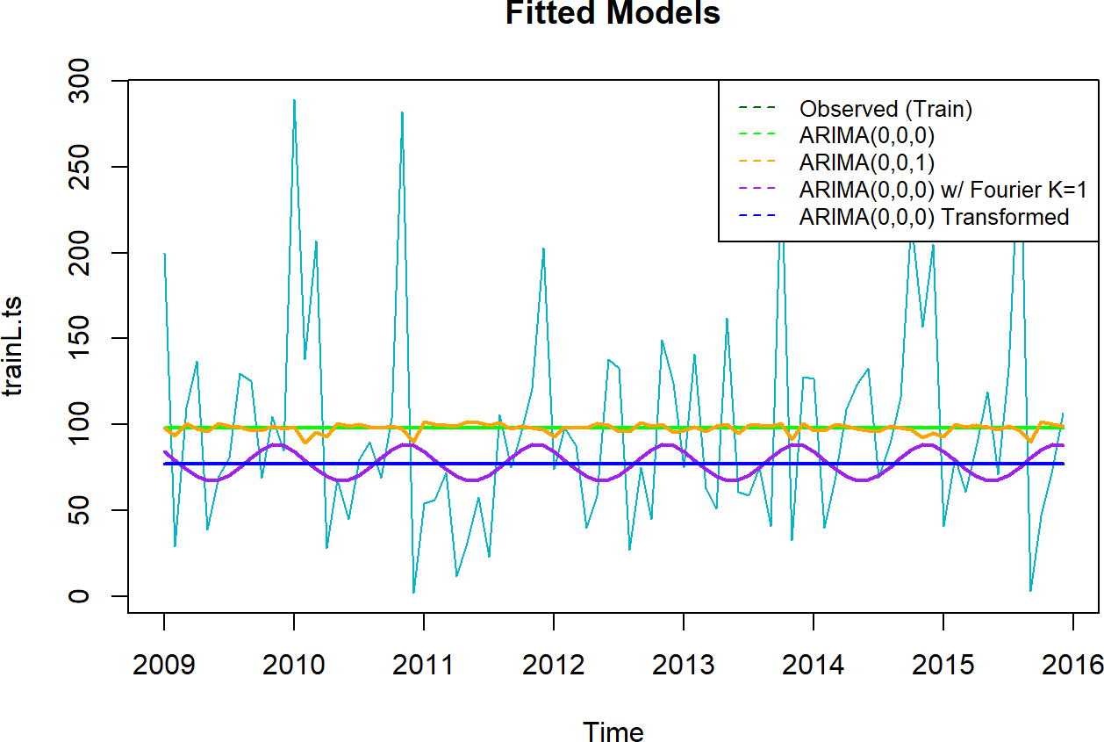

## Series: .

## ARIMA(0,0,0) with non-zero mean

## Box Cox transformation: lambda= -0.006889242 ##

## Coefficients:

## mean

## 4.2826

## s.e. 0.0862 ##

## sigma^2 = 0.6321: log likelihood = -99.42

## AIC=202.84

##

AICc=202.99

BIC=207.7

## Training set error measures:

## ME RMSE MAE MPE MAPE MASE

ACF1

## Training set 20.74885 64.73014 45.41661 -86.171 125.9319 0.6935304 -0.04492774

Look how low the AIC is for Model 4!

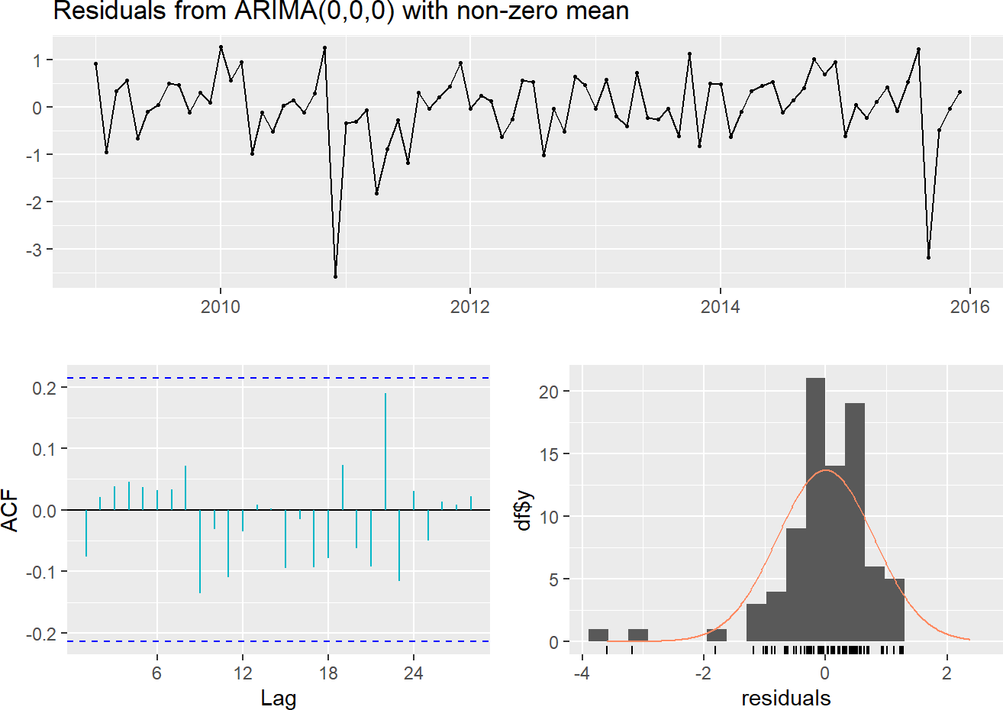

##

## Ljung-Box test ##

## data: Residuals from ARIMA(0,0,0) with non-zero mean ## Q* = 6.7373, df = 17, p-value = 0.9867

##

## Model df: 0. Total lags used: 17

There is no lag indication in the ACF plot and residual histogram has slightly improved compared to previous model 3. Forecast on Model 4

par(mfrow = c(1, 1))

fit.arima.trans.model4.fcast <- forecast(fit.arima.trans.model4, h = term) autoplot(fit.arima.trans.model4.fcast)

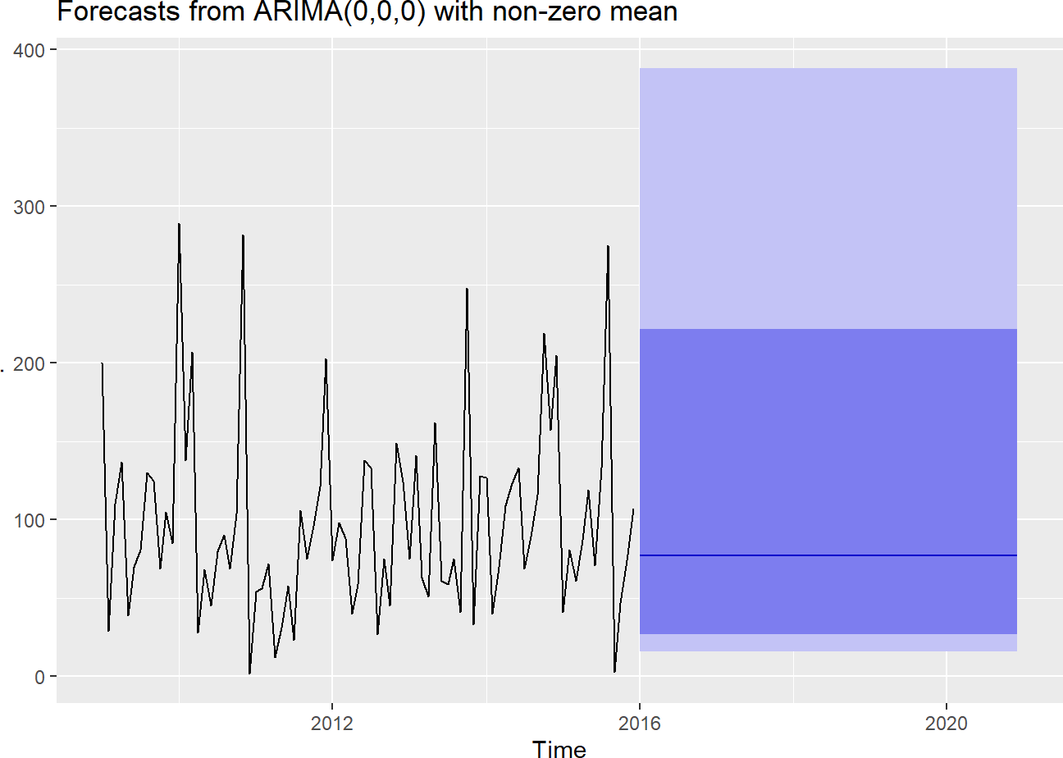

With a non-seasonality, it’s not uncommon to have a flat prediction.

## [1] 77.3

##

RMSE

MAPE

## Training set 64.73014 125.9319

## Test set 61.79506 234.1500

Record Model 4 AIC

|  |  |  |
| --- | --- | --- |
| Models Performance Table |  | |
| Method | AIC | RMSE |
| Model 1 - auto.arima ARIMA(0,0,0) | 933.9 | 61.3 |
| Model 2 - ARIMA(0,0,1) | 935.7 | 61.3 |
| Model 3 - ARIMA(0,0,0) with Fourier K=1 | 205.7 | 63.2 |
| Model 4 - ARIMA(0,0,0) w/ Transformation | 202.8 | 64.7 |

## Model 5 - Single Exponential Smoothing (SES)

Single Exponential Smoothing (SES) is useful for forecasting a series with no trend and no seasonality. SES forecasts future values using a weighted average of all previous values in the series. Advantages of this method is that it’s simple, popular, and adaptive. The key concepts is smoothing constant. This method, which results in a straight, flat-line forecast is best for volatile data with no trend or seasonality. (GreeksforGeeks 2022)  
Start Model 5a with a smaller alpha = 0.01; fit & forecast the model, and examine its coefficients

ses.fit.model5a <- ses(trainL.ts, alpha = 0.01,

h = term

)

ses.fit.model5a.coef <- summary(ses.fit.model5a) ses.fit.model5a.coef$model

## Simple exponential smoothing ##

## Call:

## ## ## ## ## ## ## ## ## ##

##

ses(y = trainL.ts, h = term, alpha = 0.01)

Smoothing parameters: alpha = 0.01

Initial states: l = 98.0139

sigma: 62.3491

AIC

AICc

BIC

## 1068.466 1068.614 1073.328

plot(ses.fit.model5a)

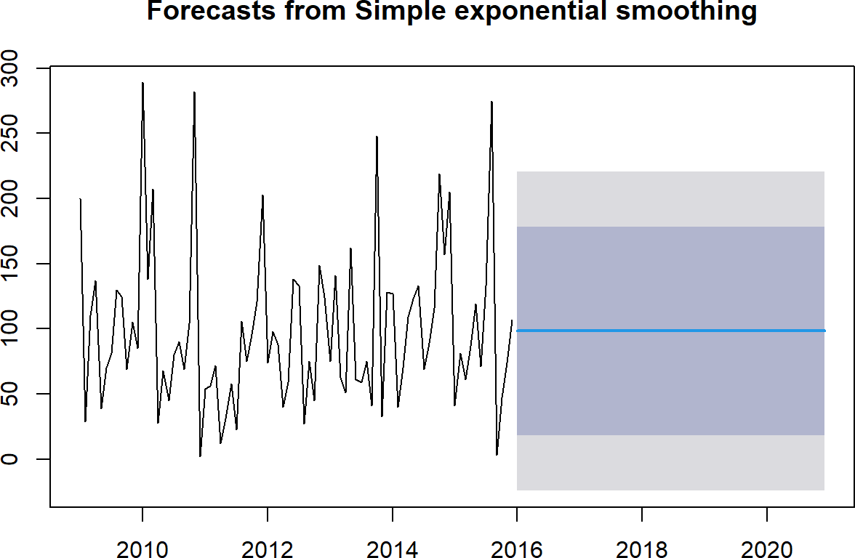

Model 5 flattens at

## [1] 98.3

Model 5 accuracy

##

RMSE MAPE

## Training set 61.6 164.2

## Test set 60.6 302.6

Compare models based on the lowest alpha

alpha <- seq(.01, .99, by = .01)

RMSE <- NA

**for** (i **in** seq_along(alpha)) { fit <- ses(trainL.ts,

alpha = alpha[i],

h = term

)

RMSE[i] <- accuracy(fit, validL.ts)[2, 2]

}

*# convert to a data frame and identify min alpha value*

alpha.fit <- tibble(alpha, RMSE)

*# alpha.fit*

alpha.min <- filter( alpha.fit,

RMSE == min(RMSE)

)

ggplot(alpha.fit, aes(alpha, RMSE)) + geom_line() +

geom_point(

data = alpha.min, aes(alpha, RMSE),

lwd = 2, color = "red"

)

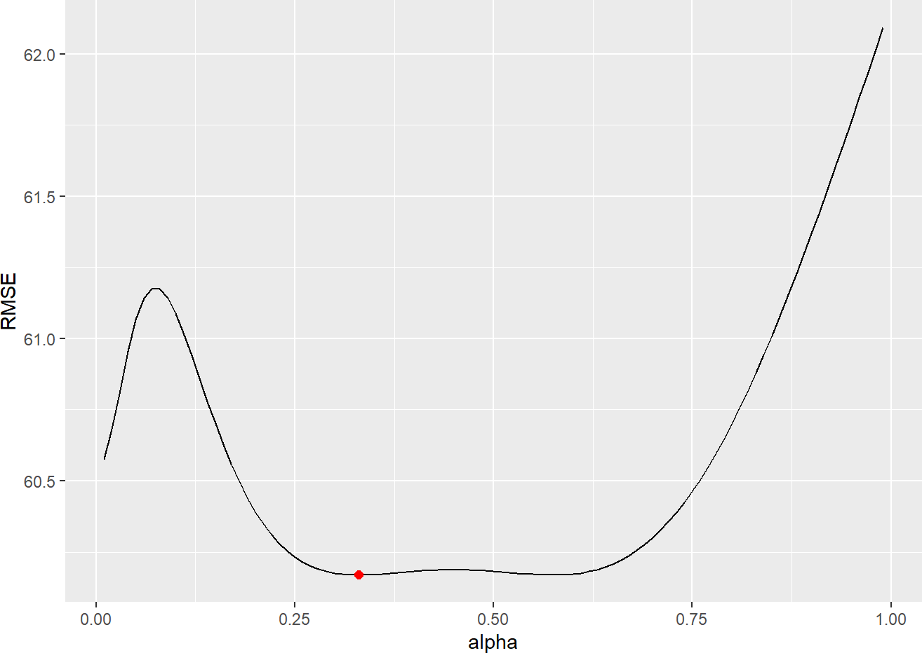

alpha.min

## # A tibble: 1 × 2 ## alpha RMSE

## <dbl> <dbl> ## 1 0.33 60.2

Now, we will try to re-fit our forecast model for SES with alpha = 0.33. We will notice the significant difference between alpha 0.01 and alpha=0.33.

ses.fit.model5b <- ses(trainL.ts, alpha = 0.33,

h = term

)

ses.fit.model5b.coef <- summary(ses.fit.model5b) ses.fit.model5b.coef$model

## Simple exponential smoothing ##

## Call:

## ## ## ## ## ## ## ## ## ##

##

ses(y = trainL.ts, h = term, alpha = 0.33)

Smoothing parameters: alpha = 0.33

Initial states: l = 117.7172

sigma: 68.9569

AIC

AICc

BIC

## 1085.389 1085.538 1090.251

Check model5b forecast accuracy

##

RMSE

MAPE

## Training set 68.13105 221.8442

## Test set 60.16912 279.1185

Based on both AIC and RMSE, ses.fit.model5a does much better than ses.fit.model5b, we’ll keep ses.fit.model5a as Model 5. Plot fitted models

plot(trainL.ts, col = "#00B7C7", main = "Fitted Models") lines(fitted(autoarima.Model1), col = "green", lwd = 2) lines(fitted(MA1.model2), col = "#ffa300", lwd = 2) lines(fitted(fit.fourier.model3), col = "purple", lwd = 2) lines(fitted(fit.arima.trans.model4), col = "blue", lwd = 2) lines(fitted(ses.fit.model5a), col = "red", lwd = 2)

legend("topright", c("Observed (Train)", "1. ARIMA(0,0,0)", "2. ARIMA(0,0,1)", "3. ARIMA(0,0,0

) w/ Fourier K=1", "4. ARIMA(0,0,0) Transformed", "5. SES"), lty = 8, col = c("darkgreen", "gr een", "#FFA300", "purple", "blue", "red"), cex = 0.8)

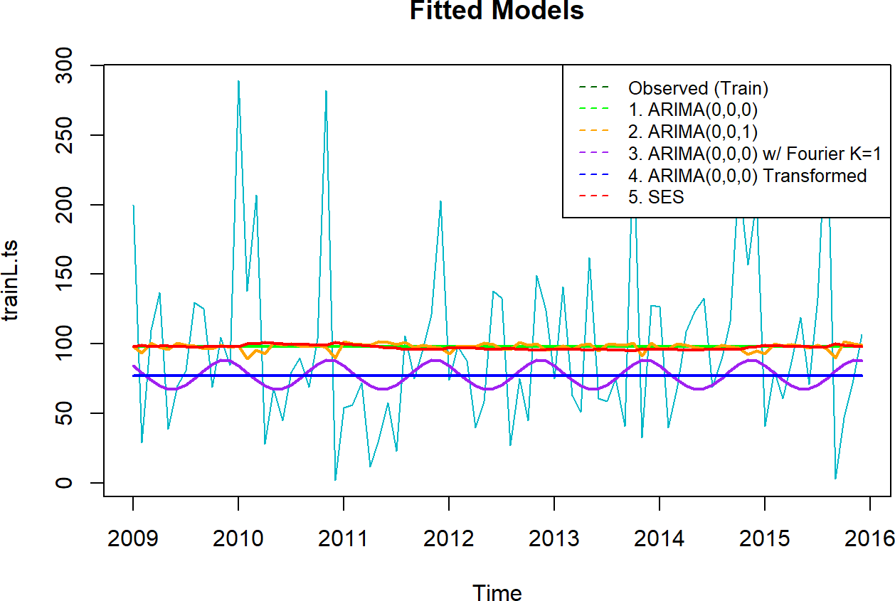

Visually Model 1, 2, and 5 look closely similar.

Model 4 seems to be the average line running through Model 3. Plot model 5 forecast

plot(ses.fit.model5a, col = "#00B7C7")

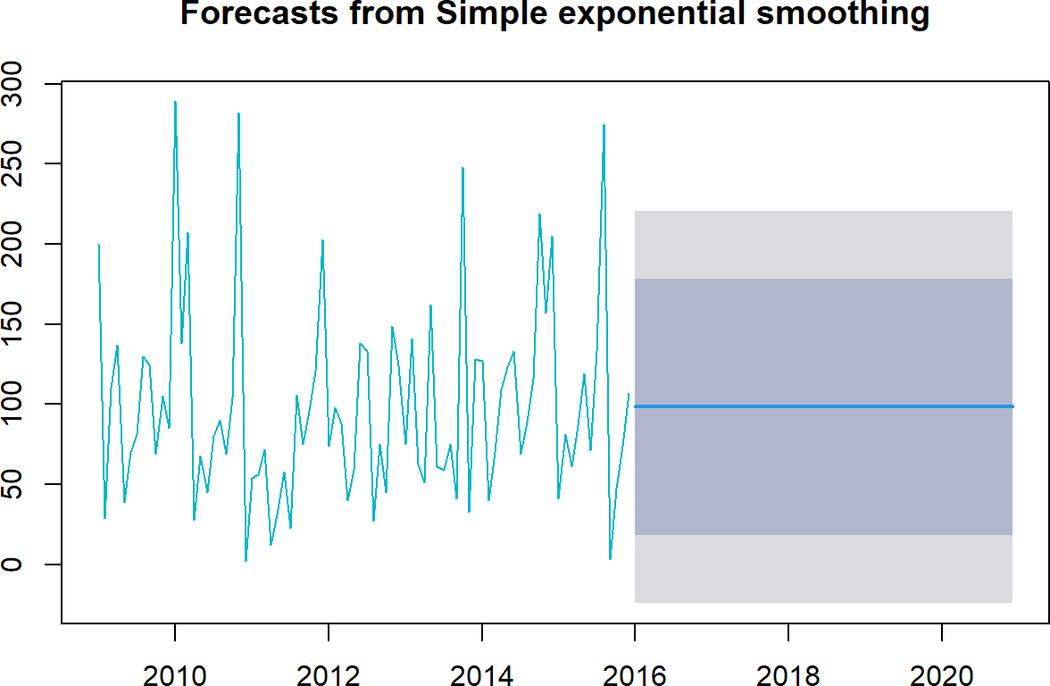

Flat Prediction at

## [1] 98.3

Examine Model 5 AIC

ses.fit.model5a.coef <- summary(ses.fit.model5a) ses.fit.model5a.coef$model

## Simple exponential smoothing ##

## Call:

## ## ## ## ## ## ## ## ## ##

##

ses(y = trainL.ts, h = term, alpha = 0.01)

Smoothing parameters: alpha = 0.01

Initial states: l = 98.0139

sigma: 62.3491

AIC

AICc

BIC

## 1068.466 1068.614 1073.328

Based on the AIC and RMSE, Model5a is better than Model5b. Record model5a’s performance as Model 5’s

Models Performance Table

|  |  |  |
| --- | --- | --- |
| Method | AIC | RMSE |
| Model 1 - auto.arima ARIMA(0,0,0) | 933.9 | 61.3 |
| Model 2 - ARIMA(0,0,1) | 935.7 | 61.3 |
| Model 3 - ARIMA(0,0,0) with Fourier K=1 | 205.7 | 63.2 |

Model 4 - ARIMA(0,0,0) w/ Transformation 202.8 64.7

Model 5 - SES 1073.0 61.6

Notice how high AIC value is for model 5. It might not be a good idea to compare Model5’s AIC with other models. Fitted model5 is based on the ses() function which uses means of data while other models whose coefficients have been estimating using maximum likelihood (ML).

It is also worthy to note that observations are lost with differencing or with lagging; therefore, we should not compare the AIC of an ARIMA model with differencing to one without differencing. (Hyndman 2013)

## Model 6 - Neural Network Auto-Regressive

We will fit one more model, Model 6 - NNEtar: Neural Network Auto-Regressive Time Series Forecast.

NNetar is a feed-forward neural networks with a single hidden layer and lagged inputs for forecasting univariate time series.

Univariate is a term commonly used in statistics to describe a type of data which consists of observations on only a single characteristic or attribute. A simple example of univariate data would be the annual liver caner number. Neural networks work better at predictive analytics because of the hidden layers. Linear regression models use only input and output nodes to make predictions. The neural network also uses the hidden layer to make predictions more accurate.(Warudkar 2020)

nnetar.fit.Model6 <- nnetar(trainL.ts) summary(nnetar.fit.Model6)

|  |  |  |  |  |
| --- | --- | --- | --- | --- |
| ## Length Class | | | | Mode |
| ## | x | 84 | ts | numeric |
| ## | m | 1 | -none- | numeric |
| ## | p | 1 | -none- | numeric |
| ## | P | 1 | -none- | numeric |
| ## | scalex | 2 | -none- | list |
| ## | size | 1 | -none- | numeric |
| ## | subset | 84 | -none- | numeric |
| ## | model | 20 | nnetarmodels | list |
| ## | nnetargs | 0 | -none- | list |
| ## | fitted | 84 | ts | numeric |
| ## | residuals | 84 | ts | numeric |
| ## | lags | 2 | -none- | numeric |
| ## | series | 1 | -none- | character |
| ## | method | 1 | -none- | character |
| ## | call | 2 | -none- | call |

Plot fitted models

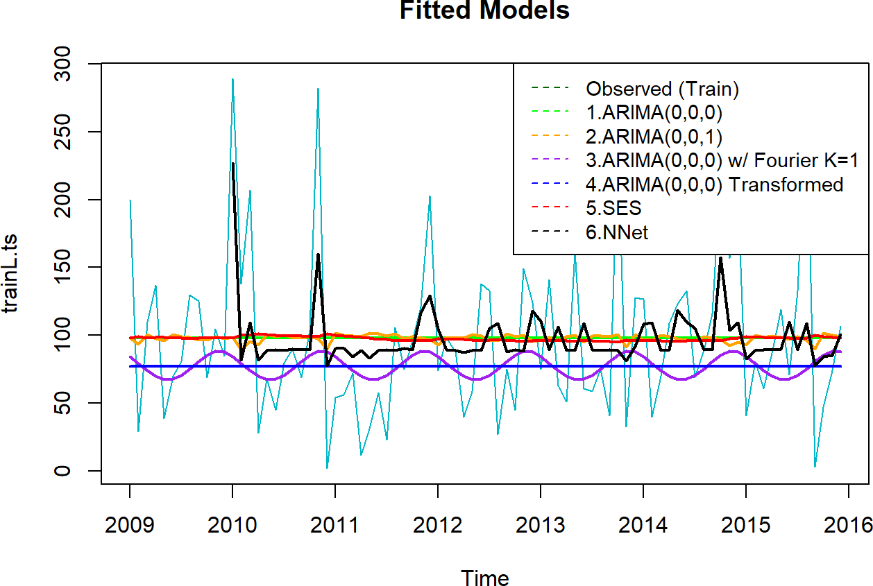

Plot the forecast

plot(forecast(nnetar.fit.Model6, h = term), col = "#00B7c7") points(fitted(nnetar.fit.Model6), type = "l", col = "#FF00CC")

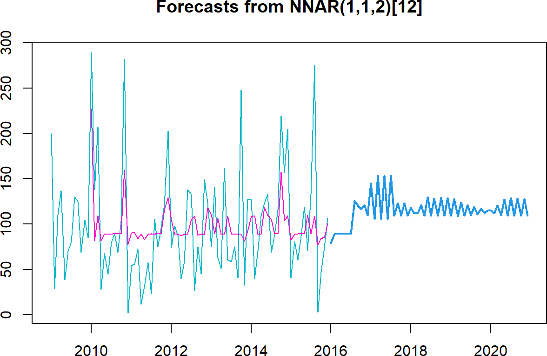

The prediction for model 6 seems to be more volatile than other models; however it also averages out to ~150 cases per month which is very close to the actual average cases.

nnetar.fit.Model6.fcast <- forecast(nnetar.fit.Model6, h = term) round(nnetar.fit.Model6.fcast$mean, 1)

|  |  |  |  |  |  |  |  |  |  |  |  |  |
| --- | --- | --- | --- | --- | --- | --- | --- | --- | --- | --- | --- | --- |
| ## | Jan | Feb | Mar | Apr | May | Jun | Jul | Aug | Sep | Oct | Nov | Dec |
| ## | 2016 79.0 | 89.6 | 89.6 | 89.7 | 89.7 | 89.7 | 89.6 | 125.9 | 120.8 | 116.6 | 121.2 | 110.1 |
| ## | 2017 145.0 | 105.9 | 153.2 | 105.8 | 153.2 | 105.8 | 153.2 | 109.5 | 123.2 | 109.4 | 123.3 | 109.5 |
| ## | 2018 118.0 | 112.0 | 112.3 | 120.9 | 109.5 | 129.8 | 109.4 | 128.2 | 109.2 | 129.1 | 109.2 | 129.0 |
| ## | 2019 109.1 | 128.0 | 109.1 | 124.4 | 109.4 | 120.9 | 110.1 | 119.1 | 110.9 | 117.2 | 112.3 | 114.8 |
| ## | 2020 115.0 | 112.0 | 120.5 | 109.7 | 127.0 | 109.2 | 128.7 | 109.1 | 128.5 | 109.1 | 127.8 | 109.1 |

Model 1 and model 5 forecast are closely similar\ Model 1 averages out at 97.6, \ Model 5 at 98.3, and \ model 6 at ~150\ The higher the forecast the closer it is to the actual data.

Check Model 6 forecast accuracy

nnetar.fit.Model6.fcast.em <- nnetar.fit.Model6 %>% forecast(h = term) %>%

accuracy(validL.ts)

round(nnetar.fit.Model6.fcast.em[, c("RMSE", "MAPE")], 1)

##

RMSE MAPE

## Training set 52.6 146.8

## Test set 64.5 348.5

It seems a huge prediction difference between training and validation data set. Maybe there is an overfitting issue with this model. Record Model 6 performance.

Models Performance Table

|  |  |  |
| --- | --- | --- |
| Method | AIC | RMSE |
| Model 1 - auto.arima ARIMA(0,0,0) | 933.9 | 61.3 |
| Model 2 - ARIMA(0,0,1) | 935.7 | 61.3 |
| Model 3 - ARIMA(0,0,0) with Fourier K=1 | 205.7 | 63.2 |
| Model 4 - ARIMA(0,0,0) w/ Transformation 202.8 64.7 | | |
| Model 5 - SES | 1073.0 | 61.6 |
| Model 6 - nnetar | NA | 52.6 |

Based on the RMSE, model 6 fairs very well compared to other models. We’ll declaring Model 6 the best fitted model.

# Validate the Best Fitted Model

Validate Model 6 against the hold-out-set

nnetar.fit.model.final <- nnetar(validL.ts) summary(nnetar.fit.model.final)

|  |  |  |  |  |
| --- | --- | --- | --- | --- |
| ## Length Class | | | | Mode |
| ## | x | 84 | ts | numeric |
| ## | m | 1 | -none- | numeric |
| ## | p | 1 | -none- | numeric |
| ## | P | 1 | -none- | numeric |
| ## | scalex | 2 | -none- | list |
| ## | size | 1 | -none- | numeric |
| ## | subset | 84 | -none- | numeric |
| ## | model | 20 | nnetarmodels | list |
| ## | nnetargs | 0 | -none- | list |
| ## | fitted | 84 | ts | numeric |
| ## | residuals | 84 | ts | numeric |
| ## | lags | 3 | -none- | numeric |
| ## | series | 1 | -none- | character |
| ## | method | 1 | -none- | character |
| ## | call | 2 | -none- | call |

Plot the best fitted model

*# Plot fitted models*

plot(validL.ts, col = "#FF7f50", main = "Final Fitted Model") lines(fitted(nnetar.fit.model.final), col = "black", lwd = 2)

legend("topright", c("Observed (valid.ts)", "NNetAR"), lty = 8, col = c("#FF7F50", "black"), c ex = 0.9)

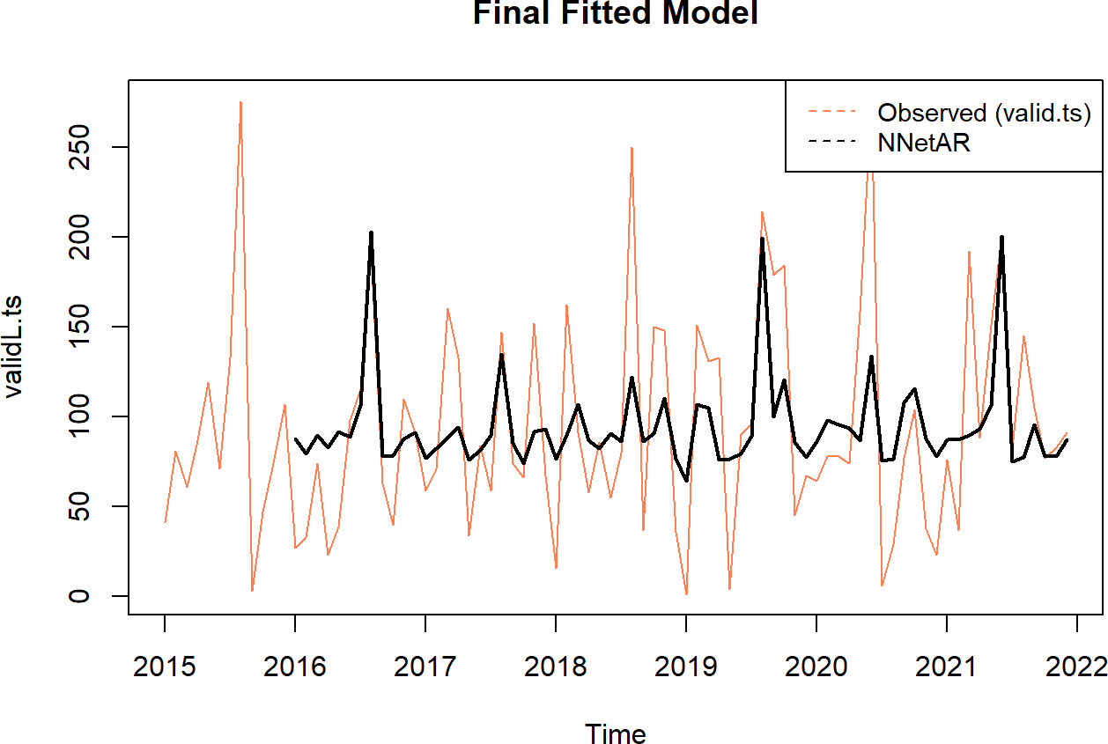

plot(forecast(nnetar.fit.model.final, h = term), col = "#FF7F50")

legend("topright", c("Observed (valid.ts)", "Forecast"), lty = 8, col = c("#FF7F50", "#3399FF"

), cex = 0.9)

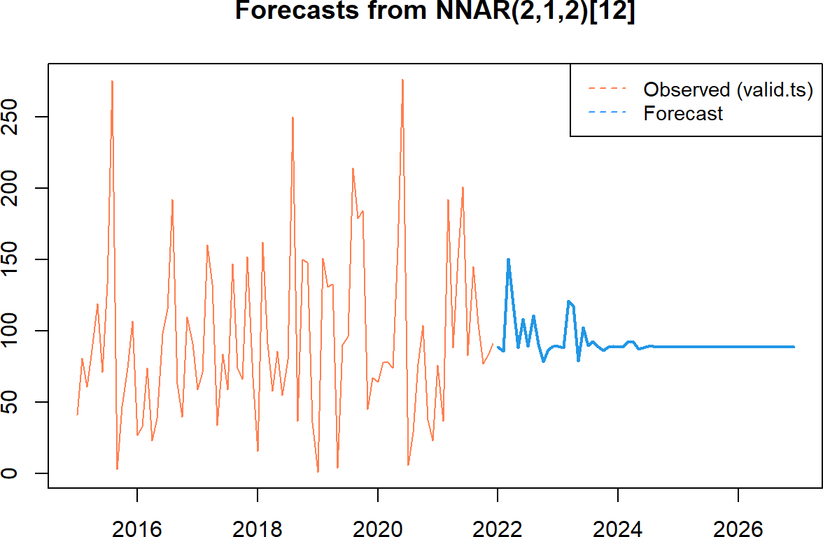

nnetar.fit.model.final.fcast <- forecast(nnetar.fit.model.final, h = term) round(nnetar.fit.model.final.fcast$mean, 1)

|  |  |  |  |  |  |  |  |  |  |  |  |  |  |
| --- | --- | --- | --- | --- | --- | --- | --- | --- | --- | --- | --- | --- | --- |
| ## |  | Jan | Feb | Mar | Apr | May | Jun | Jul | Aug | Sep | Oct | Nov | Dec |
| ## | 2022 | 88.7 | 85.8 | 150.4 | 118.3 | 88.2 | 108.1 | 89.2 | 110.9 | 90.8 | 78.5 | 87.0 | 89.3 |
| ## | 2023 | 89.0 | 88.4 | 121.0 | 117.3 | 78.8 | 102.5 | 89.7 | 92.8 | 88.8 | 86.5 | 88.5 | 89.0 |
| ## | 2024 | 88.8 | 88.6 | 92.4 | 92.3 | 87.1 | 88.0 | 89.0 | 89.0 | 88.7 | 88.5 | 88.7 | 88.8 |
| ## | 2025 | 88.7 | 88.7 | 88.9 | 88.9 | 88.6 | 88.6 | 88.7 | 88.7 | 88.7 | 88.7 | 88.7 | 88.7 |
| ## | 2026 | 88.7 | 88.7 | 88.7 | 88.7 | 88.7 | 88.7 | 88.7 | 88.7 | 88.7 | 88.7 | 88.7 | 88.7 |

The neural networks (Nnetar) time series forecasts show a monthly flux trend in the number of liver cancer cases. On a monthly average the maximum and minimum are:

## [1] 150.4

## [1] 78.5

Average max and min cases per year

Overview of the forecast values

2023 121.0 -19.5 78.8 0.4

fy avg.max pct.max.change avg.min pct.min.change 2022 150.4 NA 78.5 NA

|  |  |  |  |  |
| --- | --- | --- | --- | --- |
| 2024 | 92.4 | -23.6 | 87.1 | 10.5 |
| 2025 | 88.9 | -3.8 | 88.6 | 1.7 |
| 2026 | 88.7 | -0.2 | 88.7 | 0.1 |

The Overview of the Forecast Values table shows the fy, average max, percent max change, average min, and percent min change of the liver cancer cases.

## RMSE MAPE ## 46.3 180.2

The assessment tells us that on an average month, the predictions are off by 4.5 liver cases or around 16%. Our scale is set in thousands.

Record the final model performance and compare.

|  |  |  |
| --- | --- | --- |
| Models Performance Table |  | |
| Method | AIC | RMSE |
| Model 1 - auto.arima ARIMA(0,0,0) | 933.9 | 61.3 |
| Model 2 - ARIMA(0,0,1) | 935.7 | 61.3 |
| Model 3 - ARIMA(0,0,0) with Fourier K=1 | 205.7 | 63.2 |
| Model 4 - ARIMA(0,0,0) w/ Transformation 202.8 64.7 | | |
| Model 5 - SES | 1073.0 | 61.6 |
| Model 6 - nnetar | NA | 52.6 |
| Model6 Final - nnetar | NA | 46.3 |

# Conclusion

Actual Cases 2009-2021 —vs– Forecast Cases 2022-2026

|  |  |  |  |  |  |  |
| --- | --- | --- | --- | --- | --- | --- |
| fy | case_count | avg_count | percent_change |  | | |
| 2009 | 5267 | 92.4 | NA |
| 2010 | 5524 | 95.2 | 4.9 |
| 2011 | 6026 | 103.9 | 9.1 |
| 2012 | 6809 | 113.5 | 13.0 |  | fy avg.max pct.max.change avg.min | pct.min.change |
| 2013 | 7223 | 118.4 | 6.1 |  | 2022 150.4 NA 78.5 | NA |
| 2014 | 7948 | 134.7 | 10.0 |  | 2023 121.0 -19.5 78.8 | 0.4 |
| 2015 | 9124 | 147.2 | 14.8 |  | 2024 92.4 -23.6 87.1 | 10.5 |
| 2016 | 9023 | 147.9 | -1.1 |  | 2025 88.9 -3.8 88.6 | 1.7 |
| 2017 | 9443 | 154.8 | 4.7 |  | 2026 88.7 -0.2 88.7 | 0.1 |
| 2018 | 9821 | 158.4 | 4.0 |  | | |
| 2019 | 9549 | 151.6 | -2.8 |
| 2020 | 9908 | 154.8 | 3.8 |
| 2021 | 9297 | 145.3 | -6.2 |
|  |  |  |  |

Selecting Model 6 NNetar as our final may be a good choice. It is accurately characterized the trend of liver cancer volume.

Examine the Actual Cases 2009-2021 and Forecast Cases 2022-2026 above side by side. Based on the actual **avg_count cases and the percent change** with the forecast **avg.max cases and percent change**, our model prediction is pretty accurate.

On average, from 2009 to 2021 the liver cancer cases gradually increased from 92 to 145 cases; from 2021 to 2022 the cases increase to 159, and from 2023 to 2026, it gradually decreases from 136 to 101 cases.

Fitting ARIMA model is more of an art than a science (weecology 2021). In reality, over two dozen models were fitted but only six are presented in this project.

## Additional Work

We acknowledge that the time frame of this project is a limitation. Specifically, liver cancer data were only available from 2009 to 2021.

Include Box-Cox Transformation in the model fitting process. Box-Cox method helps to address non-normally distributed data by transforming to normalize the data. When the assumption of data normally distributed is violated or the relationship between the dependent and independent variables in case of linear model are not linear, In such situations some transformations methods that may help the data set follow a normal distribution. It’s worthy to note that a value of λ=0 corresponds to the multiplicative decomposition while λ=1 is equivalent to an additive decomposition. You can use a Box-Cox Transformation by setting lambda = 0 because the variance increases with the level of the series.(Dynamic harmonic regression by datacamp).

Clean any outliers using tsclean(), if necessary impute any missing values. Time Series data have a continuity and a dependence and having any missing values will affect your model severely.

Additional data and trend analysis would be helpful including lag.plot,

Perform decompose() to isolate irregular data and seasonal, if there are seasonal signals in the data.

Future work could examine how the time trends could change according to specific demographic subgroups and geographic regions.

## Lesson Learned

The AIC penalizes complex models. A certain penalty for complex models is necessary to avoid overfitting of our statistical models. Overfitting is an undesirable machine learning behavior that occurs when the model gives accurate predictions for training data but not for new data or hold-out-set data. To prevent model overfitting, it’s a good idea to train the model on a known data set before making prediction.

When fitting model ARIMA(1,0,22), we discovered that it’s almost identical to Model 2 ARIMA(0,0,22) based on the AIC.

It may not be a good idea to include Fourier terms if there are not any seasonality in the data. For long term forecasting **seasonality** has to take into account as well as using smoothness and regressing on a few Fourier terms. See illustration by (Scortchi-Reinstate Monica, 2017)

The output of your models is only as good as your input. Adding regressors to an ARIMA model only makes sense if there is some clear correlation between the variables. The auto.arima() function handles regression terms via the xreg argument.

Arima() will fit a regression model with ARIMA errors if the argument xreg is used. The order argument specifies the order of the ARIMA error model. If differencing is specified, then the differencing is applied to all variables in the regression model before the model is estimated. (Hyndman,9.2)

Relative model performance metrics

* 1. Akaike Information Criterion (AIC), shows you how good a model is relative to the other models. AIC penalizes complex models (with more parameters) in favor of simple ones.

AIC calculated formula: \(AIC = 2k - 2Ln (\hat{L})\) Where k is the number of parameters in the model, L-hat is the maximum value of the likelihood function for the model, and ln is the natural logarithm.

* 1. Bayesian Information Criterion (BIC) is an estimate of a function of the posterior probability of a model being true under a certain Bayesian setup. Once again, the lower the value, the better the model.

BIC calculated formula: BIC = kln(n) - 2Ln\((\hat{L})\) Where k is the number of parameters in the model, \(\hat{L}\) is the maximum value of the likelihood function for the model, n is the number of data points (sample size), and ln is the natural logarithm.

both AIC and BIC are relative metrics, so you can’t directly compare models for different datasets. Instead, choose the model with the lowest score.

General regression metrics

1. RMSE — Root Mean Squared Error

RMSE tells you how many units your model is wrong on average. In our airline passengers example, the RMSE will tell you how many passengers you can expect the model to miss in every forecast.

1. MAPE — Mean Absolute Percentage Error

MAPE tells you how wrong your forecasts are percentage-wise. I like it because, in a way, it is equivalent to accuracy metric in classification problems. For example, the MAPE value of 0.02 means your forecasts are 98% accurate. (Dario 2021)

## References

Boateng, Nana, Time Series Analysis Methods, Building Arima Models for Forecasting, https://rstudio-pubs-static.s3.amazonaws.com/303786_f1b99d6b7e9346c4b1488a174bab839a.html.

Brown, Kyle W., Nov 25, 2020, Download CSV from Github with R, https://rpubs.com/kylewbrown/gi thub-csv-r.

Burns Emily, Jan 14, 2021, Data Cleaning in R Made Simple, https://towardsdatascience.com/data-cleaning-in-r-made-simple-1b77303b0b17.

Chen, James, March 18, 2022, What is EMA? How to use Exponential Moving Average with Formula, [https://www.investopedia.com/terms/e/ema.asp.](http://www.investopedia.com/terms/e/ema.asp)

Cheryl, Jan 21, 2020, Handling Skewed data for Machine Learning models, https://reinec.medium.com/my-notes-handling-skewed-data-5984de303725.

cylurian, 2011, *Skewed Histogram (Left Skewed Right Skewed Histogram)*, [https://www.youtube.c](http://www.youtube.c/) om/watch?v=H9ITfdaX2ZQ.

DataCapmp, *Dynamic harmonic regression*, https://campus.datacamp.com/courses/forecasting-in-r

/advanced-methods?ex=4.

DataCamp, fourier: Fourier terms for modelling seasonality, [https://www.rdocumentation.org/packages/forecast/versions/8.12/topics/fourier.](http://www.rdocumentation.org/packages/forecast/versions/8.12/topics/fourier)

Geeksforgeeks, Jun 20, 2022, Exponential Smoothing in R Programming, [https://www.geeksforgeeks.org/exponential-smoothing-in-r-programming/.](http://www.geeksforgeeks.org/exponential-smoothing-in-r-programming/)

Hyndman, Rob J. and Athanasopoulos, George, Forecasting: Principles and Practice (2nd ed), 8.1 Stationarity

and differencing, https://otexts.com/fpp2/stationarity.html.

Hyndman, Rob J., Principles and Practice (2nd ed), 9.2 Regression with ARIMA errors in R, https://otexts.com/fpp2/regarima.html.

Hyndman, Athanasopoulos, Bergmeir et al, Neural Network Time Series Forecasts, https:/

/pkg.robjhyndman.com/forecast/reference/nnetar.html#:~:text=Feed%2Dforward%20neural%20networks

%20with,for%20forecasting%20univariate%20time%20series.

Hyndman, Rob J., Jul 4, 2013, Facts and fallacies of the AIC, https://robjhyndman.com/hyndsig ht/aic/.

International Institute of Forecasters, international journal of forecasting(ijf), https://forecasters.org/ijf/awards/.

Stack Exchange, June 20, 2016, Jeremias K., What selection critieria to use and why? (AIC, RMS E, MAPE) - All possible model

selection for time series forecasting,

https://stats.stackexchange.com/questions/219747/what-selection-criteria-to-use-and-why-aic-rm se-mape-all-possible-model-s#:~:text=They%20have%20the%20drawback%20of,a%20better%20value%20fo r%20RMSE.

Khikmah, Khusnia Nurul, Jan 31, 2022, Simple Moving Average, Task 2 Time Series Analysis Pract icum,

https://rpubs.com/khusniank/SMAADWprac2.

Losada, Luis, Feb 3, 2020, Time Series Analysis with Auto.Arima in R, Regression with ARIMA Errors using Auto Arima,

https://towardsdatascience.com/time-series-analysis-with-auto-arima-in-r-2b220b20e8ab.

Ludlow, Jorge & Enders Walter, September 2000, International Journal of Forecasting, Estimatin g non-linear ARMA

models using Fourier [coefficients,https://www.sciencedirect.com/science/article/abs/pii/S01692](http://www.sciencedirect.com/science/article/abs/pii/S01692) 07000000480.

Mithcell, Cory, Nov 17, 2021, Displace Moving Average (DMA): What it is, How Traders Use it, [https://www.investopedia.com/terms/d/displacedmovingaverage.asp.](http://www.investopedia.com/terms/d/displacedmovingaverage.asp)

National Cancer Institute (NCI), Sept 1, 2021, Cancer Health Disparities Research, [https://www.cancer.gov/research/areas/disparities.](http://www.cancer.gov/research/areas/disparities)

The Office of Cancer Centers (OCC), NCI, 2023, Data Table 3, https://cancercenters.cancer.gov/ DT/DT3.

NIST, April, 2012, Engineering Statistics Handbook, [https://www.itl.nist.gov/div898/handbook/eda/section3/eda33f.htm.](http://www.itl.nist.gov/div898/handbook/eda/section3/eda33f.htm)

National Library of Medicine, National Center for Biotechnology Information (NCBI), Aug 19, 20 19, Forecasting annual incidence and mortality rate for prostate cancer in Australia until 2022 using autoregressive integrated moving average (ARIMA) models, [https://www.ncbi.nlm.nih.gov/pmc/arti](http://www.ncbi.nlm.nih.gov/pmc/arti) cles/PMC6707661/.

Radecic, Dario, Jul 26, 2021, Time Series From Scratch — Train/Test Splits and Evaluation Metr ics,

https://towardsdatascience.com/time-series-from-scratch-train-test-splits-and-evaluation-metri cs-4fd654de1b37.

Rasheed, Rayhann, July 11, 2020, Why Does Stationarity Matter in Time Series Analysis?, https://towardsdatascience.com/why-does-stationarity-matter-in-time-series-analysis-e2fb7be744 54.

SelcukDisci, Oct 24, 2020, Approaches to Time Series Data with Weak Seasonality, [https://www.datasciencecentral.com/approaches-to-time-series-data-with-weak-seasonality/.](http://www.datasciencecentral.com/approaches-to-time-series-data-with-weak-seasonality/)

Singh, Deepika, July 12, 2019, Time Series Forecasting Using R, [https://www.pluralsight.com/guides/time-series-forecasting-using-r.](http://www.pluralsight.com/guides/time-series-forecasting-using-r)

Stack Exchange, June 10, 2019, How to read checkresiduals graphics in R? https://stats.stackexchange.com/questions/386875/how-to-read-checkresiduals-graphics-in-r.

Stack Exchange, 2017, Scortchi-Reinstate Monica, Seasonality not taken account of in auto.arim a(),

https://stats.stackexchange.com/questions/213201/seasonality-not-taken-account-of-in-auto-arim a).

Tech Know How, 2020, *Stock Price Forecasting - Part 1- Loading the Data and Preparing it!*, [https://www.youtube.com/watch?v=P-I0ljQpRCI.](http://www.youtube.com/watch?v=P-I0ljQpRCI)

Tracyrenee, Aug 1, 2022, AIC vs RMSE When Gridsearching SARIMAX Hyperparemeters, https://python.plainenglish.io/aic-vs-rmsc-when-gridsearching-sarimax-hyperparemeters-e1c8d5c4 0578.

Warudkar, Hemant, Feb 27, 2020, Prediction using Neural Networks, [https://www.expressanalytics.com/blog/neural-networks-prediction/.](http://www.expressanalytics.com/blog/neural-networks-prediction/)

weecology, 2021,*Introduction to Time Series [Decomposition*,https://www.youtube.com/watch?v=D4](http://www.youtube.com/watch?v=D4) 5ddUVcEfY.

weecology, 2021, *Modeling seasonal signals in ARIMA models*, [https://www.youtube.com/watch?v=](http://www.youtube.com/watch?v) m6fplOpo4qs.

weecology, 2021, *Using auto.arima() in r*, [https://www.youtube.com/watch?v=JUIoMc0isdI](http://www.youtube.com/watch?v=JUIoMc0isdI)

zhou, Nai Biao, March 11, 2021, Exploring Four Simple Time Series Forecasting Methods with R E xamples,

[https://www.mssqltips.com/sqlservertip/6778/time-series-forecasting-methods-with-r-examples/.](http://www.mssqltips.com/sqlservertip/6778/time-series-forecasting-methods-with-r-examples/)

Zach, May 25, 2021, Augmented Dickey-Fuller Test in R (With Example), [https://www.statology.org/dickey-fuller-test-in-r/.](http://www.statology.org/dickey-fuller-test-in-r/)