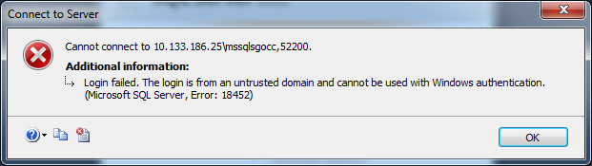

Snapshot of database login:

NCIDB-D111.nci.nih.gov\MSSQLSGOCC,52200

Ensure that ncidb-d111.nci.nih.gov maps to 10.133.186.25

And that when you ping ncidb-d111.nci.nih.gov it’s lived.

