8/29/2023 at 9:30am

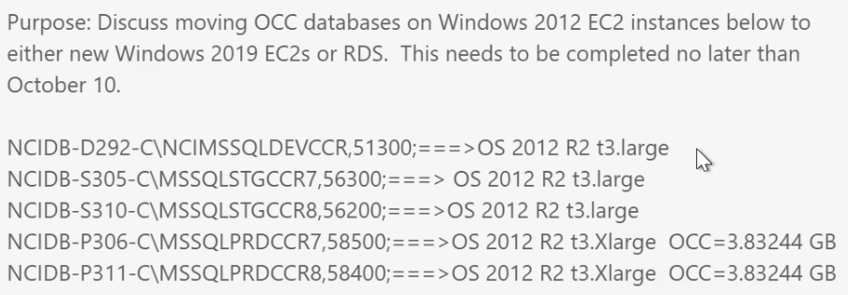

David Keller   
Loubna Ahiri   
- Roha Seyoum   
Two **EC2** - HA  
using enterprise license

Stand alone   
back up every 15 min

Amazon **RDS** – access   
Fully managed by AWS.   
**Pro:**   
**Cons:**

Roha -   
  
ECS – smaller size and scale UP later.

Managed Rel DB – Amazon RDS pricing: <https://aws.amazon.com/rds/pricing/>

AWS Pricing Calculator: <https://calculator.aws/#/addService/ec2-enhancement>

8/29/2023

Per your request, here is an update on the OCC Database, its current size, data sources, and how the data is being utilized across various platforms. We hope this will help you in making informed decisions regarding the most suitable architecture services for our needs.

Currently, the OCC Database is approximately 2,727 MB of data. Our data is derived from various sources including the 72 NCI-designated cancer centers, through egrants (<https://egrants.nci.nih.gov/>).

|  |  |  |
| --- | --- | --- |
| **OCC Data are being used on Platforms** | **Desc** | **User/acct** |
| <https://cancercenters.cancer.gov/Center/CCList> <https://cancercenters.cancer.gov/Center/RP> <https://cancercenters.cancer.gov/Center/SharedResource> <https://cancercenters.cancer.gov/Center/COE> <https://cancercenters.cancer.gov/Center/ET> <https://cancercenters.cancer.gov/DT/DT1>  <https://cancercenters.cancer.gov/DT/DT2>  <https://cancercenters.cancer.gov/DT/DT3>  https://cancercenters.cancer.gov/DT/DT4 | These are the data-driven pages on our public facing site.   Any changed made to the views within the OCC database will automatically propagate onto these pages. | OCCreadonly  Read only access |
| PowerBI App | NCI-OCC-SA serves as the bridge between PowerBI and OCCdb | NCI-OCC-SA |
| <https://nih.sharepoint.com/sites/NCI-OCConnect>,  <https://nih.sharepoint.com/sites/NCI-TeamOCC-IT>,  https://nih.sharepoint.com/sites/NCI-TeamOCC | These 3 sites display information including OCC Staff Emergency POC, Staff Assignments, P30Partners, and more. | Multi-Factor Authentication (MFA) |

Detailed cost estimates for the DB, Compute, and Storage services across the three tiers have been pointed by Krish Seshadri. You can access the estimates here: <https://calculator.aws/#/estimate>.

These services encompass 3 AWS Fargate instances, 3 Amazon RDS for MariaDB instances, 3 Elastic Load Balancing instances, and 1 standard Amazon Simple Storage Service (S3) instance dedicated to production.

Please feel free to reach out for any questions.

Best regards,

Chi