Calculating xyz calculation for a given Kepler’s orbital elements

To accurately calculate the position of an orbiting body in a given Keplerian elliptical orbit at any given time, *T*, one needs six parameters (3 position and 3 velocity components). I.e., if you know a object’s position and velocity at a given time (i.e., total 6 parameters) for a given force field, you can accurately calculate its past or future position and motion. A commonly used set of six parameters in astronomy is Kepler’s six orbital elements.

### Orbital Elements

* A diagram of an area of an area

  Description automatically generated with medium confidencesemi-major axis (a): determines the size of an orbit. For a given mass of the central object (e.g., Sun), a is directly related to an orbital period (P) through Kepler's 3rd law.
* eccentricity (e): shape of the ellipse. In an elliptical orbit, Sun is located at one of two foci.
* inclination (i): the tilt angle of the orbital plane with respect to observer's line of sight.
* longitude of the ascending node (Ω): In an inclined orbit (i.e., non-zero i), there are two points where a planetary orbit crosses the plane of reference. We choose one of these points as Ω where a planet moves from below the reference planet to above the plane.
* argument of periapsis (ω): determines the orientation of the ellipse in the orbital plane. From the focus where the Sun is located at, the direction toward the periapsis can be anywhere on the plane. An angle measured from the ascending node to the periapsis can fix the orientation of the ellipse.
* true anomaly (ν): the position of the planet measured in angle from the periapsis for a given time (or epoch).

### Calculation of XYZ and UVW

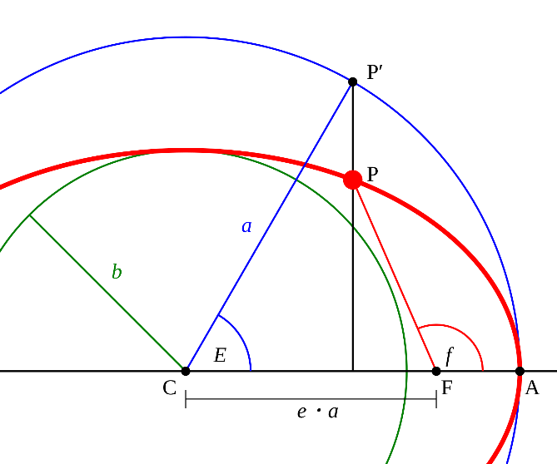For a given set of orbital elements, one can calculate the orbiting body’s accurate position (XYZ in the Cartesian coordinate) and velocity (UVW). In this formalism, x is toward the periapsis and z is toward the north pole.

We will calculate XYZ by using Kepler’s equation, $M=E-e\sin{E}$, where M is mean anomaly and E is eccentric anomaly. M and E are related to the true anomaly. It is impossible to calculate true anomaly at any given time analytically hence we will use M and E for a quick approximated solution.

For a given elliptical orbit, we will first calculate its mean motion (i.e., an equivalent circular motion with the same orbital period) from which we can easily calculate the position on the circular orbit (i.e., Mean Anomaly M). Then, we will obtain eccentric anomaly E from M which is the angle toward the orbiting body from the center of the ellipse (not focus). From E, we can calculate the angle toward the orbiting body from the focus of the ellipse which is the true anomaly.

In summary, we will calculate $ν$ from M and E in the following steps.

$$M\left(t\right)=M_{0}+n\left(t-t_{0}\right) where n=\sqrt{GM/a^{3}} \\ M=E-e\sin{E} \\ ν=2\arctan\left(\sqrt{\frac{1+e}{1-e}}\tan\left(\frac{E}{2}\right)\right)$$

After we obtain $ν$, we can calculate XYZ using the following set of formulae.

* 1. **M(t) for a given t**

At a given time t where we want to calculate the orbiting body’s position, calculate the mean anomaly from the orbital axis.

$$M\left(t\right)=M_{0}+n\left(t-t_{0}\right) where n=\sqrt{GM/a^{3}}$$

and ensure that $M\left(t\right)$ lies within 0 to 360 degrees.

* 1. **Calculate *M* from *E***

From the Kepler equation, $M(t)=E(t)-e\sin{E(t)}$, we cannot solve for E analytically. We will use an iterative method (Laguerre algorithm).

$$x_{i+1}=x_{i}-\frac{nf(x_{i})}{f^{'}\left(x_{i}\right)±\sqrt{{\left(n-1\right)}^{2}{\left[f^{'}\left(x_{i}\right)\right]}^{2}-n\left(n-1\right)f\left(x_{i}\right)f^{''}\left(x_{i}\right)}}$$

where you can choose any initial integer value for *n*. When *n*=1, the above Laguerre algorithm becomes Newton’s algorithm. *n*=5 is a reasonable choice.

In our case of solving the Kepler equation, $M=E-e\sin{E}$,

$$x_{i}=E_{i} \\ f\left(x_{i}\right)≡M-E_{i}+e\sin{E_{i}} \\ f^{'}\left(E_{i}\right)= -1+e\cos{E_{i}} \\ f^{''}\left(E_{i}\right)=-e\sin{E_{i}}$$

In Python programming code, we can calculate *E* as follows.

import numpy as np  
# calculate eccentric anomaly from mean anomaly  
M = M0 # initial guess  
tolerance = 1E-5 # very small number. Iteration stops if the change is smaller than this.  
Ei = E0 # initial guess  
n = 5  
  
def f(E, M, e):  
 return M – E+e*sin(E)  
def fp(E,e):  
 return -1 + e*cos(E)  
def fpp(E,e):  
 return -e*sin(E)  
  
while difference > tolerance:  
 denom = fp(E,e) + np.sqrt( (n-1)**2*fp(E,e)**2 – n*(n-1)*f(E,M,e)*fpp(E,e))  
 Enew = Eold – n*f(E,M,e) / denom  
 difference = Enew – Eold  
 Eold = Enew

* 1. **Calculate $ν$ from $E$**

From the calculate $E$ value from the previous step, calculate true anomaly using the following formula.

$$ν=2\arctan\left(\sqrt{\frac{1+e}{1-e}}\tan\left(\frac{E}{2}\right)\right)$$

Then, orbiting body’s XYZ position can be calculated from $ν$ and other orbital elements.

$$x=r\left(\cos{Ω}\cos\left(ω+ν\right)-\sin{Ω}\sin\left(ω+ν\right)\cos{i}\right) \\ y=r\left(\sin{Ω}\cos\left(ω+ν\right)+\cos{Ω}sin\left(ω+ν\right)\cos{i}\right) \\ z=r\sin{i}\sin\left(ω+ν\right)$$