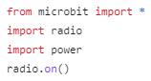

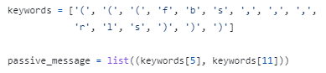



Get your ingredients together before you make the receiver program   
 (message decoder)

Teaches the Micro:bit what messages should be accepted and creates a blank message

(message decoder)

Teach the Micro:bit how it should set up the radio. (message decoder)

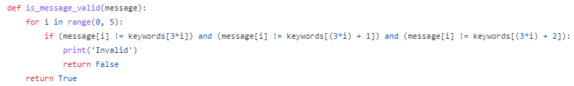

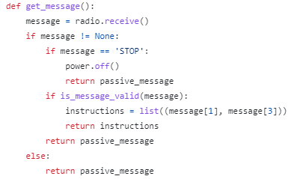

It picks up the message and decides if it’s a valid message. It then send it to the main program

(message decoder)

In the end, tell the Micro:bit how it should setup the radio

(message decoder)