



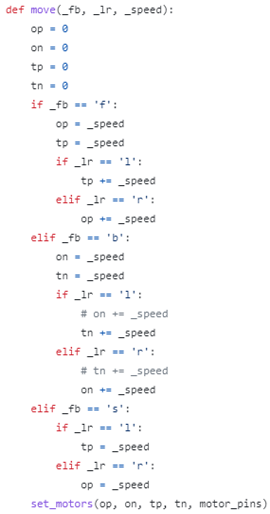

Get your ingredients together before you make the receiver program (motor control)

Teach the micro:bit which pins the motors are (motor control)

First figure out how the user wants to move the bus

(motor control)

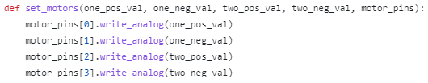

Secondly, tell the motors how to move and what direction to move in

(motor control)