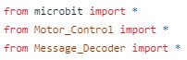



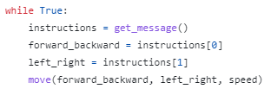

Get your ingredients together before you make the receiver program (Receiver)

Give the bus instruction about going forwards/backwards and left/right using the speed declared before this function

(Receiver)

Tell the bus how fast to go by replacing with a number and   
Tell the bus which channel to listen to by replacing  with a number (Receiver)