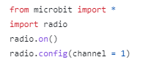

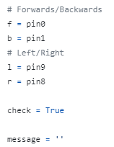

Get your ingredients together before you make the Transmitter program

(Transmitter)

Before you write the code, teach the Micro:bit what directions are what on the controller

(Transmitter)

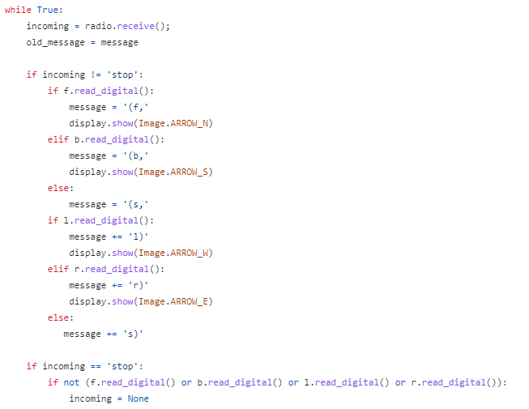



Your code checks what way the controller is moving.

(Transmitter)

In the end of you code, send the message you just created to the bus via radio (Transmitter)